Autism Friendly Lightning Theatre
SOCIAL STORY FOR FAMILY VISITS
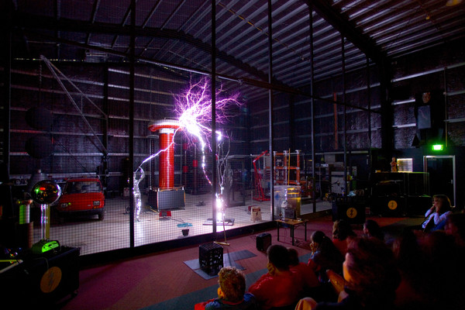
What is the Lightning Theatre?
I am going to see a Lightning Theatre show at Scienceworks.
The show will be about lightning and electricity and can be very loud. The show will go for about 30 to 45 minutes.
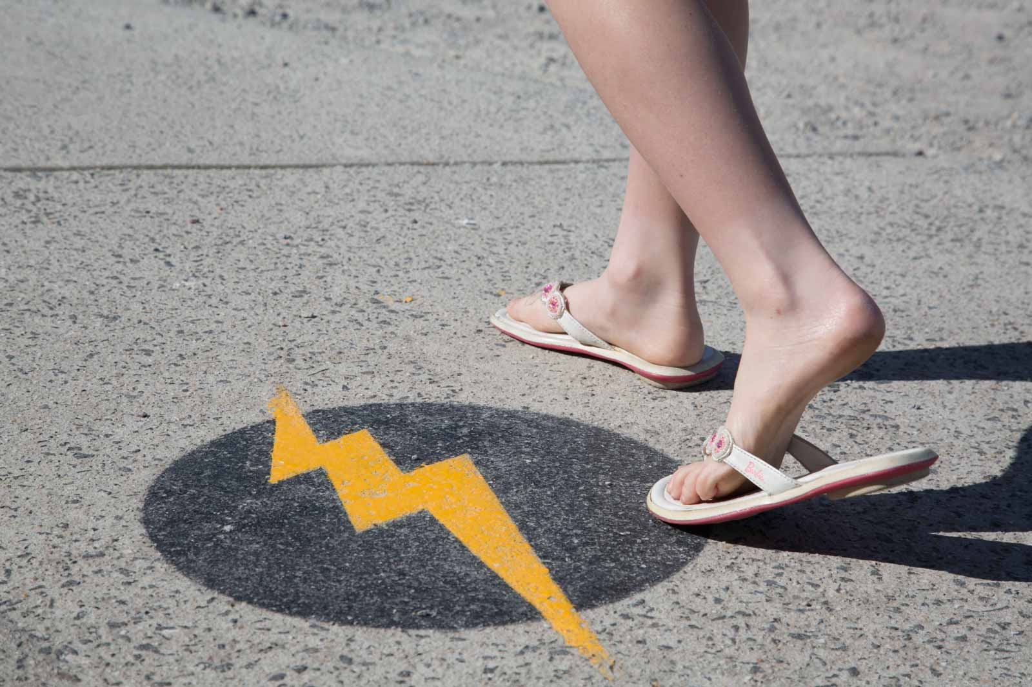

Getting to the Lightning Theatre
To get to the Lightning Theatre I go outside, past the café and follow the lightning bolt symbols painted on the ground.
I line up with everyone else who is going to see the show.
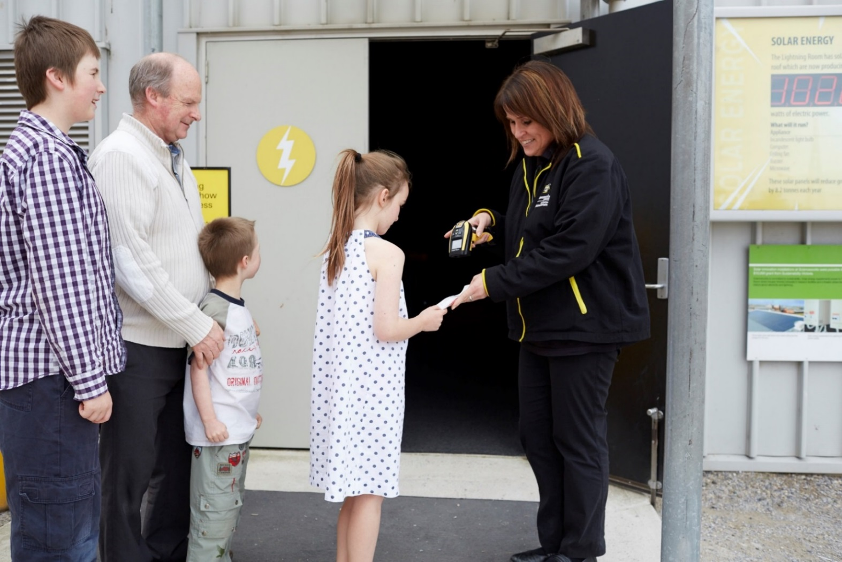
Going in to the Lightning Theatre
I may need to wait about 10 minutes for the door to open.
When I get to the front of the line, museum staff will scan my ticket so that I can go into the Lightning Theatre. The scanner will make a loud bleep when my ticket is scanned.
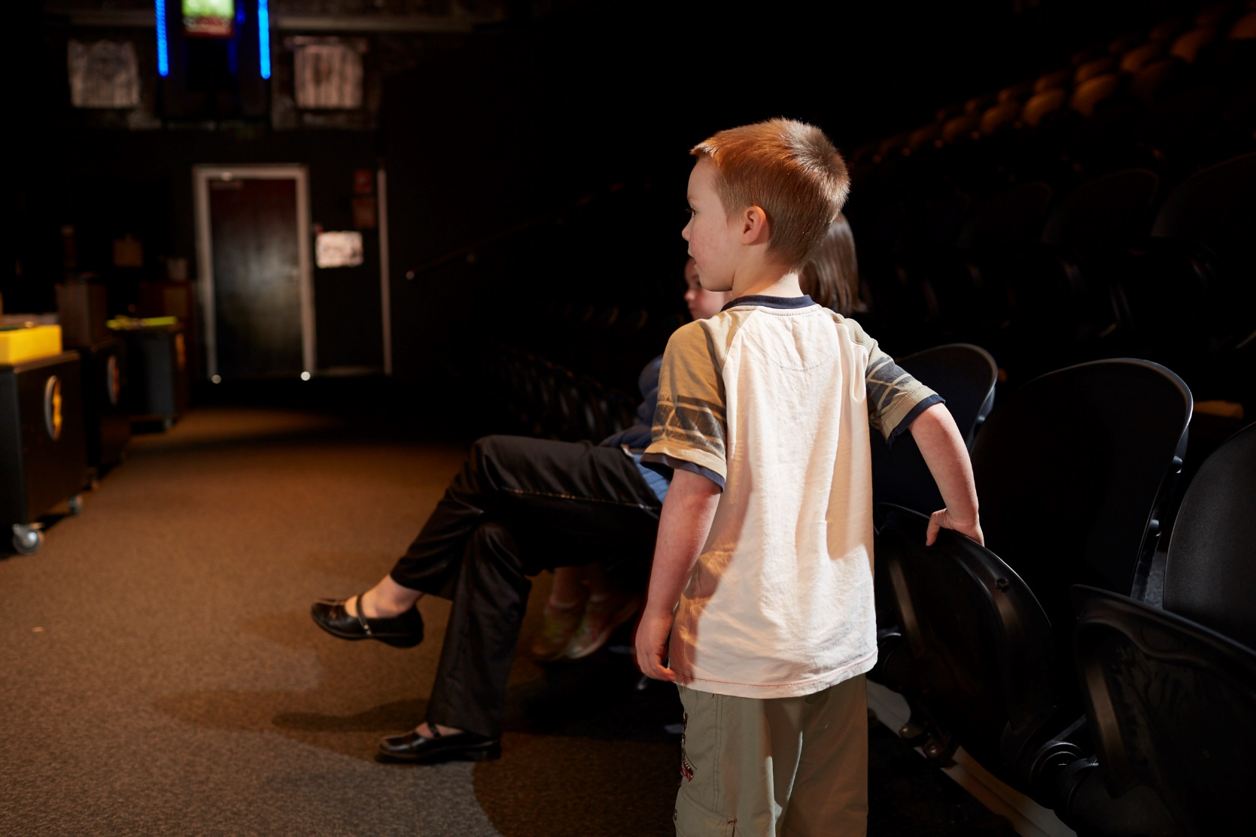
Inside the Lightning Theatre
When I enter the Lightning Theatre it will be dark.
I will sit quietly with other audience members to wait for the show to start.
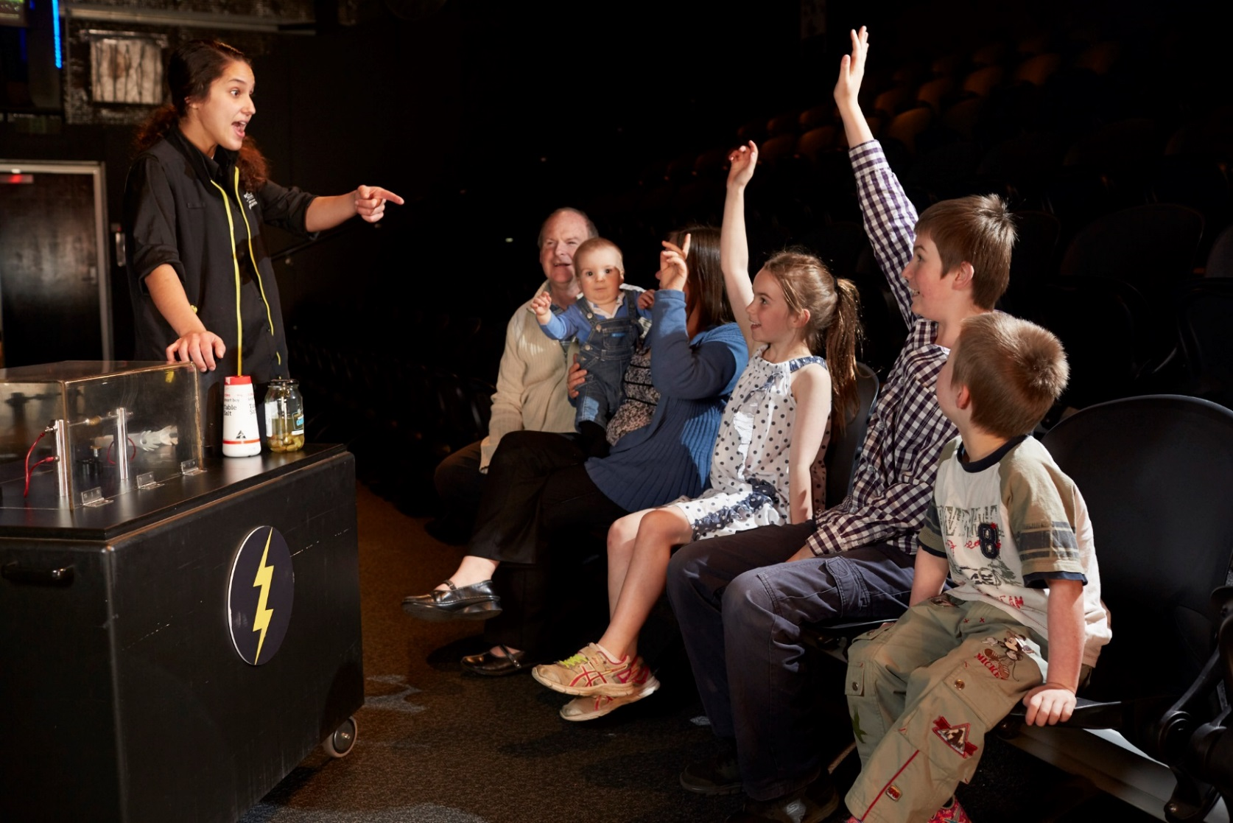
During the show
I will stay in my seat for the whole show and watch the staff member doing some demonstrations.
I will hear loud sounds and see bright lights. I can cover my ears and close my eyes if it is too loud or bright.
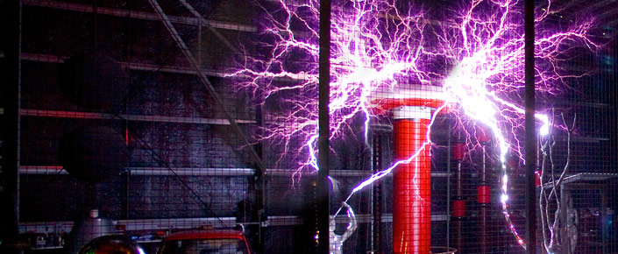

The Lightning Demonstration
Towards the end of the show, the staff member will use the Tesla Coil in the Faraday Cage to make lightning.
The metal Faraday Cage will keep me safe. The lightning will strike inside the cage and it will be loud and bright. I must cover my ears. I can also close my eyes if it is too bright.
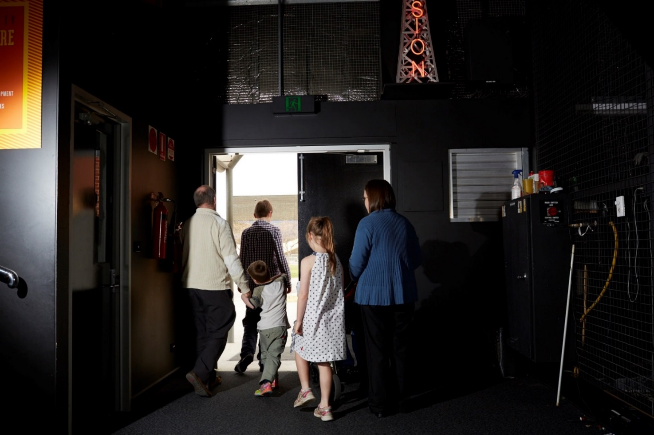
The show ends
When the show ends I will leave the Lightning Theatre. I will remember to take all my things with me when I leave. It can be bright outside after being in the Lightning Theatre.

