SOCIAL STORY

Air Playground

This book belongs to ____________________
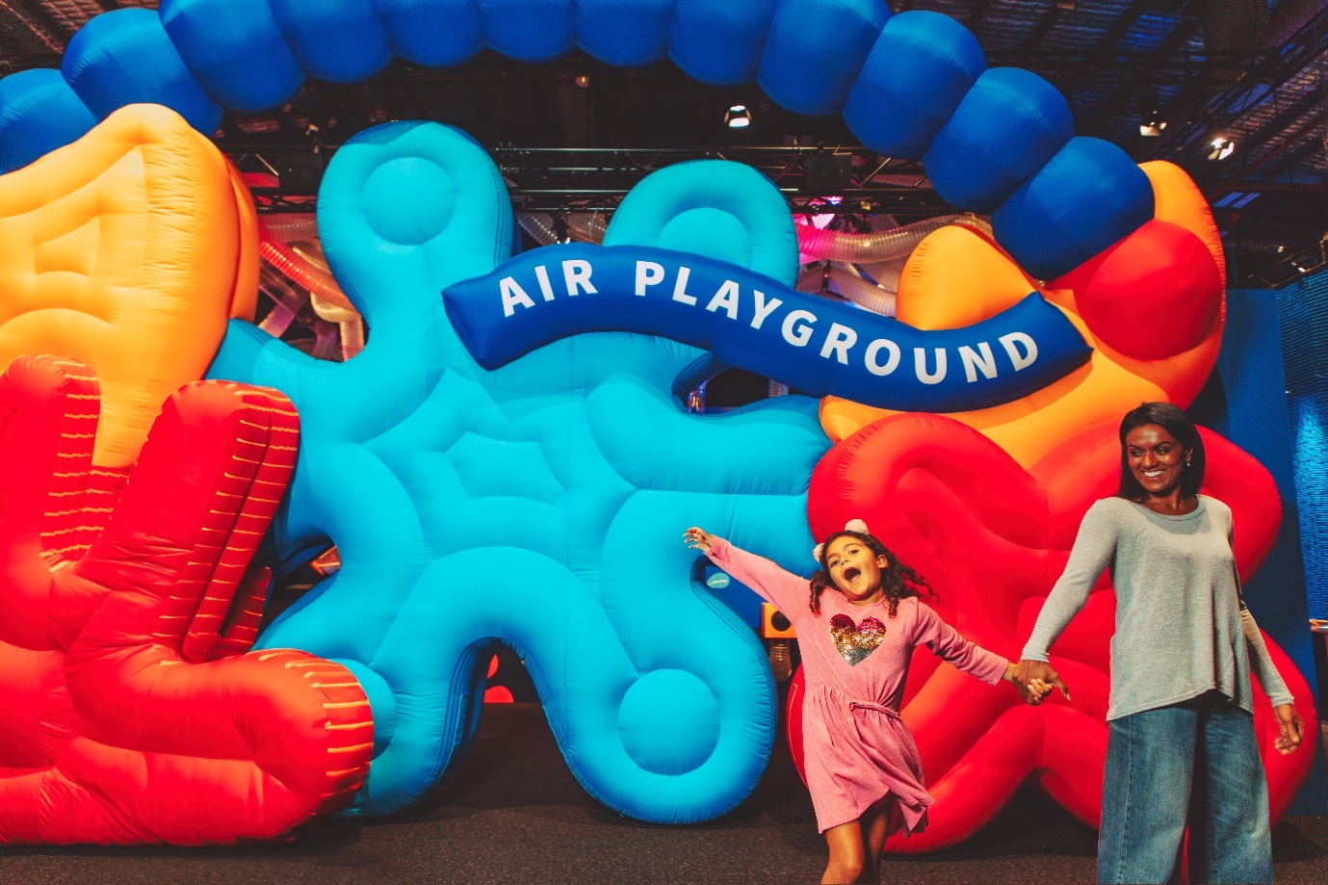

I am going to visit the Air Playground exhibition at Scienceworks.
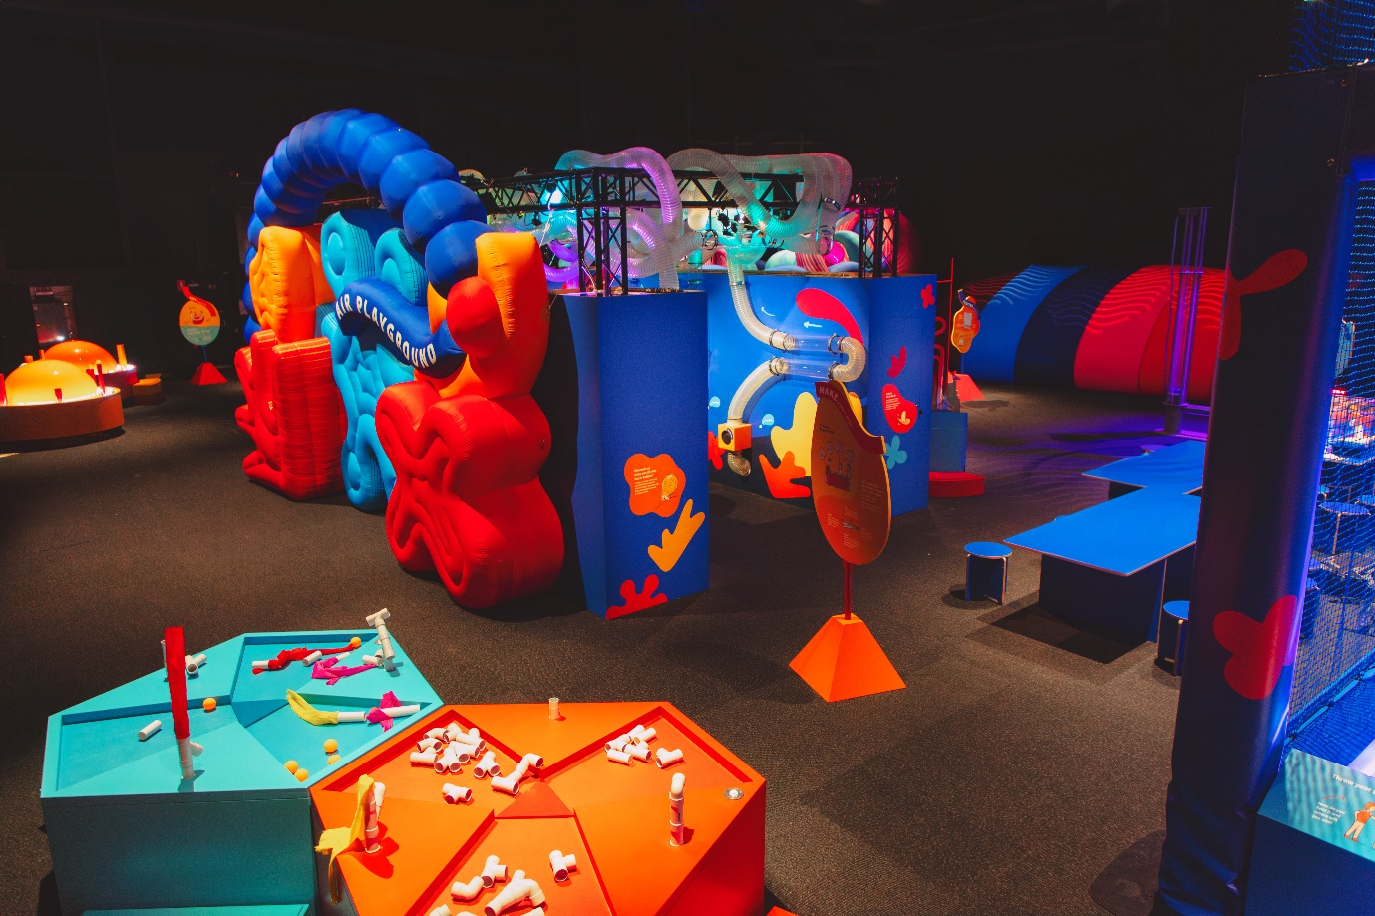
It is a fun, colourful and sometimes noisy place where I can play with air.
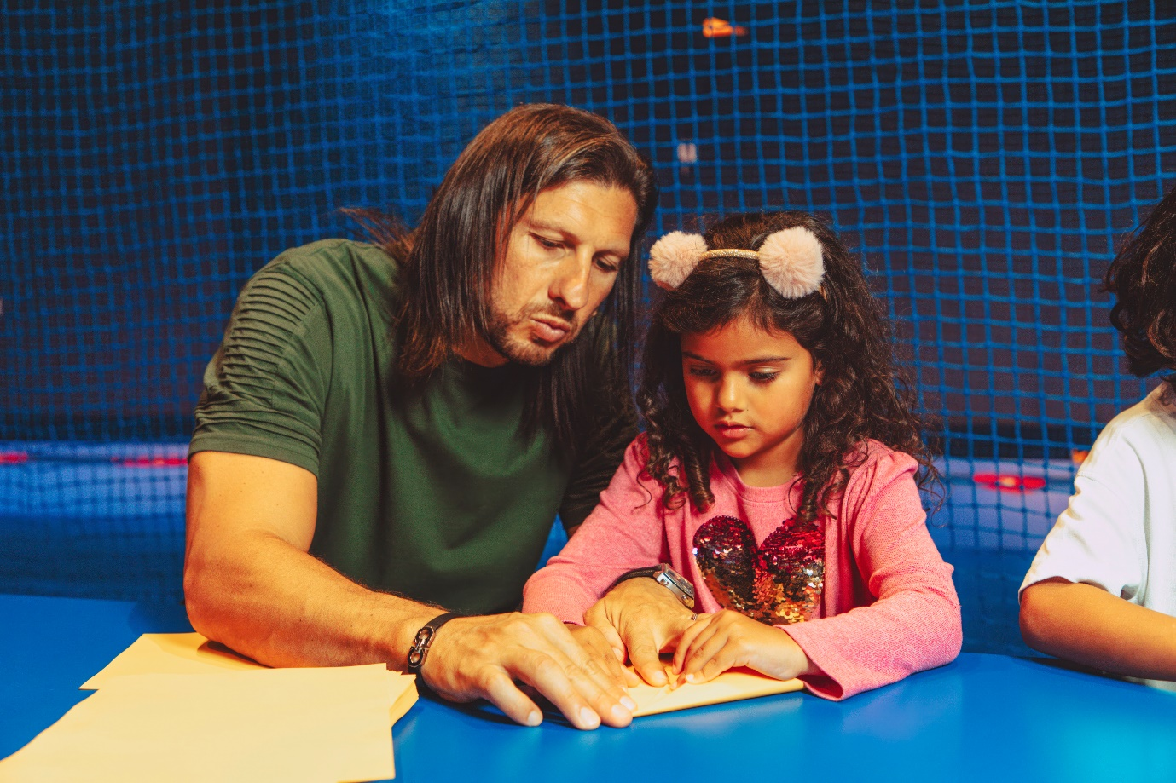
I can make paper aeroplanes to throw through the air. I may need help with some of the harder designs.
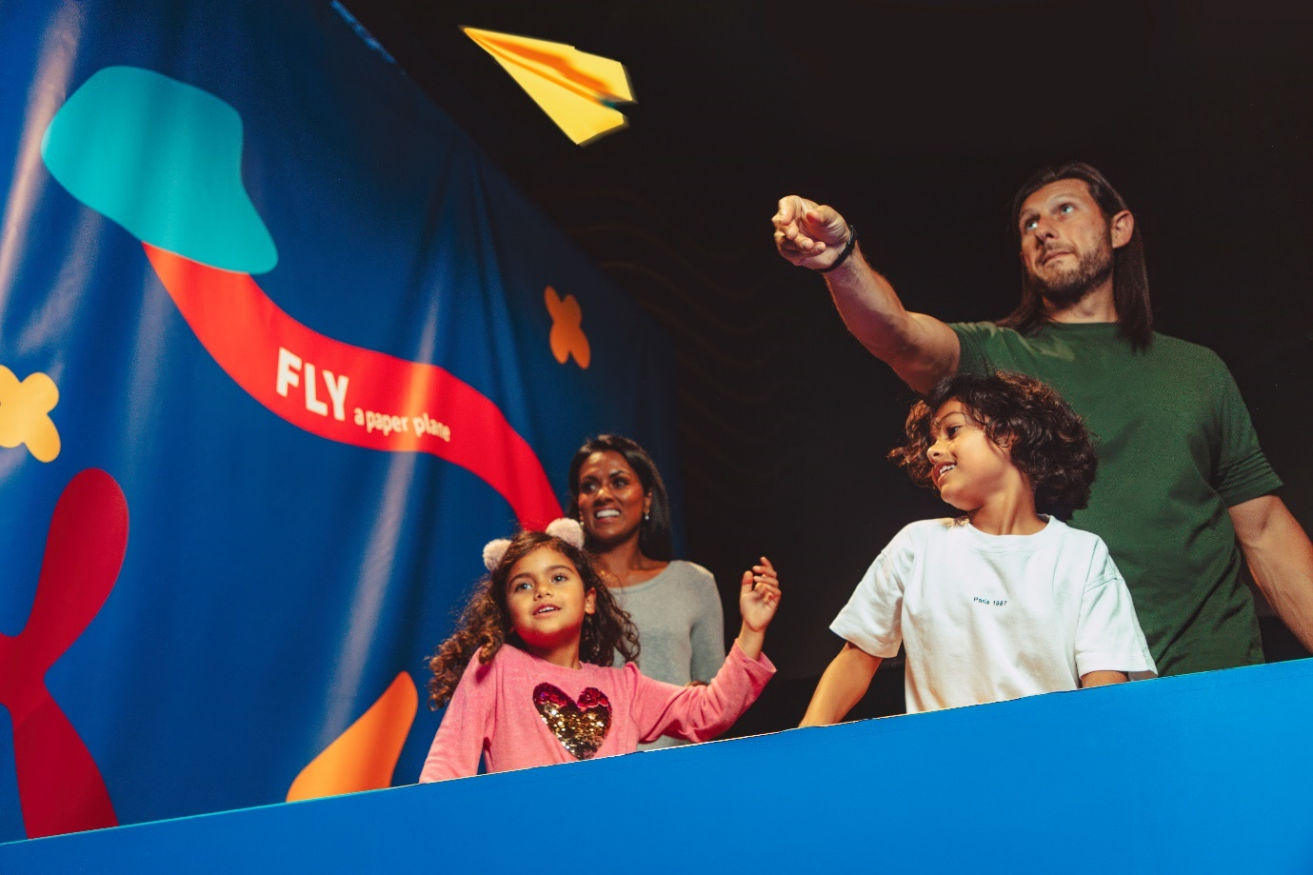
I will line up with my family to throw my aeroplane into the big pile of planes. If I want to throw again, I can make a new plane.
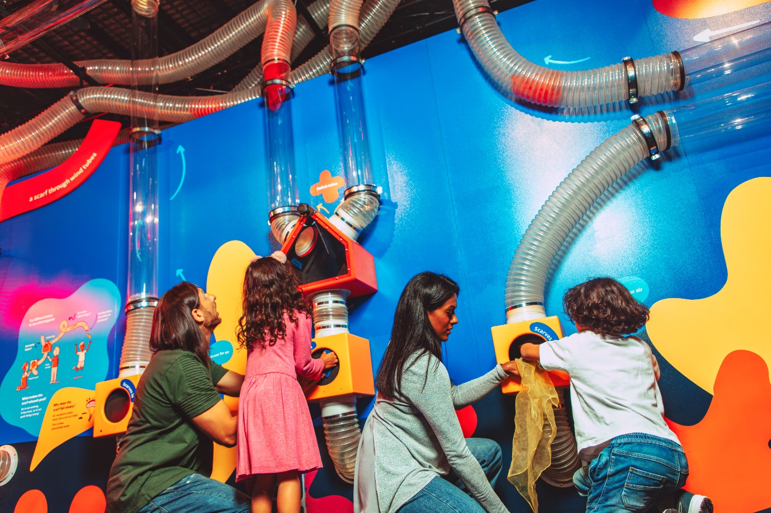
I can push colourful scarves into these boxes. With a button press, I whoosh them away with air.
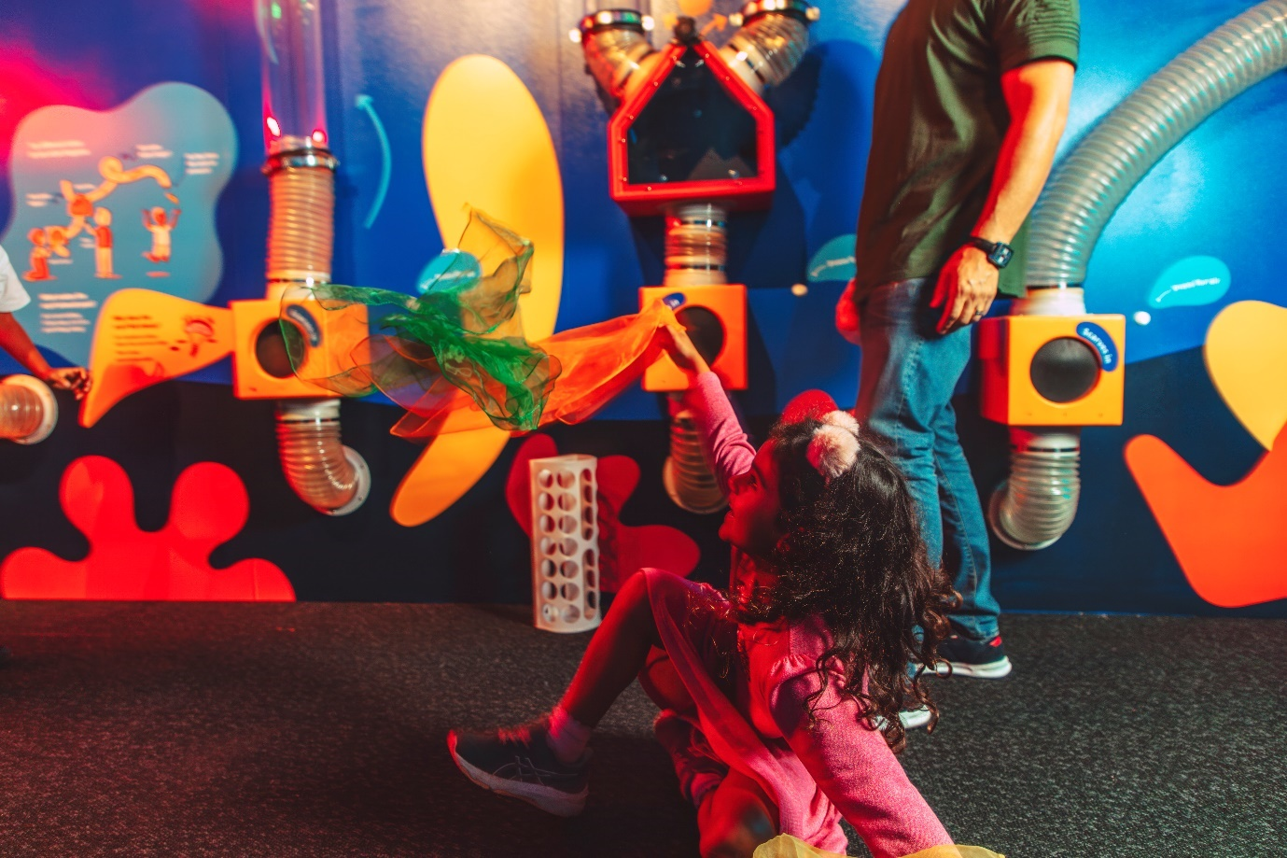
After travelling through the tubes, the scarves will float down and I can try to catch them.

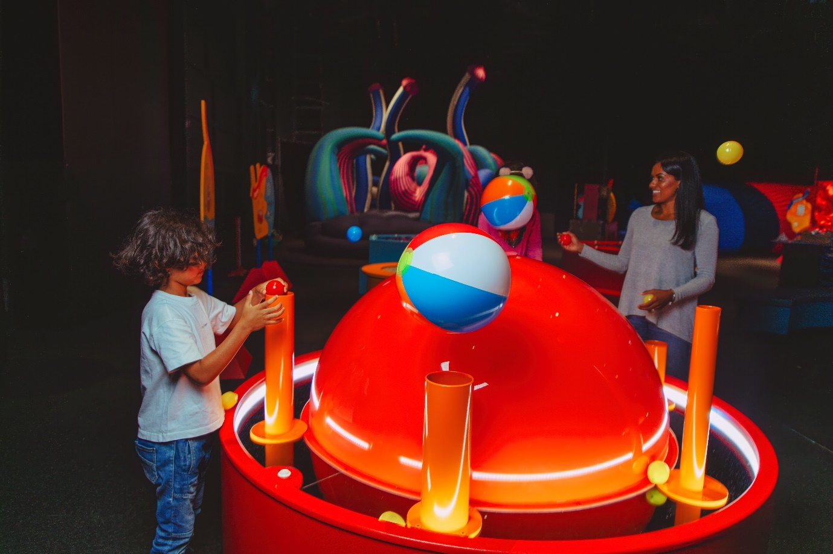
I can try to float things in mid-air and see which shapes float better.
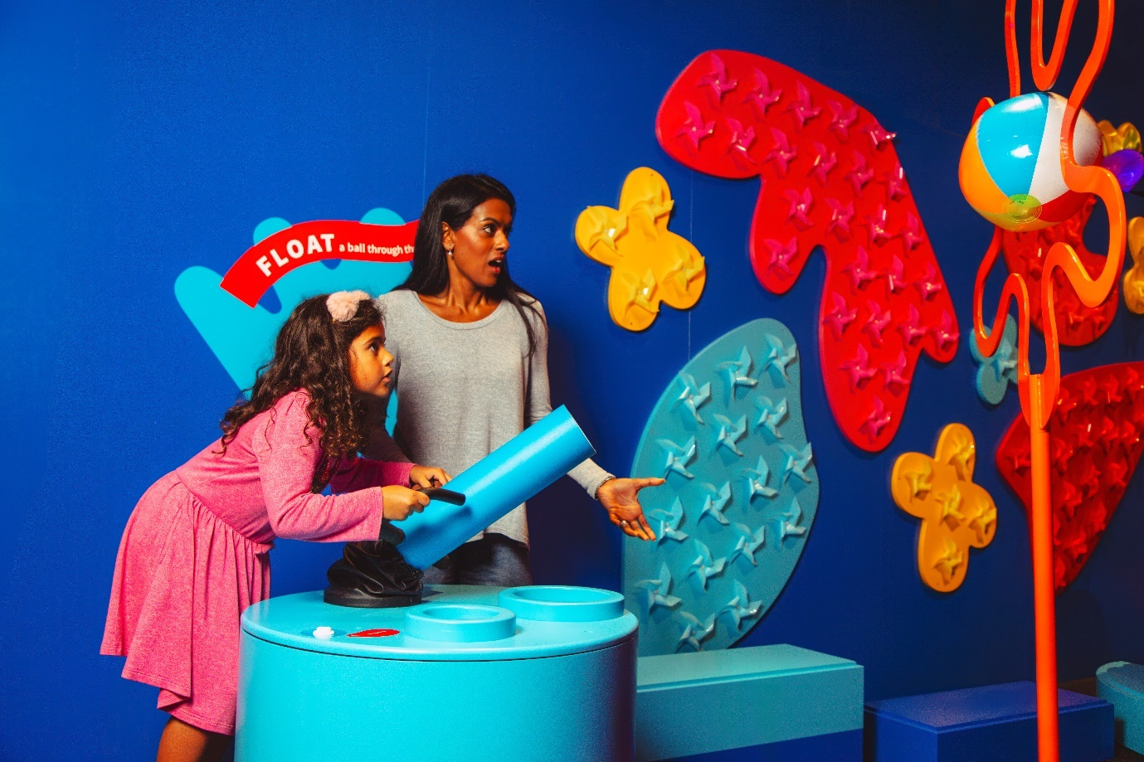

I can use air to guide a floating ball through a goal.
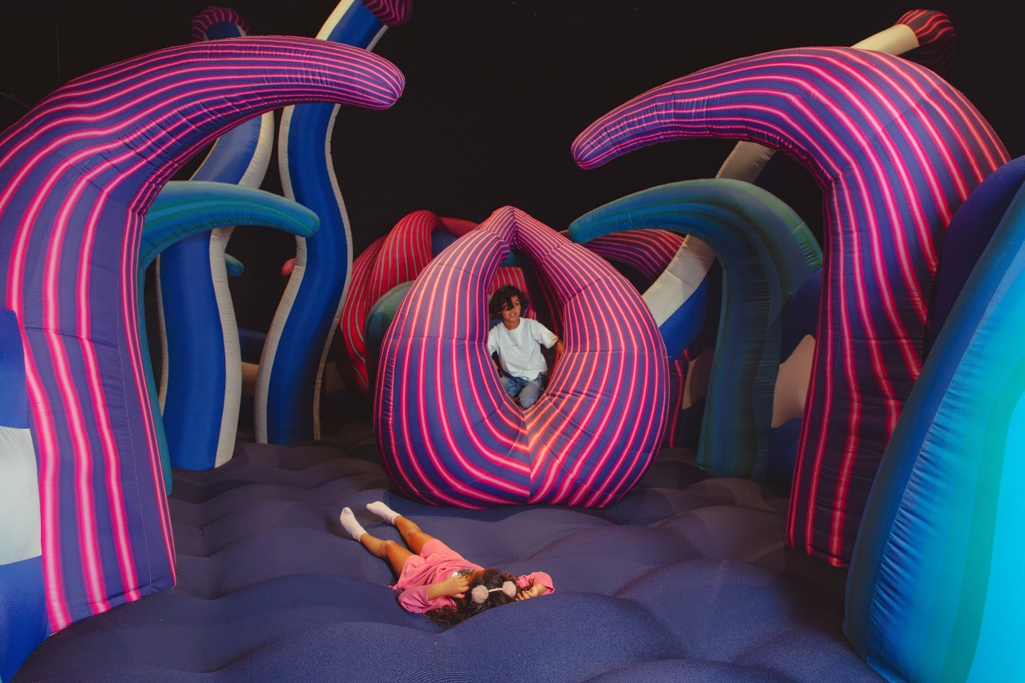
I can take my shoes off and line up for my turn on Squish, a giant air-filled sculpture. I can squash the air underneath me with my body but I need to be careful of those around me.
I listen out for the announcement and follow directions of Scienceworks staff to leave Squish when my turn is up.
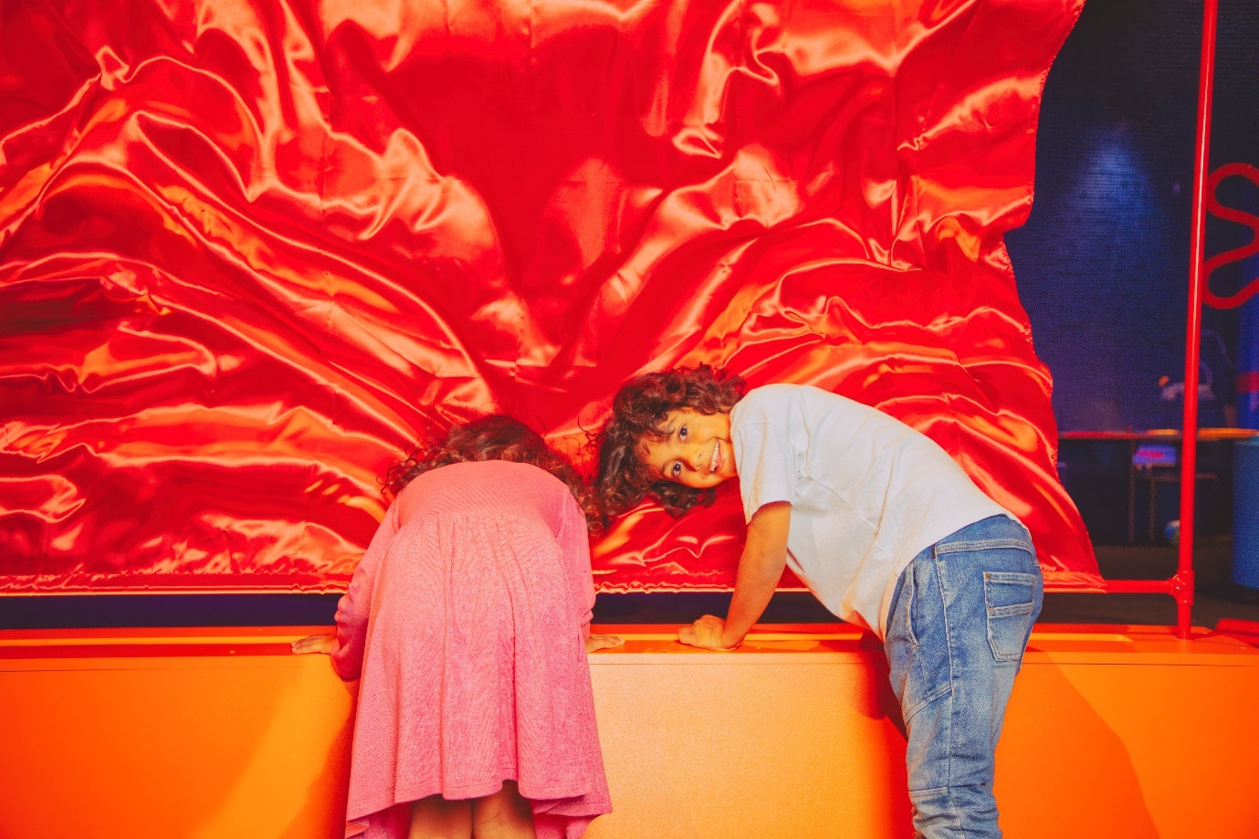
I can watch air flutter a piece of fabric. This looks different when I use my hands to block the air.
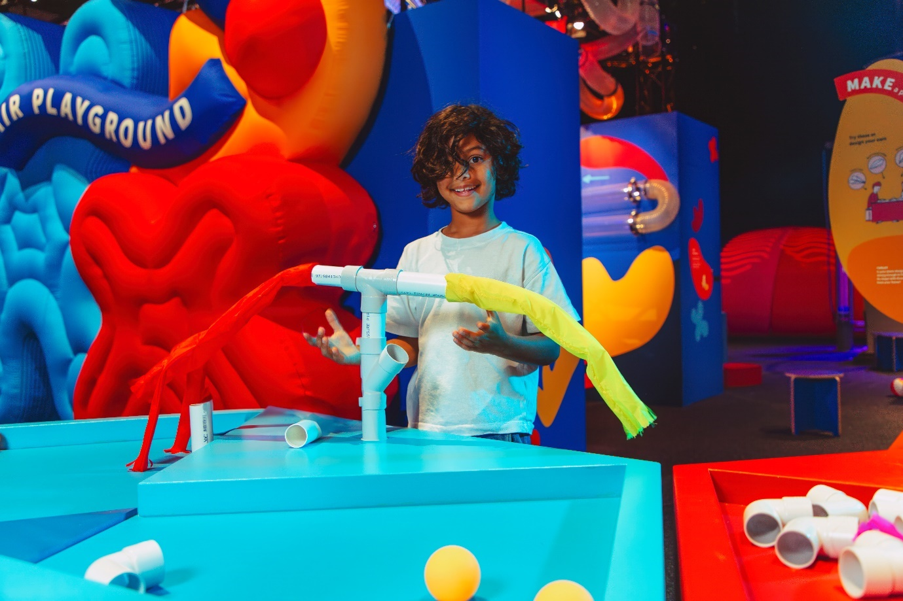
I can experiment with different tubes: soft and hard, curvy and straight to see how the air flow changes.

I can play games with my family using air. We can try to get a ball in a goal using the air from different fans.
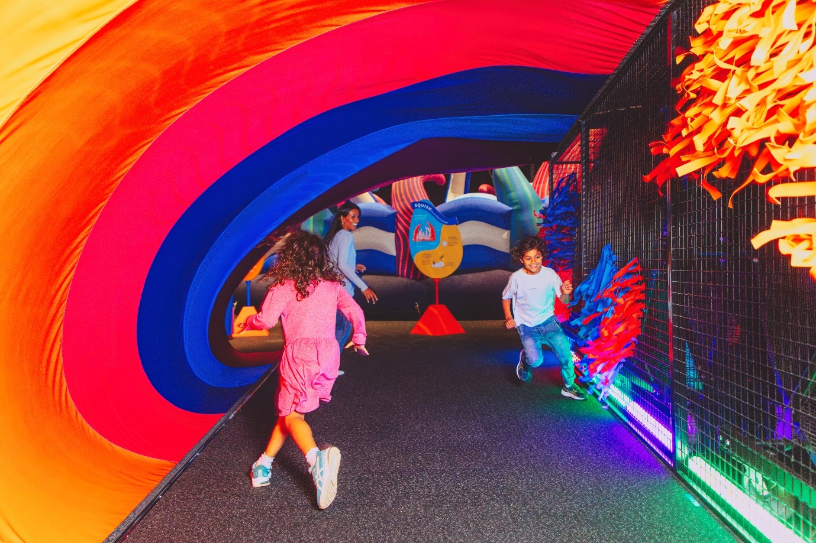

I can play in a rainbow windy tunnel. There are some really big fans here which make strong gusts of wind and can be a little loud.

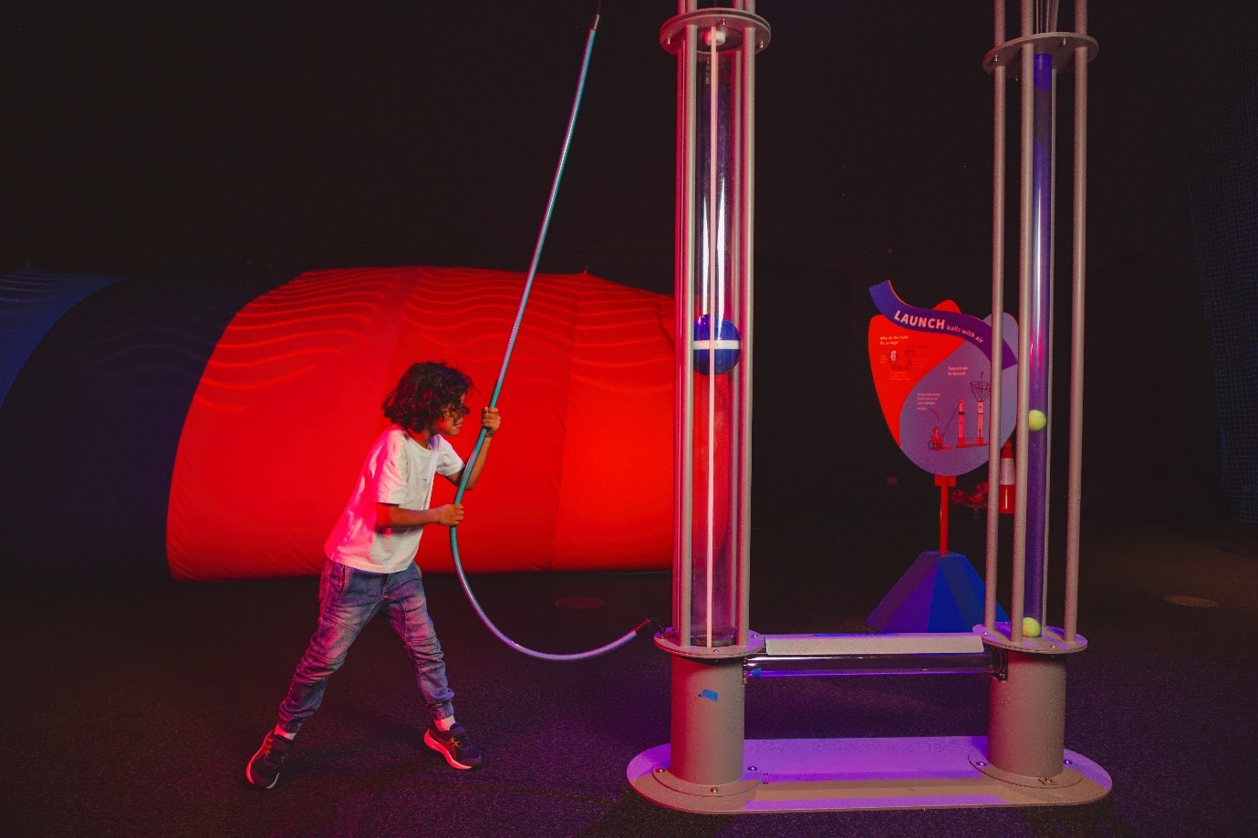
I can make balls fly high in the air by pulling on a weight and then letting it drop.
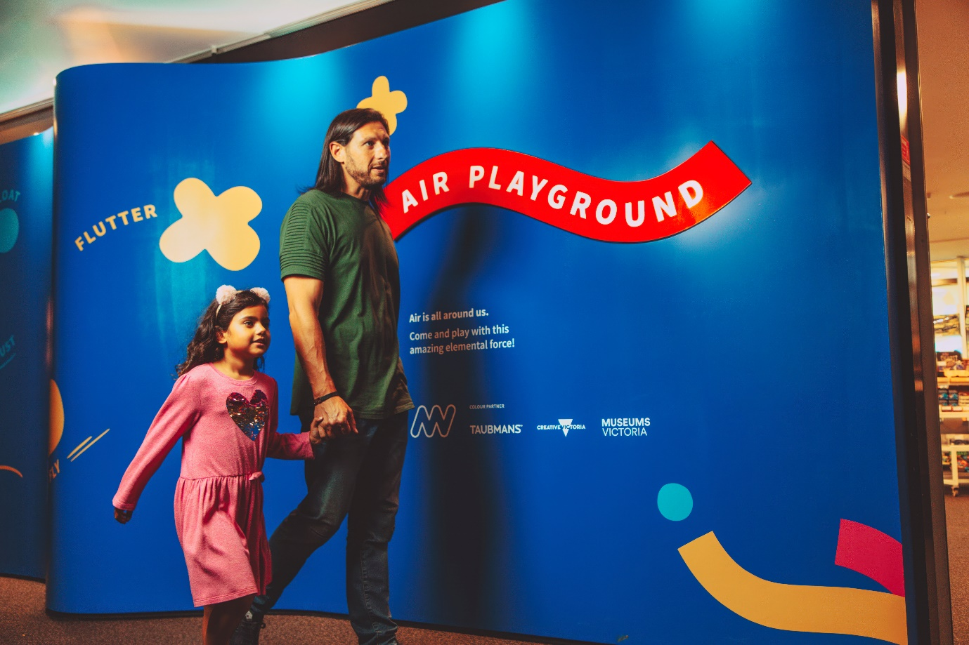

I might not want to leave Air Playground, but I can always come back during my visit or another time!

