TOP DESIGNS 2024

ACCESS GUIDE

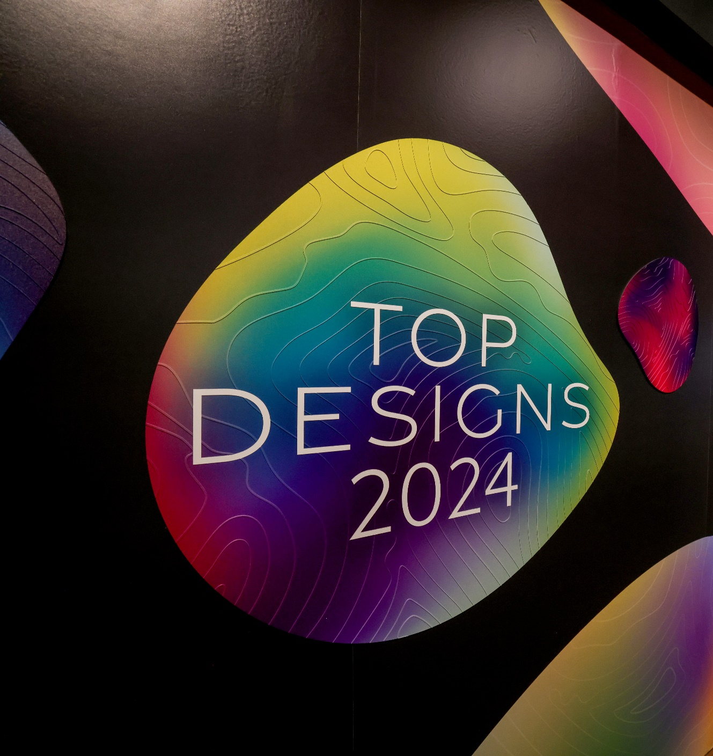

Table of Contents
TOP DESIGNS 2024 ACCESS GUIDE 1
INTRODUCTION 3
CONTACT 3
DEAF ACCESS / 24-HOUR RELAY CALL NUMBERS 3
ABOUT TOP DESIGNS 2024 4
LOCATION 4
DATES AND TIMES 4
TICKETS 5
MELBOURNE MUSEUM QUICK LINKS 5
EXHIBITION ACCESSIBILITY 6
TOP DESIGNS QUICK LINKS 7
GETTING TO THE MUSEUM 7
TRAM 7
TRAIN 8
PARKING 8
TAXI ZONE 9
ACCESSIBLE DROP-OFF SPOT 9
GETTING TO THE MUSEUM ENTRANCE 10
GREEN SPACES FOR DOG GUIDES & ASSISTANCE ANIMALS 11
FOYER 12
INFORMATION DESK 13
RECEPTION 13
CLOAKROOM 14
WAY-FINDING SIGNAGE TO EXHIBITION 14
TOILETS 15
GETTING TO THE MIND AND BODY GALLERY 16
LIFTS 16
ESCALATORS 20
EXHIBITION INFORMATION 24
WELCOME WALL 24
STUDY AREA BANNERS 27
LAYOUT OF STUDY AREAS 27
SEATING 30
HOW THE EXHIBITS ARE DISPLAYED PLUS SENSORY INFORMATION 30
AUDIO DESCRIPTIONS 36
MELBOURNE MUSEUM WIFI TO ACCESS AUDIO DESCRIPTIONS 37
QUIET SPACE 37
DINING AT MELBOURNE MUSEUM 38
PHOTO CREDITS 38

INTRODUCTION

This Access Guide provides convenient information about accessing Top Designs 2024 at Melbourne Museum and is available online to prepare for your visit in advance.
The guide can be read independently or shared with a friend, family member, carer or support worker. Contextualised photographs have been used to summarise information and experiences.
This Access Guide has been prepared by Vitae Veritas on behalf of Melbourne Museum and the Victorian Curriculum Assessment Authority (VCAA) and has been reviewed by Deaf and disabled community representatives.
We hope you find the guide useful and welcome feedback.

CONTACT

If you would like to talk to Melbourne Museum about particular access requirements, or if you need more information about accessibility, please contact their bookings office on 13 11 02 or email AskUs@museum.vic.gov.au.

DEAF ACCESS / 24-HOUR RELAY CALL NUMBERS

TTY/voice calls: 133 677
Speak & Listen: 1300 555 727
SMS Relay: 0423 677 767

ABOUT TOP DESIGNS 2024

In its 24th year, Top Designs features outstanding works by students who completed VCE and VCE VET design studies in 2023.
With applications received from government, independent and Catholic schools across Victoria, panels of expert educators selected 92 works across each of the 10 design studies- VCE Media, Product Design and Technology, Theatre Studies, Systems Engineering, Visual Communication and Design, and VCE VET Creative and Digital Media, Music (Sound Production), Integrated Technologies, Furnishing and Engineering Studies.
The panels considered the imaginative ways students responded to the assessment criteria and the strength of design development and folios in their decision-making.
Managed by the Victorian Curriculum and Assessment Authority (VCAA), Top Designs is part of the VCE Season of Excellence, which also includes Top Talks, Top Screen, Top Arts, Top Class and Top Acts.

LOCATION
Top Designs is located at the Melbourne Museum, situated within Carlton Gardens, adjacent to the Royal Exhibition Building.
Address: 11 Nicholson Street, Carlton. Google Maps link.
The exhibition is located inside the Mind and Body Gallery on the Upper Level.

DATES AND TIMES
The exhibition is open between 9am and 5pm from Saturday 23 March to Sunday 14 July. Closed Good Friday. Melbourne Museum tends to be quieter between 3pm and 5pm on weekdays during the school term.

TICKETS

Your visit to Top Designs is included with Museum entry.
More information and tickets here.
If you have trouble booking online, email: mvbookings@museum.vic.gov.au or call the bookings office on 13 11 02, available 9am–4.30pm daily.
If you have a Companion Card, you qualify for a second, free ticket.
You do not have to book ahead for your companion.
Simply present your companion card at the reception.
If you have a Concession Card, you qualify for a free ticket.

MELBOURNE MUSEUM QUICK LINKS

Plan your visit
Getting here and parking
Book your car park at Melbourne Museum online
Visitor Map
Sensory Friendly Melbourne Museum floorplan
Accessibility information
Autism friendly Museum social stories

EXHIBITION ACCESSIBILITY

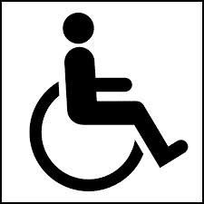
This exhibition is fully wheelchair accessible.
This exhibition includes 24 audio descriptions.
All audio content in this exhibition is open-captioned.
This exhibition is described in an access guide.
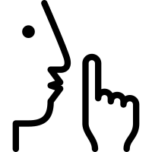
The nearest Quiet Room is located near the entrance of the Gandel Gondwana Garden and has a sign on the door saying Quiet Room.
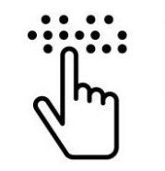
An acrylic Braille tactile map of this exhibition is available.
Large print exhibition labels are available online and in print.

TOP DESIGNS QUICK LINKS
On this webhub you can find:
- Visit the exhibition
- Accessibility resources
- Virtual tour
- Meet the exhibitors
- View the works
- Request exemplar folio pages
- Catalogue of works

GETTING TO THE MUSEUM
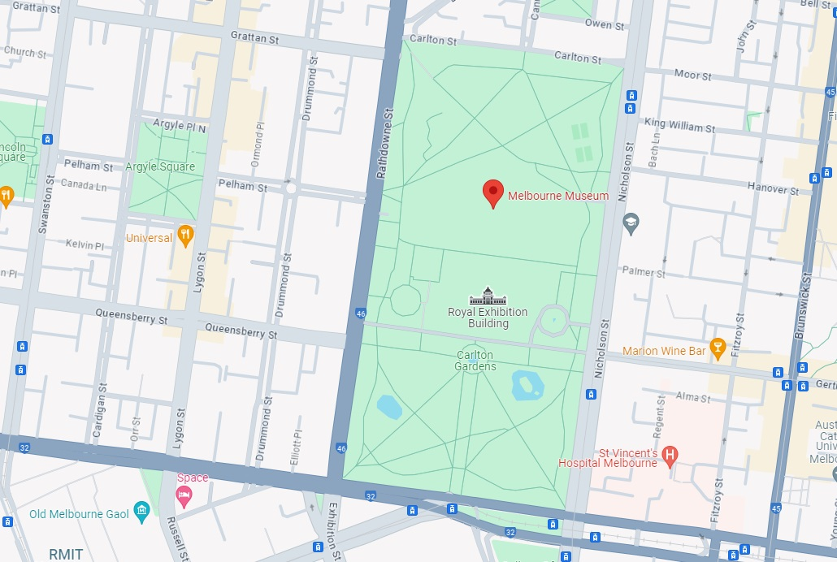
Image 1- A computer screenshot of Melbourne on Google maps. The streets surrounding the Museum are Rathdowne Street on the west side, Victoria Street on the south side, Nicholson Street on the east side.

TRAM
If taking Tram route 86 or Tram route 96, get off at Stop 11, corner of Nicholson and Gertrude Streets. Melbourne Museum is 300 metres from here.
If taking the free City Circle Tram, get off at the Victoria Street and Nicholson Street intersection. Melbourne Museum is 550 metres from here.

TRAIN
If catching a train get the City Loop train to Parliament Station, which has lift access to the top of Lonsdale Street. Melbourne Museum is 750 metres from here.

PUBLIC TRANSPORT QUICK LINKS
PTV Journey Planner
Yarra Trams
Metro Trains Melbourne

PARKING
The car park is open seven days a week from 6am to midnight. Entry is via Rathdowne Street or Nicholson Street. It contains a number of accessible parking spaces on level P2 including pram parking.
The car park entrance has a height restriction of 2.15m. Accessible parking for vehicles over this limit is located on Rathdowne Street.
Two Delta Energy Systems AC EV chargers fitted with type 1 connectors are located on level P2 Nicholson Street. There is no additional cost to use the chargers.
2-hour metered parking can be found along Nicholson and Rathdowne Street.
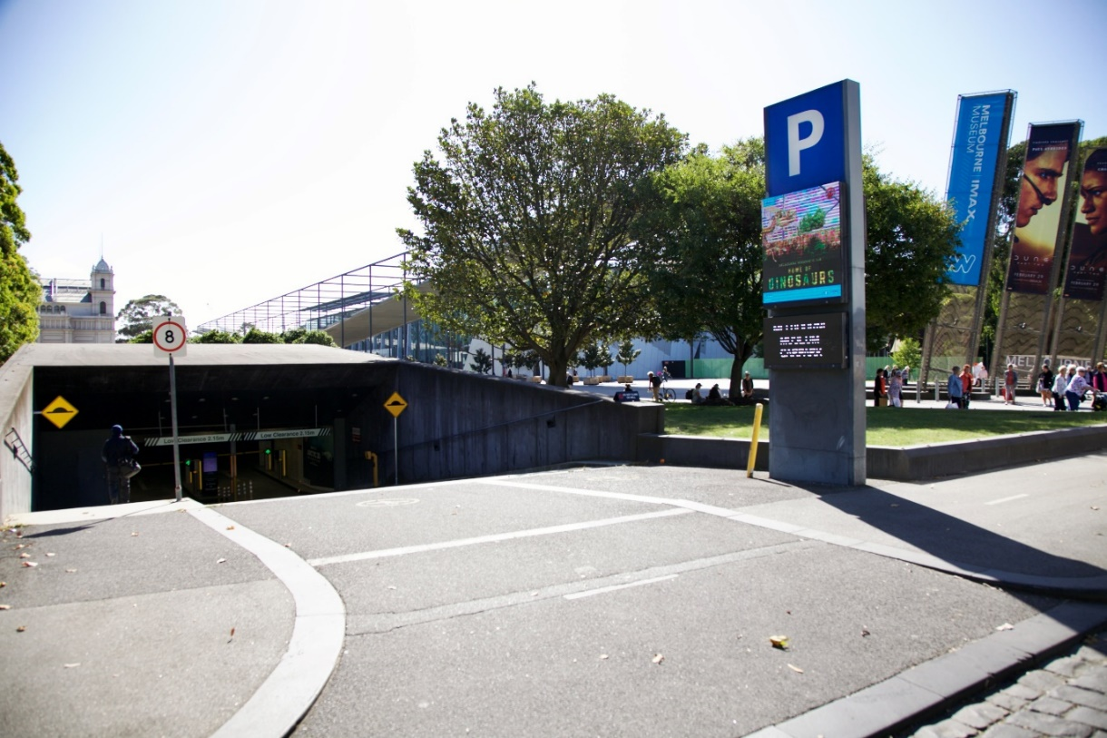
Image 2- a photo of the entrance to the Museum underground carpark on Nicholson Street.

TAXI ZONE
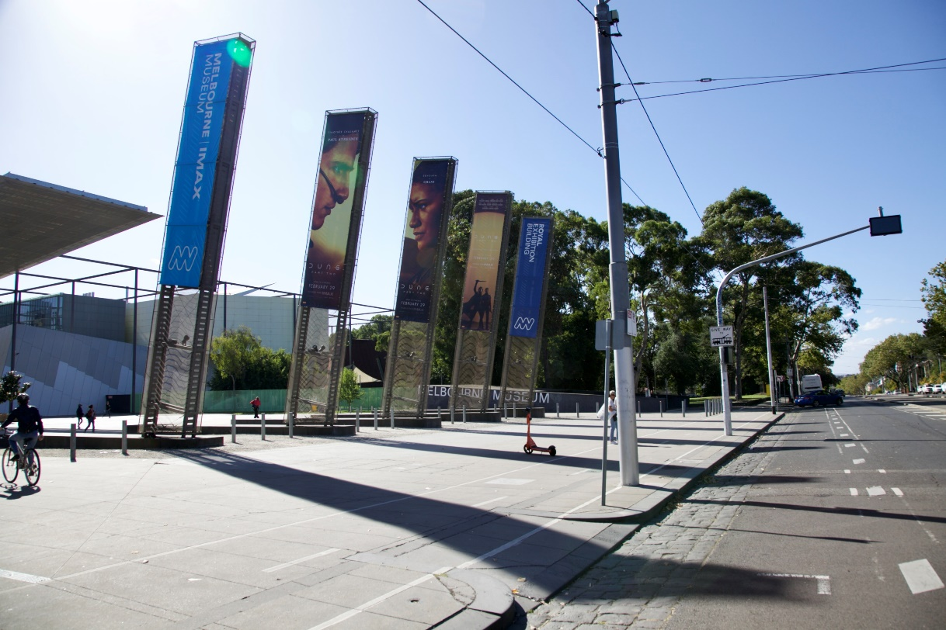
Image 3- a photo of the taxi zone at 11 Nicholson Street, Carlton.

ACCESSIBLE DROP-OFF SPOT
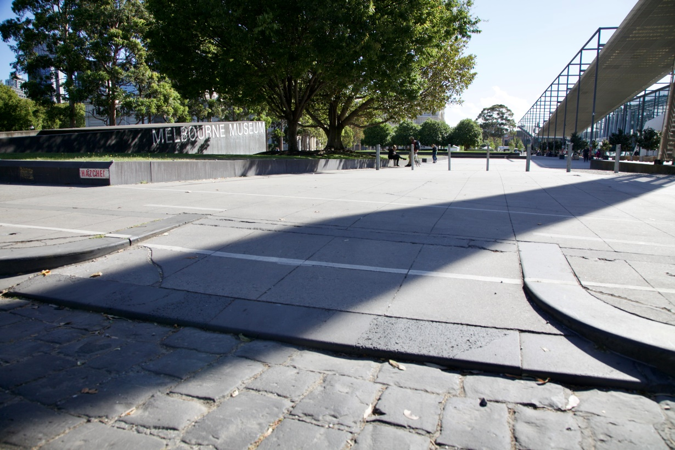
Image 4- a photo showing a 2-metre-wide driveway in the taxi zone on Nicholson St

GETTING TO THE MUSEUM ENTRANCE

The entrance to the Museum is 200 metres from the taxi zone / accessible drop-off-spot.
The path is flat, wide, paved, step-free and shaded.
The pathway is shared by different users including cyclists, skaters and e-scooter riders.
As you approach the entrance you will pass bollards, planter boxes and a row of concrete cubes.
The Museum is the big building on your right.
The Royal Exhibition Building is on your left.
Refer to image below.

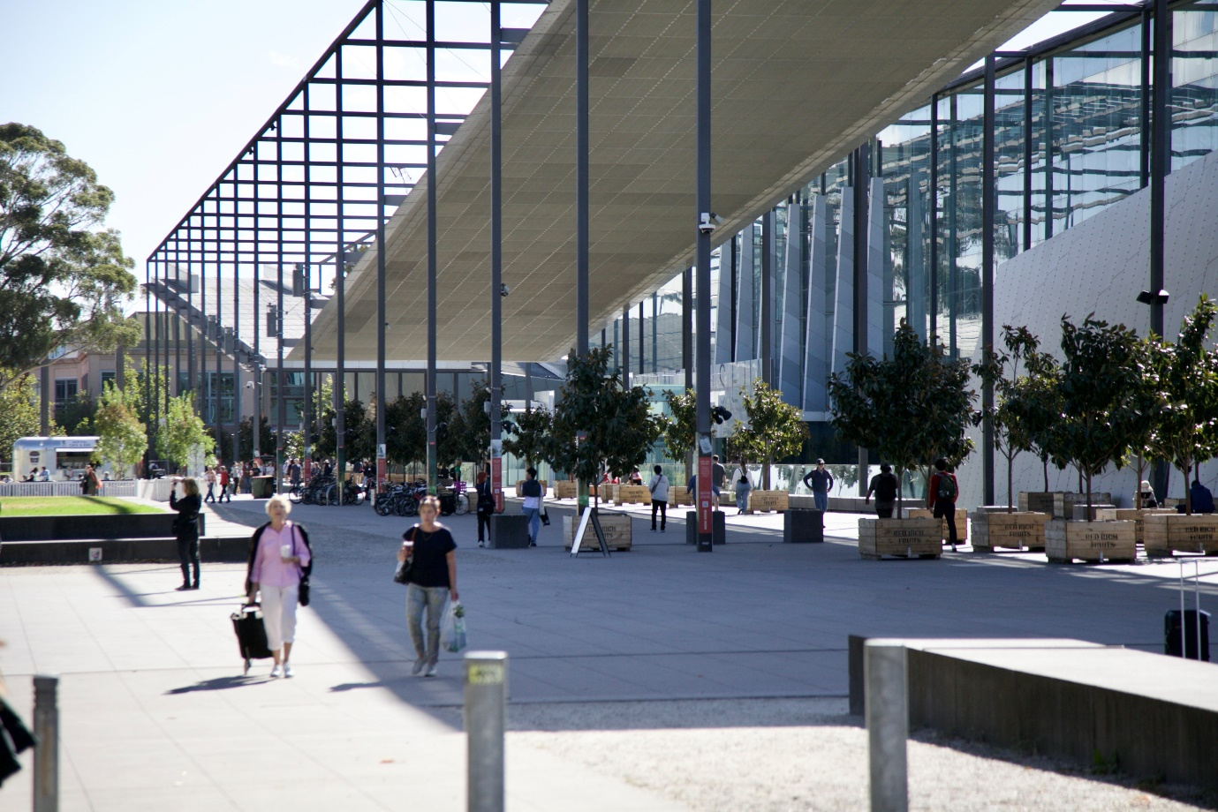
Image 5- a photo of the pathway that leads to the Museum entrances from the taxi zone / accessible drop-off spot from 11 Nicholson Street.

You have reached the Museum entrances when you see words ‘MELBOURNE MUSEUM’ in large capital letters written above on the glass windows.
There is one entrance under the word MELBOURNE, and another entrance under the word MUSEUM. The entrances are directly opposite the Royal Exhibition Building.
The two entrances are 20 metres apart. The glass exterior is highly reflective. Refer to image below.
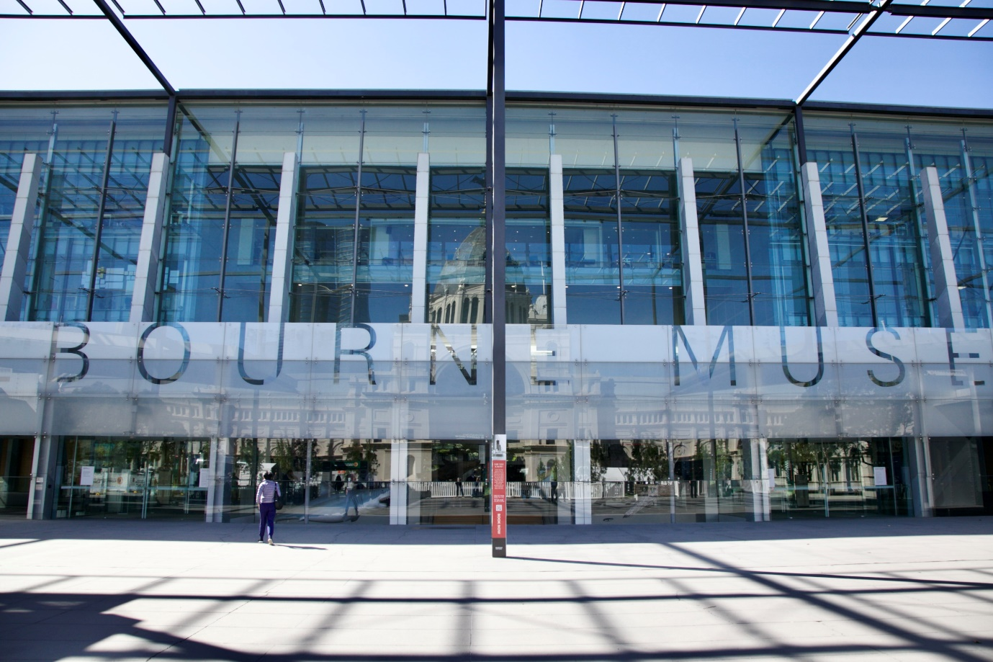
Image 6- a photo showing the Museum’s glass exterior front. The closest entrance from Nicholson St is under the word MUSEUM.

GREEN SPACES FOR DOG GUIDES & ASSISTANCE ANIMALS
The nearest green space is halfway between Nicholson St and the Museum’s main entrance, on your left. More green spaces can be found in the surrounding parks and gardens behind the Royal Exhibition Building and Melbourne Museum.
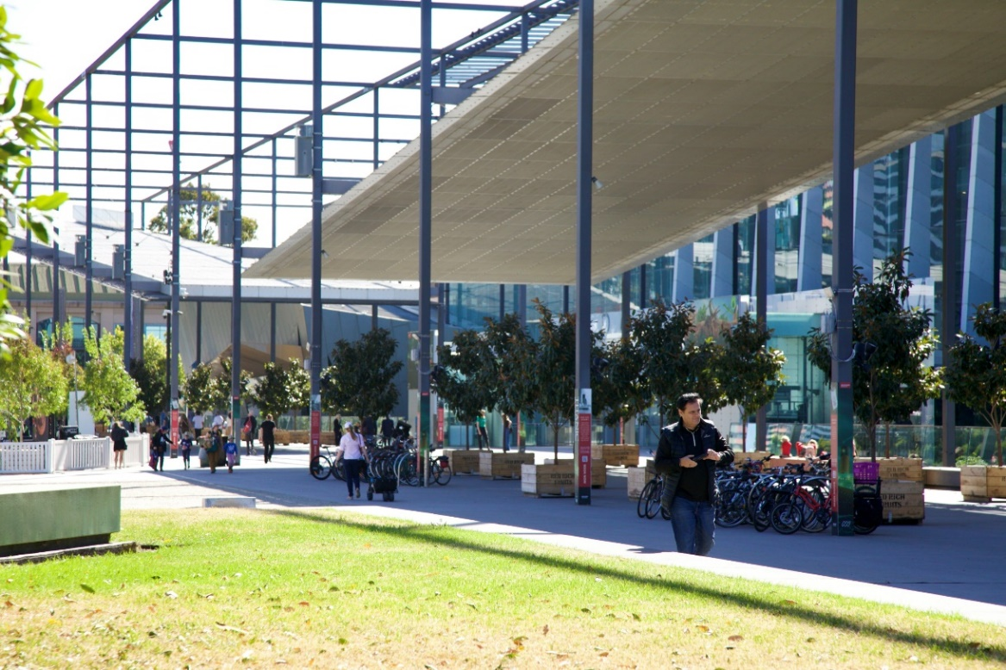
Image 7- a photo of the nearest green space to the Museum’s entrance. Please note this area is not wheelchair accessible and has two big steps.

FOYER
The Foyer is a wide open concrete floored space. Visitor Engagement Officers are located inside near the entrance, at the Information Desk and at Reception to welcome and assist people with enquiries and ticketing. Refer to the next 4 images below.
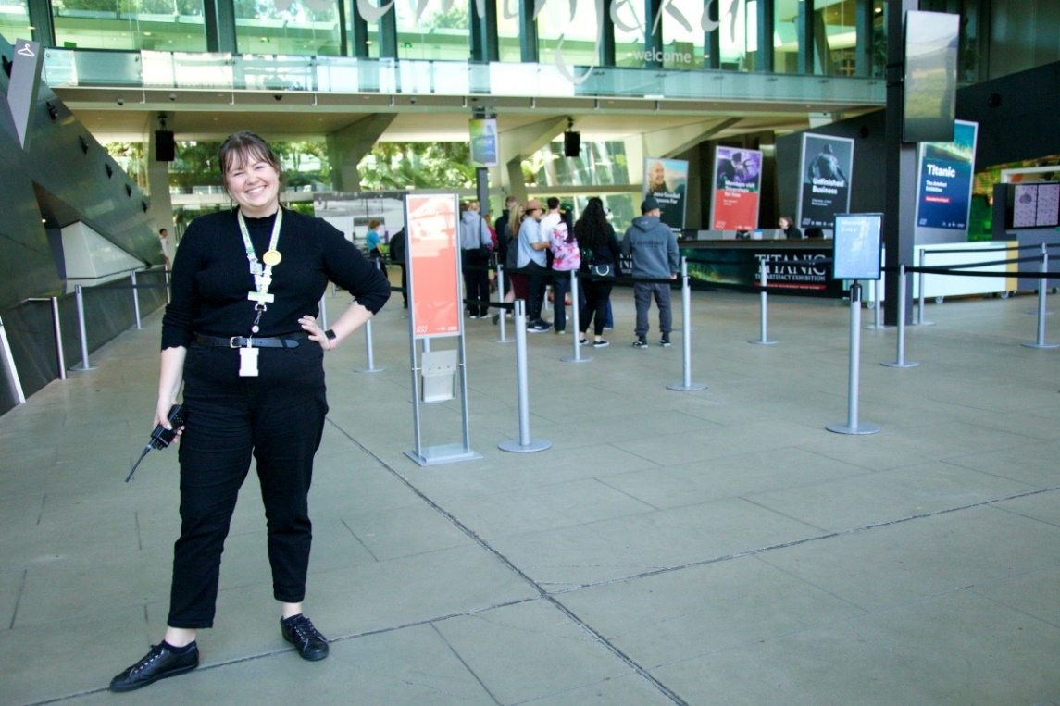
Image 8- a Visitor Engagement Officer stands near the entrance in the Foyer. Behind them, on the left, is the Cloakroom, and to their right is the Reception desk.

INFORMATION DESK
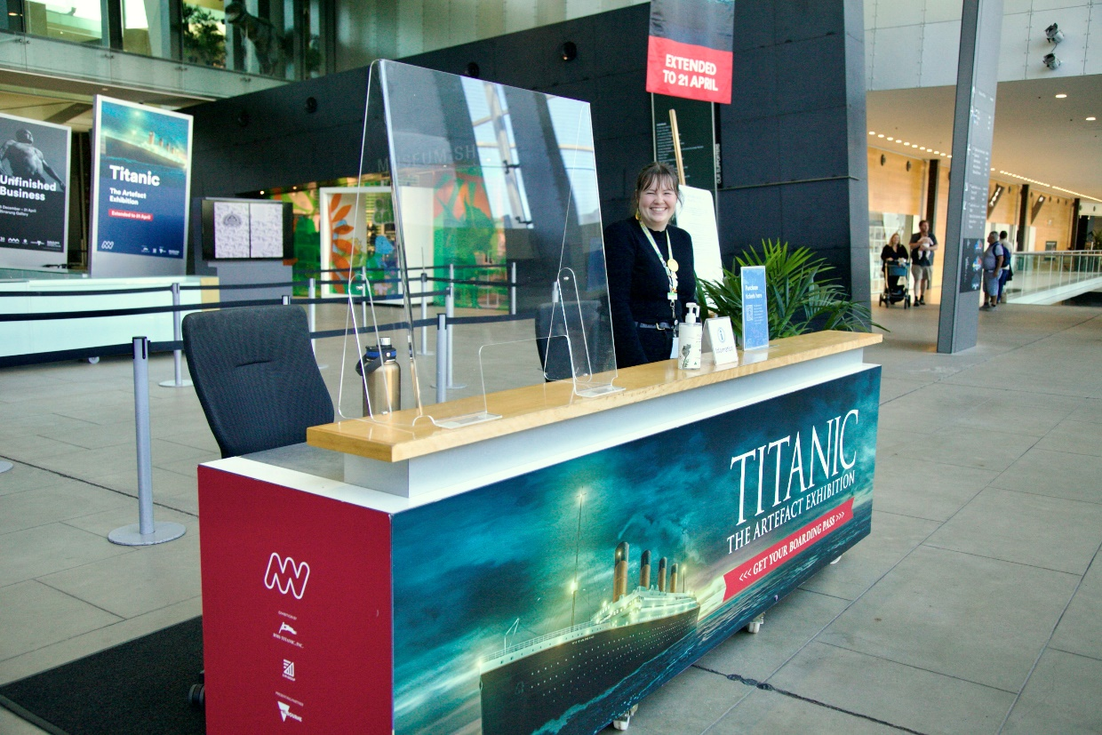
Image 9- a photo of the Information desk nearest the Museum entrances. Visitor Engagement Officers can be found here. Behind them is Reception.

RECEPTION
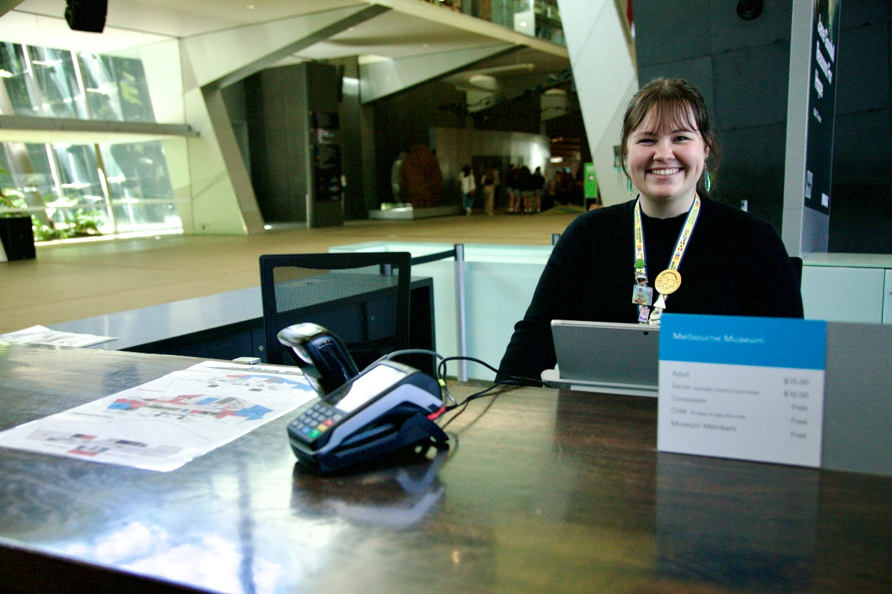
Image 10- a photo of a Visitor Engagement Officer sitting behind the reception desk. An EFTPOS machine, Museum floorplan and a sign with ticket prices is on the desktop.

CLOAKROOM
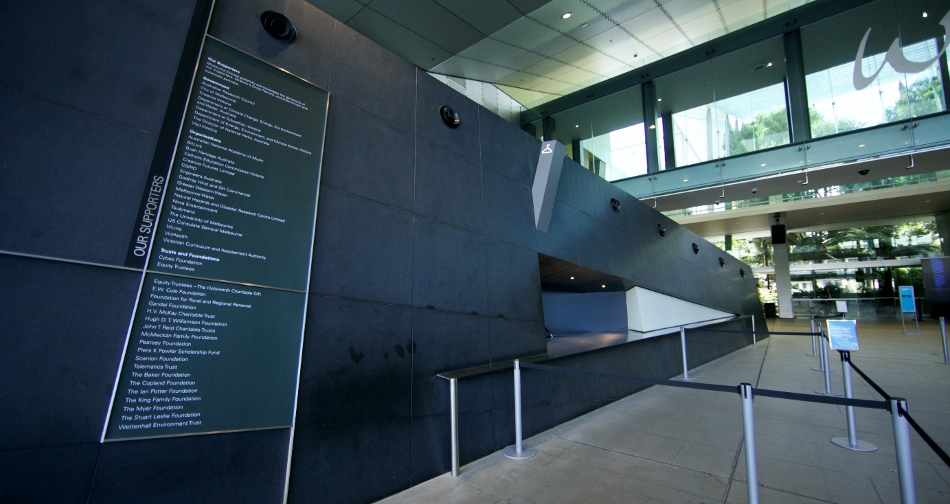
Image 11- a photo of the Cloakroom desk where a Visitor Engagement Officer can assist with storing your belongings during your visit.

WAY-FINDING SIGNAGE TO EXHIBITION
Image 12- a photo of two signage stands side by side, each 120 cms high x 30 cms wide.
The sign on left reads ‘Learning Lab’. The sign on right is black with white text that reads ‘Top Designs 2024’ and has a brightly coloured oval shape beneath. These are situated in the foyer and along the main corridor towards the escalators leading to the Mind and Body Gallery on the upper level.

TOILETS
Accessible and all persons bathrooms are located across all three levels of Melbourne Museum.

On ground level (refer to image of map below)-
RIGHT: Between the Museum Shop and Café and in front of Bunjilaka Aboriginal Cultural Centre.

LEFT: Between the Learning Lab and IMAX, and near the Children’s Gallery.
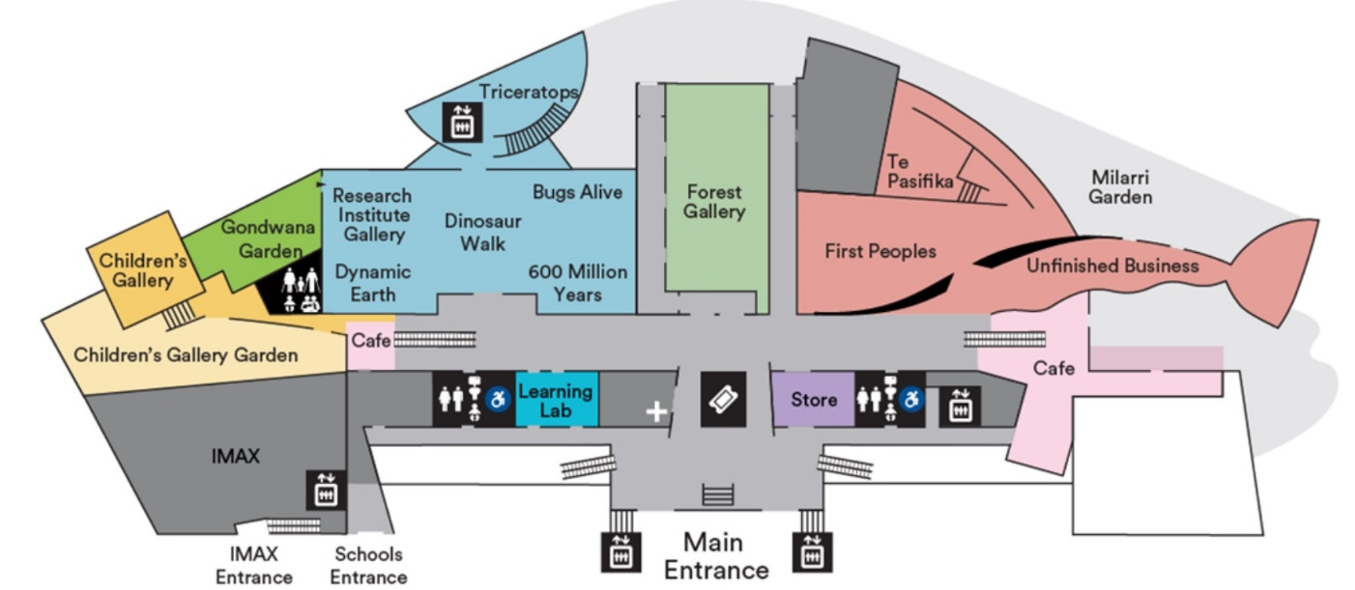

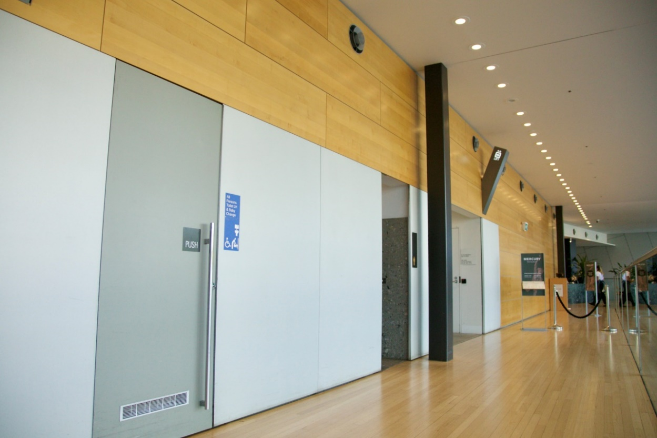
Image 13- a photo of the accessible bathrooms between the Museum Shop and Café on ground level.
On upper level (refer to image of map below)-
RIGHT: Foyer across from Mind and Body Gallery
LEFT: Foyer across from Melbourne Gallery
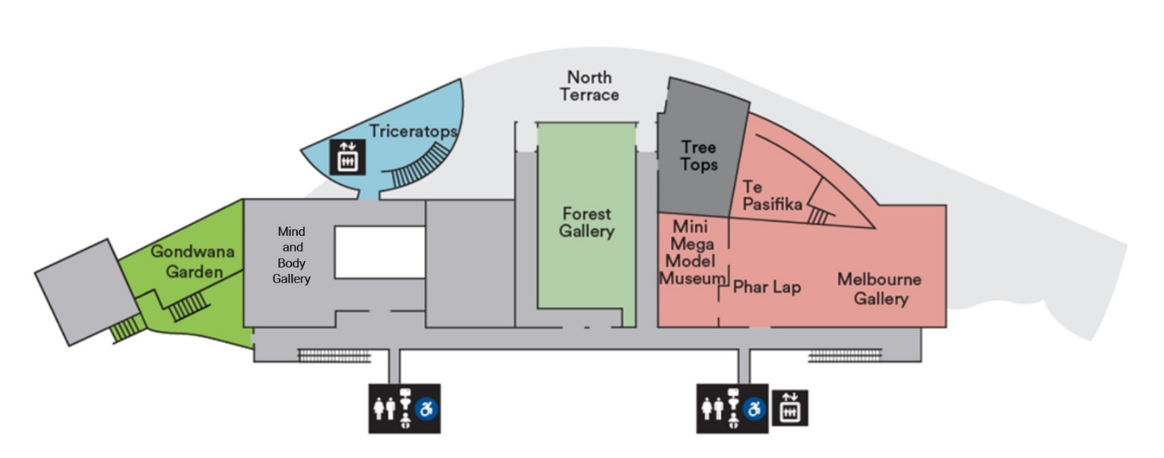

GETTING TO THE MIND AND BODY GALLERY

LIFTS
Whilst there are two lifts within the Museum, the easier lift to go to the Upper level is found on ground level, turning right from the entrance, between the accessible toilets and Café. Refer to image below.
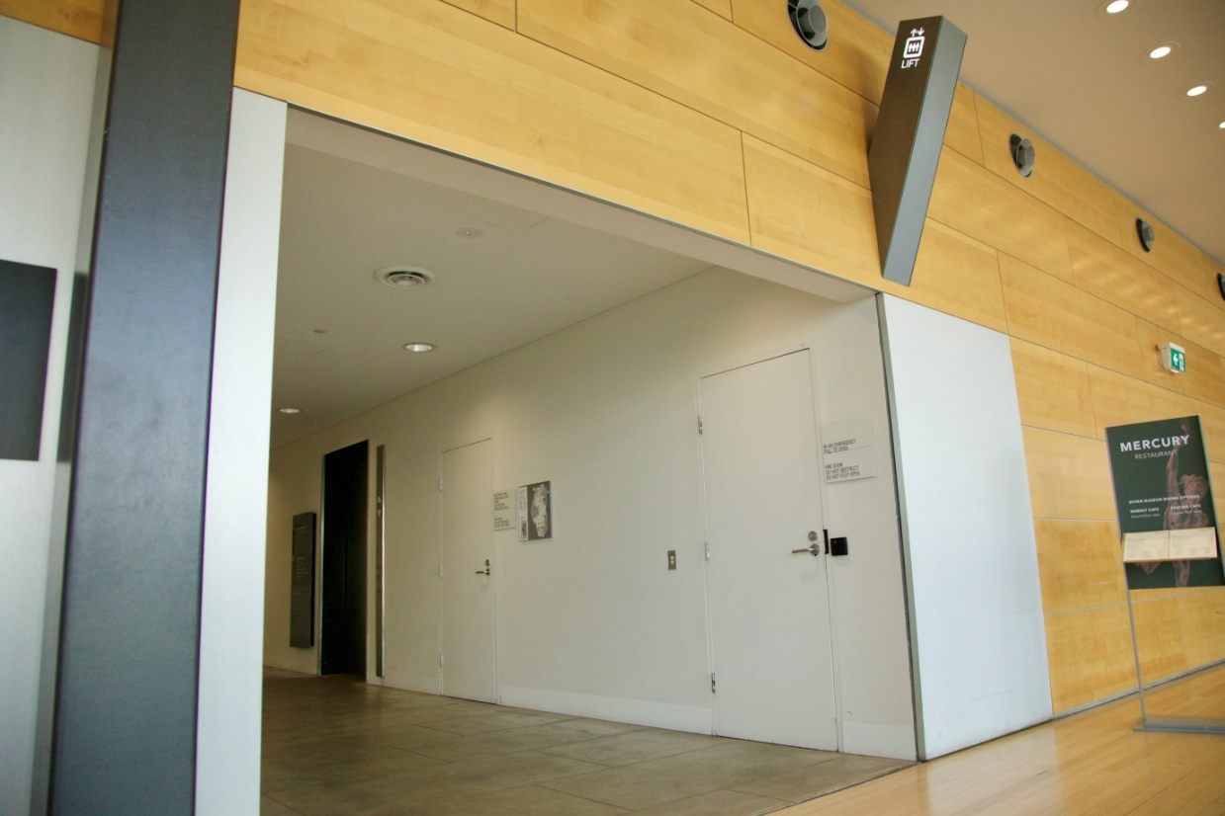
Image 14- a photo of the alcove where the lift is on your right.
The lifts have tactile indicators in the form of raised print numbers on the buttons, but without Braille or voice guidance. Refer to images below.
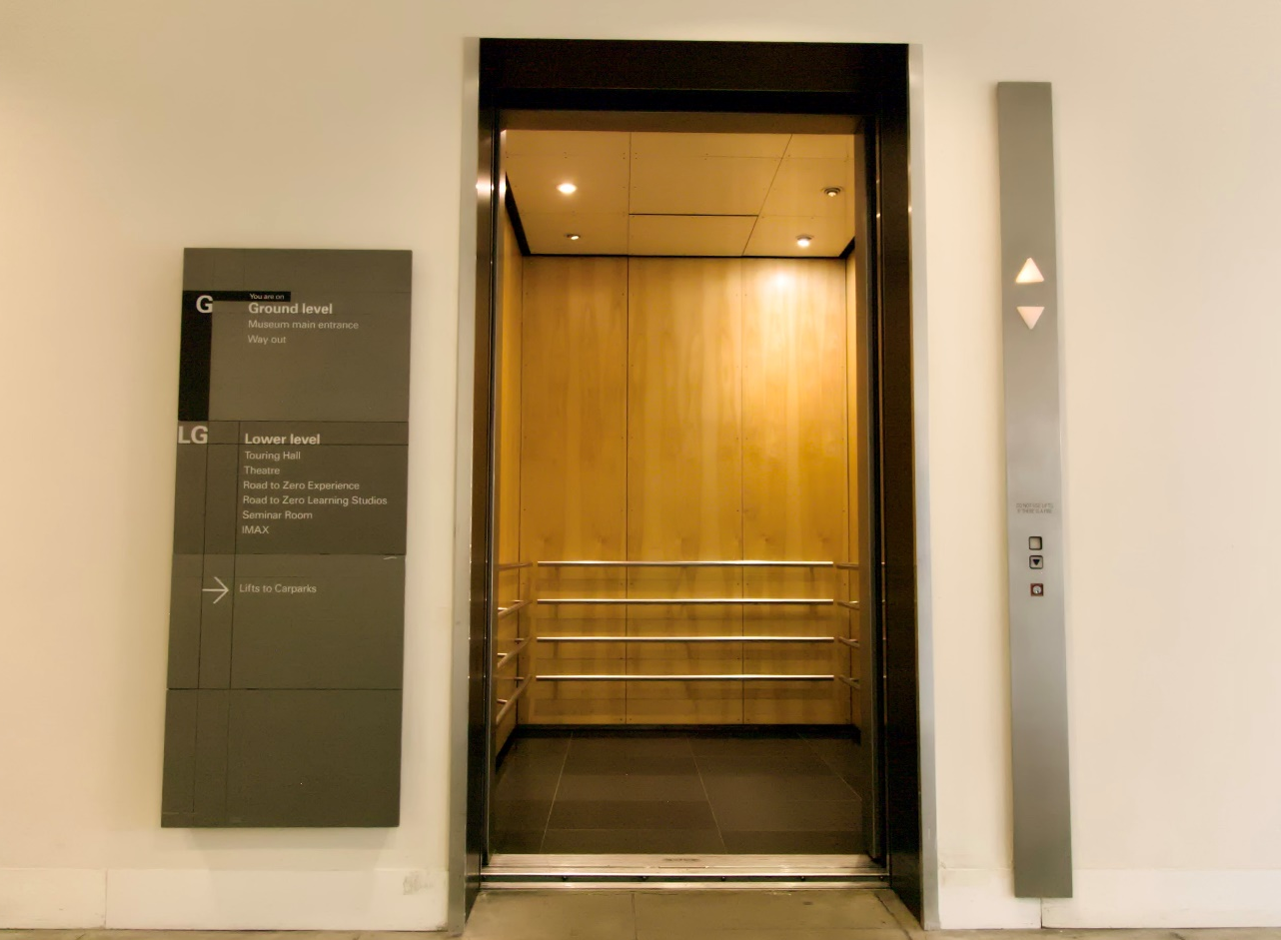
Image 15- A photo of the open lift on ground level. There are handrails inside.
The Mind and Body Gallery is on Level 1, the Upper level.
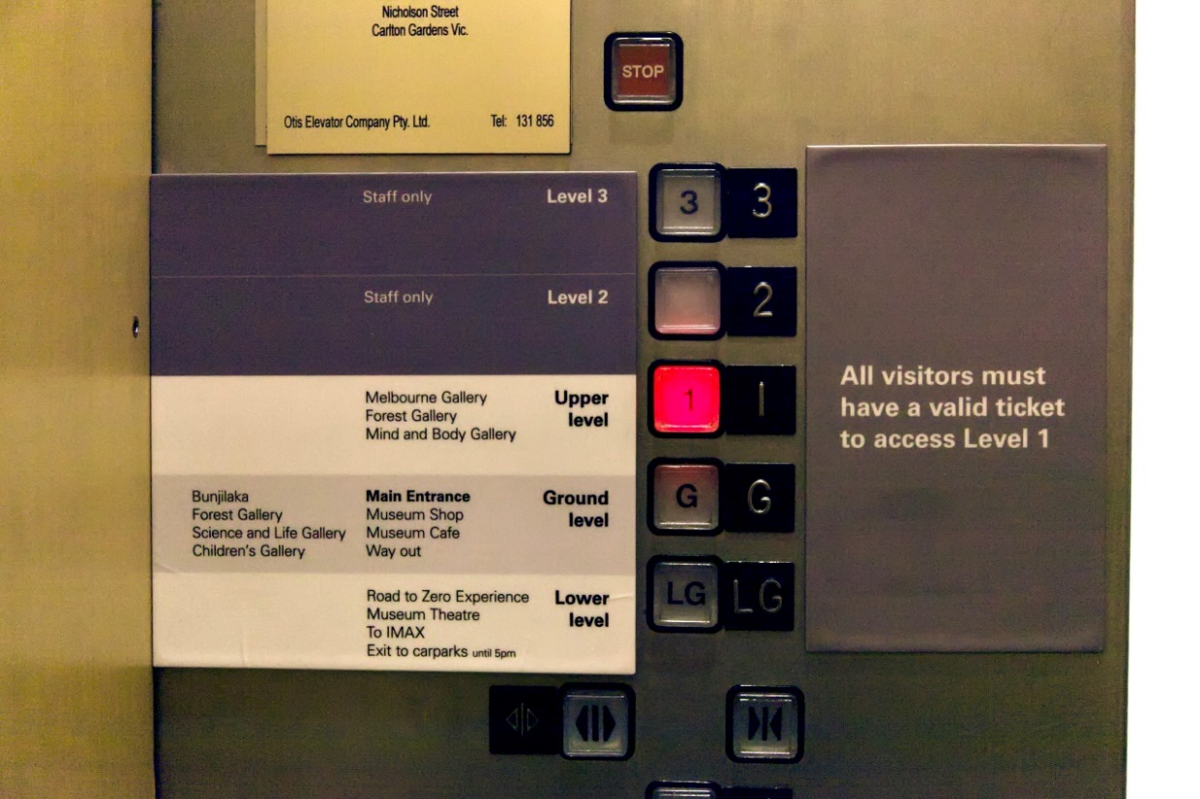
Image 16- a photo of the panel inside the lift on the right hand side as you enter.
Exit lift. Turn right.
Travel along the passageway, past the accessible and all persons bathrooms on left and right, towards the ascending ramp. It has handrails on both sides. Refer to image below.

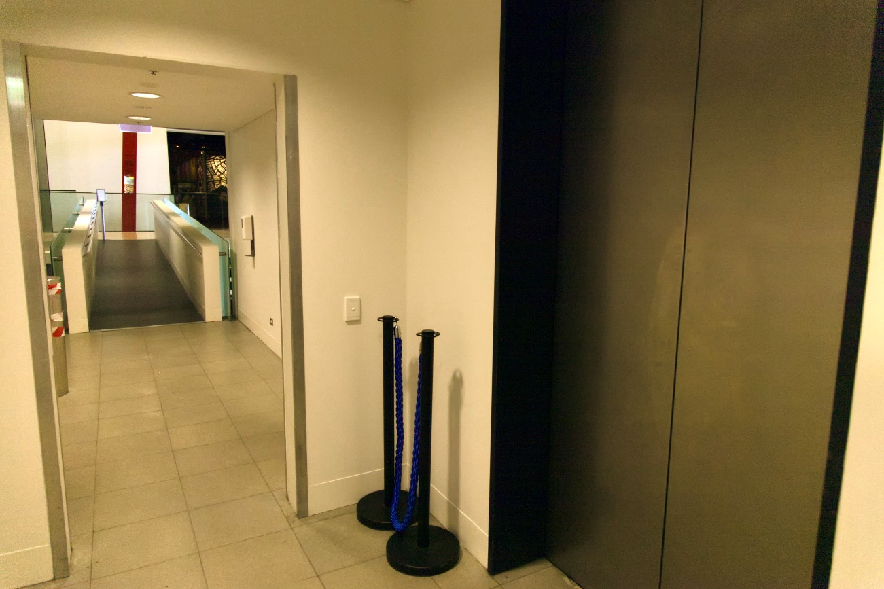
Image 17- a photo of the passageway after exiting the lift.

At the end of the ramp, turn left.
You are now on the Upper level wooden floor mezzanine.
Travel down the 200 metre length of the mezzanine to the entrance to the Mind and Body Gallery on the right. Refer to images below.
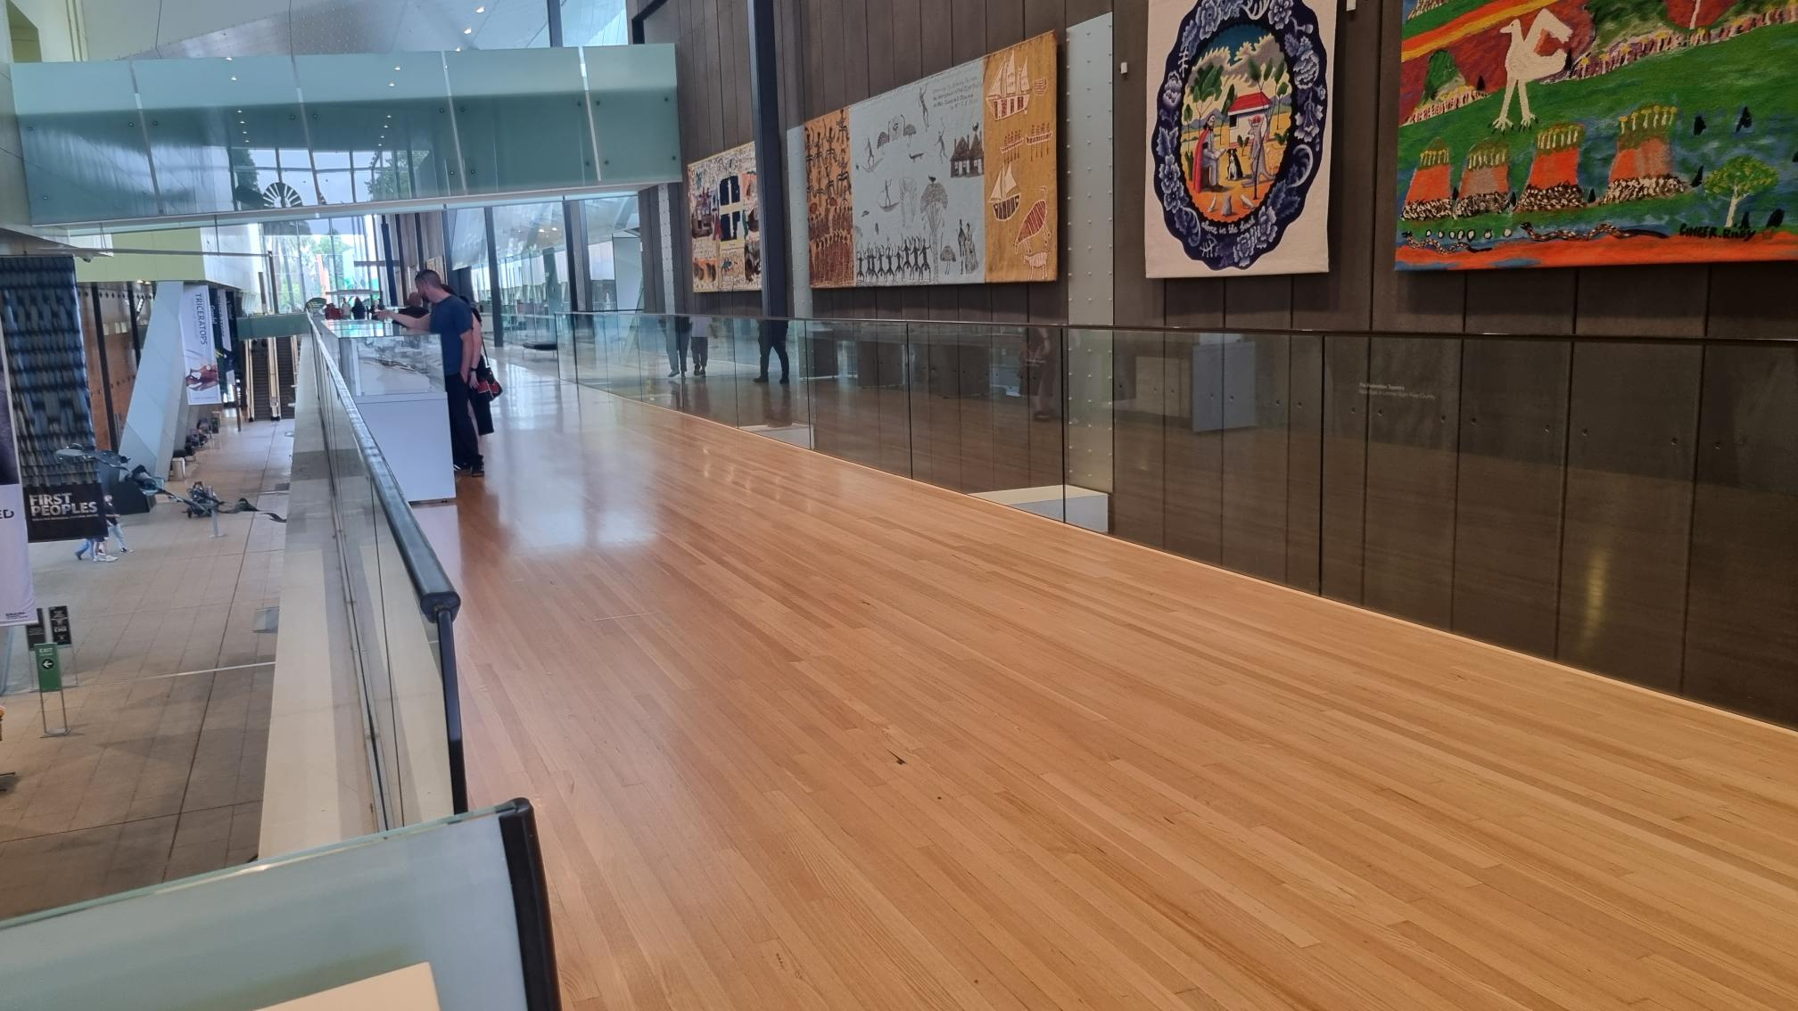
Image 18- a photo of the length of the Upper level mezzanine. It is approximately 3 metres wide. There are glass barriers on either side.

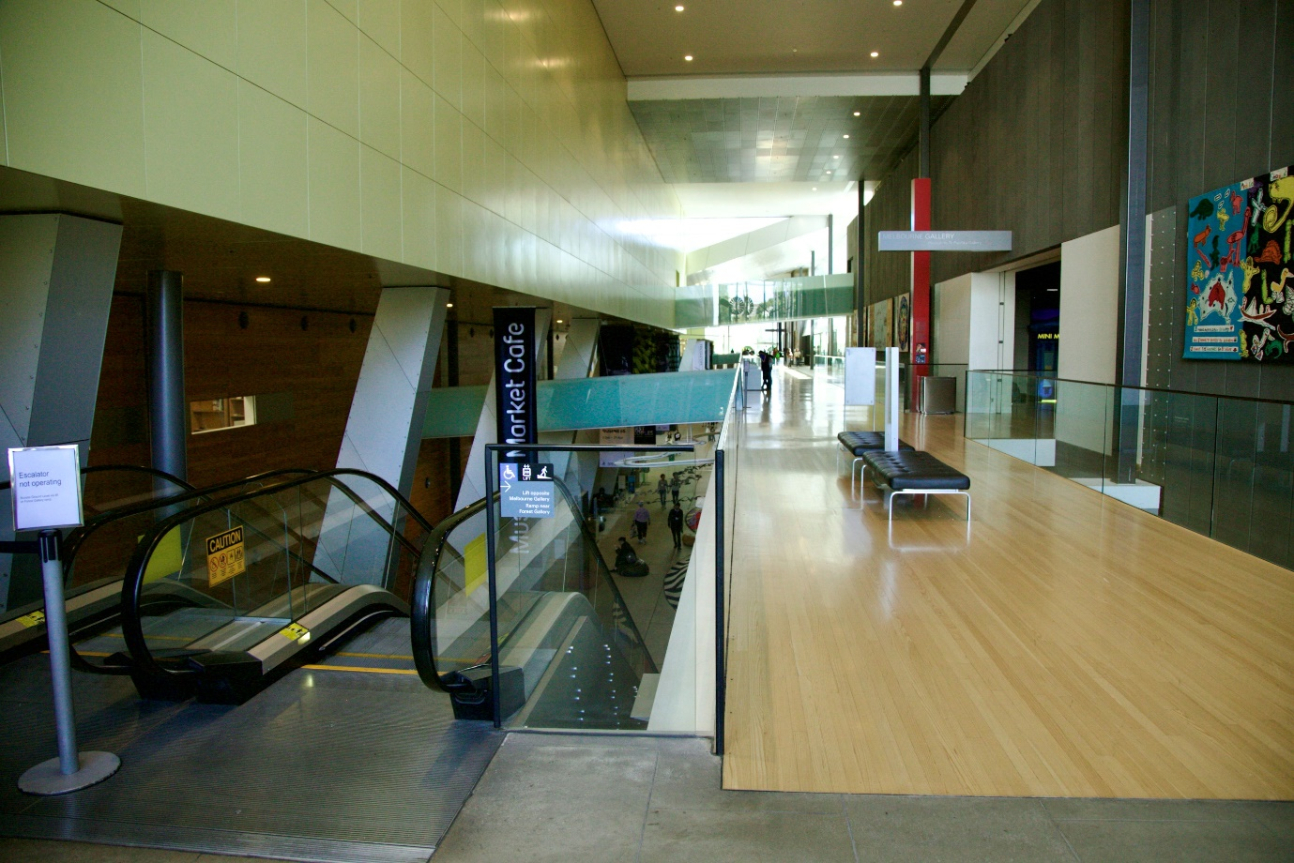
Image 19- a photo similar to above but showing a set of escalators in the foreground. The ramp from the lift is behind, about 10 metres away. These escalators can be found on ground level near Bunjilaka Gallery, and Melbourne Gallery on Upper level.

ESCALATORS
After obtaining your tickets from reception, the escalators are located behind the Foyer area.
The most direct way to the exhibition is to turn left.
Travelling down the long corridor, at end, about 100 metres away, you will find a pair of escalators that will take you directly to the Upper Level.
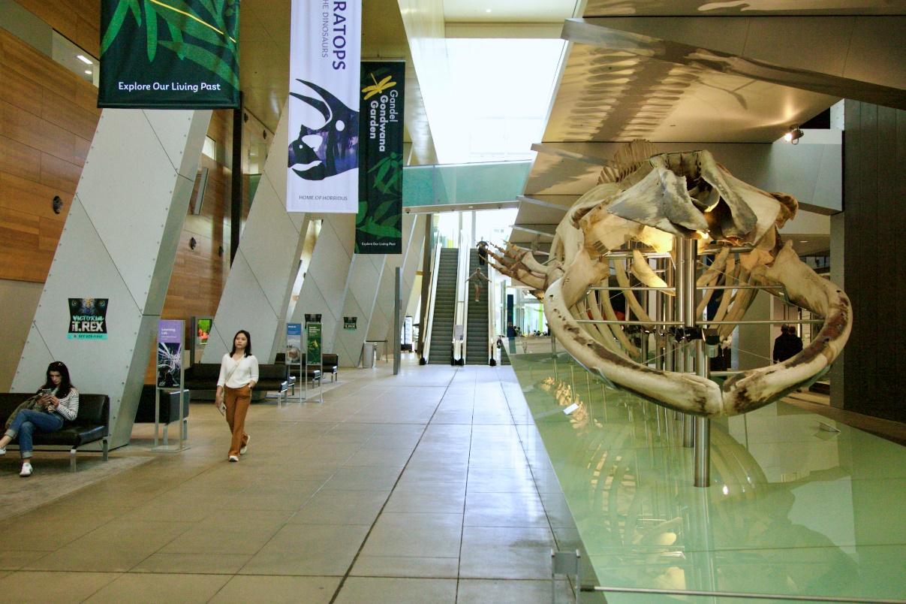
Image 20- a photo of the corridor that leads to the escalators as described above.
You will pass an 18.5 metre Blue whale skeleton and the Science and Life Gallery on your right, and sitting areas and bathrooms on your left. If you have come to the Children’s Gallery, you have gone too far.

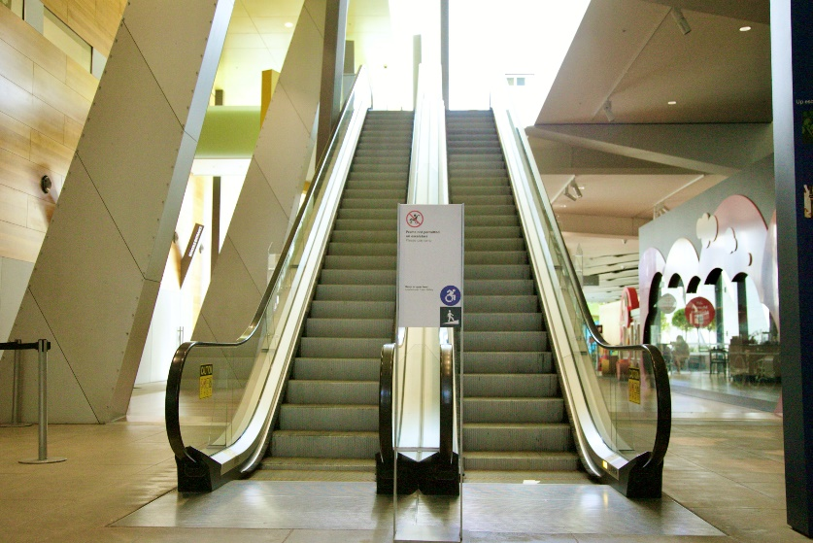
Image 21- a close-up photo of the escalators. The left escalator goes up. The right escalator goes down.
At the very top, directly opposite, is the outdoor Gandel Gondwana Garden and immediately to your left, along a short passageway, is the Quiet Room.
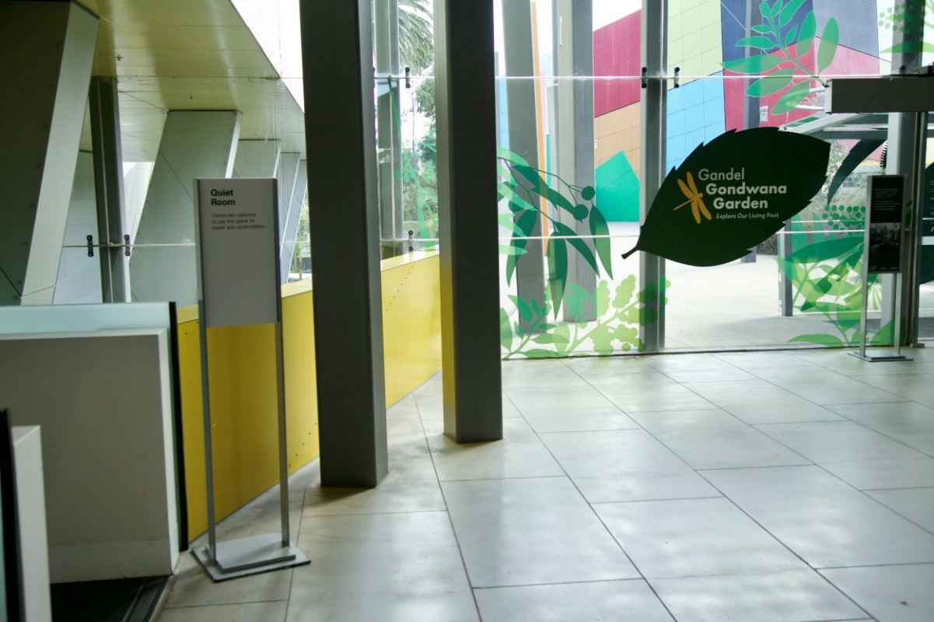
Image 22- a photo of the view at the top of the escalators as described above.
Turn right. Travel 5 metres and turn right again. You are on the mezzanine. The overhead sign and entrance to the Mind and Body Gallery is 20 metres on your left. Refer to image 23 below.
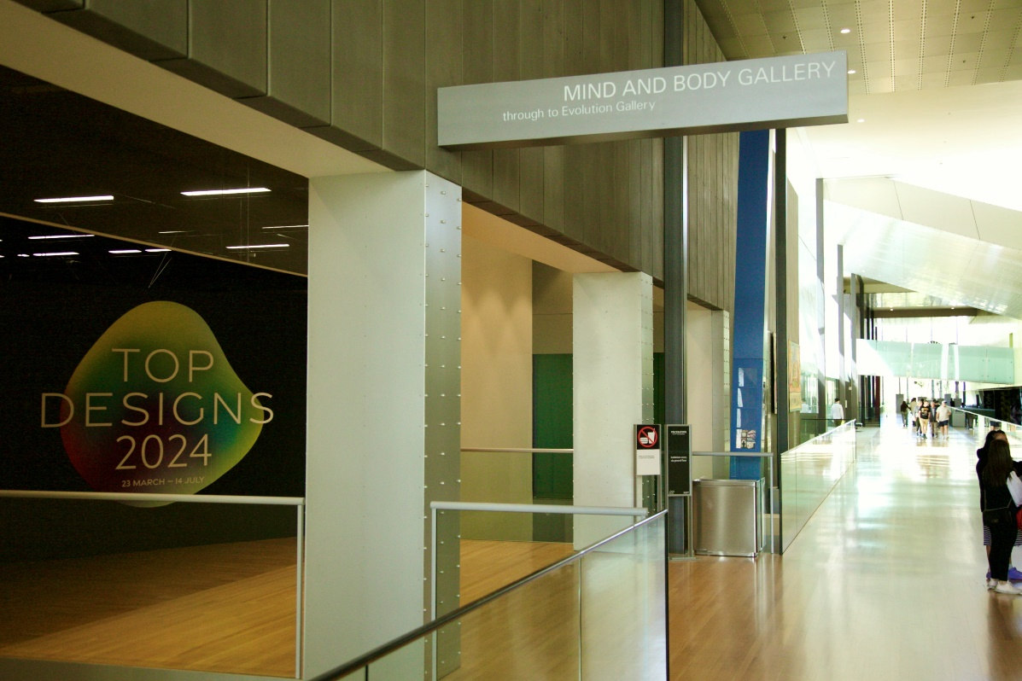
Image 23
Just inside the entrance of the Mind and Body Gallery there is a long black wall with ‘Top Designs 2024’ in bold white capital letters on a colourful oval shape. Refer to image 24 below.
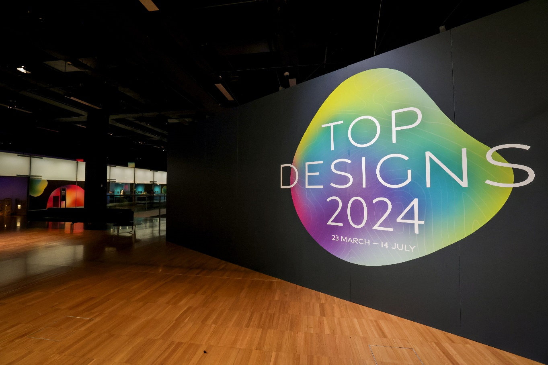
Image 24
Travel 5 metres forward. Turn left. Travel 15 metres through a lit foyer area with black couches on either side, towards another brightly coloured and lit wall with text on it. Refer to image 25 below.
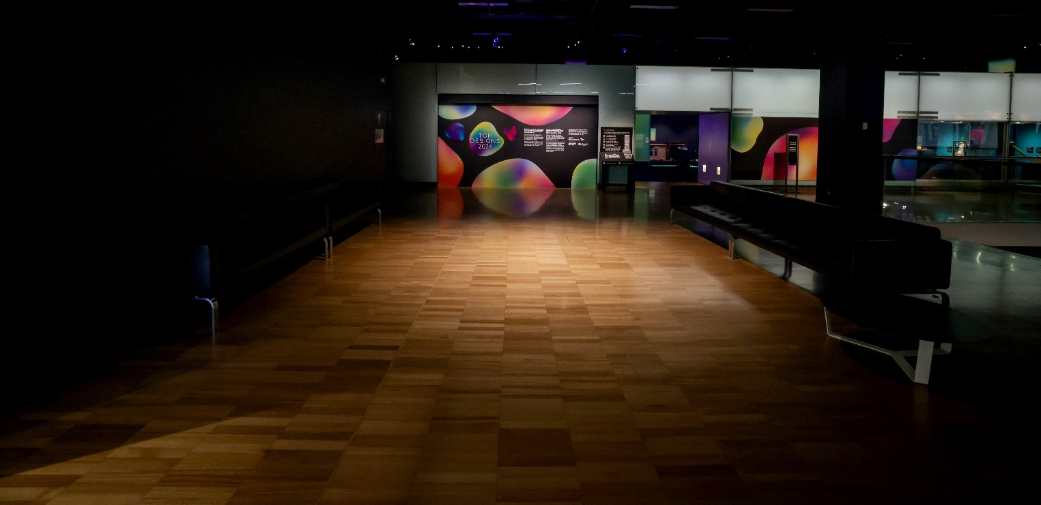
Image 25
Note about second pair of escalators:
There is another set of escalators from Ground level to Upper level near Bunjilaka Gallery. Refer to image below and image 19.
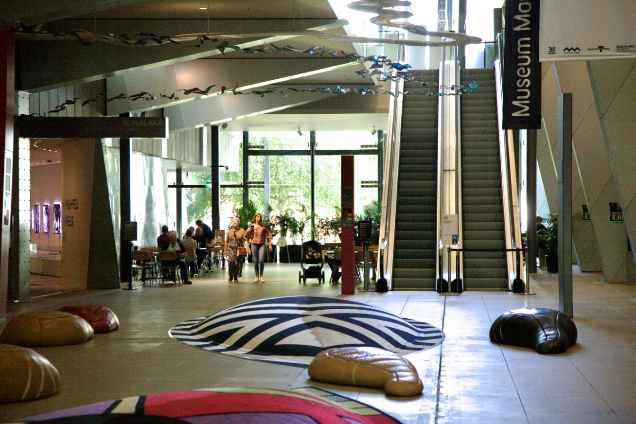
Image 26- a photo of the escalators after passing through reception and turning right. There are large, textured floor cushions decorated in First Nation designs along this corridor. There are sitting areas and bathrooms on your right. If you have reached the cafeteria you have gone too far.

EXHIBITION INFORMATION

WELCOME WALL
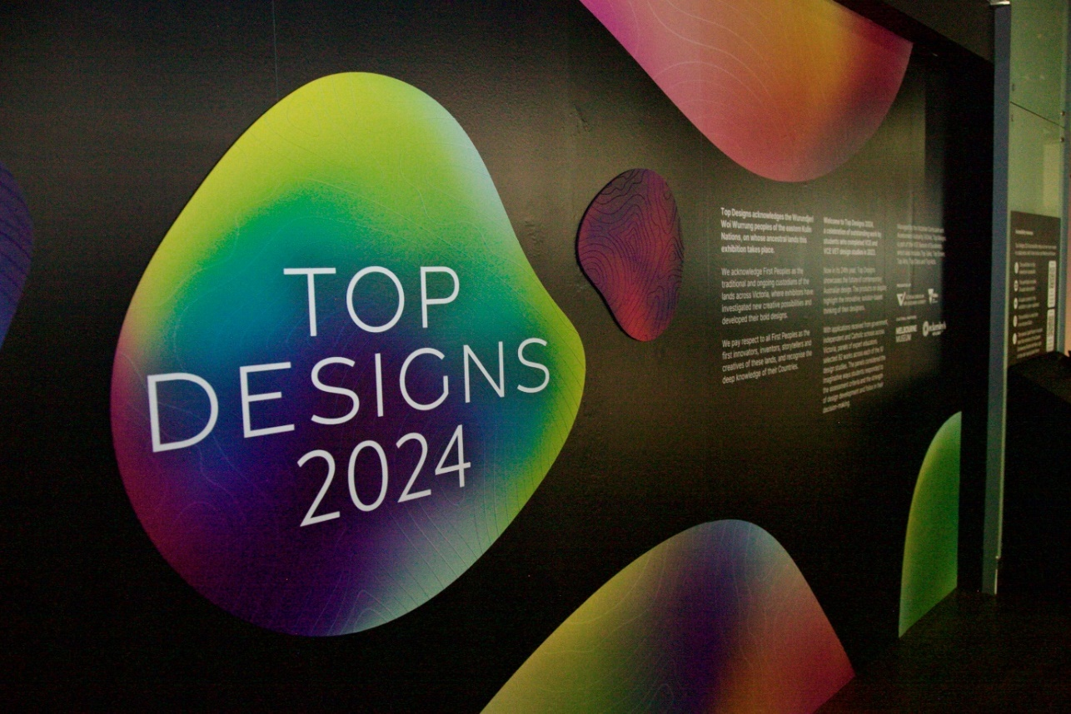
Image 27
It features colourful oval shapes and white text against black background. Refer to image 27 above.
One large oval, left of centre has ‘Top Designs 2024’ printed.
This area has raised linework, inspired by cartographic maps signifying the different pathways available to students post-VCE. You are welcome to touch this area of the wall and it is accessible to wheelchair users.
To the right of the Welcome Wall there is an ‘Accessibility Resources’ information panel. Refer to image 28 below and page 6.

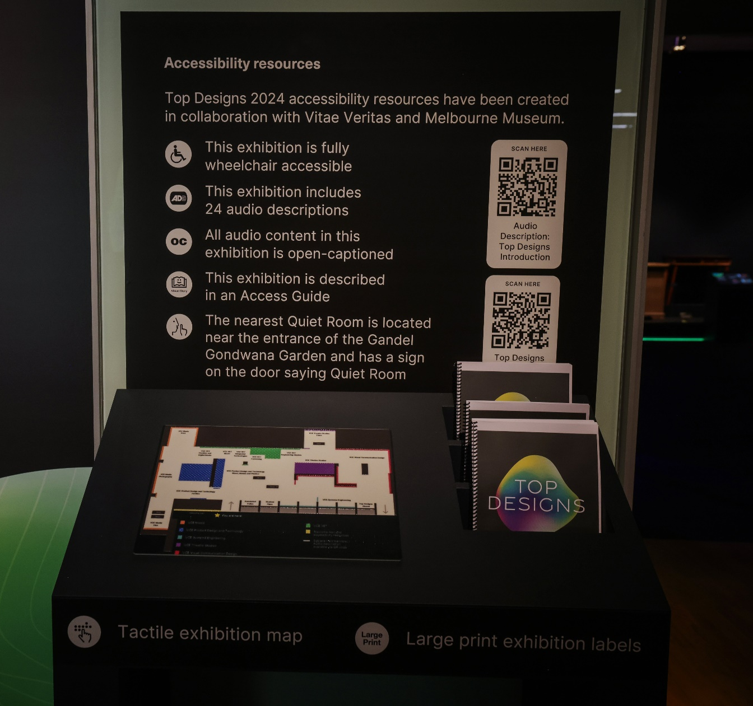
Image 28
This panel has two QR codes on the right-hand side margin and both are placed at a wheelchair accessible height.
The first QR code is an audio recording of the text and designs featured on these panels. The second QR code will take people to the Melbourne Museum Top Designs accessibility resources webhub.
Beneath this panel, there is a tactile, Braille-labelled, A3-sized exhibition floorplan on a pedestal and is accessible to wheelchair users. Refer to image 29 below.
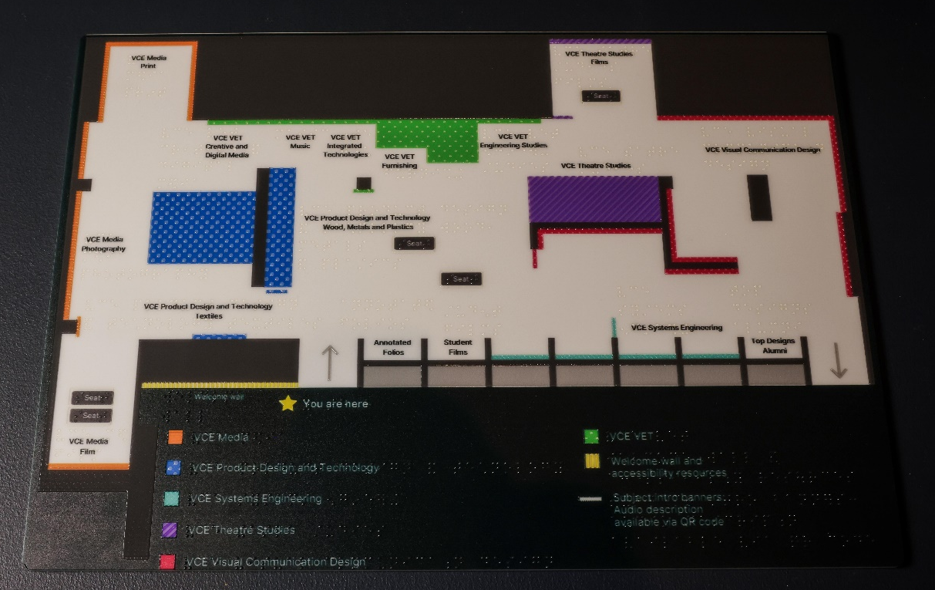
Image 29
To the right of the Welcome Wall, Accessibility Resources panel and Tactile Map is the entrance to the carpeted exhibition space where 92 student works are displayed. On the right hand side of the entrance, the decorative wall designs continue, and four glass window cases towards the end exhibit a number of Systems Engineering works. Refer to image below.
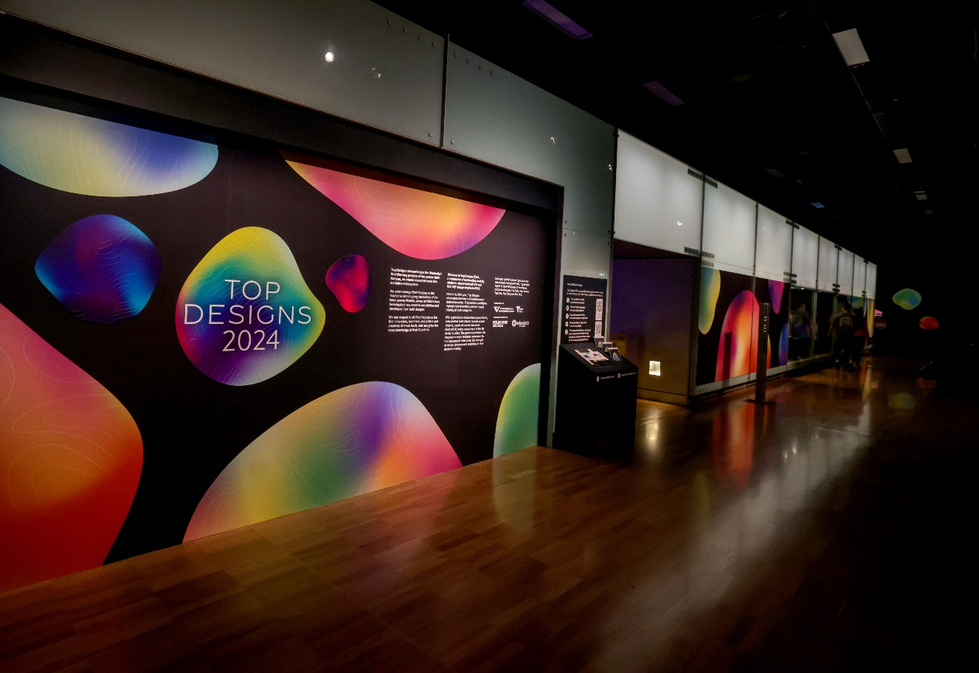
Image 30

STUDY AREA BANNERS
Each VCE and VCE VET design study area has a four-metre-high x 90 centimetre wide banner in a distinct colour. Study banners are brightly lit in warm tones from overhead. Refer to image below.
Image 31 – a row of study area banners. From left to right: orange Media banner, blue Product Design and Technology banner, green VCE VET banner, purple Theatre Studies banner, red Visual Communication Design banner, blue-green Systems Engineering banner. Name of study area on upper half. Study area statement and QR code on lower half.

LAYOUT OF STUDY AREAS

Please also refer to image 29, the Tactile Map.
Navigating the exhibition in a clockwise direction, using compass directions, we will start from the entrance and refer to this side of the space as South.
VCE Media- Film, Photography and Print feature on the West wall.
VCE Product Design and Technology- Woods, Metals, Plastics and Textiles feature in the inner area on the left hand side of the space.
Refer to image below.

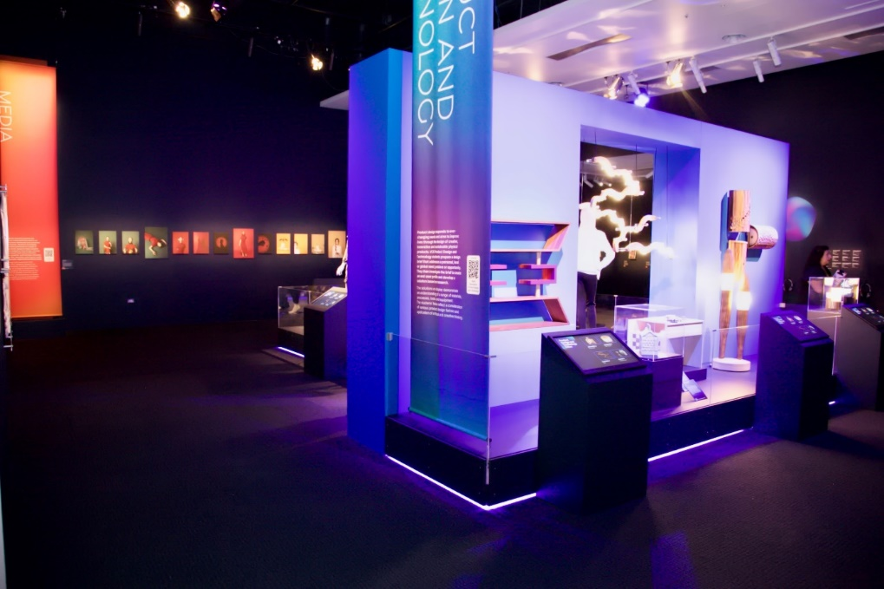
Image 32- West (or left hand side) view from the p.o.v of the entrance.

VCE VET has a number of study areas and all are along the North wall and feature from left to right: Creative and Digital Media, Music (Sound Production), Integrated Technologies, Furnishing and Engineering Studies. Continuing along the North wall towards the East wall is also VCE Theatre Studies and Visual Communication Design.
Refer to next 2 images below.

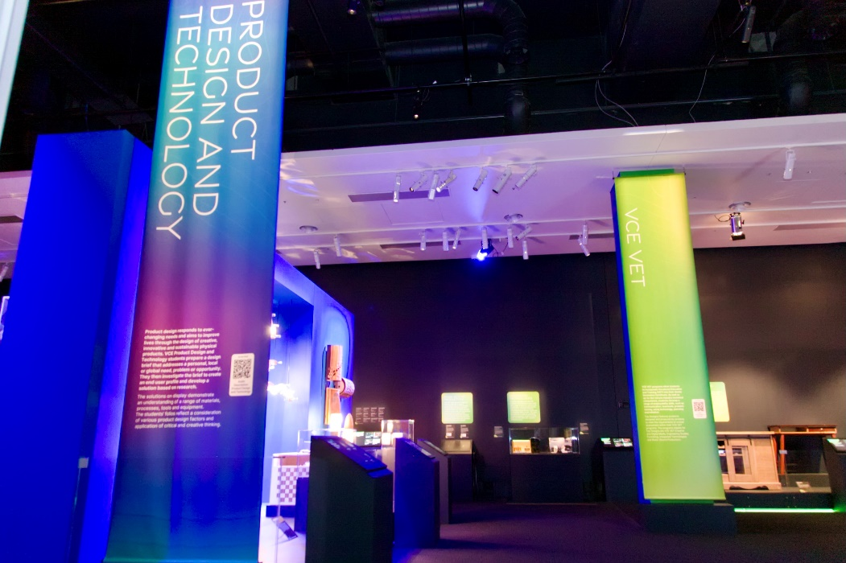
Image 33- North view, directly opposite the entrance
The East wall continues with Visual Communication Design.
In the inner area on the right, there are more VCE Theatre Studies and Visual Communication Design exhibits.
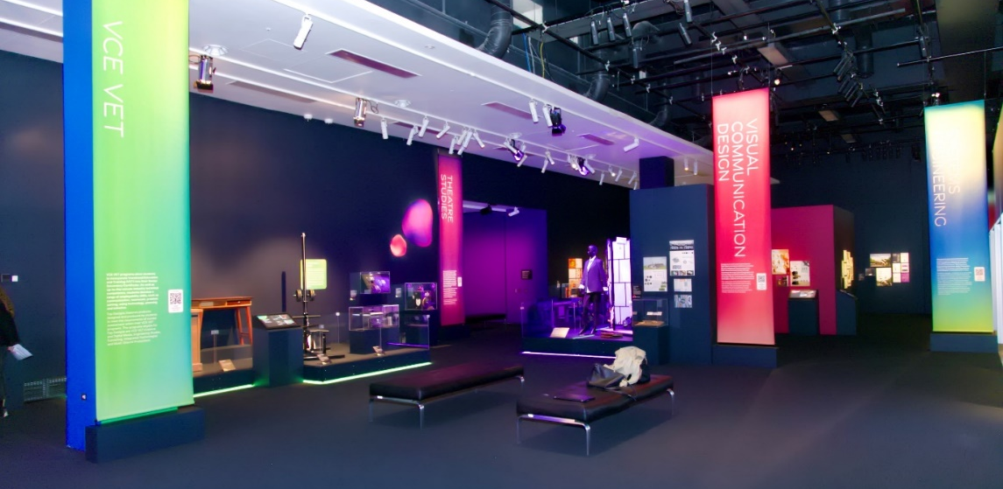
Image 34- East (or right hand side) view from p.o.v of the entrance.
The South wall, right of entrance and in order, feature annotated folios, Student Interview videos playing on one large screen, Systems Engineering works and a panel of text with photos of the Top Designs alumni from past years. Refer to image below.
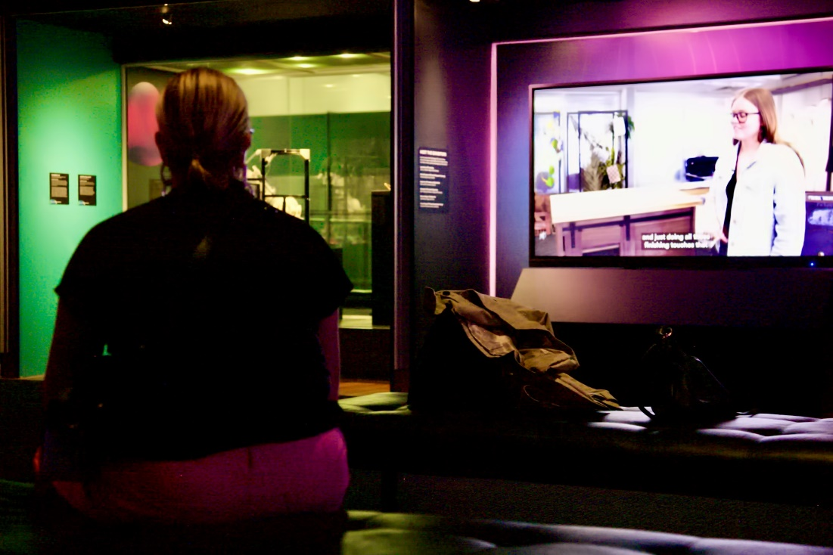
Image 35- South view from the middle of the exhibition space of someone seated on an ottoman-style bench. They are viewing the student interviews playing on a large LCD screen.

SEATING
There is ottoman-style bench seating in the central area of the exhibition space, as well as in the Media- Film and Theatre Studies areas. Refer to images below.
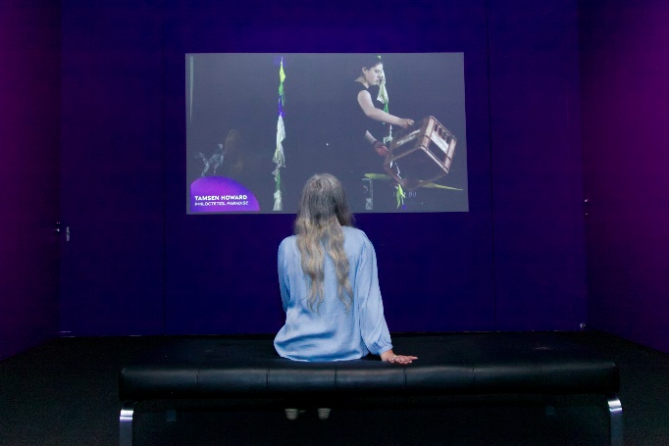
Image 36 (left)- the ottoman-style bench in front the Media Film screen.
Image 37 (right)- the ottoman-style bench in front of the Theatre Studies showreel projected and playing on the wall.

HOW THE EXHIBITS ARE DISPLAYED PLUS SENSORY INFORMATION
Objects are displayed on walls, plinths and platforms at various wheelchair accessible heights, behind clear acrylic barriers or within clear acrylic cases. Each exhibit is lit with overhead lighting. There is no flashing or strobing lights throughout the exhibition. Refer to images below.
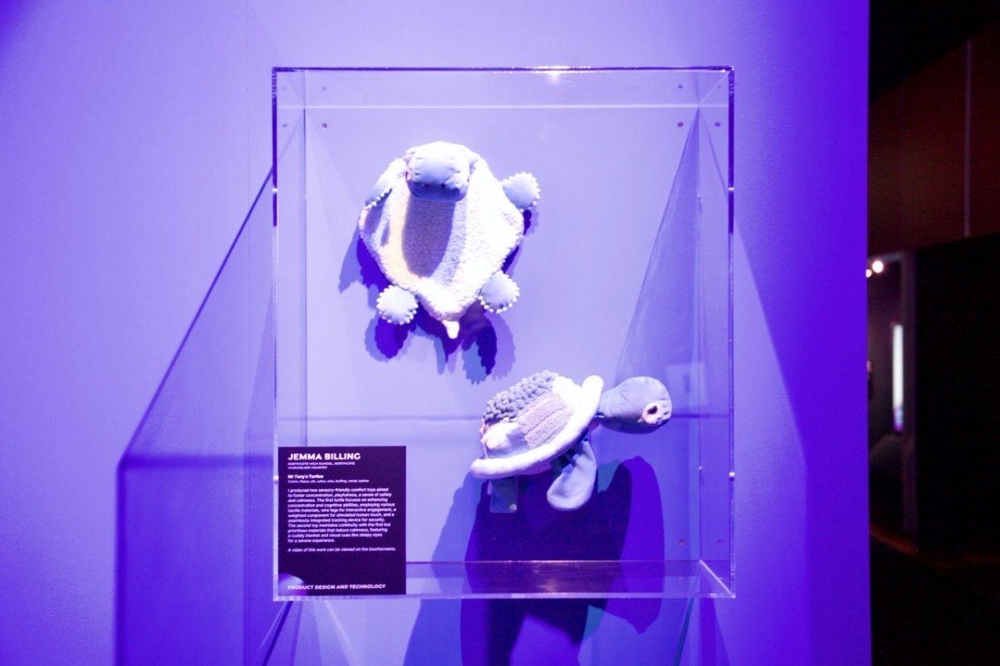
Image 38- two turtles made of soft textiles displayed on wall, housed within a clear acrylic wall-mounted case. This exhibit is in the Product Design and Technology area.
Exhibitor labels with student name, school name, title of work and statement is displayed near the work. Refer to image above and below.
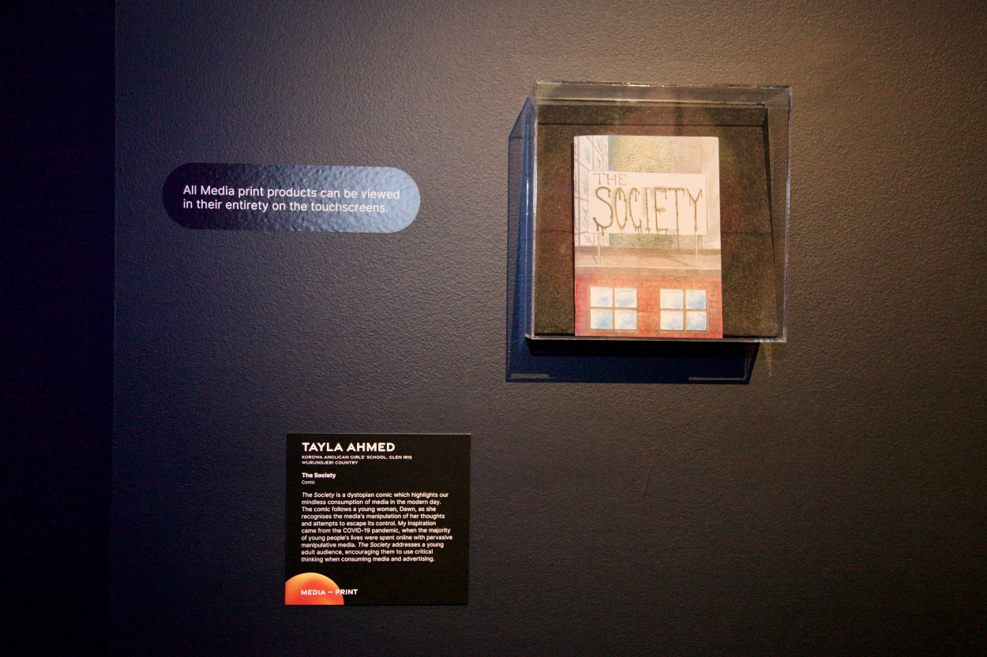
Image 39- a printed comic displayed within a clear acrylic wall-mounted case. It is the front cover of a Media Print work titled The Society. On the left-hand side of the case, on the wall, is a decal (sticker on wall) with text that reads: All Media print products can be viewed in their entirety on the touchscreens. Below this, also to the display’s left, is the exhibitor label.

A content warning sign is displayed on the wall near the Media- Film area.
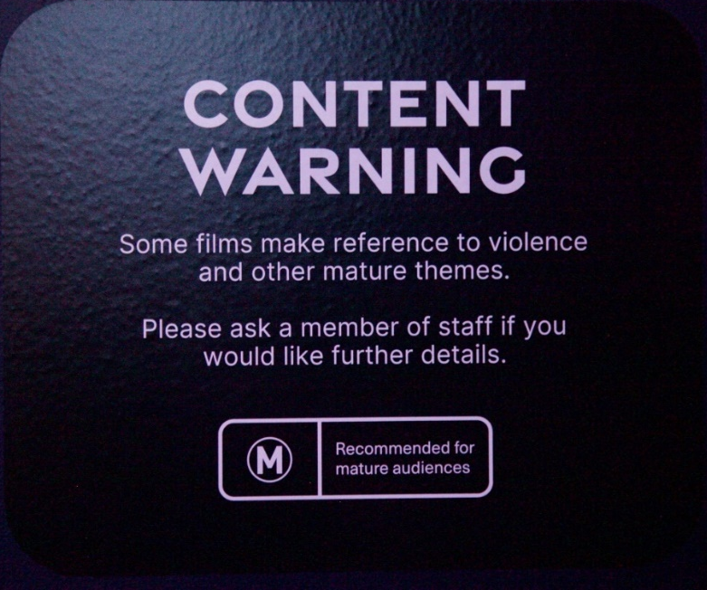
Image 40- White text on black background reads: Content Warning. Some films make reference to violence and other mature themes. Please ask a member of staff if you would like further details. Recommended for mature audiences.
LED strip lighting illuminates the bottom edges of all platforms to highlight different study areas and paths through the space. All paths within the space are wheelchair accessible. Refer to images 41, 42 and 43 below.
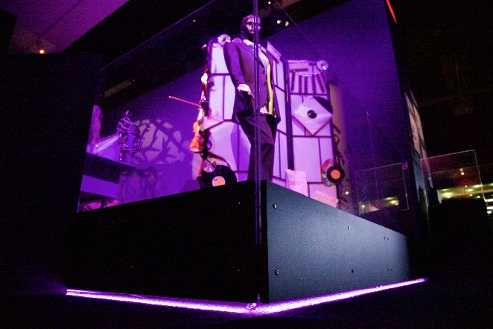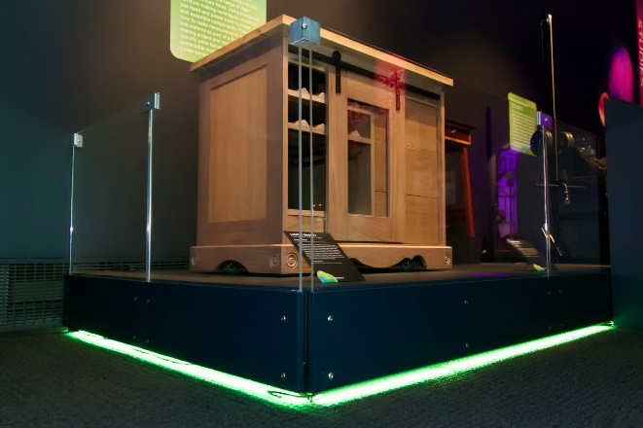
Image 41 (left)- purple LED strip lighting illuminates the bottom edges of the Theatre Studies platform on which exhibits are displayed.

Image 42 (right)- green LED strip lighting illuminates the bottom edges of the VCE VET platforms on which exhibits are displayed.

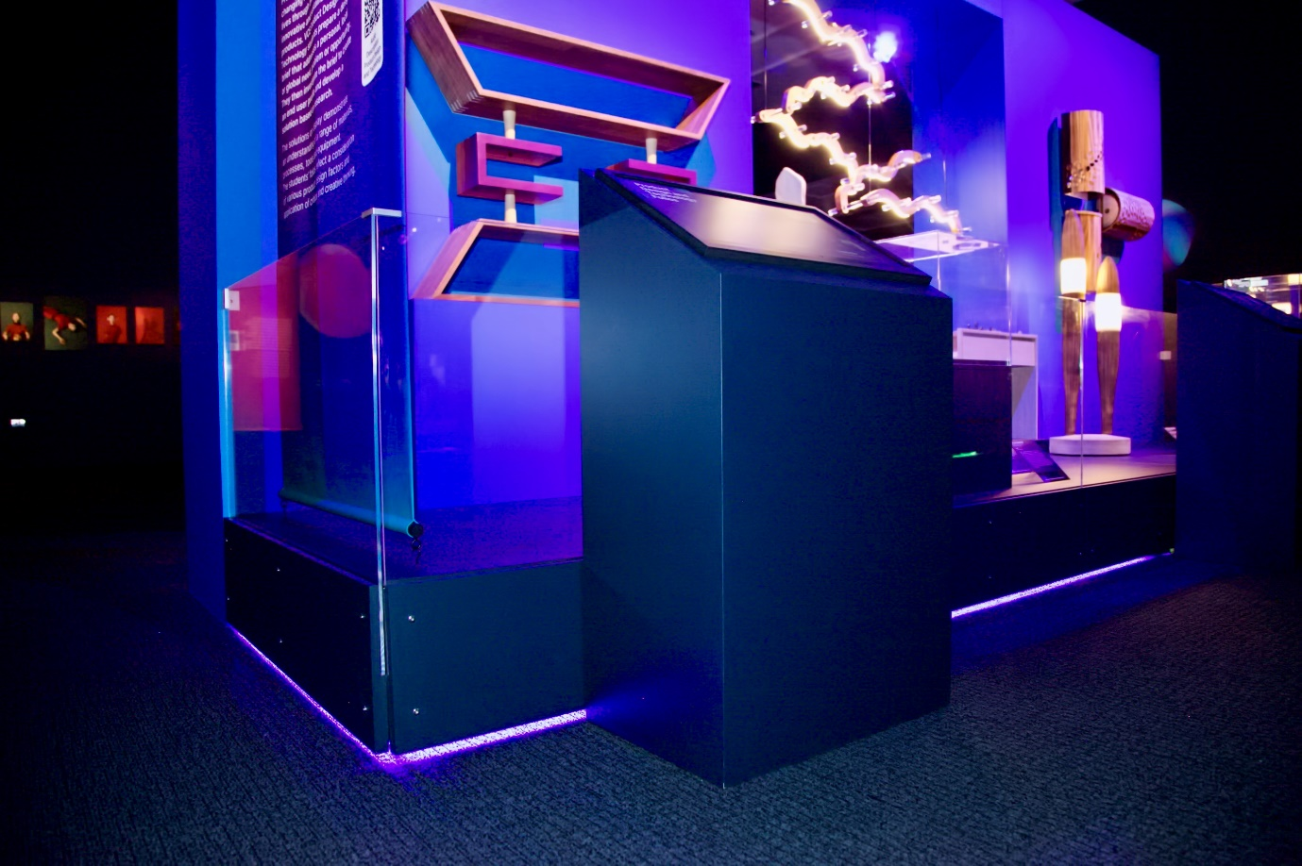
Image 43- blue LED strip lighting illuminates the bottom edges of the Product Design and Technology platforms on which exhibits are displayed.

Each study area will have a number of ‘digital hubs’. These are touchscreens mounted onto slanting pedestals where one can scroll through digitally scanned student folios. Refer to images below.
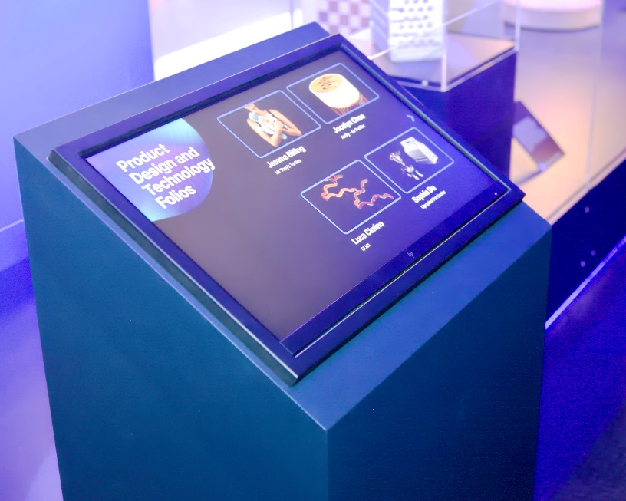
Image 44
Some digital hubs have 1, 2 or 3 touchscreens mounted.
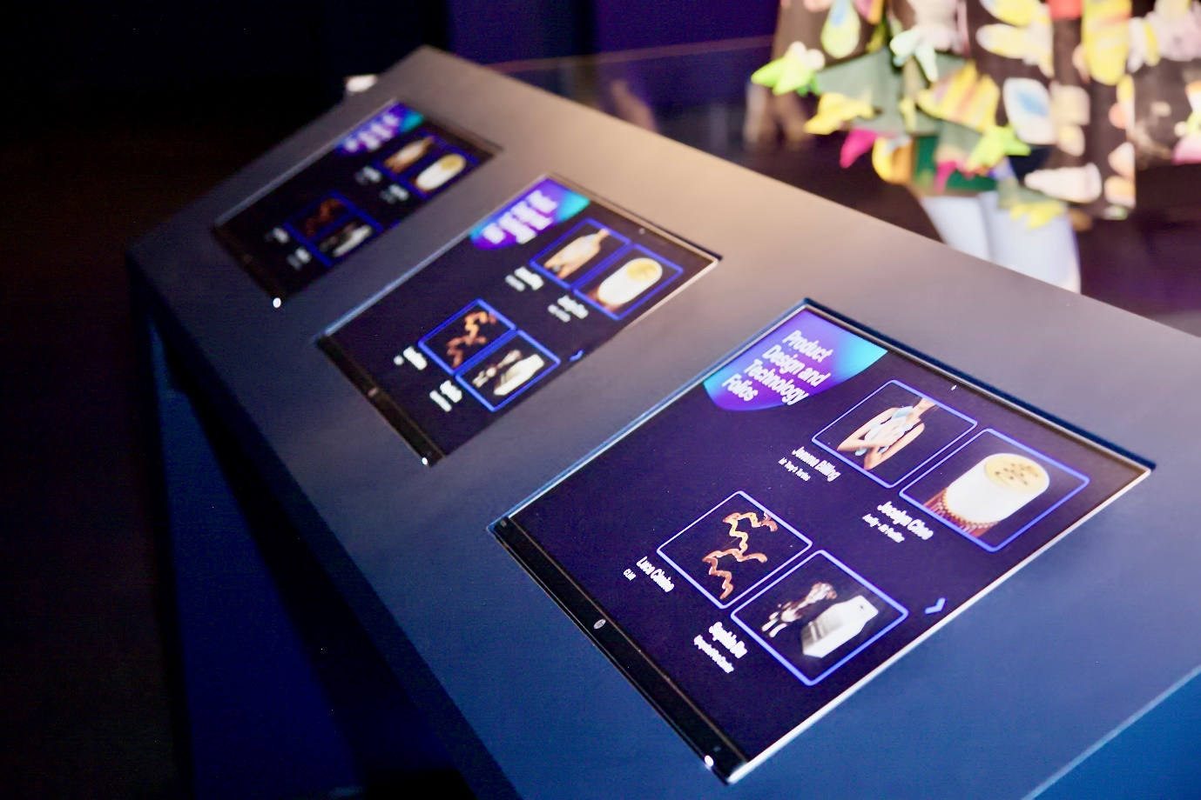
Image 45- a digital hub with 3 touchscreens mounted on the surface
Some touchscreens have also been mounted on the wall, such as in the Creative and Digital Media and Systems Engineering areas. Refer to image 46.
Although the touchscreens are not screen reader accessible, the font size is large, with high contrast colours, with white text on black background.

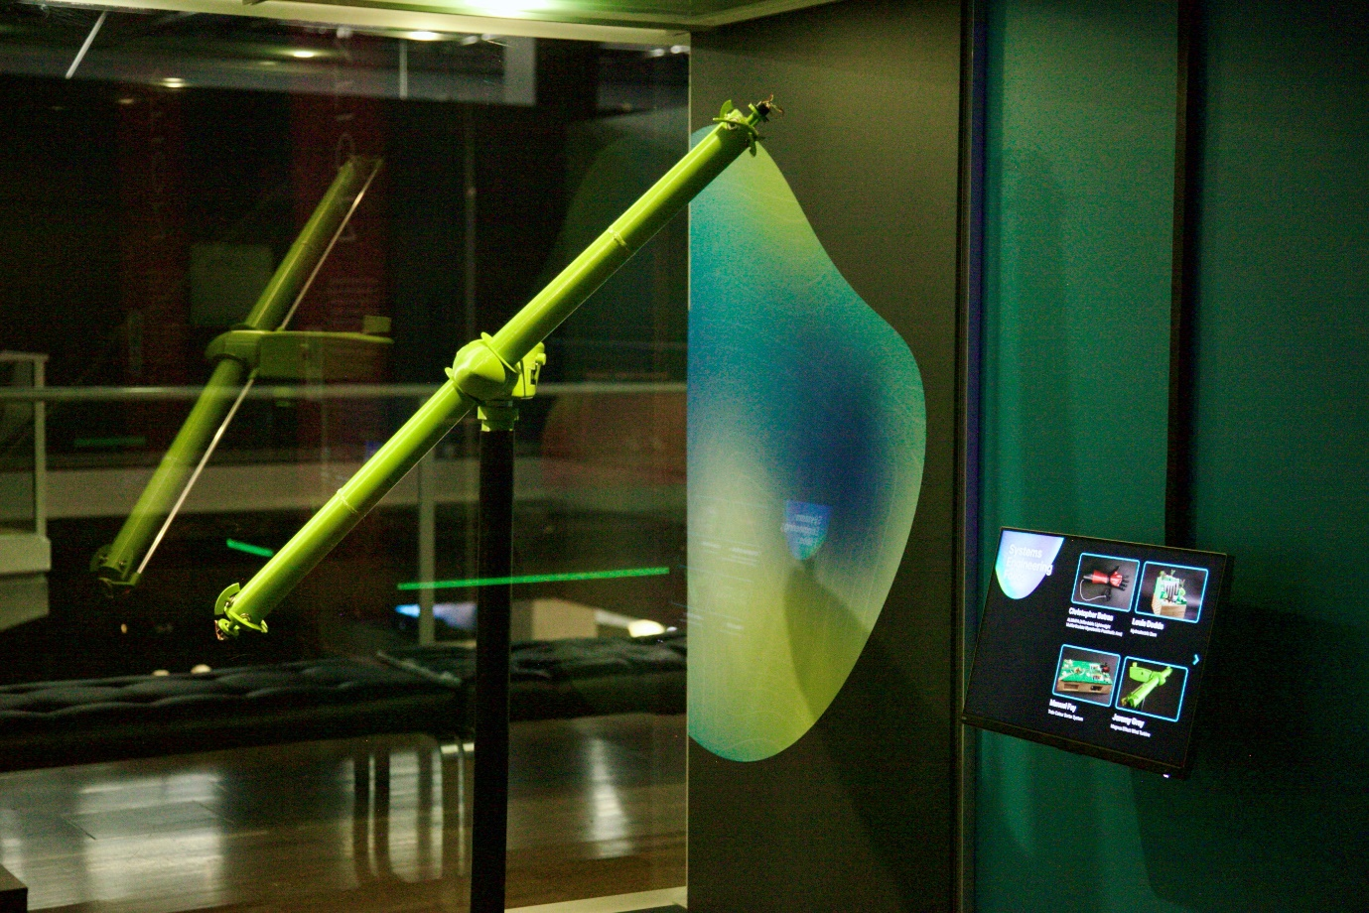
Image 46- a photo of the wall mounted touchscreen accompanying the Systems Engineering student works along the South wall.

All films have open captioning.
The student interview films have sound playing through the speakers, while Media, Creative and Digital Media and Music (Sound Production) works provide headphones for listening. Refer to images 47 and 48.
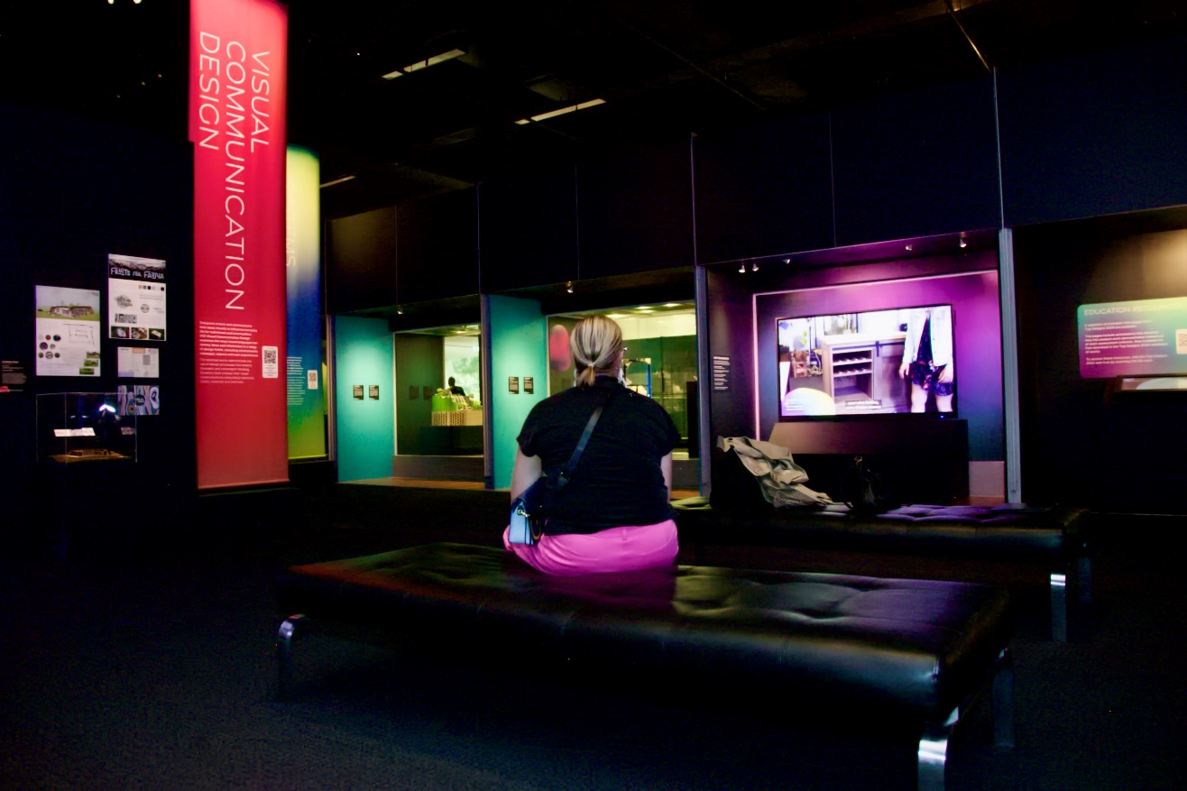
Image 47- a person sitting in the middle of the space on the ottoman-style seating viewing the student interview videos playing on a large LCD screen along the South wall.

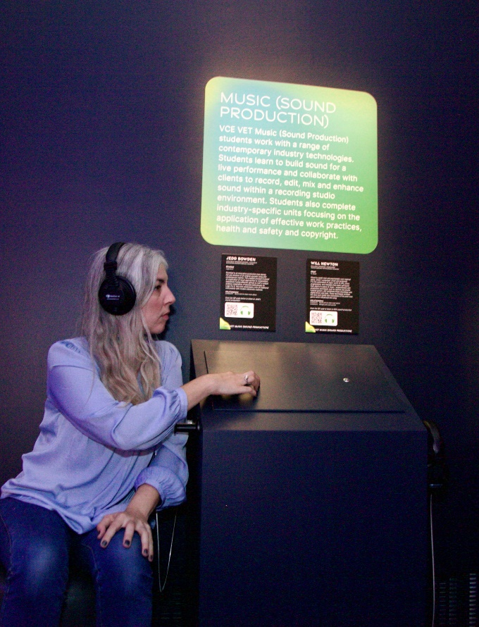
Image 48- a photo of the Music (Sound Production) listening station which has two tactile buttons on the pedestal’s surface to press and play different tracks, a chair it’s right, and a headphone on both sides.

AUDIO DESCRIPTIONS
There are 23 audio described works, most ranging from 2-4 minutes in length, except for a few which are up to 6 minutes long.
The A5 sized QR codes are displayed on the right-hand side margin of the study banners, 130 cms from the ground. Refer to image below.
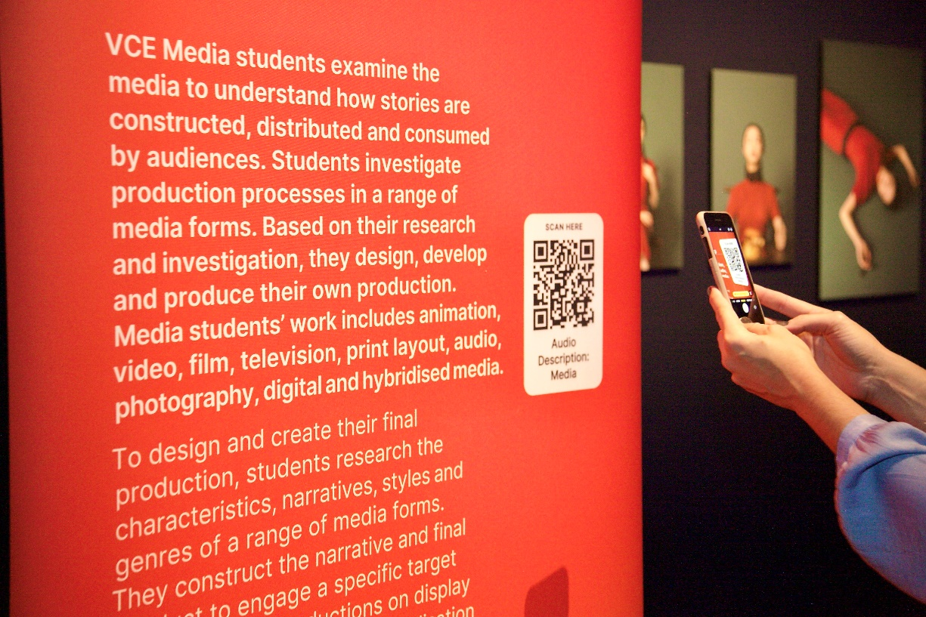
Image 49
The black and white graphic of the code is on a white background, with text above that reads: Scan Here, and text below that reads: Audio Description, then the name of the study area.
After scanning you will be directed to the webpage where all audio described works per study area, hosted by Youtube, are embedded, including their accompanying transcripts.
VCE Media Film, Photography and Print has a total of 26 works of which 5 are audio described.
VCE Product Design and Technology has a total of 16 works of which 4 are audio described.
VCE VET Creative and Digital Media, Integrated Technologies, Furnishing and Engineering Studies has a total of 20 works of which 5 are audio described.
VCE Theatre Studies has a total of 5 works of which 2 are audio described, plus a 5-minute silent showreel which is also audio described.
VCE Visual Communication Design has a total of 15 works of which 3 are audio described.
VCE Systems Engineering has a total of 8 works of which 3 are audio described.

MELBOURNE MUSEUM WIFI TO ACCESS AUDIO DESCRIPTIONS
Select 'VicFreeWiFi' service. The service requires no login, passwords or other personal data, and is ad-free.

QUIET SPACE
The Quiet Space is located on the Upper level, at the top of the escalators, near the Gandel Gondwana Garden and Mind and Body Gallery.
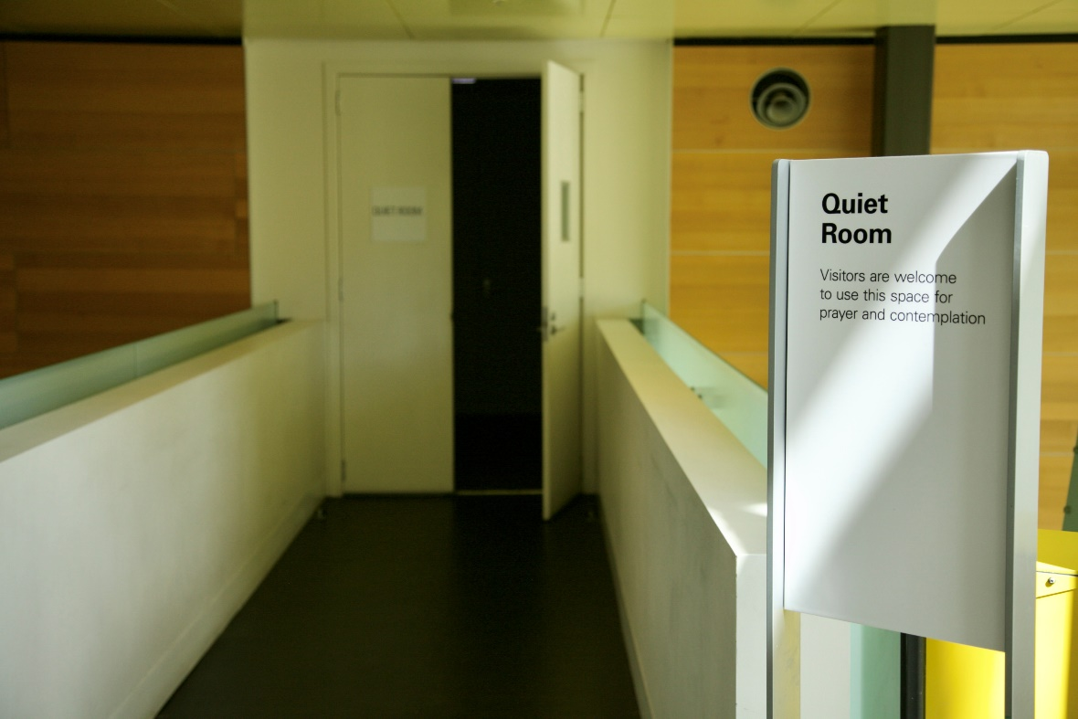
Image 50- a photo of a sign that reads ‘Quiet Room’, with the door ajar in background.
Turn left into and travel along the short bridge or walkway.
Enter the room where you will find a couch, side table and lamp that is dimly lit. Refer to image below.
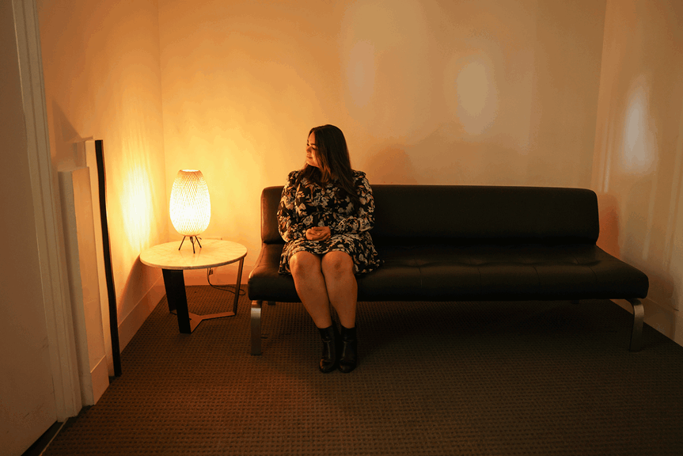
Image 51

DINING AT MELBOURNE MUSEUM
On ground level there is the dine-in only Mercury Restaurant and dine-in and takeaway Museum Market Café, each very near to each other, close to Bunjilaka Gallery.
There is also the dine-in and takeaway Museum Station Café in the Children’s Gallery, near the Science and Life Gallery on ground level.
More information about opening hours and menus here.

PHOTO CREDITS
David Hansen and Nicole Cleary.
End.

