Autism Friendly Scienceworks
SOCIAL STORY FOR SCHOOLS

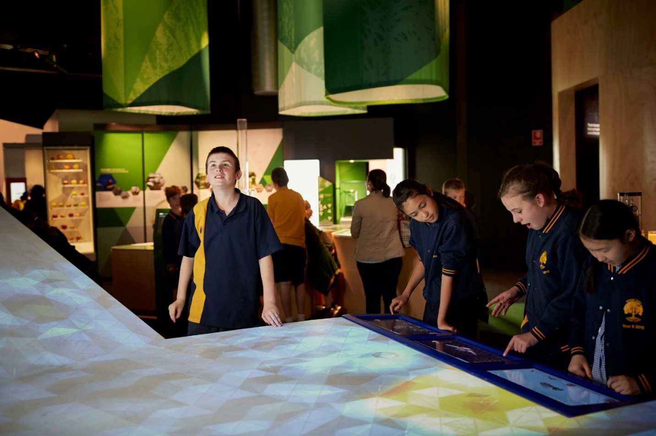

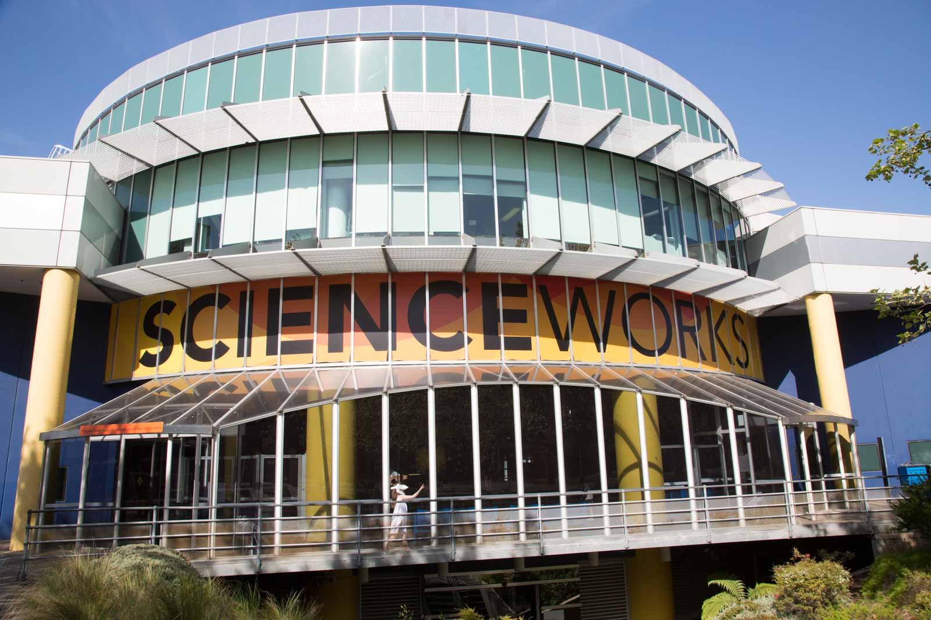

What is Scienceworks?
My class is going to Scienceworks.
Scienceworks is a museum where I can learn about science and technology.
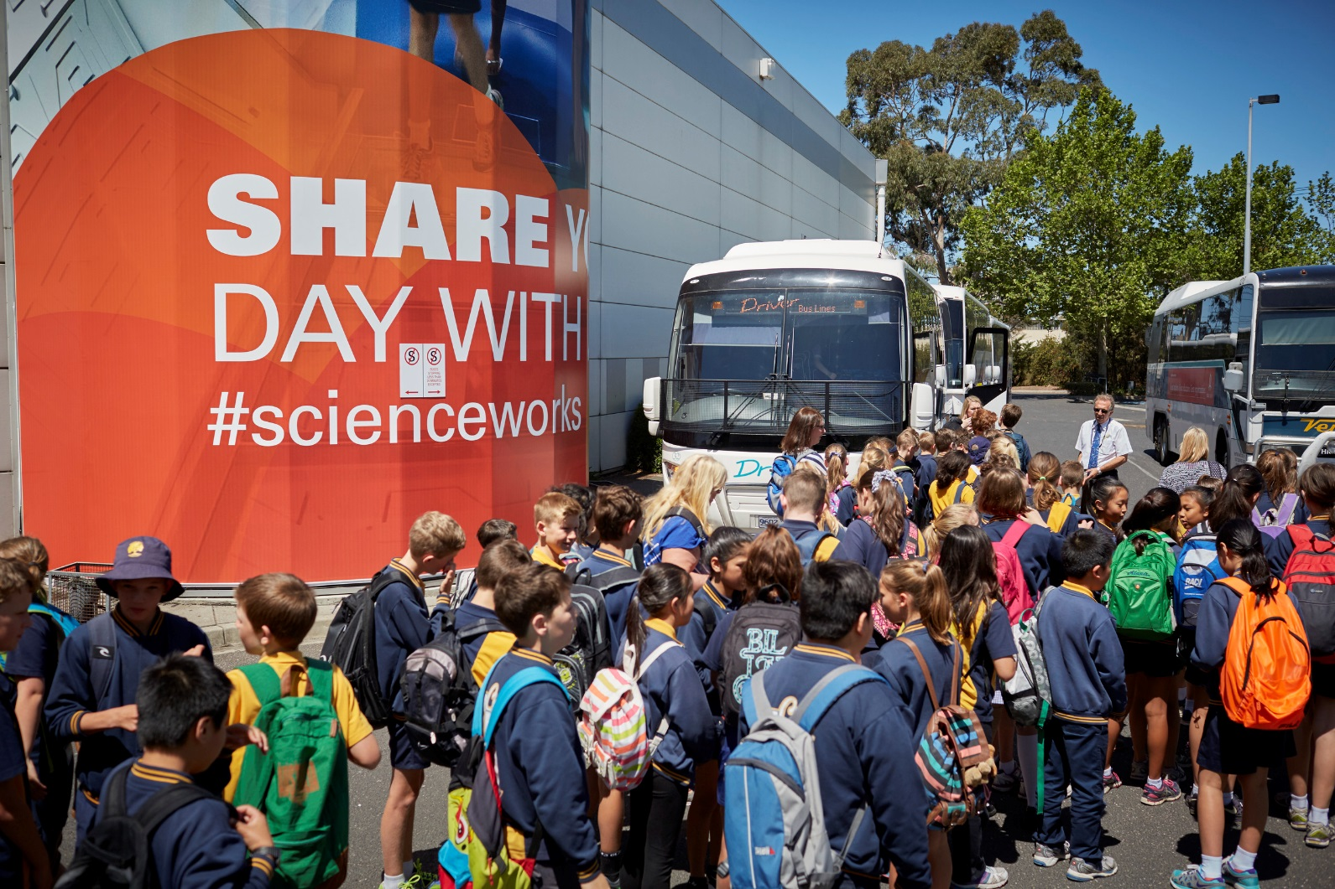
Arrival
Unique Identifier - 000217579
When I arrive at Scienceworks, a staff member will meet my class and show me where I need to go. There might be a lot of other schools visiting as well.

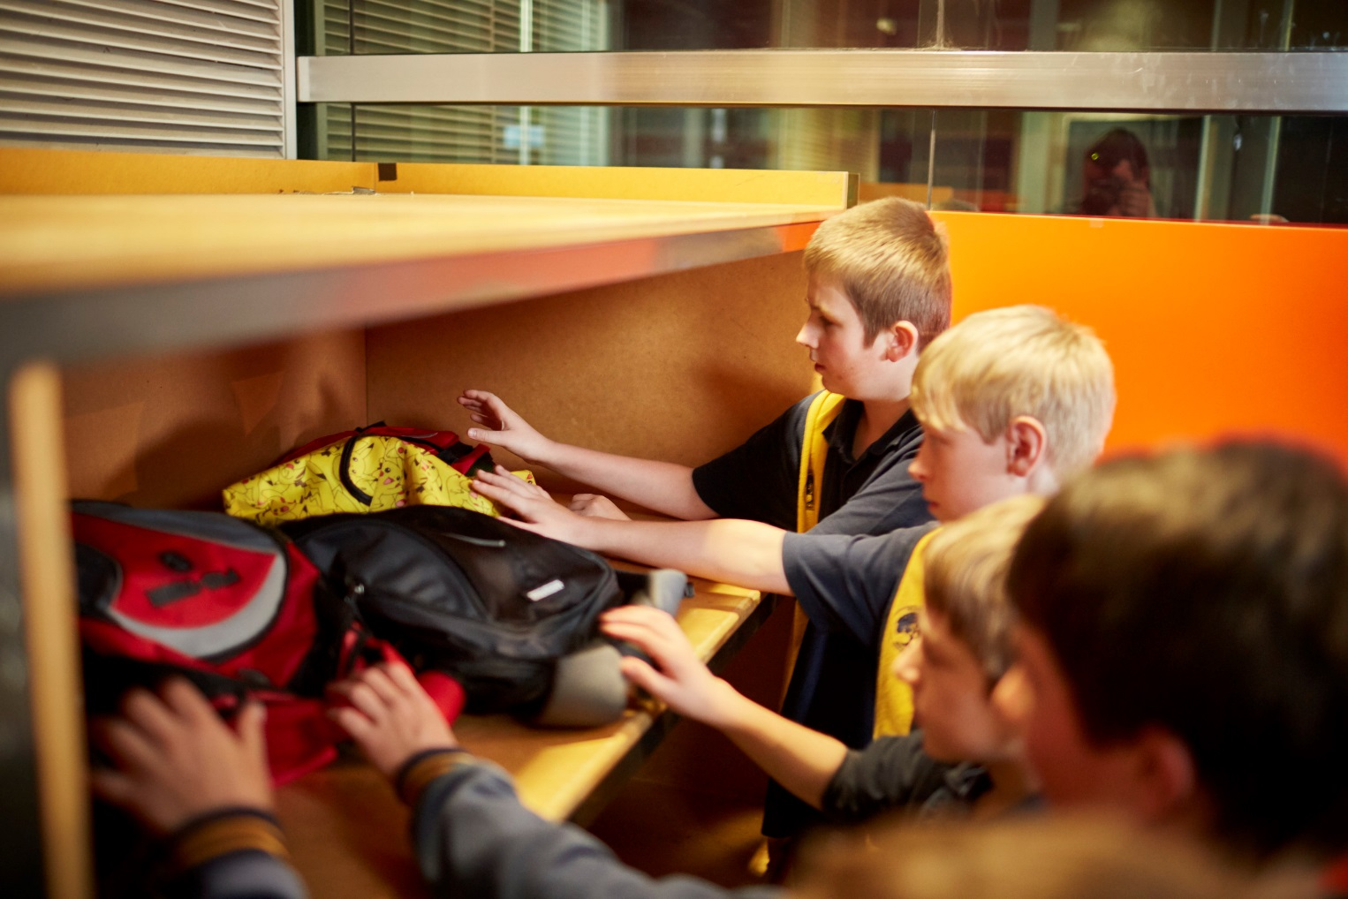

Storing our bags
I will go downstairs and enter Scienceworks through automatic sliding doors. I will put my bag away with the bags of the rest of my class. I can get my bag back later for lunch and when I leave Scienceworks.

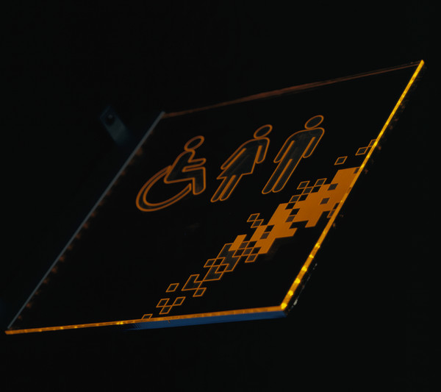

Toilets
I will tell my teacher if I need to go to the toilet.

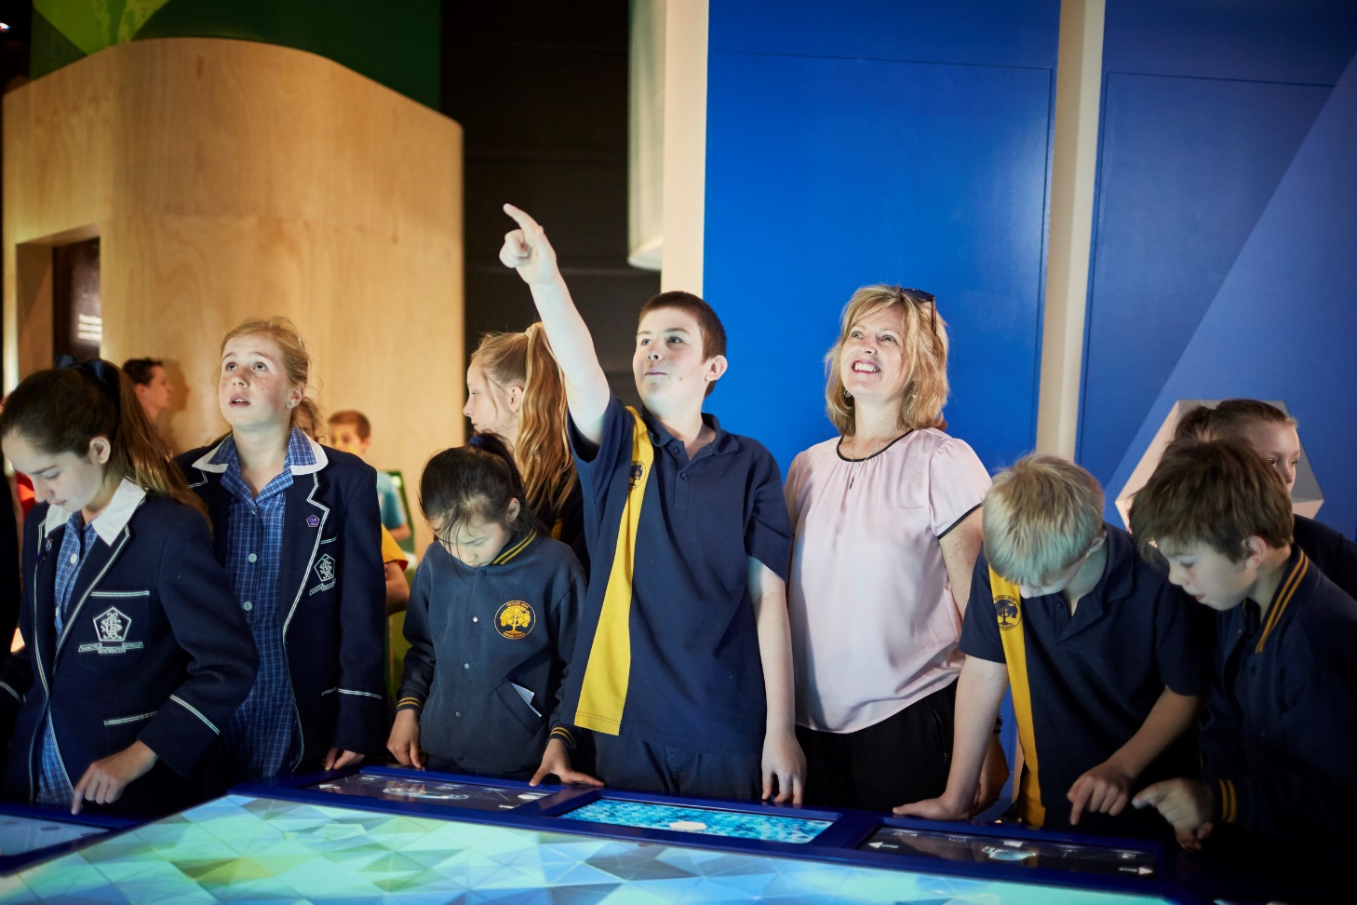
Unique Identifier - 000217558
Exploring Scienceworks
At Scienceworks I might see exhibitions and science shows. My teacher will tell me what the class is doing and when.

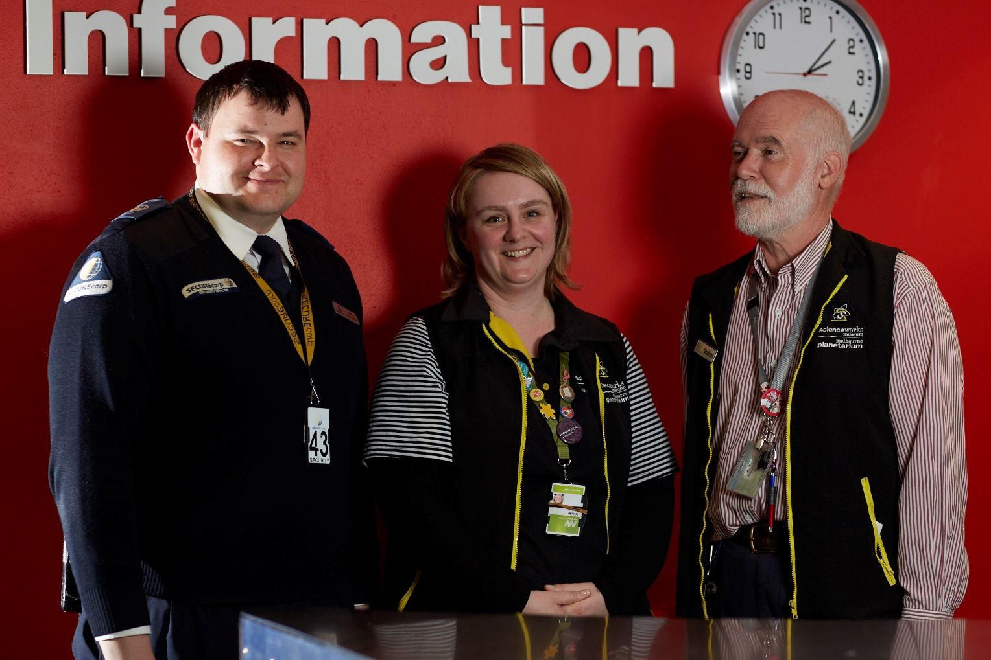
People who work at Scienceworks
People who work at Scienceworks wear straps around their neck or nametags or might wear black vests. I can ask these people for help if I can’t find my group.
Unique Identifier - 000025193

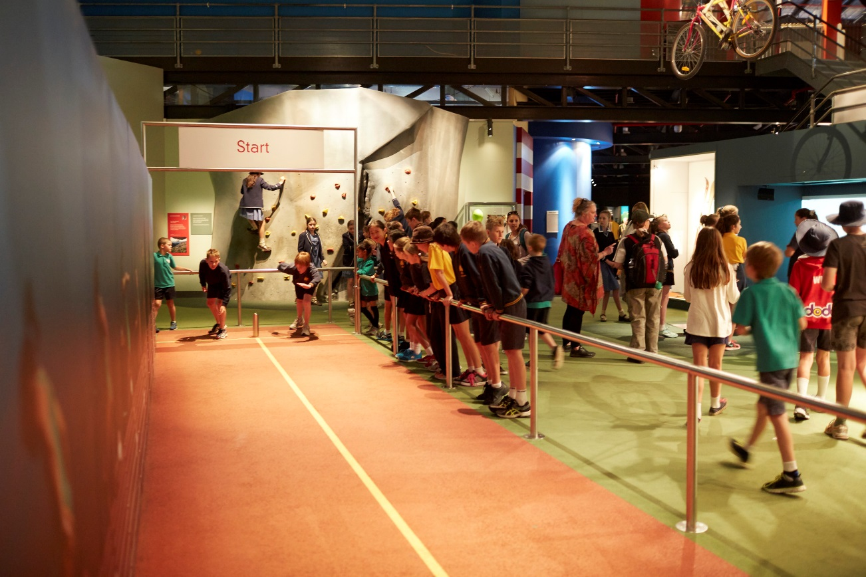

Some important things to remember at the museum
When I visit Scienceworks I must remember to:
- Follow the adult who is leading my group
- Stay close to my group
- Walk between activities
- Speak with my quiet voice, even though it may be noisy
- Take turns with other children
- Wait patiently when I have to line up
- Only touch things I am told that I am allowed to

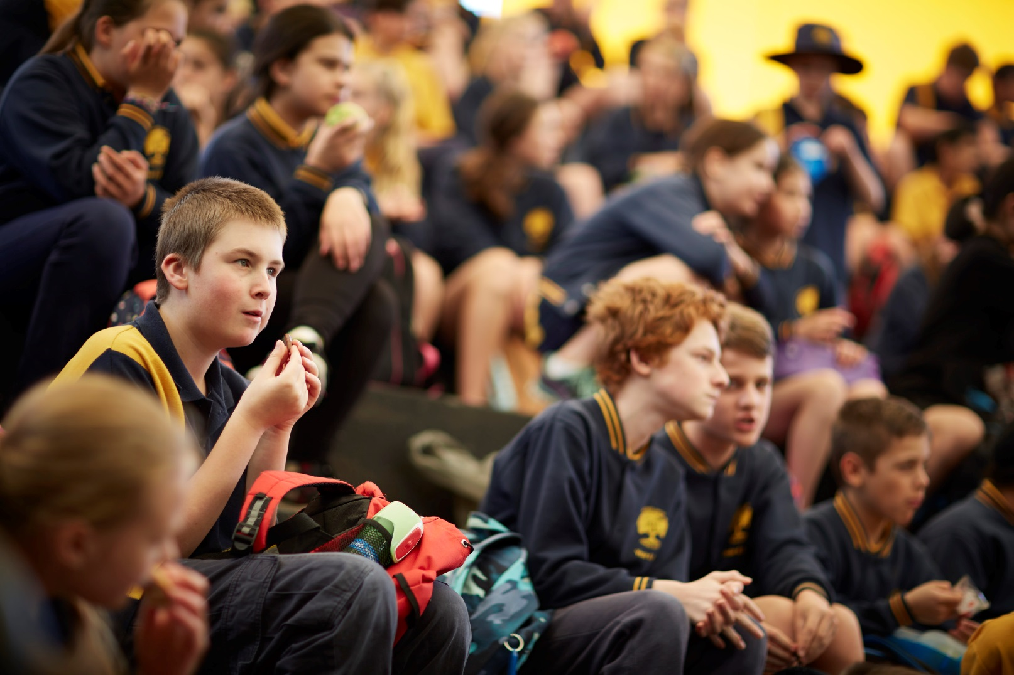

Eating
When it is time to eat I will get my lunch and sit with my class outside. There may be a lot of other school students eating lunch outside too.

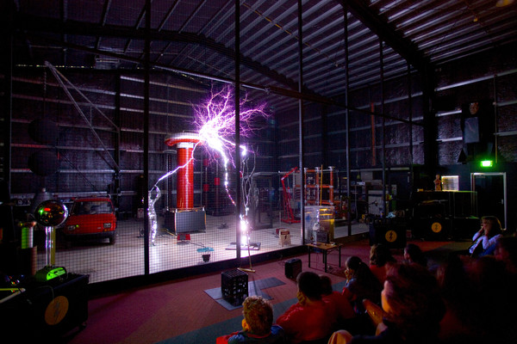

Visiting the Lightning Room
My school might have booked to see a 40 minute show in the Lightning Room. I will wait outside for a staff member to show me to my seat. I will watch a show with demonstrations at the front. If I put my hand up when asked, I might be chosen as a volunteer. Towards the end of the show there will be a lightning demonstration. I will be safe outside of the metal cage which protects me from the lightning strikes. It will be loud so I will need to cover my ears. I can also cover my eyes any time. I will tell my teacher if I need to leave the Lightning Room during the show.
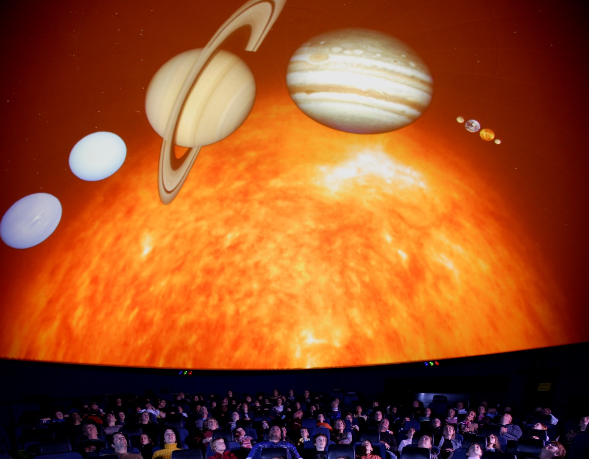

Visiting Melbourne Planetarium
My school might have booked to see a 45 minute show in the Planetarium. I will wait outside for a staff member to show me to my seat. The seats tilt back so I can see the screen on the ceiling. There will usually be two parts to the show: a movie and a talk about the stars in the night sky. I will try to stay quiet the whole time so everyone can hear the show. The room needs to be dark to see the stars, so I will put away anything that makes light. If any of the moving images make me feel dizzy, I can close my eyes during these parts of the show. When the show ends, I will sit up and wait for the teacher to let me know when I can leave with my school group. I will tell my teacher if I need to leave during the show.
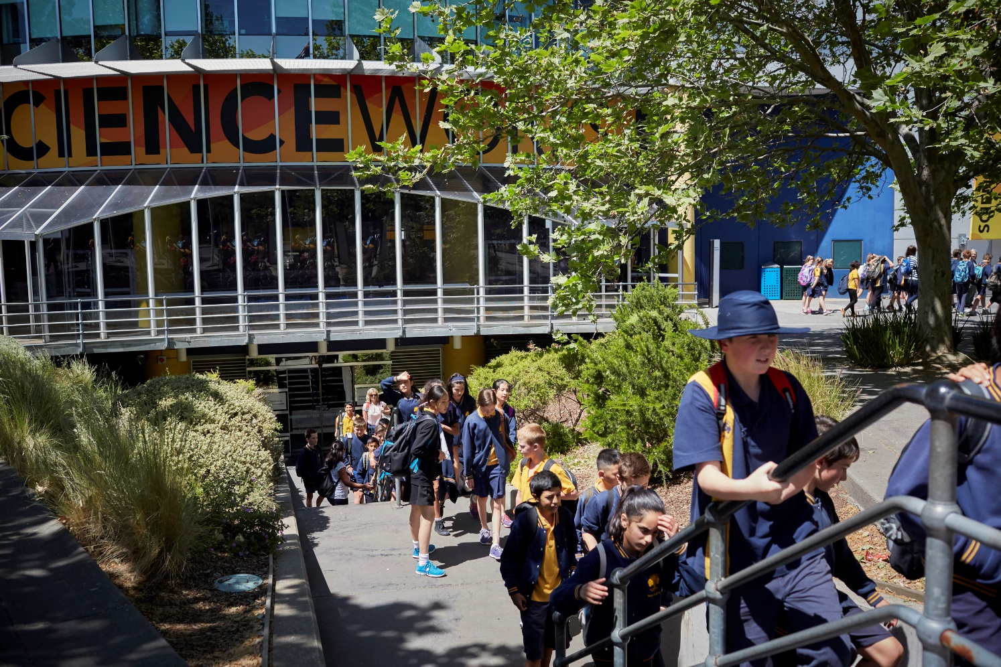

Leaving
When it is time to go home, I will go downstairs and get my bag with the rest of the class. I will leave through the automatic sliding doors.
Going to Scienceworks is fun.

