Autism Friendly Melbourne Planetarium
SOCIAL STORY FOR FAMILIES
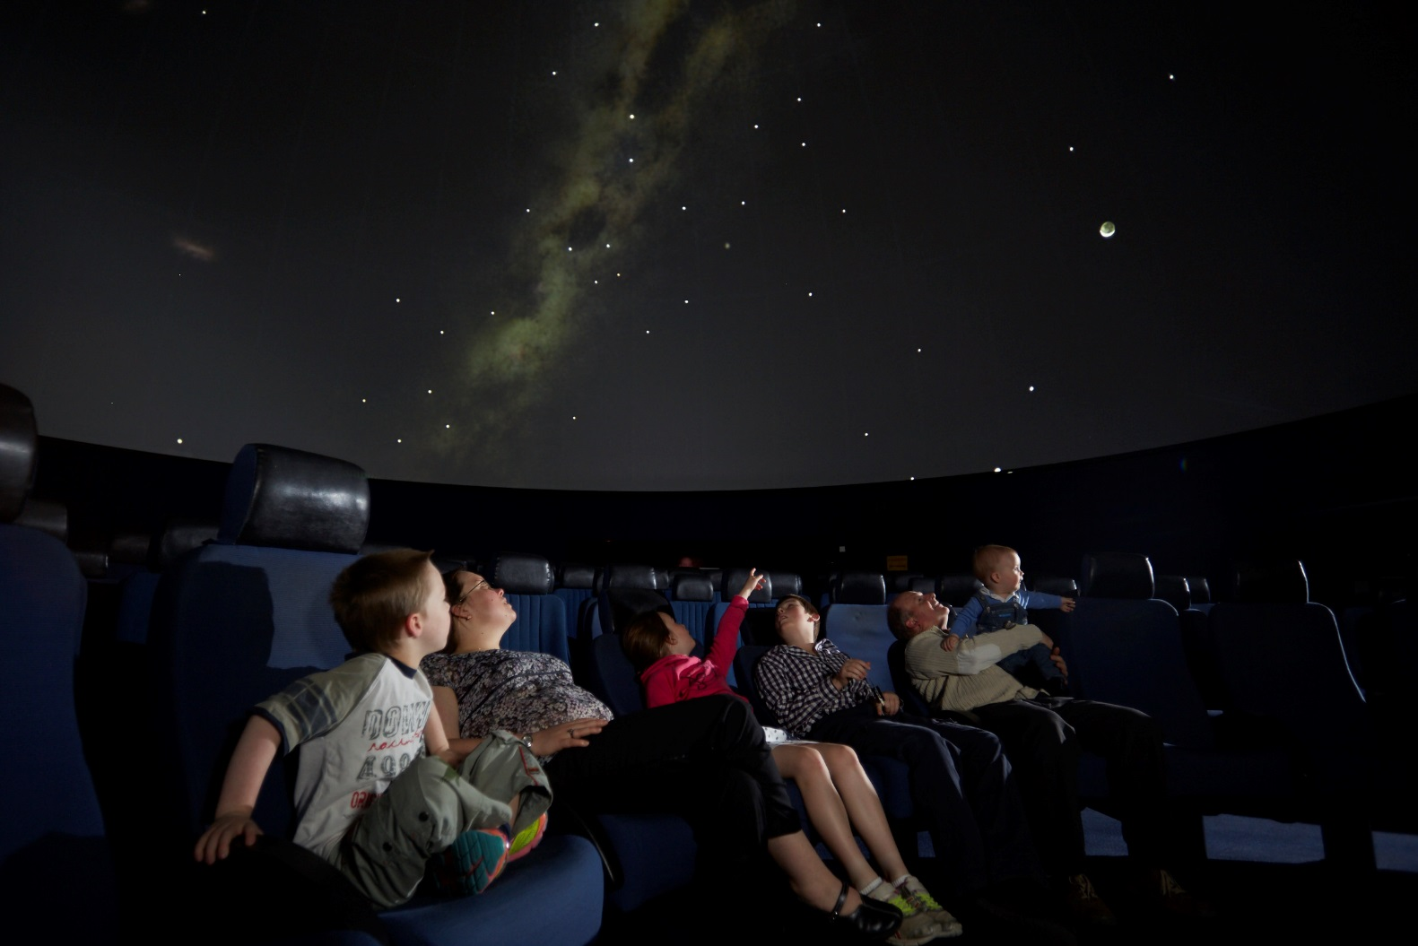
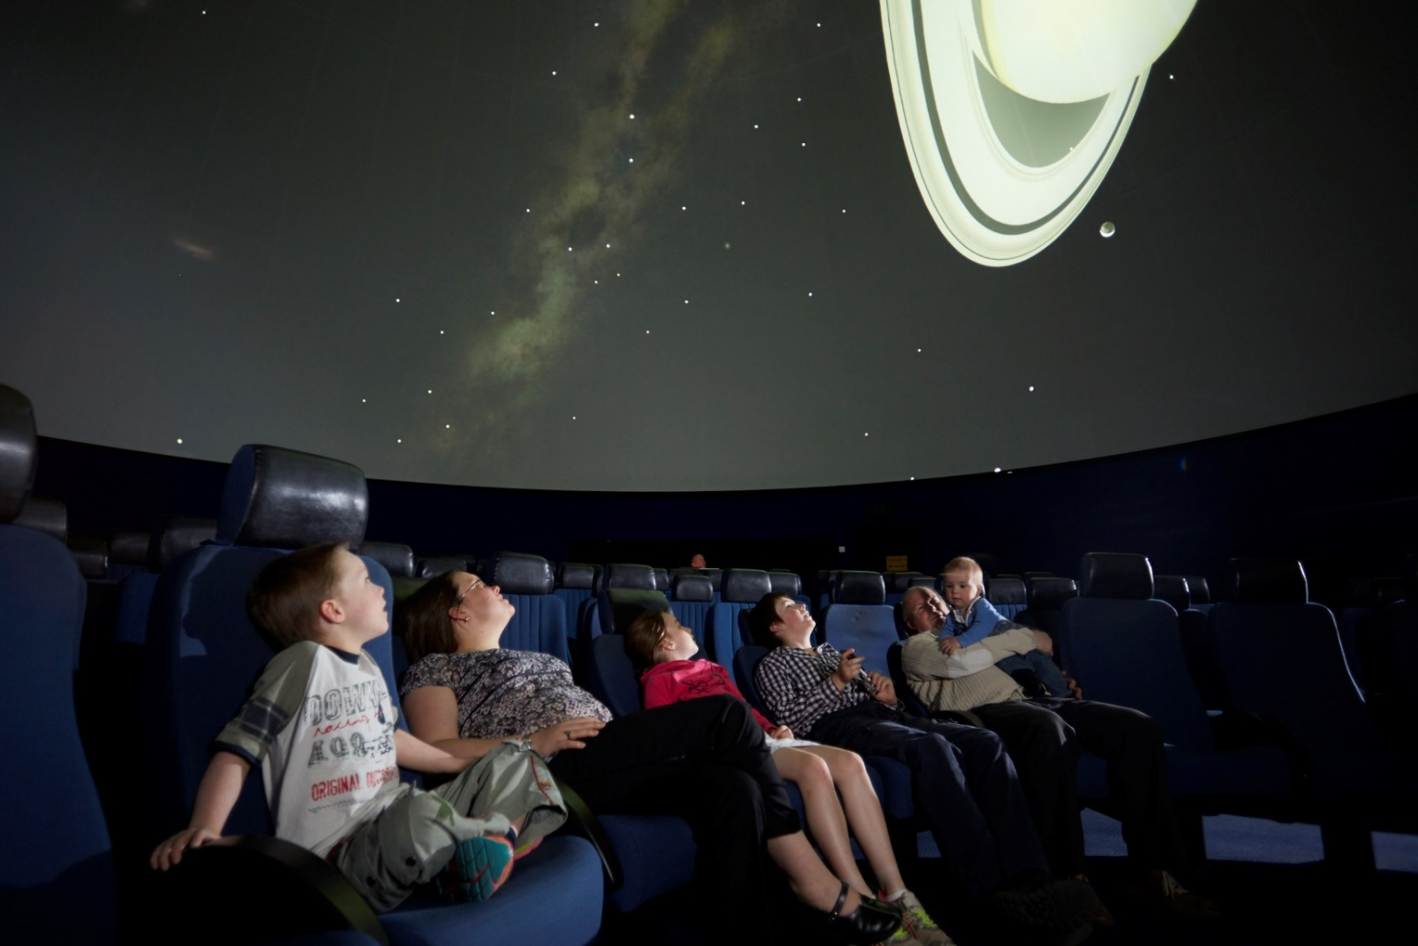
What is the Melbourne Planetarium?
At Scienceworks there is a Planetarium where I can learn about the stars and planets. Going to the Planetarium is like going to the movies. The theatre has a screen that is above my head and the seats lie back. Most planetarium shows go for about 45 minutes.
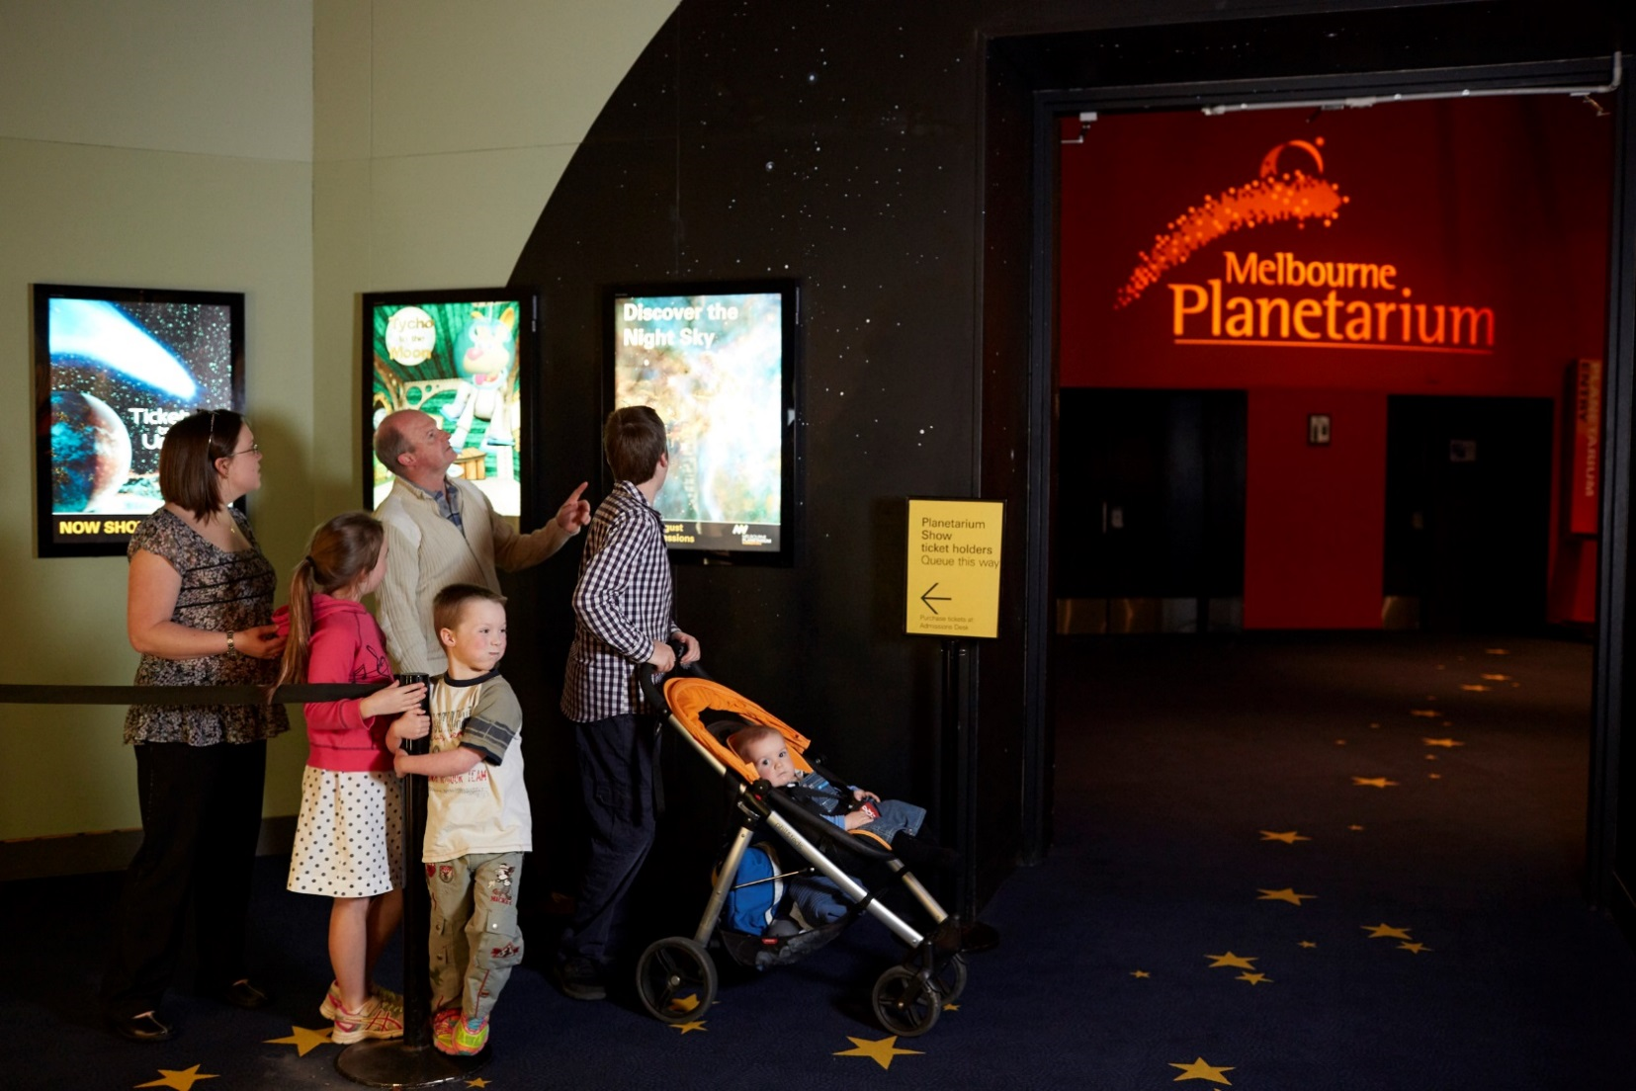
Getting to the Planetarium
To get to the Planetarium we can follow the stars on the carpet near Sportsworks or painted on the ground outside.
I line up near Sportsworks with everyone else who is going to see the show.
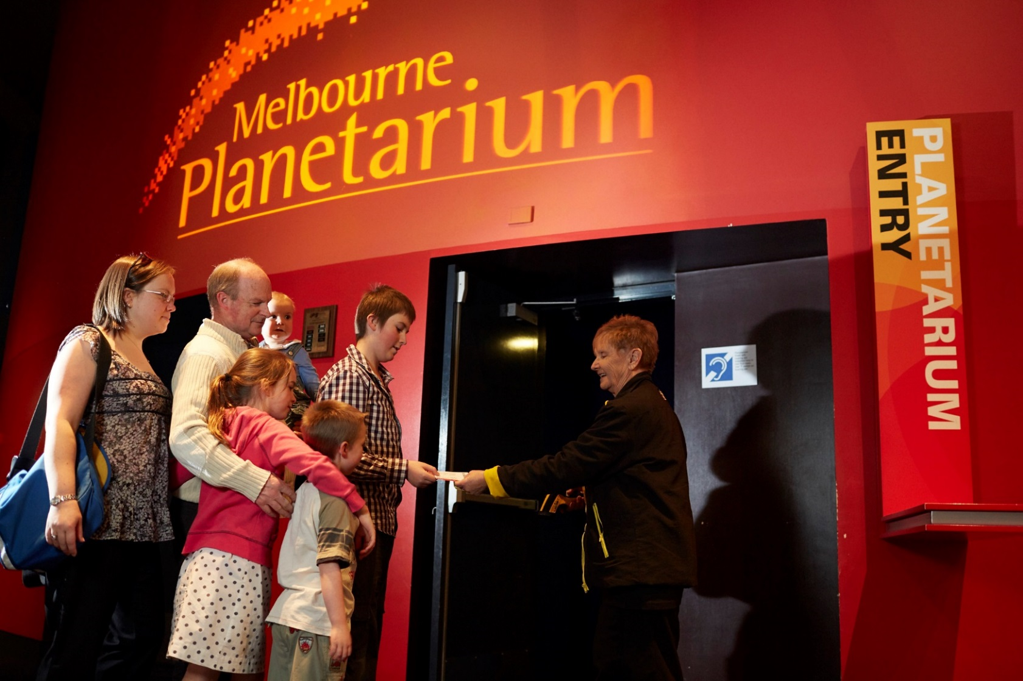
Arriving at the Planetarium
Before I go into the Planetarium, I can use the toilets nearby in the Planetarium foyer. A staff member will check our ticket with a scanner that makes a loud beep.
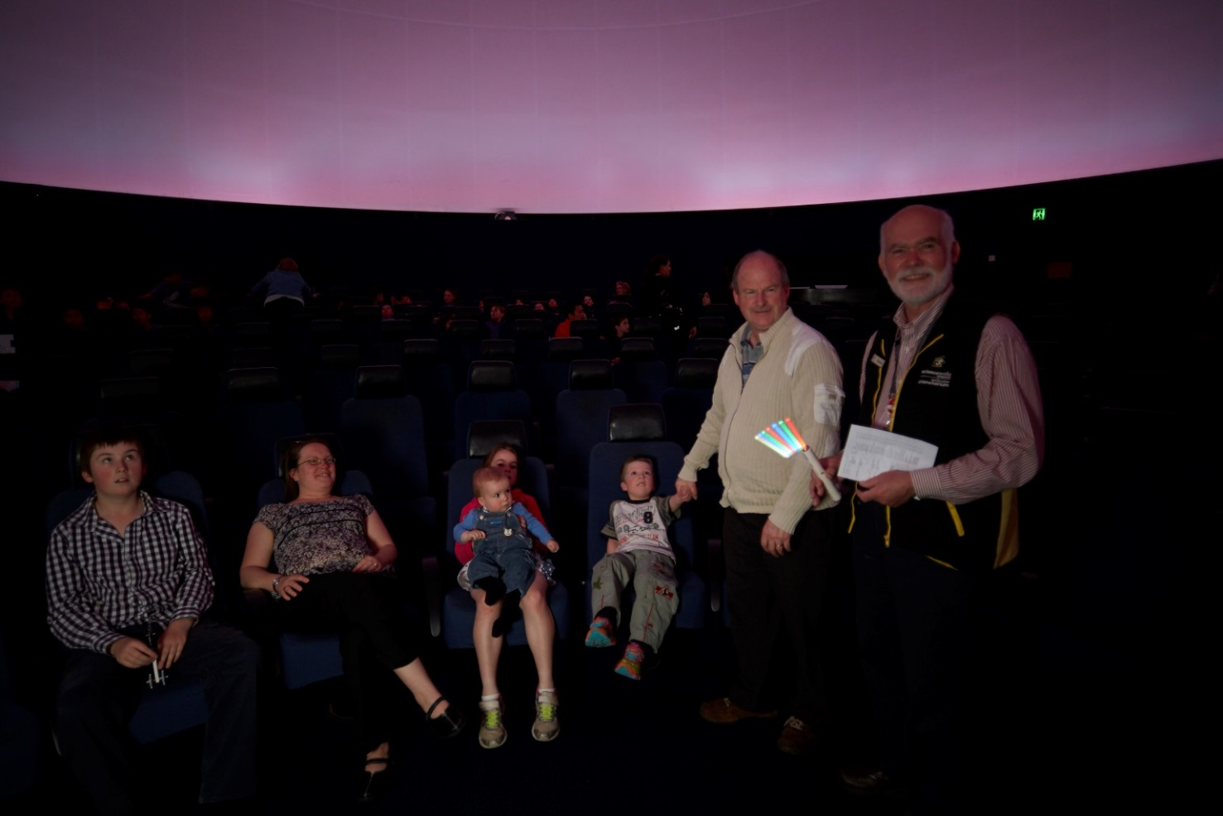
Inside the Planetarium
It will be dimly lit inside the Planetarium, but I’ll be able to see the seat I am directed to.
The seats are really fun because they lean back so I can see the round screen above my head.
A presenter will tell us about the movie.
When the movie starts it will get dark. The movie may be noisy and have bright pictures. The darkness helps me to see the stars. If I feel dizzy, I can close my eyes until I feel better.
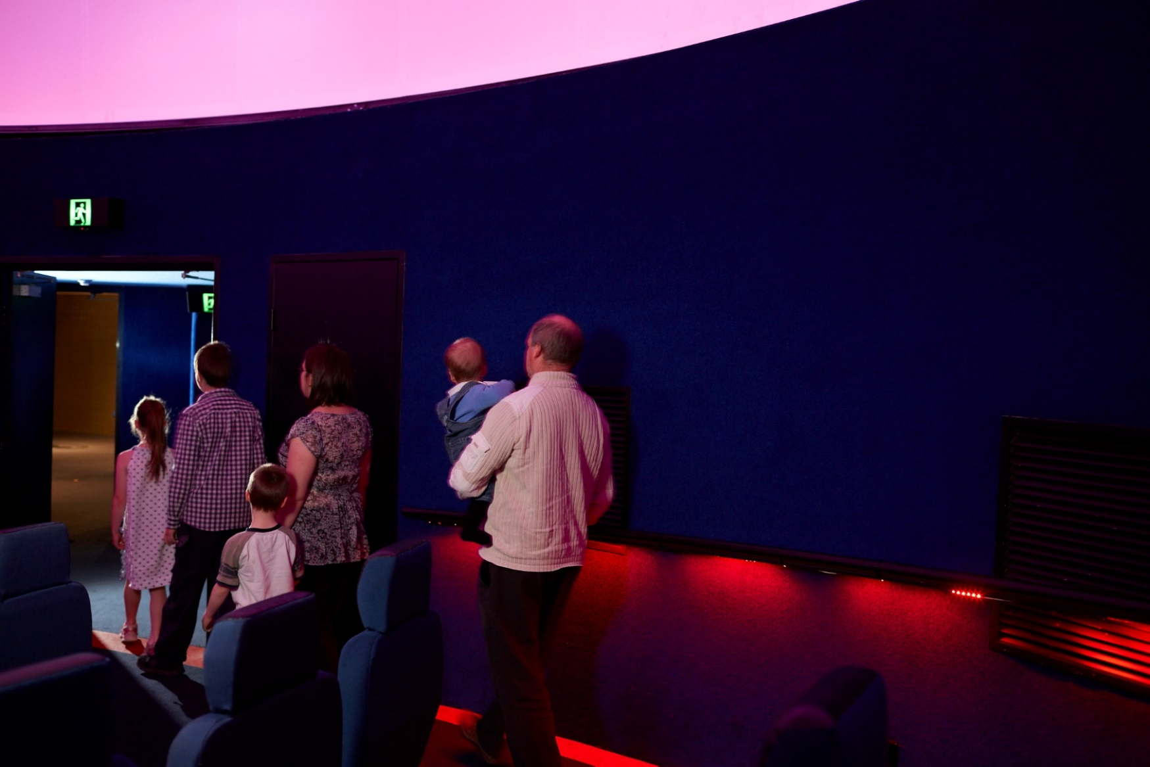
Leaving the Planetarium
When the presenter has finished talking, the lights will come back on so I can see how to get out. I’ll check I haven’t left anything behind and leave through the double doors when my family is ready to go.

