SOCIAL STORY FOR YOUNGER CHILDREN

My adventure to Ground Up at Scienceworks

This book belongs to ____________________
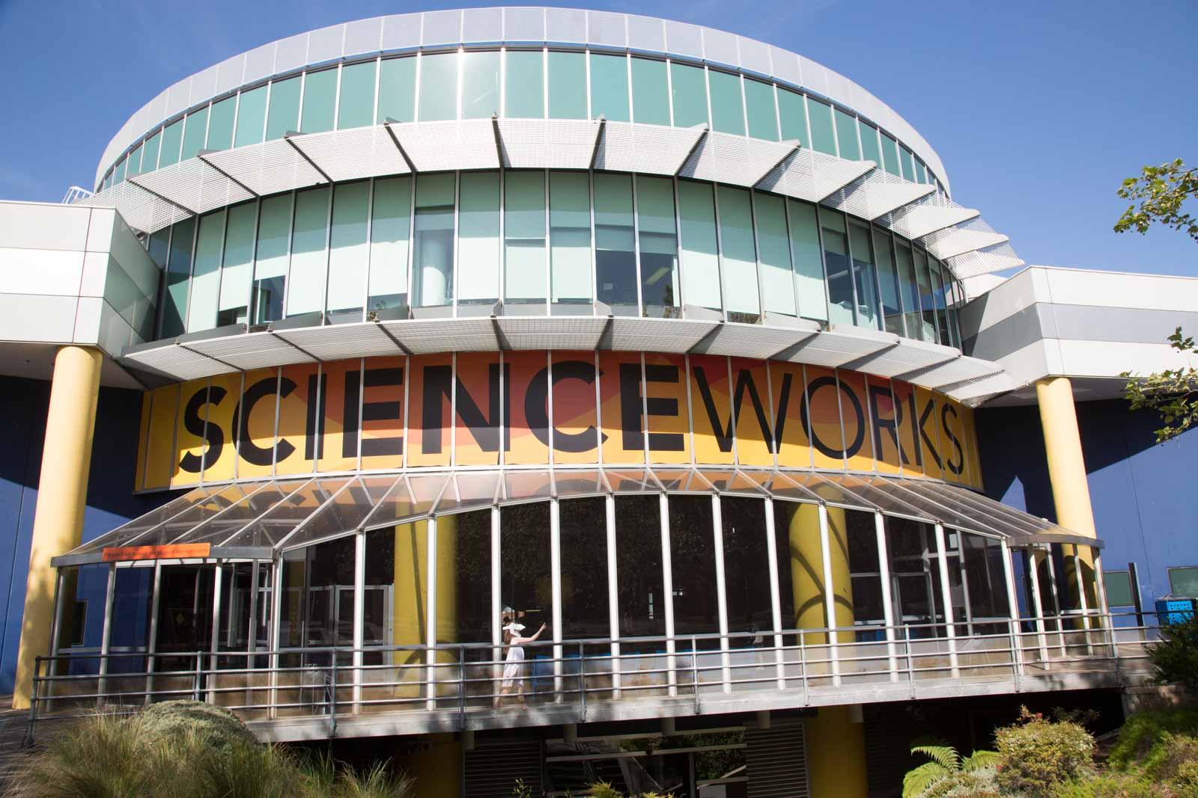
Scienceworks is a museum where I can learn about science and technology. I am going to visit the Ground Up exhibition at Scienceworks.
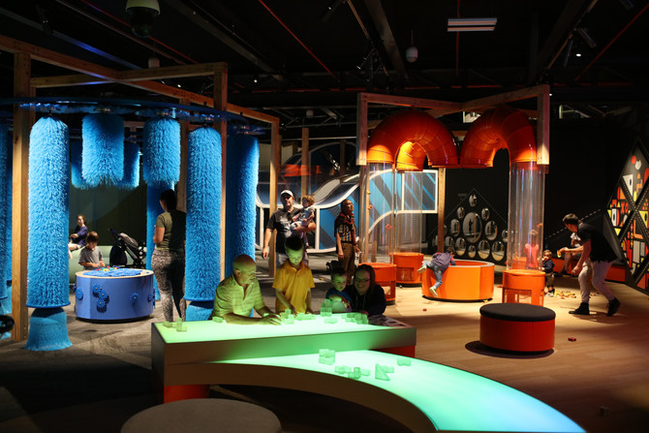
Ground Up is a place where I can have fun, build and play. It is made especially for children my age.
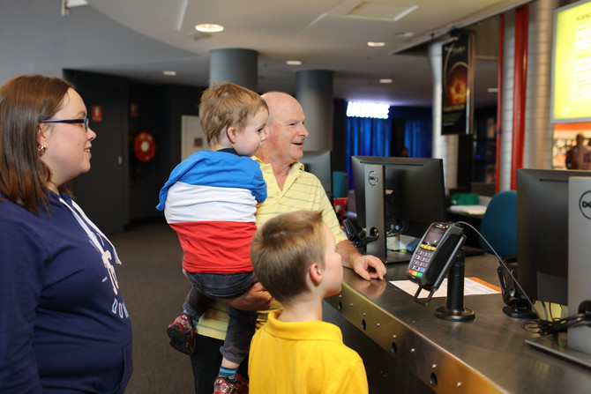
I will have to wait with an adult to buy the tickets to go into Scienceworks.
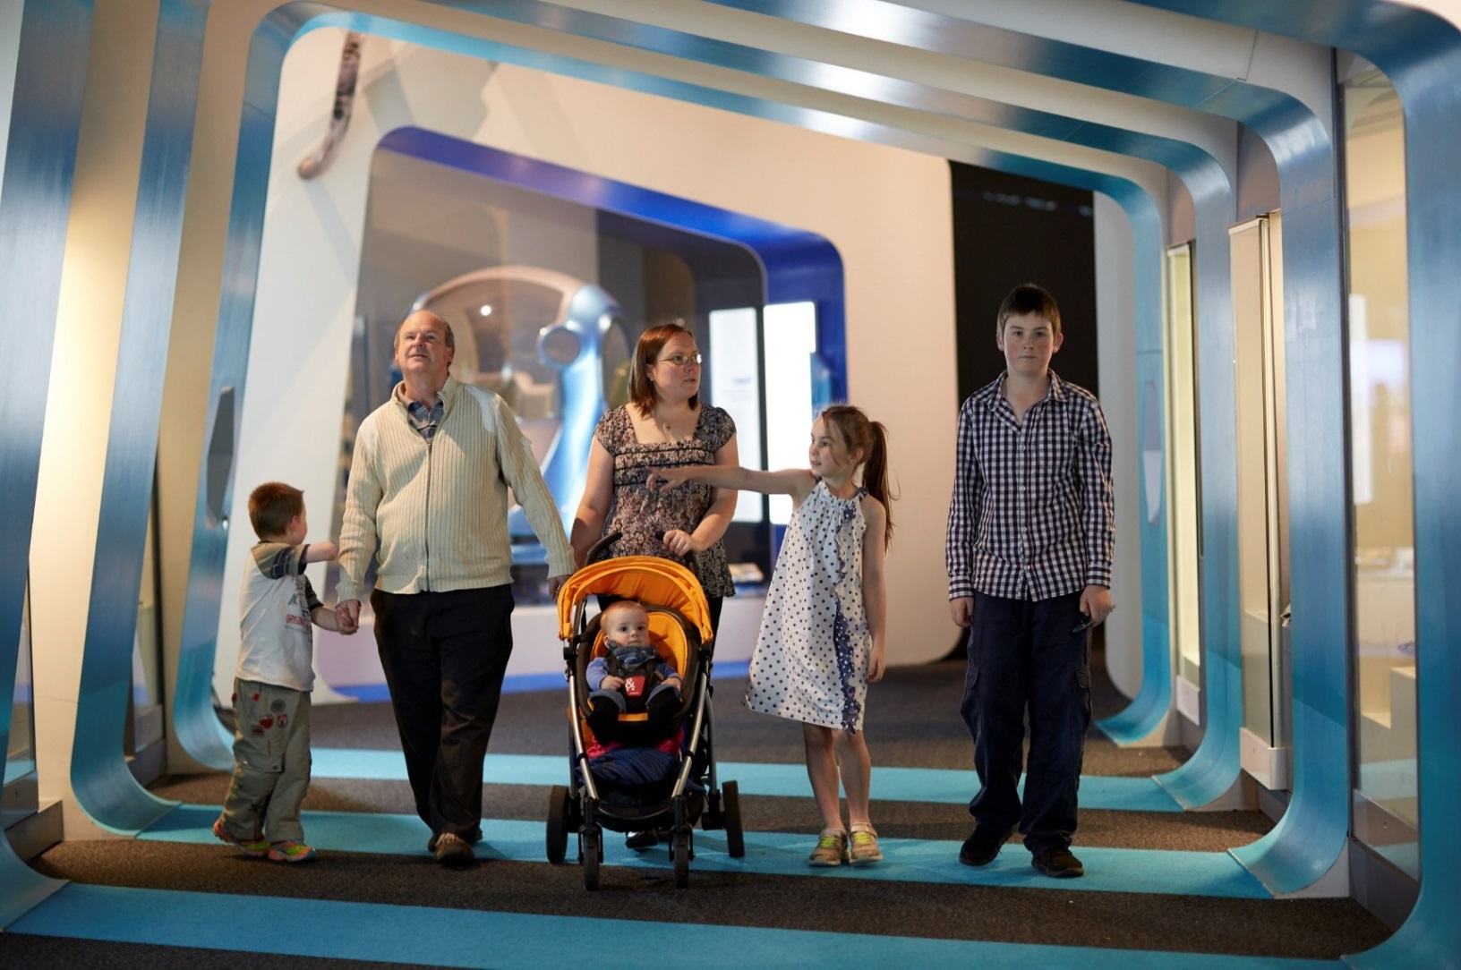
We will walk through other exhibitions to get to Ground Up.
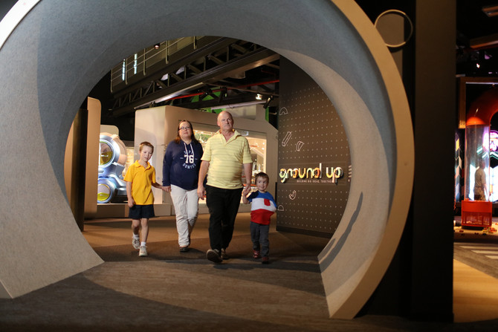
When I go into Ground Up I will walk through a short tunnel.
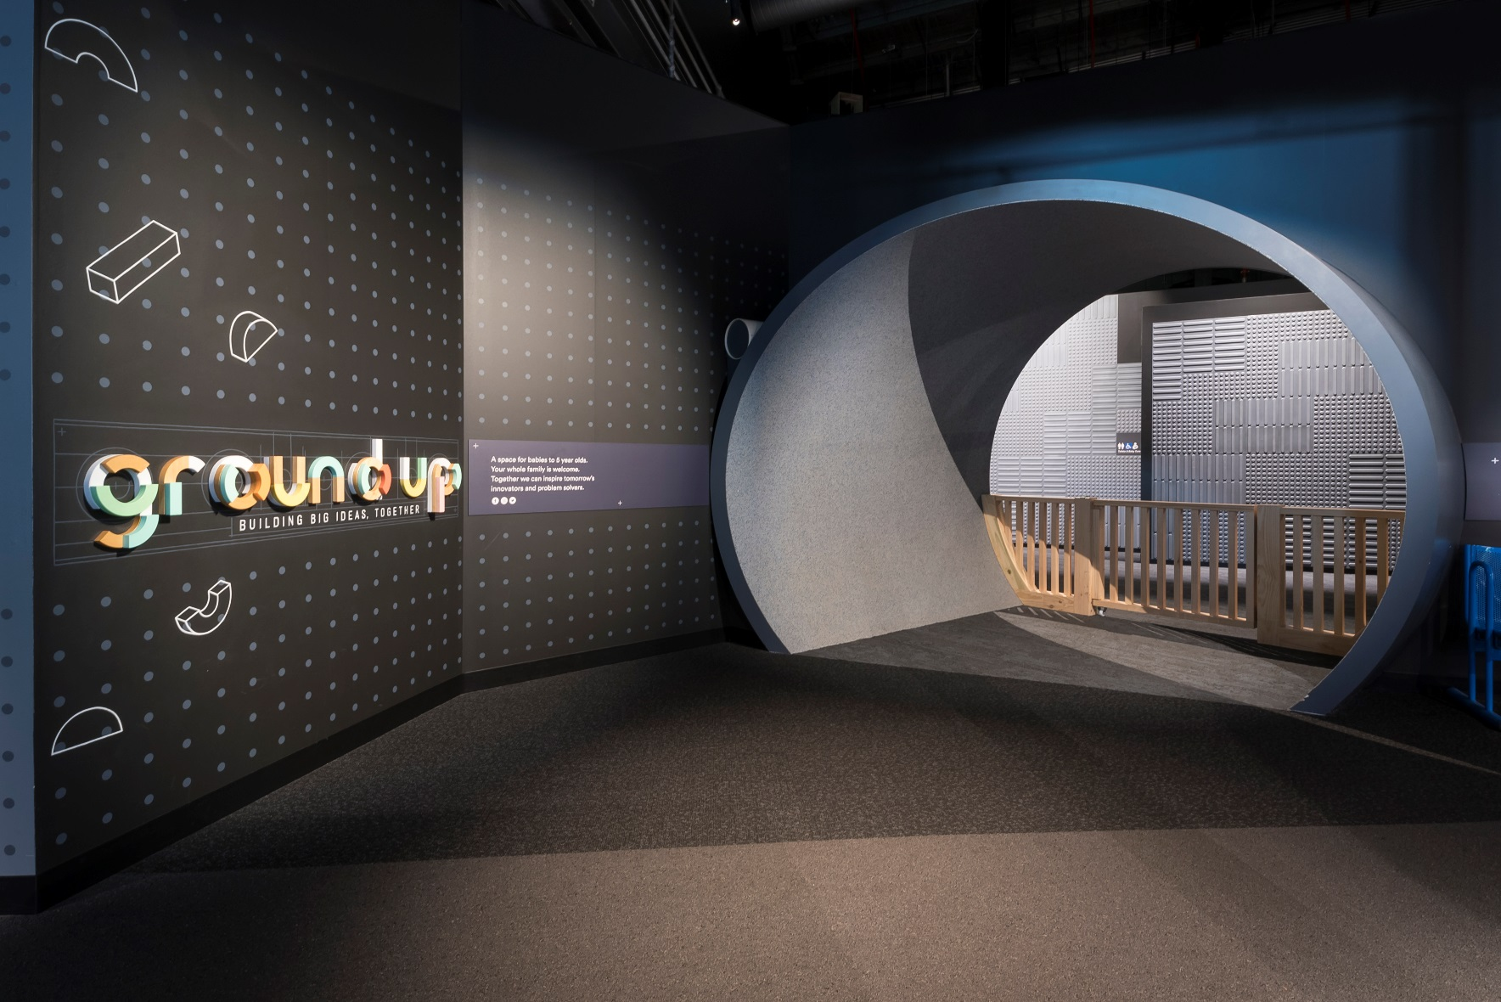
I will need to go through some wooden gates to get into and out of Ground Up.
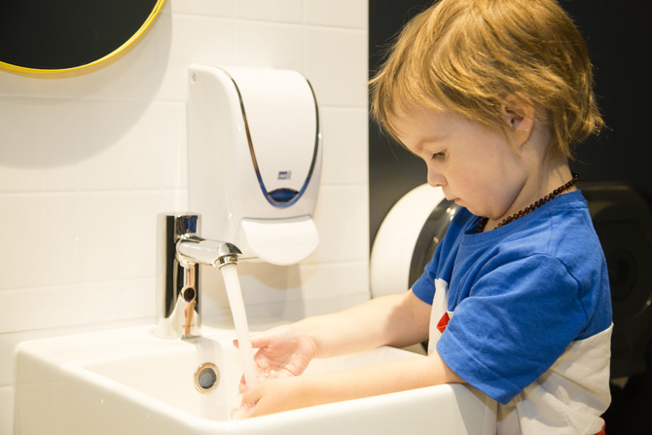
If I need to go to the toilet I can ask my grown up to take me to the bathrooms in Ground Up.
There are hand dryers in the toilet. Some people use them after they wash their hands. I do not have to use them.
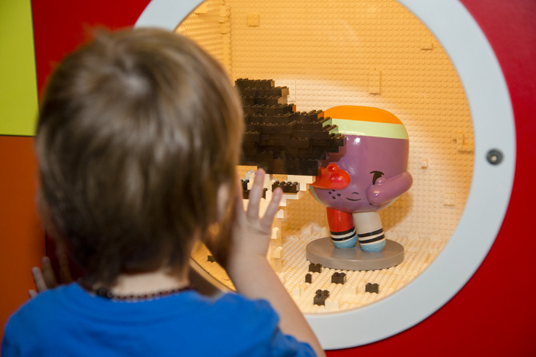
In Ground Up there is a purple figure, her name is Dot. I can find her in different places.
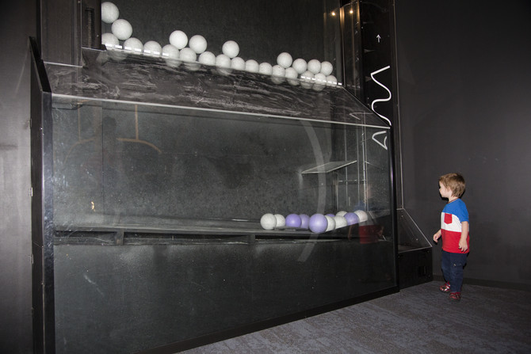
There is a big ball run I can watch that reaches almost to the roof. It will not fall down.
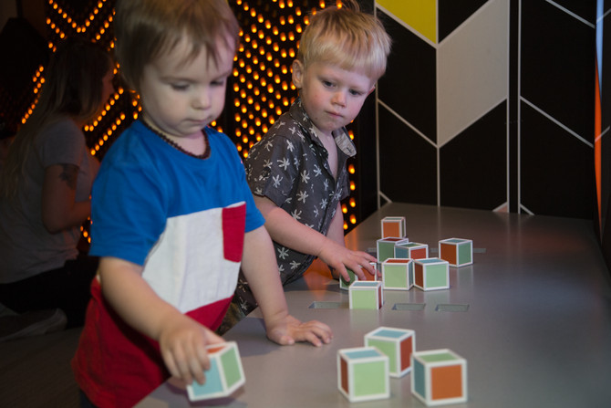
In Ground Up I will need to take turns or share with other children.
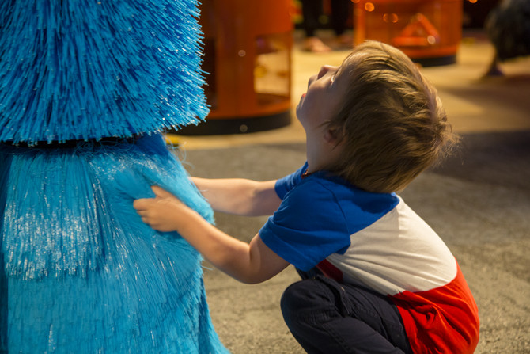
There are big blue brushes that I can make turn. These brushes feel spiky.
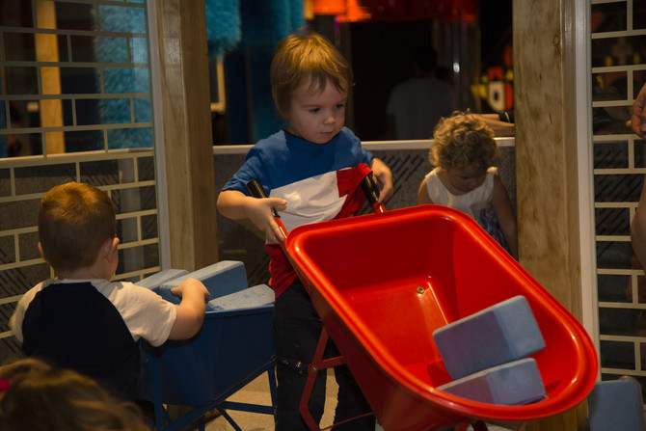
There is a big house I can build with other children.
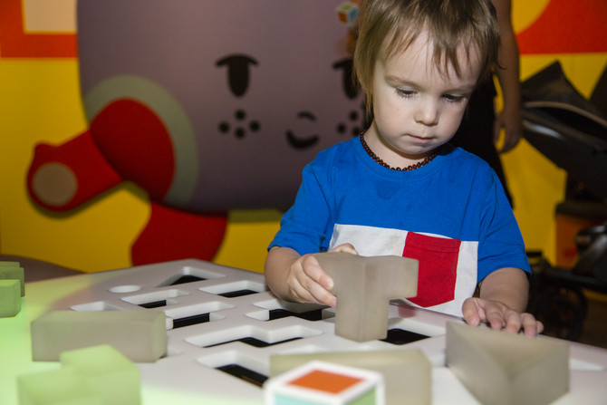
There is a table with colourful lights where I can build with blocks. I can play by myself if I want to.
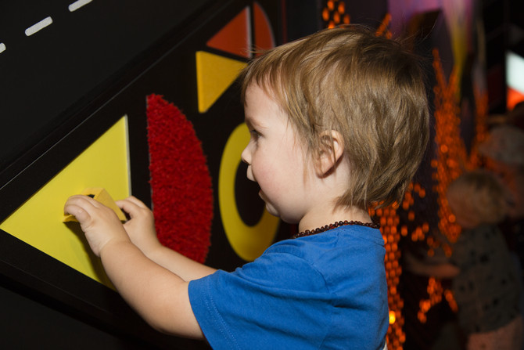
One wall is covered in lots of different materials that all have a different feel and shape.
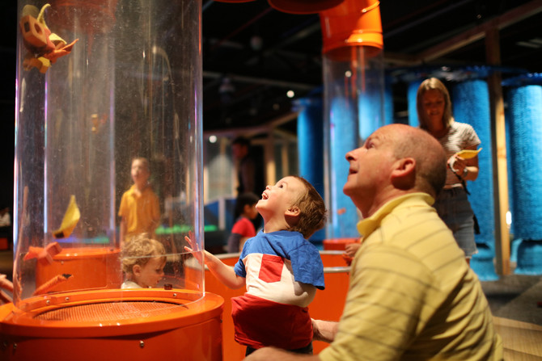
There are some wind tubes that blow air to put my own inventions into and watch them fly.
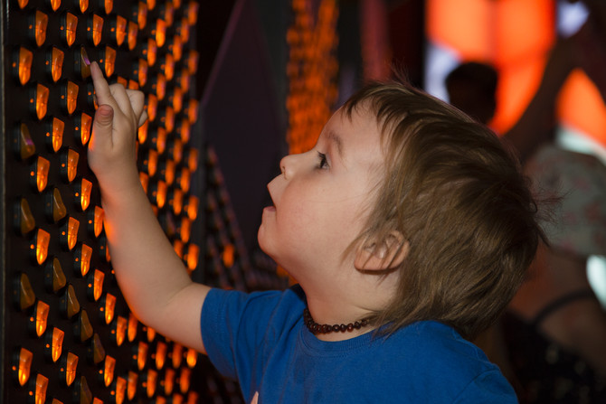
One wall has lots of switches and little lights to make patterns and shapes with.
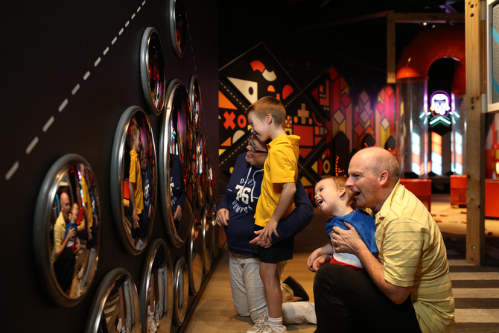
There is a wall covered in round mirrors. I might look different in the mirrors.
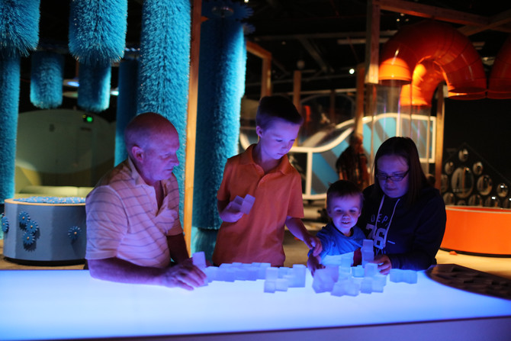
There are many more things to play with in Ground Up. My family can play with me too.
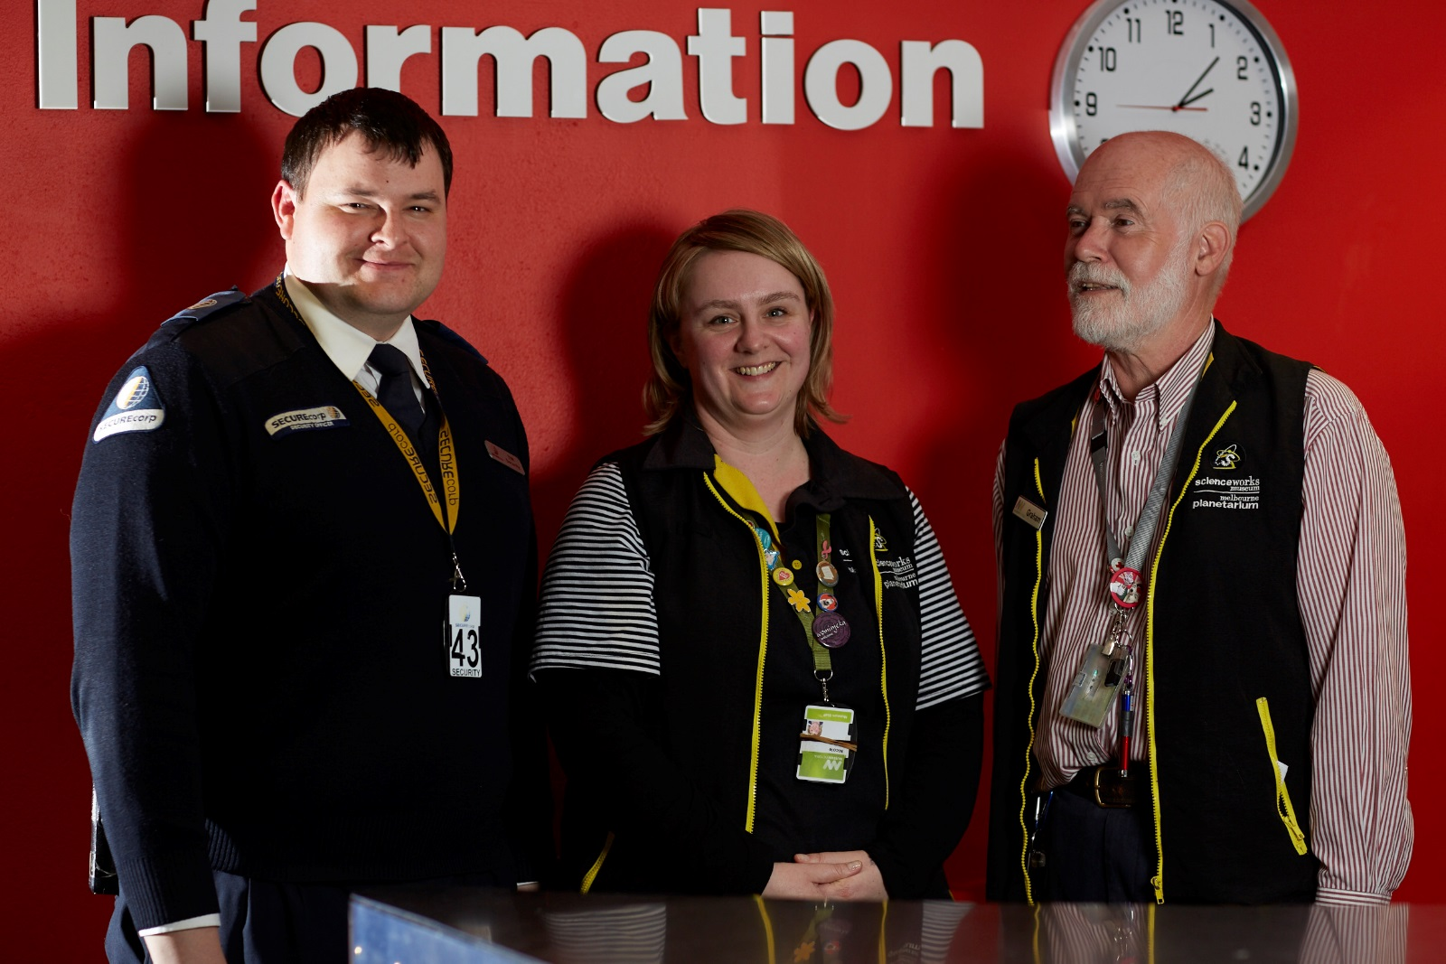
If I want to know more about anything I can ask my grown up or a Scienceworks staff member. Staff wear straps around their necks or nametags.
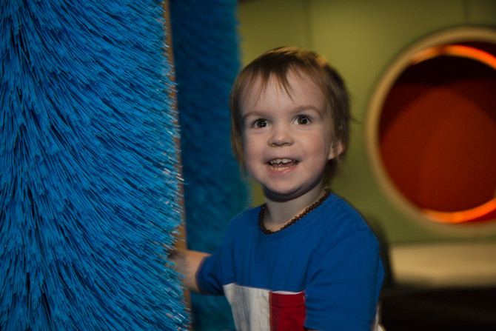
Going to Ground Up at Scienceworks will be fun.
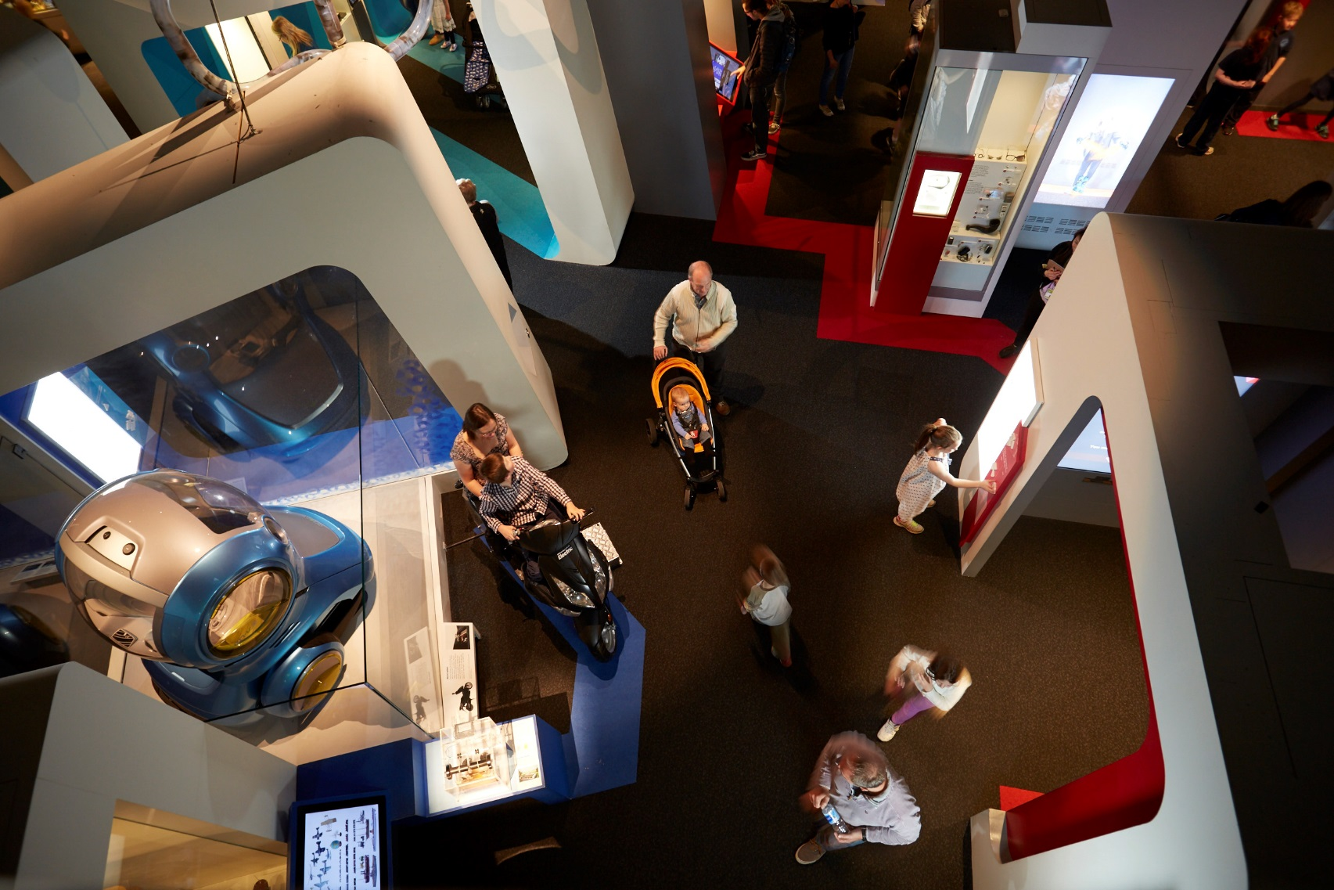
So much fun that we might stay and do other things!

