SOCIAL STORY FOR EARLY YEARS GROUP VISITS

My adventure to Ground Up at Scienceworks

This book belongs to ____________________
What is Scienceworks?
My class is going to Scienceworks. Scienceworks is a museum where I can learn about science and technology.
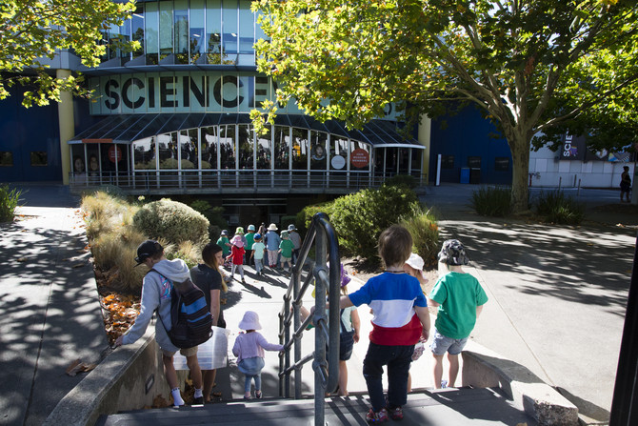
My teacher will come with me and tell me where to go and when.
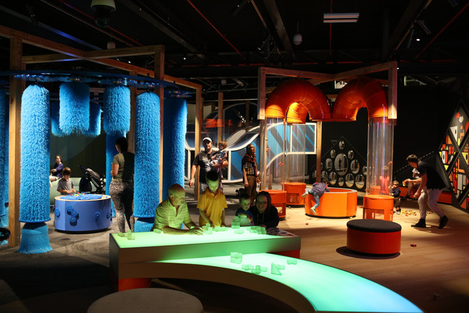
Inside Scienceworks there is a special room I will visit called Ground Up which is made especially for children my age.

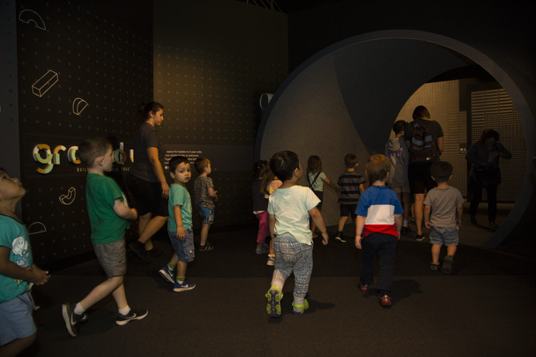
When I go into Ground Up I will walk through a short tunnel. I will stay in Ground Up until my teacher tells me it is time to go somewhere else.
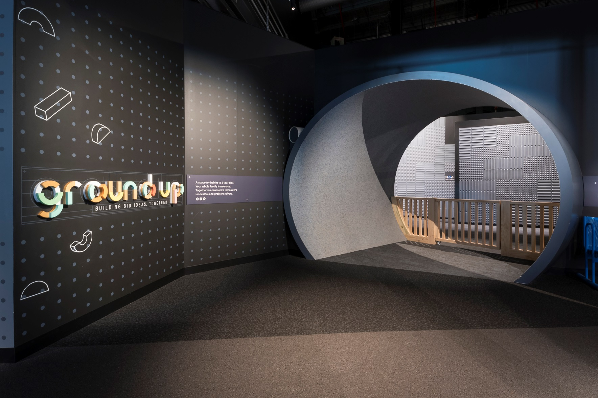

We will need to go through some wooden gates to get into and out of Ground Up.
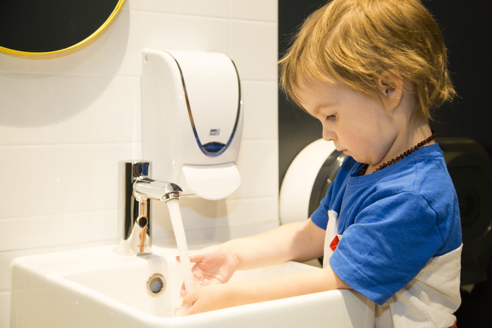
There are bathrooms in Ground Up. If I need to go to the toilet I can ask my teacher to take me.
There are hand dryers in the toilet. Some people use them after they wash their hands. I do not have to use them.
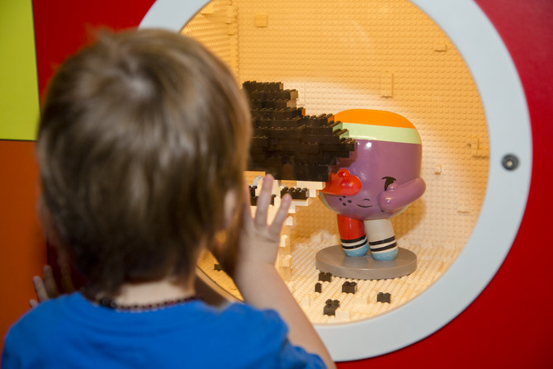
In Ground Up there is a purple figure, her name is Dot. I can find her in different places.
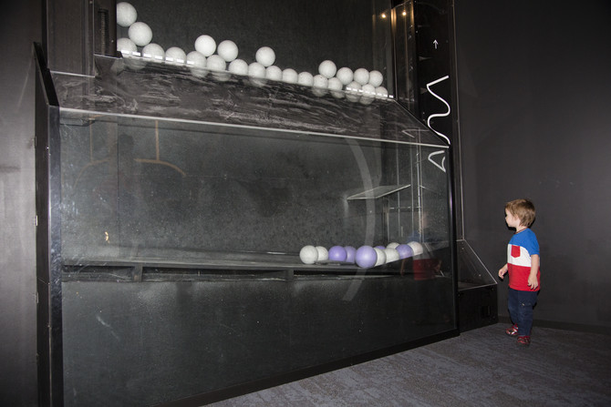
There is a big ball run I can watch that reaches almost to the roof. It will not fall down.
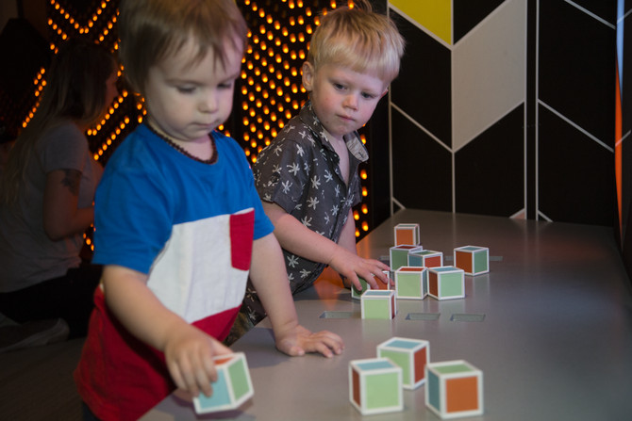
In Ground Up I will need to take turns or share with other children.
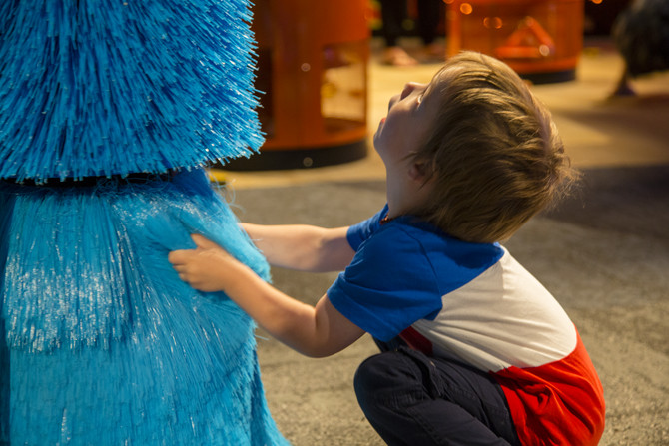
There are big blue brushes that I can make turn. These brushes feel spiky.
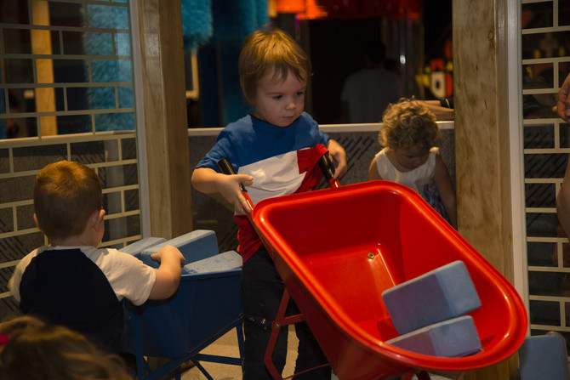
There is a big house I can build with other children.
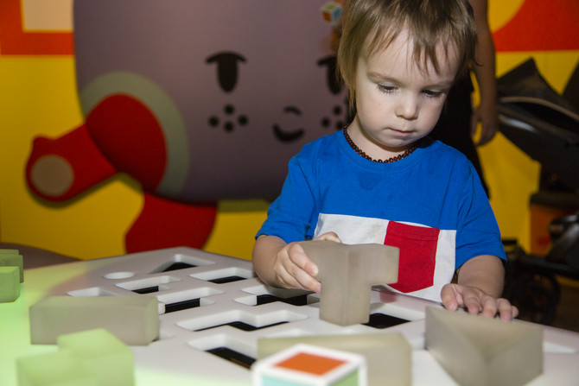
There is a table with colourful lights where I can build with blocks. I can play by myself if I want to.
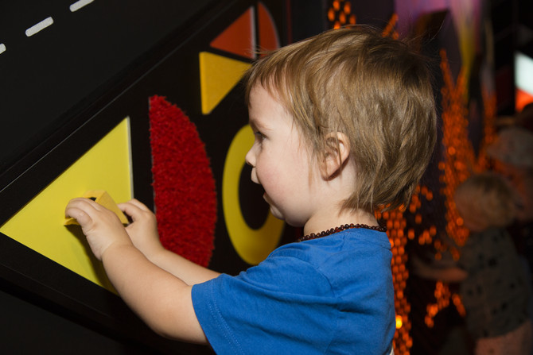
One wall is covered in lots of different materials that all have a different feel and shape.
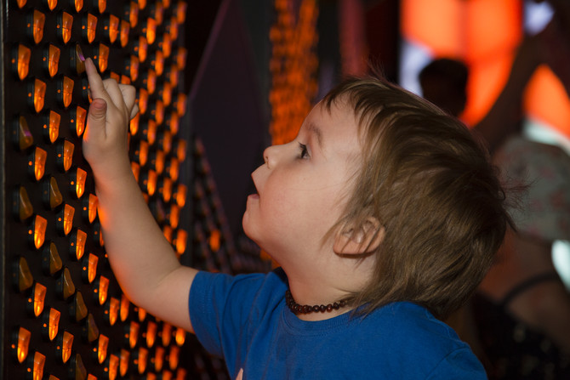
One wall has lots of switches and little lights to make patterns and shapes with.
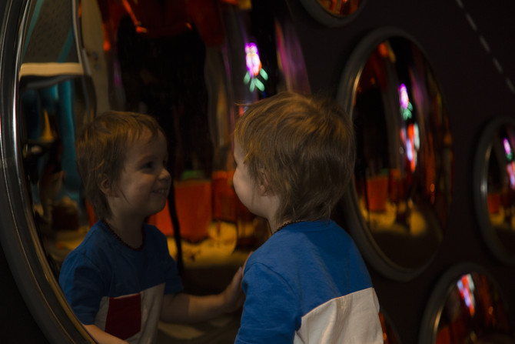
There is a wall covered in round mirrors. I might look different in the mirrors.
There are many more things to play with in Ground Up.

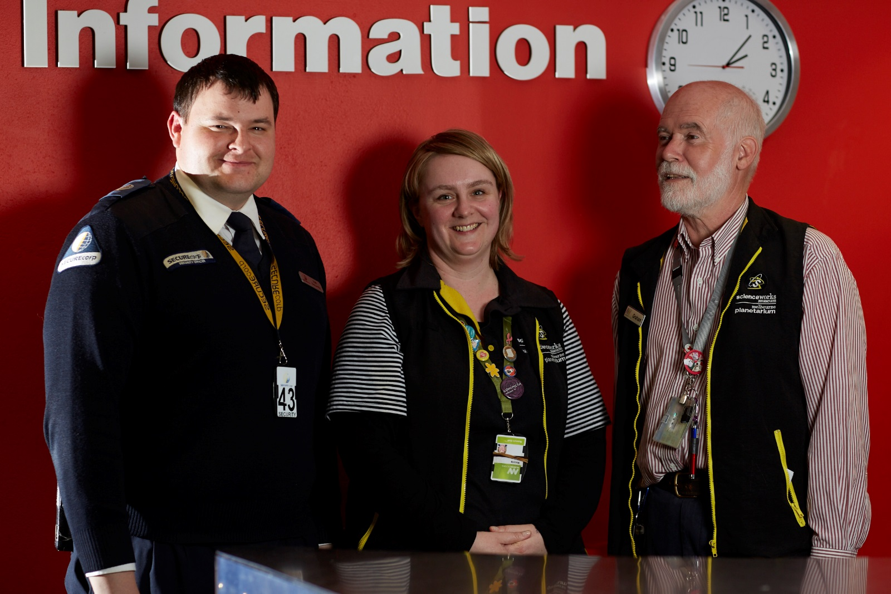
If I want to know more about anything I can ask my teacher or a Scienceworks staff member. Staff wear straps around their necks or nametags.
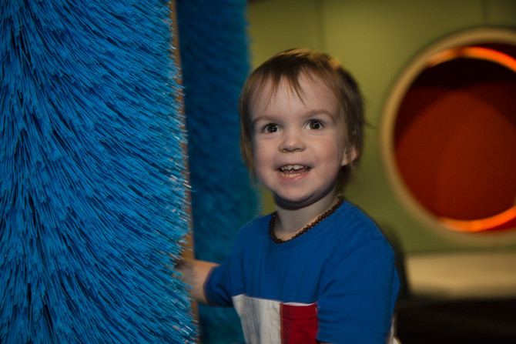
Going to Ground Up at Scienceworks will be fun.

