Autism Friendly Melbourne Museum
SOCIAL STORIES FOR FAMILIES
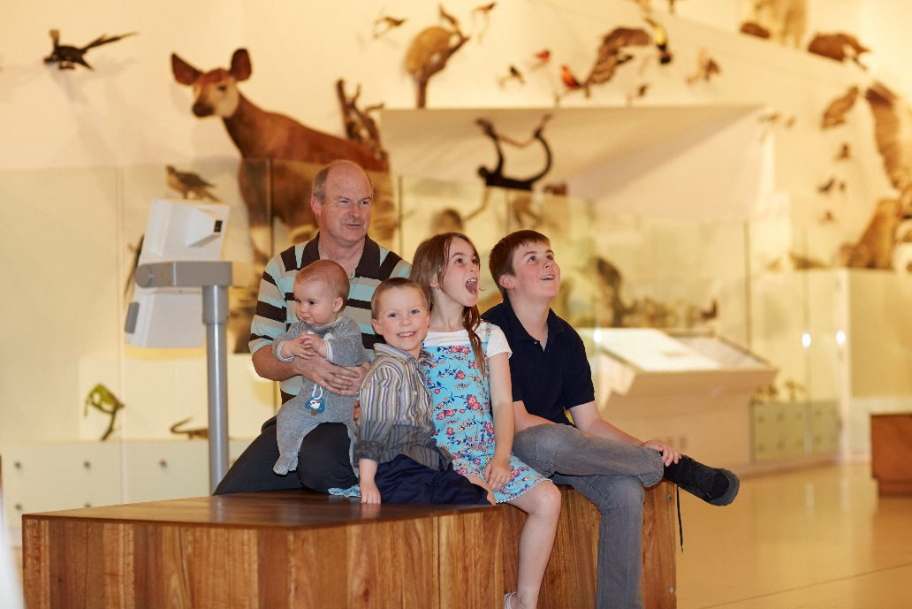
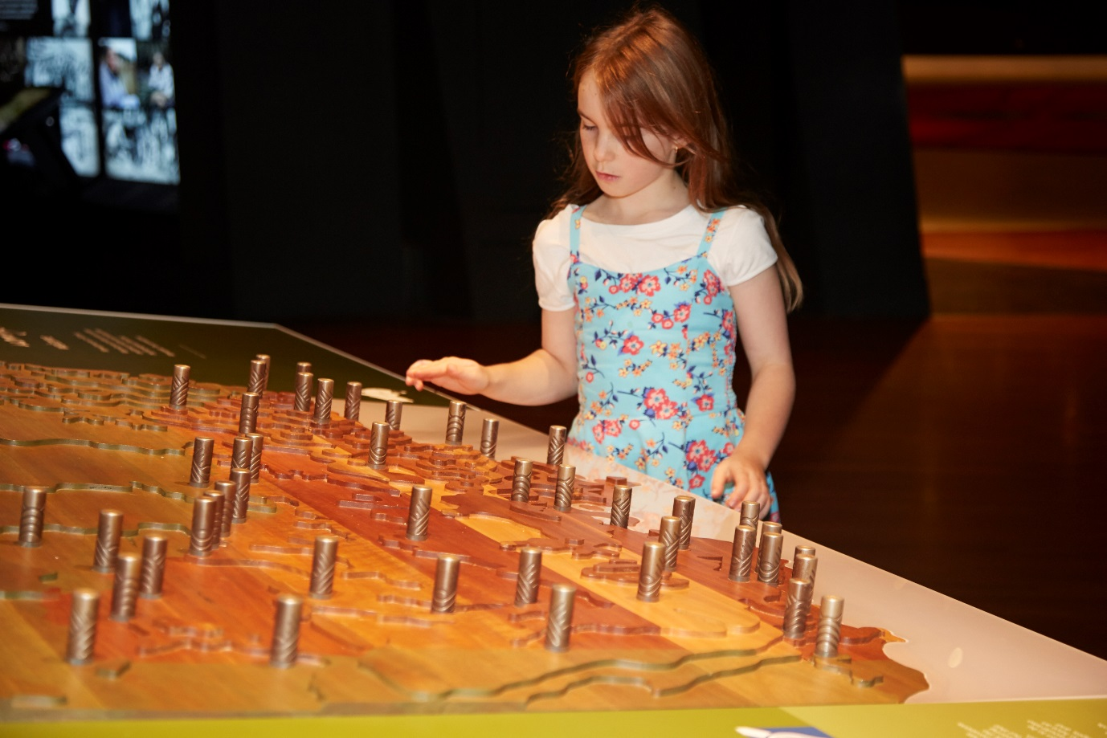
What is Melbourne Museum?
Melbourne Museum has thousands of big and small things on display. I might see dinosaurs, fossils, plants, animals, rocks and minerals, and things that people have made like canoes, computers and cars. These things, as well as images and sounds, explain our history and the natural world. I can look, listen and learn at the museum.

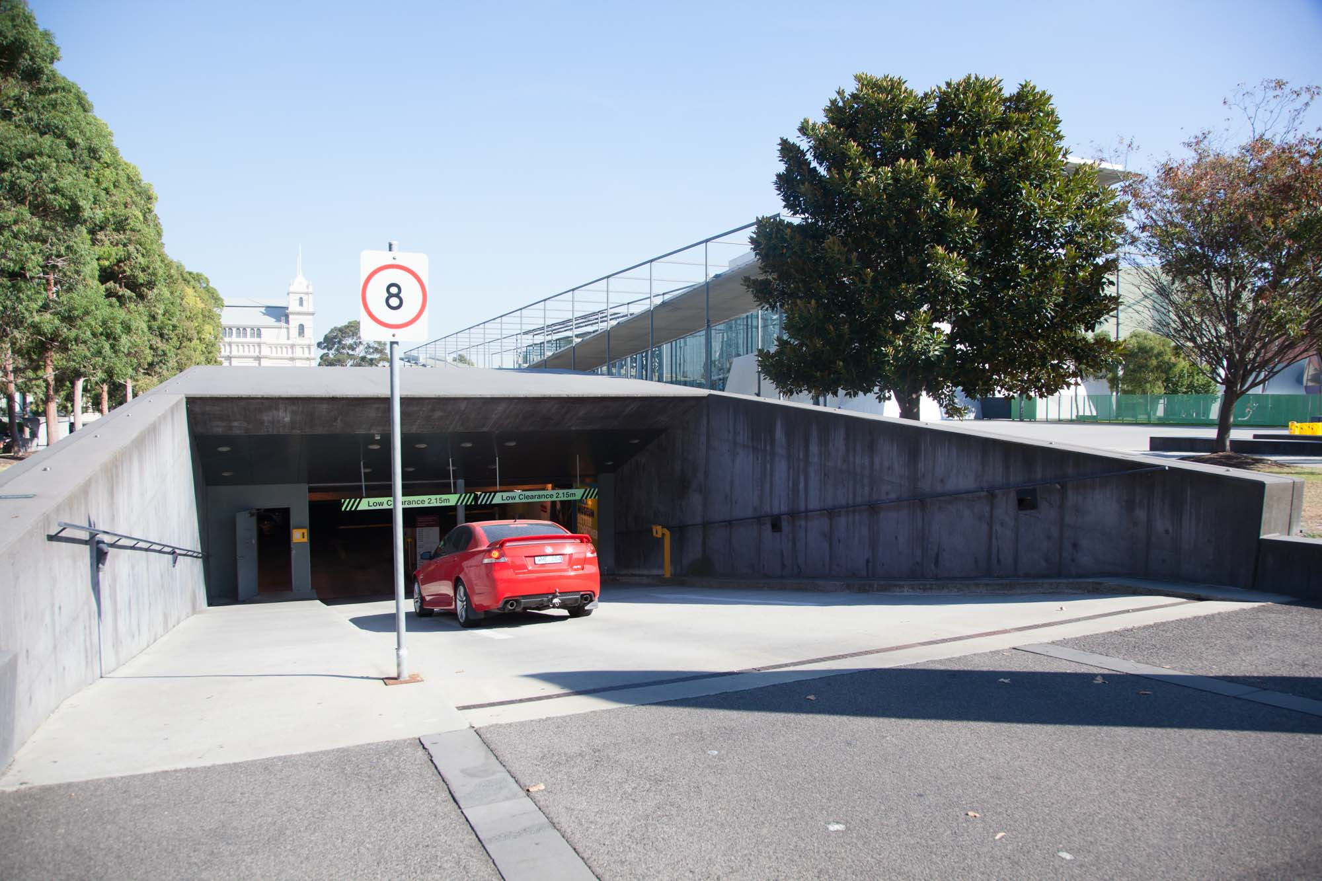
Getting to the museum
When I visit the museum I may get there by car, bus, tram or train. I will look for the big building with a front of glass which is Melbourne Museum, with another large older brick building called the Royal Exhibition Building opposite it.
If I come by car, we might park in one of the parking spots around Carlton Gardens or go into the museum car park from Nicholson or Rathdowne Streets. We will drive our car down a ramp, take a ticket from a machine, the barrier will lift and then we will drive into the museum car park. The car park is a large concrete area on two levels, and the lights will come on as we drive in. Once our car is parked, we will walk through the car park and can use a lift, stairs or a ramp to get to the entrance of the museum.
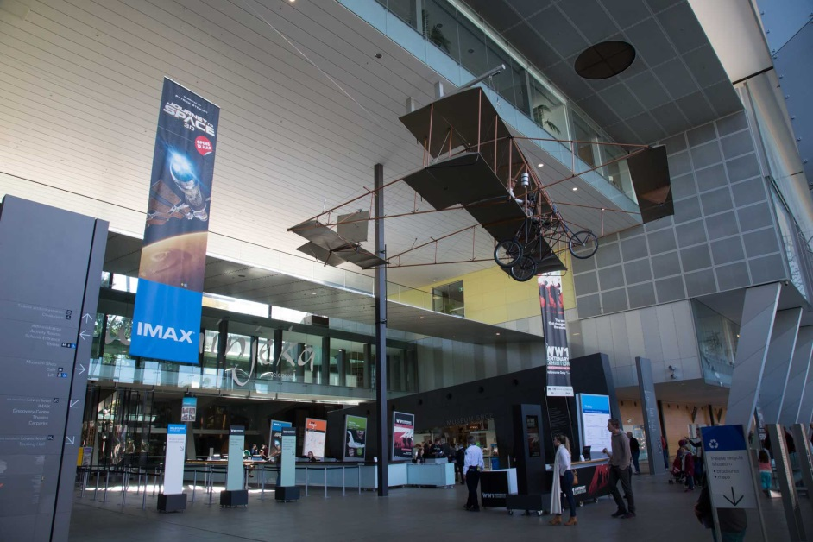
Going into the museum
I know I have arrived at the entrance to the museum when I see the big glass sliding doors and a pretend shark, seals, penguins and little fish on display in the window.
I will walk into the foyer of the museum through the sliding glass doors and I will be in a big space with a very high ceiling. There will be an aeroplane hanging from the ceiling above me which is held up by a strong cable and it will not fall on me.
If I have a bag I can leave it in the cloakroom. Museum staff will take my bag and give me a green plastic tag with a number on it in return. I will keep the tag until my visit to the museum finishes and I can get my bag back from the cloakroom.
The ticket desk is next to the cloakroom and we will buy our tickets to get into the museum. Sometimes I will have to wait patiently behind other people, but we will get our turn After we buy our tickets, I can enter the rest of the museum.
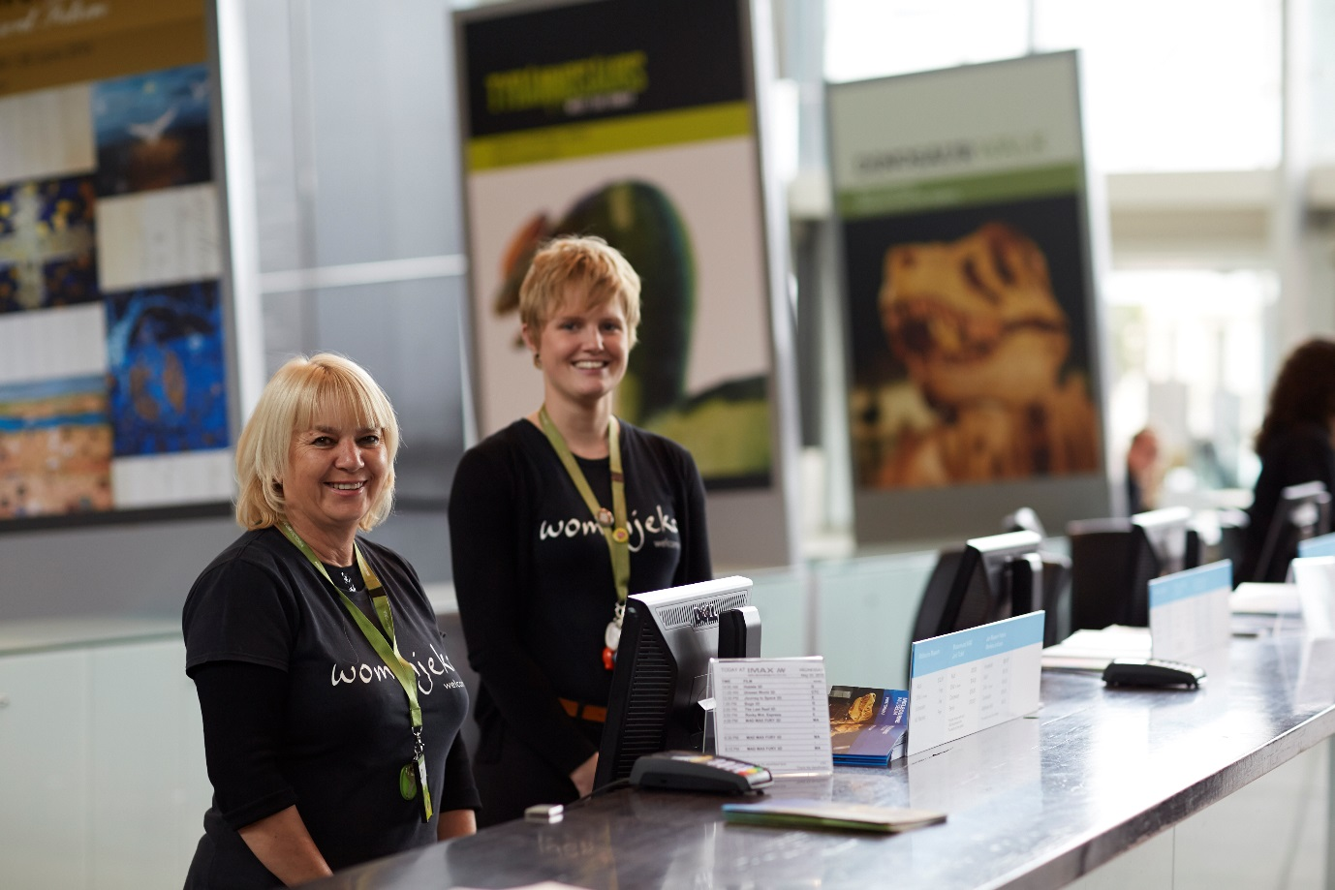
Staff at the museum
Many people visit the museum and many people work there too.
If I get lost, a Customer Service Officer can help me. They wear black t-shirts and have coloured straps around their necks.

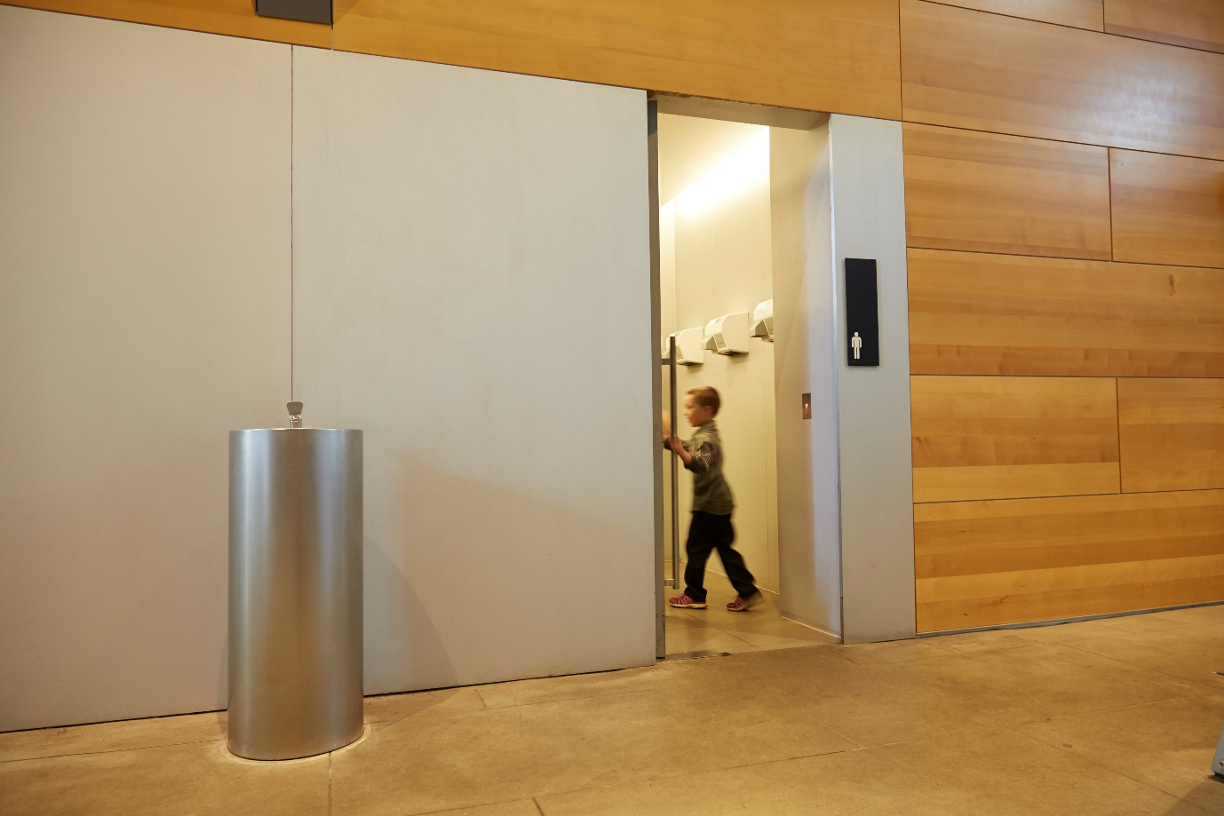
Toilets at the museum
There are lots of bathrooms in the museum. There might be other people in the bathroom too. When I am finished using the toilet, I will wash my hands.
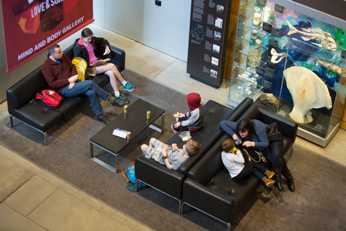
Food and eating at the museum
When I want to eat, I can go to sit on black couches, or use chairs and tables near the cafe or go outside to the playground. I do not eat in the exhibition galleries.

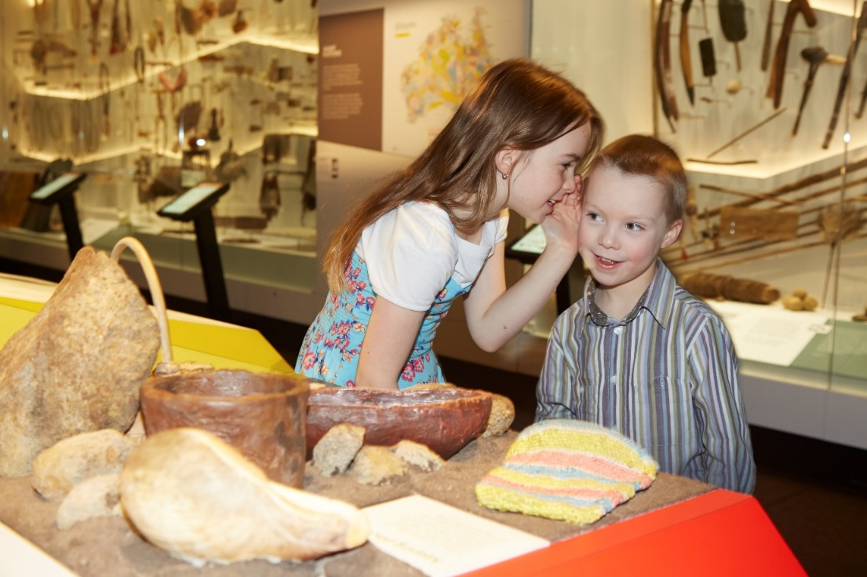
Some important things to remember at the museum
When I explore Melbourne Museum I must remember to:
- Stay close to/with my adult
- Walk and not run
- Speak with my quiet voice, even though it may be noisy
- Take turns with other children
- Wait patiently when I have to line up
- Only touch objects I am told that I am allowed to
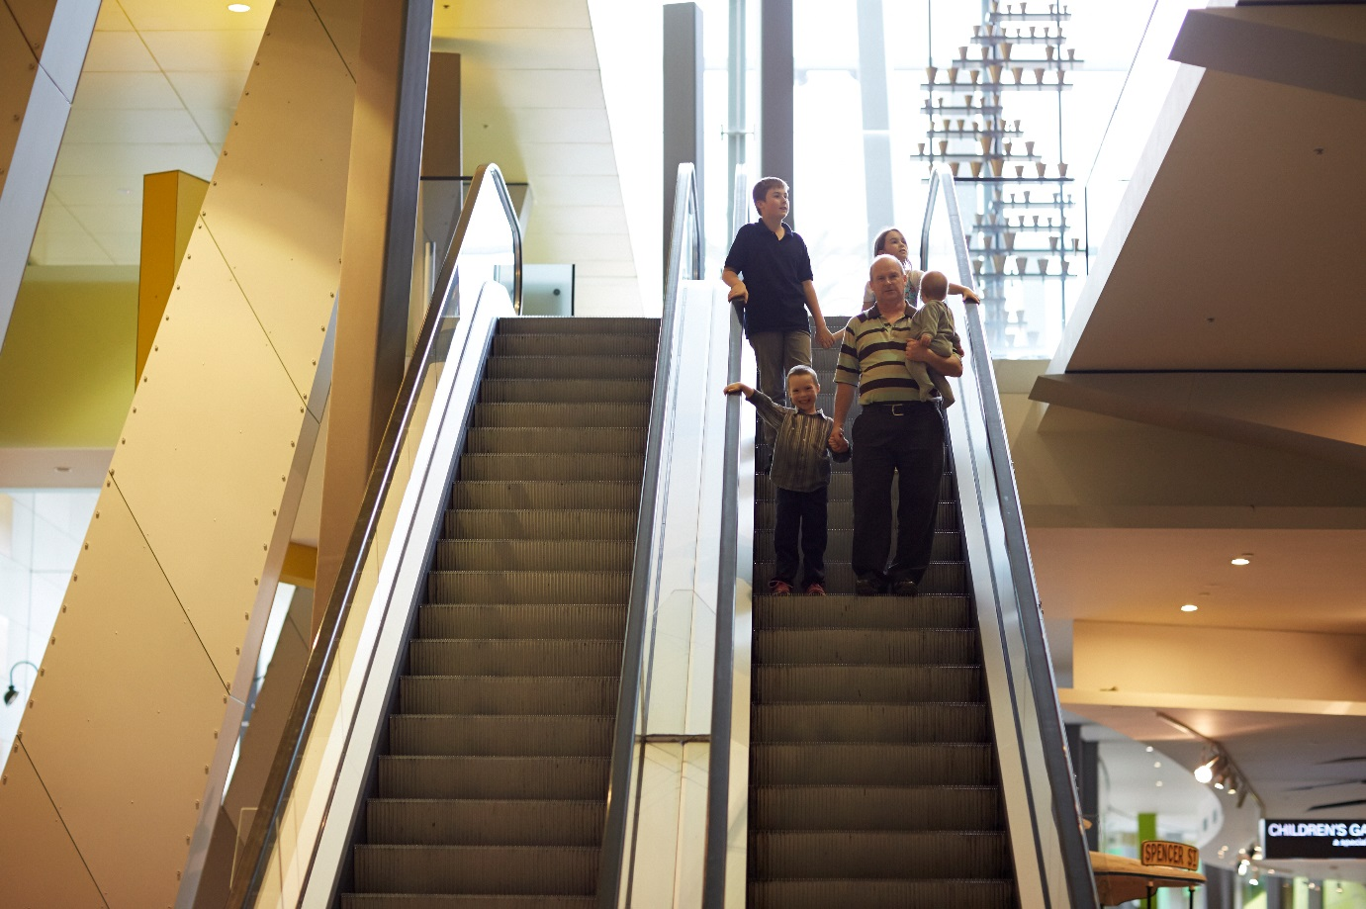
Getting around the museum
When I visit the museum I will look at many different things. Some areas of the museum I will enjoy more than others and that is okay.
There are three floors at the museum. I might use stairs, ramps, lifts or escalators as I move around. If I use escalators, I will be careful to step on, hold onto the rail and step off when I reach the top or bottom. The lifts can be hard to find; I can ask a Customer Service Officer for directions if I need. The lifts are small but will arrive quickly at the floor I want to visit.

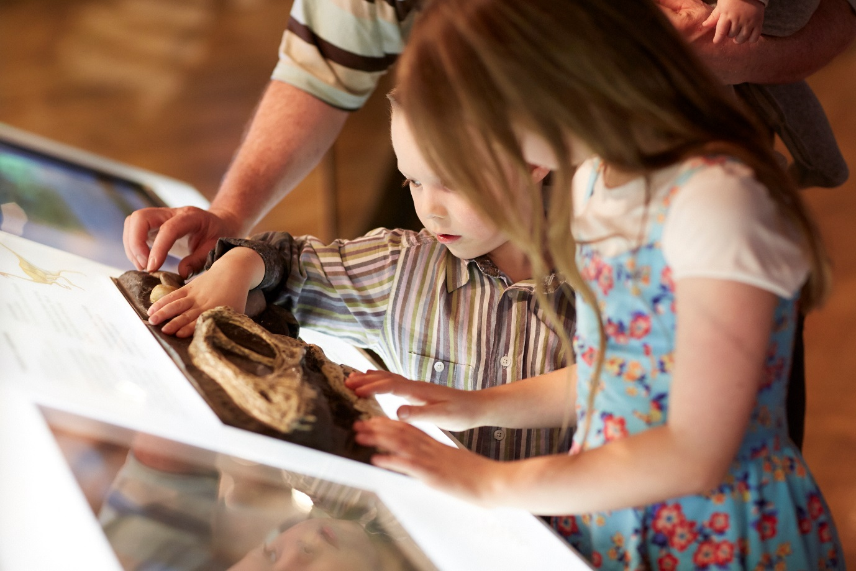
What can I touch?
At the museum there will be lots of interesting things. I am allowed to touch some of these things. There are other things that I cannot touch. I will just look at these things. I will be told which ones I can touch and which ones to just look at. If I am not sure whether I can touch something I will ask an adult.

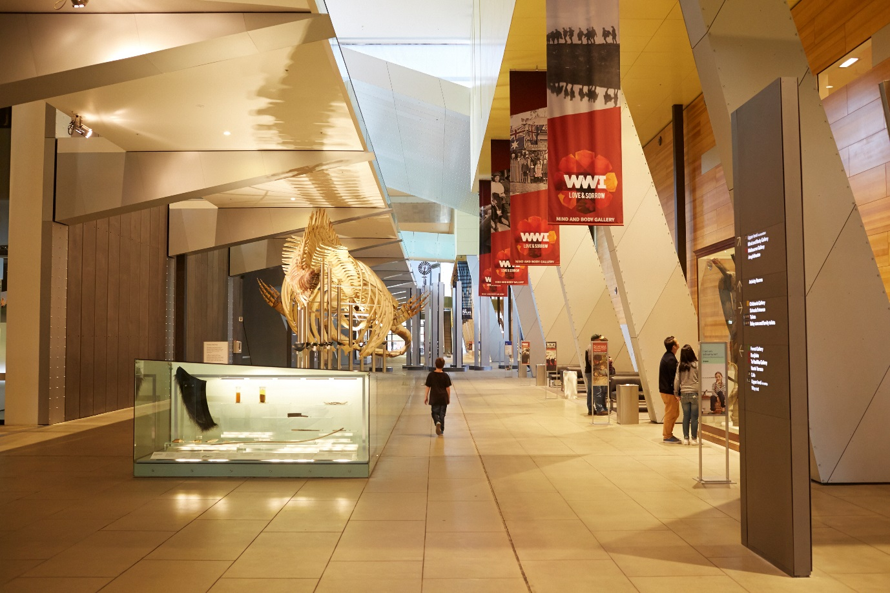
Big spaces
The museum is a special building and inside it looks and feels different to home or school. Some rooms at the museum are big. Some rooms at the museum are small. Some rooms at the museum might be dark or bright. If I don’t like being in a room and feel uncomfortable I will tell an adult.

