VCE Psychology at Melbourne Museum
  - Perception and Illusion - Unit 2 2016-2020 VCE Study Design – student trail

Information for teachers
This student-led trail covers content from Unit 2 of VCE Psychology.
Area of Study 1 – What influences a person’s perception of the world?
- Sensations and perceptions
- Distortions of perception
Area of Study 2 – How are people influenced to behave in particular ways?
- Social cognition

Students will use the Mind gallery at Melbourne Museum to complete the trail. The trail includes activities based around themes covered in the study design. These activities cover the parts of the gallery most relevant to Unit 2, but you may find other exhibits that relate to your class.
Please note, The Human Body exhibition is no longer open.
Depending on your learning intention, or duration of visit, you may like to edit the document for your class. The following suggestions are not exhaustive, but may help focus your students:
- Select certain activities to focus on limited themes and content in line with the students’ current areas of study
- Give students classroom time prior to visiting to self-select a limited number of activities, or focus on just one for deeper inquiry
- In groups, students may be allocated one activity/theme to present back to the class.

We recommend familiarising yourself with the trail prior to your class excursion. Visiting the gallery before the excursion will also assist you in directing your students.
VIT registered teachers can get into Melbourne Museum free of charge by subscribing to MV teachers:
https://museumsvictoria.com.au/learning/mv-teachers-network/

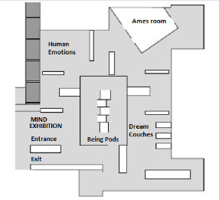
Ames Room
Work Station Site
Go to the Ames Room in the Mind Exhibition.

Enter the Ames room and walk slowly from the entry door to the exit door.
- What do you notice? List 2 unusual things going on in this room. Hint: look at the shape of the room.

Once outside the room, look at the TV screen on the outside wall; after a few moments a video of you will appear.
- Try to explain what you see and what might be causing this.

Now, ask your partner to walk through the Ames room again while you watch through the peephole (middle box) to the right of the TV screen. Repeat this, swapping roles with your partner.
- What do you notice? Discuss your observations with your partner and suggest an explanation for what you have both observed?

Repeat the previous step once more, but this time look at your partner through the small window above the peephole.
- How did this view differ from the peephole? Discuss your observations with your partner and suggest an explanation for what you have both observed.

- Draw the shape of the room as viewed through the peephole.

Enter the Ames room once again. Look at how the walls and the floor are designed.
- Do a quick sketch of the floor plan. Describe the shape of the floor.

- Describe how the back (left) wall compares to the front (right) wall in terms of shape and angle.

Breaking the Ames Room Illusion
- What is the theory behind the illusion created in this room?

The Müller-Lyer Illusion
Work Station Site
Wall on the far side of the Ames Room

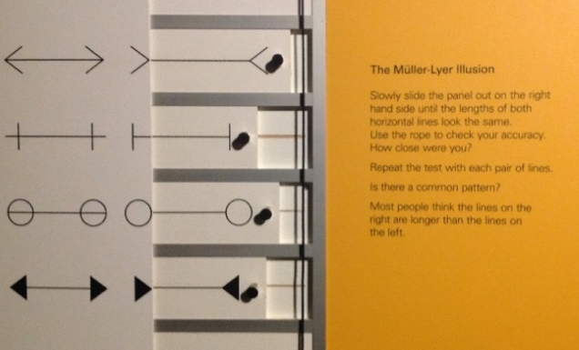

Locate the display above depicting a series of shapes connected by a horizontal line.
Look at the first set of shapes (> <). Slowly slide the handle on the right hand side, until the horizontal lines on both sides look to be the same length.
Use the rope provided to check the length of both lines.
- What do you notice? Are they in fact the same length?

This is referred to as the Müller-Lyer Illusion.
One of the explanations for how this illusion works relies on the idea that we see similar ‘patterns’ around us. For example, our experience of viewing external corners of buildings or internal walls (Carpentered World Hypothesis) or the fact the we may apply the Gestalt principle of Closure (The Perceptual Compromise theory), both may influence our perception of length.
Testing the explanation
Three more shape types (+ o ●) have been provided to test the explanation of the Müller-Lyer Illusion.
- Would you expect the changed ends to make a difference? Explain.

With a partner, test each pair of figures.
- Do your observations match your predictions? Explain your findings.

Extension
To extend this investigation, you may wish to draw your own modifications of the original illusion figures.

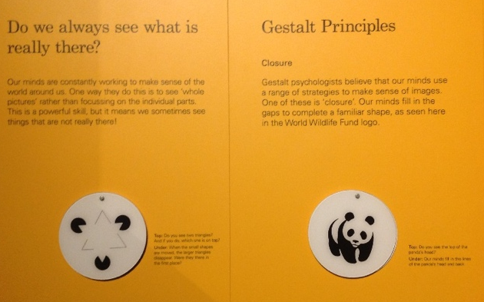
Gestalt Principles
Work Station Site
The wall on the far side of the Ames Room

Examine the illustrations provided. Find the images that illustrate the Gestalt Principles at work.
1. Sketch one image representative of each Gestalt Principal below. Write a brief explanation of how the selected sample illustrates the Gestalt Principle category at work.
Figure- ground | Closure
Similarity | Proximity
Extension
Examine the colour-blindness charts in Mind exhibition. These are on the outside wall of the Ames Room, near the plasma screen. Explain what you see and how it works. (a drawing may help you.)

Dream couches
Work Station Site
Continue through the exhibition to the Dream Couches

- Lie on the couches and experience the sensations. How do you feel?

You may have noticed your sensations change from Normal Waking Consciousness to an Altered State of Consciousness. To illustrate this, you might have had an altered sense of the passage of time and/or changes in your awareness of external stimuli.
- Describe the three processes that take part to allow visual sensation to occur:
1.
2.
3.
- Would our perception of this ‘dream’ experience be the same for everyone? Explain your response.

- Compare and contrast visual sensation and visual perception in the table below:
Visual Sensation | Visual Perception

