VCE Psychology at Melbourne Museum
  - Unit 1 2016-2020 VCE Study Design – student trail

Information for teachers
This student-led trail covers content from Unit 1 of VCE Psychology:
Area of Study 1 – How does the brain function?
- Role of the brain in mental processes and behaviour
- Brain plasticity and brain damage
Area of Study 2 – What influences psychological development?
- Atypical psychological development

Students will use The Mind exhibition at Melbourne Museum to complete the trail. The trail includes activities based around themes covered in the study design. They do not represent a comprehensive coverage of all of the material relevant to Unit 1 in the galleries, but a selection of those exhibits most relevant. The trail is organised in order of location as the students walk through the The Mind.

Please note, the Human Body exhibition is now closed, and is no longer available.

Depending on your learning intention, or duration of visit, you may like to edit the document for your class. The following suggestions are not exhaustive, but may help focus your students:
- Select certain activities to focus on limited themes and content in line with the students current areas of study
- Give students classroom time prior to visiting to self-select a limited number of activities, or focus on just one for deeper inquiry
- In groups, students may be allocated one activity/theme to present back to the class.

We recommend familiarising yourself with the trail prior to your class excursion. Visiting the galleries before the excursion will also assist you in directing your students.

VIT registered teachers can get into Melbourne Museum free of charge by subscribing to MV teachers:
https://museumsvictoria.com.au/learning/mv-teachers-network/

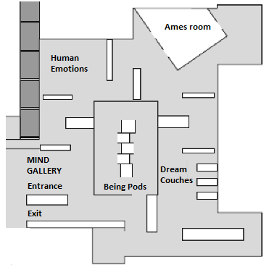
Psychology Timeline
Work Station Site
Timeline table at the entrance to the Mind gallery.

Choose one key event from each time period on the timeline below.
Why did you choose it? Why is it important?

2000

1950

1900

1800

1300

5000BCE

The Brain and Nervous System
Work Station Site
Entrance to the Mind gallery

- Observe the wall of twinkling lights at the entrance of the gallery.
What do you think the lights represent?

- How accurately does this represent our nervous system as we know it today?
Record your thoughts in the table below:

Similarities | Differences

Enter the gallery to view information panels and interactives regarding brain and nerve cell function
- Label the following parts on the diagram below:
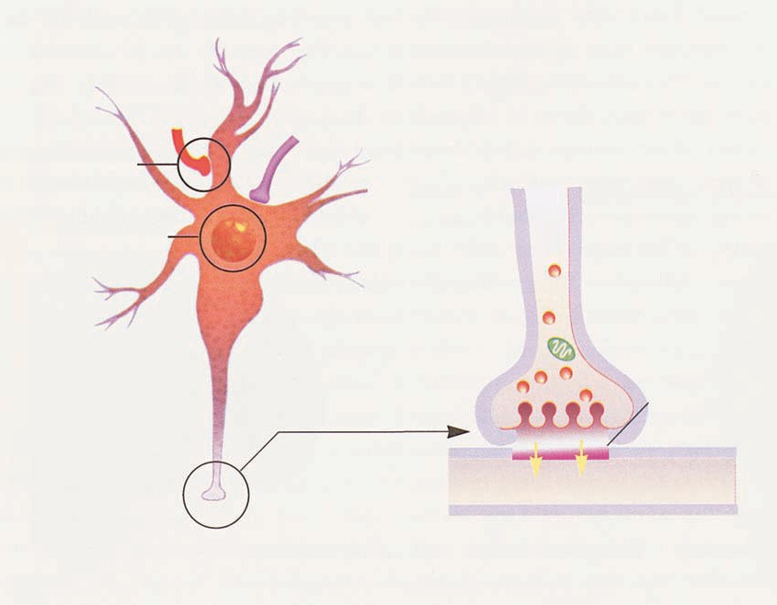
- Dendrite
- Cell body
- Synapse
- Synaptic gap
- Axon

- Look at the New Scientist interactive located on the wall. Locate the regions of the brain responsible for the following activities and mark them in on the diagrams by shading the appropriate areas.
Vision | 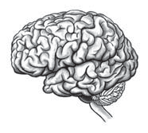 | Sound
Speech and language |  | Touch
Decisions |  | Social interactions

Watch the video animation:

After six months the foetal brain contains _______________nerve cells or neurons.

- What does it mean when they say that neurons migrate to locations in the brain?

- How are neural connections strengthened and what causes connections to die off?

…………………………………………………………………………………………………………

Write a key feature of brain development in each of the following stages of life:

Stage of development | Brain development
Childhood

By the age of two

Adolescence

Adulthood

Old age

Is it true that we only use about 10% of our brain? Explain.

- What is plasticity of the brain?

Normal and Abnormal Behaviour
Work Station Site – Various locations
Look at the information about treating abnormal behaviour in The Mind Exhibition, by visiting the locations indicated on the map

- If behaviour is defined as an observable action made by a person, how would you define abnormal behaviour?

2. Some abnormal behaviour can be treated. List and explain how three treatments are administered.

Treatment | Method of giving the treatment

3. How has an understanding of the brain influenced the treatment of mental disorders?

Human Emotions
Work Station Site
Enter the area behind the Human Emotions wall and watch the video clips.

Complete the table below for the video clips shown on the ‘Human Emotions’ screen.

Video Segment | What emotion did you  Experience? | What cues were used to evoke emotion? | List other ‘cues’ from your  day to day life that would evoke the same emotions
Laughter
Scream
Dogs
Vomit/maggots
Bullying
Crying people

Drugs and the Brain
Work Station Site
The wall to the right of the Human Emotions video wall.

- These men in this photo are using two drugs – what are they?

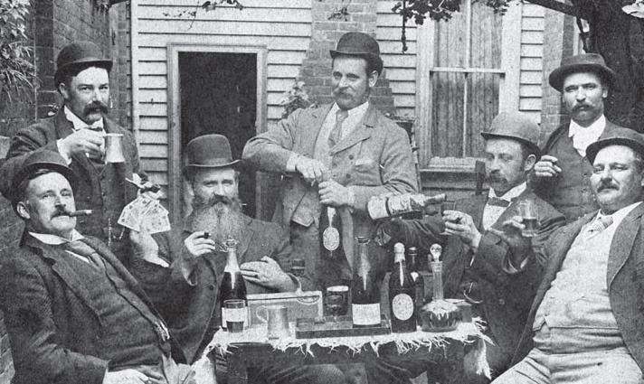

Next to the men relaxing in the backyard in Bendigo, you will find a television screen. Watch the video clip on the television screen.
- Describe how addictive substances work:

- Which neurotransmitter is involved?

Understanding the brain
Work Station Site
Locate the brain and skull specimens on the “Differences” wall, and continue around the corner to the EEG.

- What has happened to the brain in the following conditions
(Please note: specimens are currently off display, but the content to answer the questions is still in the gallery):
Haemorrhage after an aneurysm:

Senile atrophy:

Neurosyphilis:

- Alzheimer’s disease is the result of a genetic condition that causes:

- How are the neurons in the brain of an Alzheimer’s sufferer affected?
- The effects of Alzheimer’s disease include:
Suggest three ways you could stimulate the brain to build reserves of brain cells and improve brain cell connections:
1.
2.
3.

Anaesthesia is a state in which consciousness is reduced to decrease the sensation of pain. Anaesthetics exert their effect on the nervous system.
- How do anaesthetics work?

- What other sorts of medicines effect the central nervous system?

- How long have anaesthetics been available?

- Imagine what it would have been like to have an operation without anaesthetics. Why would you willingly allow a doctor to operate on you without anaesthetic?

Mental Health Case studies
Work Station Location
Enter a booth in the Being: Identity and Interaction section and listen to one of the personal stories.

Select and name one condition to focus on for your investigation

- Condition: ___________________________

- Explain how the condition affects the human body or how it manifests itself.

- How do the symptoms affect the day-to-day lives of people who have this condition?

- What do these accounts say about the stigma associated with unusual mental conditions?

- In each case, talking to somebody else was important. Why was this the case in the story that you listened to?

