# Classroom activities

## Activity 1: Dinosaur graffiti wall

Objective

The objective of this activity is to assess students’ prior knowledge of the topic of dinosaurs, and to use this information to build and reflect on their knowledge.

What you need

* Textas
* paper
* pins or Blutak

What to do

1. Brainstorm with the students what they already know about dinosaurs. You can do this in a class discussion, with you writing their comments on pieces of paper and sticking them to a board. If the students are able to write their own sentences, have the students write what they know on pieces of paper.
2. These pieces of paper form part of a ‘graffiti wall’. During the unit, students add extra pieces of information about dinosaurs.
3. 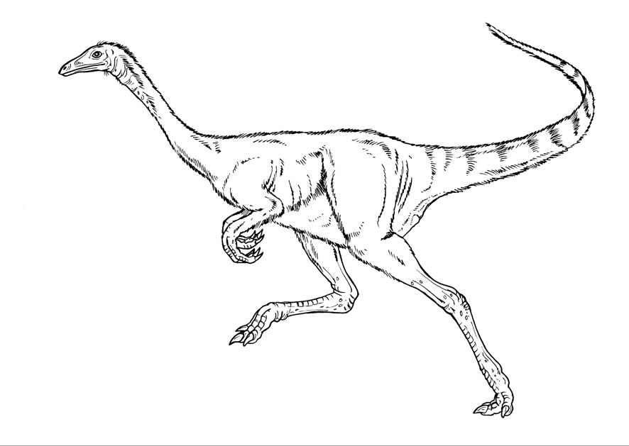The students think of questions, or things they would like to know about dinosaurs. These questions are added to the graffiti wall. When the questions are answered during the unit, they are replaced with the information that the students have discovered.

Artist: Andrew Plant. Source: Museum Victoria.

## Activity 2: Dinosaur poems

**Objective**

In this activity students are encouraged to share their knowledge and thoughts about dinosaurs by completing a poem.

A name poem or acrostic poem uses a name or word to begin each line.

**What to do**

1. Photocopy this worksheet for each student, or they can write in their workbook.
2. Students write a word or short statement that begins with the letters in the word ‘dinosaur’ to describe something about dinosaurs.
3. Students’ poems can then be displayed around the classroom.

D ………………………………..

i……………………………………

n……………………………………

o……………………………………

s……………………………………

a……………………………………

u……………………………………

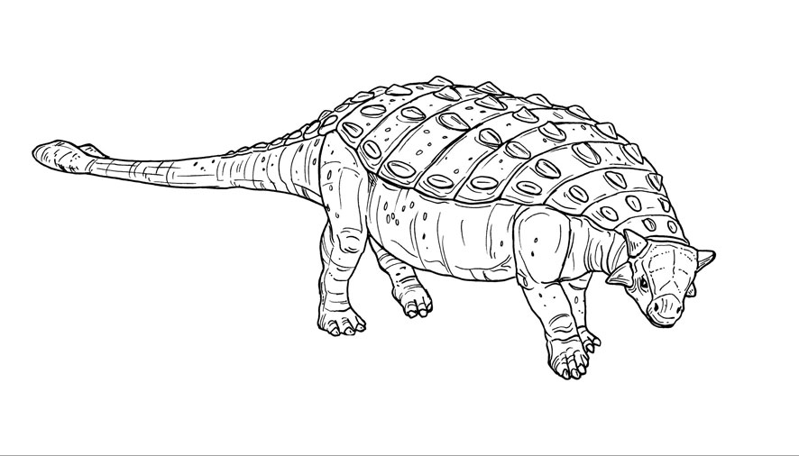 r……………………………………

Artist: Andrew Plant. Source: Museum Victoria.

## Activity 3: Pterosaur life

**Objective**

In this activity students are encouraged to use their knowledge and thoughts about pterosaurs to write a short story about the life of these flying reptiles.

**What to do**

1. Photocopy a picture of one of the pterosaurs from the *[Dinosaur Walk](https://museumsvictoria.com.au/website/melbournemuseum/discoverycentre/dinosaur-walk/meet-the-skeletons/index-2.html)* [website](https://museumsvictoria.com.au/website/melbournemuseum/discoverycentre/dinosaur-walk/meet-the-skeletons/index-2.html)
2. Encourage students to read about their animal to find out more. They can begin with the information on the *Dinosaur Walk* web site.
3. Write appropriate vocabulary on the board, e.g. pterosaur, glide, fly, wings, teeth, claws.

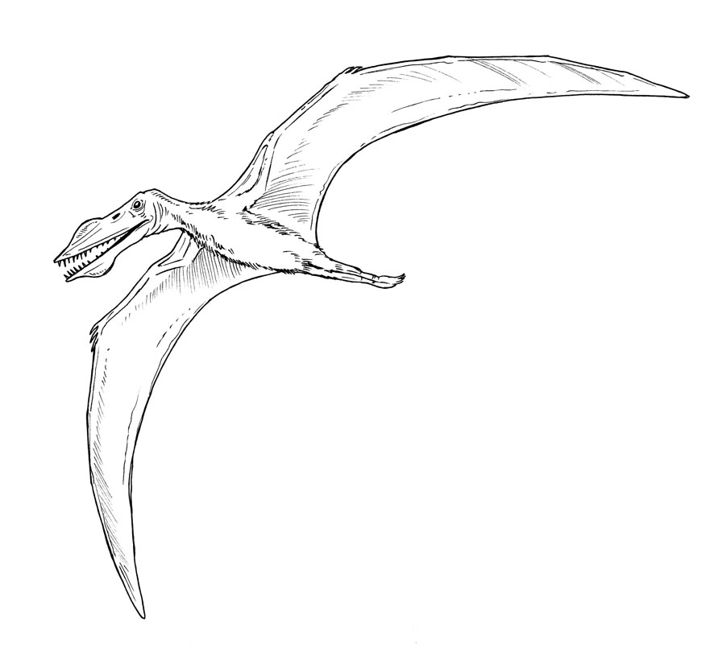

Artist: Andrew Plant. Source: Museum Victoria.

## Activity 4: Making a feathered dinosaur

**Objective**

This activity encourages students to think about the lives of dinosaurs and to visually represent their knowledge and thoughts in a model.

**What you need**

* play-dough, plasticine or clay
* feathers
* pictures of dinosaurs
* digital camera

**What to do**

1. The way that palaeontologists think about dinosaurs has changed. They have now found many dinosaurs covered in feathers! To find out more, visit the [*Dinosaur Walk* website](https://museumsvictoria.com.au/website/melbournemuseum/discoverycentre/dinosaur-walk/meet-the-skeletons/index-2.html) to watch a clip about feathered dinosaurs
2. Students look at the pictures of dinosaurs and chose a favourite feathered dinosaur.
3. 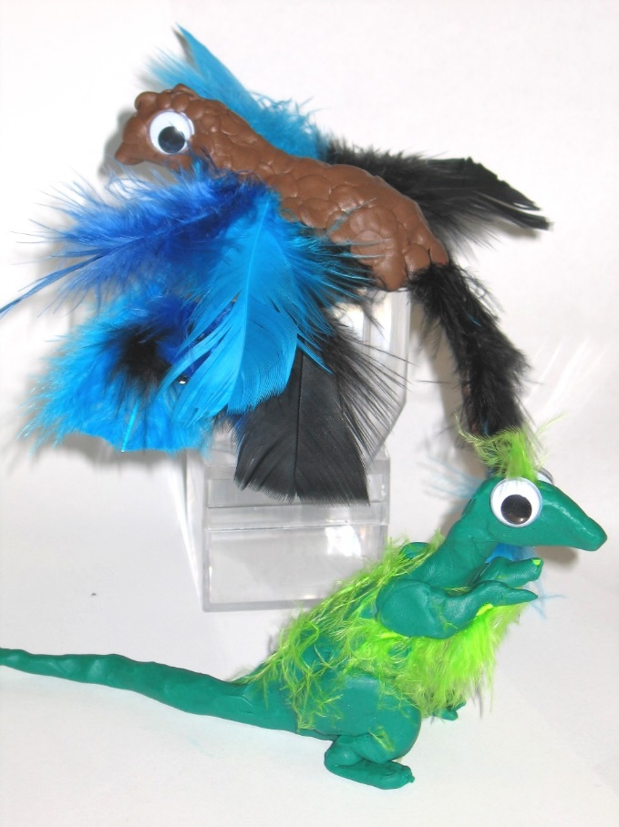Discuss the colours of dinosaurs with the students. Do we really know what colours they were?
4. Each student makes a feathered dinosaur.

When the students have finished their models of feathered dinosaurs, they could:

* give a one-minute talk to the class about their model. They should explain how they chose the colours, what kind of dinosaur it is, and any other information they have obtained;
* take a photo of their dinosaur model, and send the photo as an email to a friend;
* write a story about a day in the life of their dinosaur.

## Activity 5: Dinosaur story book

**Objective**

This activity encourages students to research and discuss how dinosaurs reproduced, and to write short sequenced texts.

**What you need**

* Photocopied image set for each student (see next page)
* Scissors
* Glue
* Coloured pencils

**What to do**

1. Give each student a set of the images, and have them cut out the images and sort them into the order they think they belong.
2. Ask students to talk together about the order of the images. You might like to photocopy an enlarged version and discuss their order as a class.
3. Have the students justify why they put the images in the order they have.
4. When the students are happy with the order, have them write some simple sentences to describe what they see in each picture.
5. Students may like to colour in the pictures when they have finished their story.

**Background information**

The sequence of images is based on a famous fossil site in Patagonia called Auca Mahuevo. The 80 million year old deposits preserve the remains of a titanosaur nesting ground.

For generations, herds of titanosaurian sauropods would visit the site and lay from 15 to 40 eggs in a shallow nest scraped into the ground. The eggs were nearly spherical in shape and about 14 cm in diameter. Fossil embryos of tiny babies have been found within the eggs, some with their scaly skin preserved. Even though the baby dinosaurs were much smaller than the adults, scientists believe that there was little or no parental care among this kind of dinosaur.

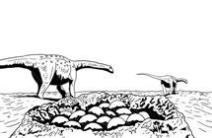

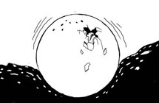

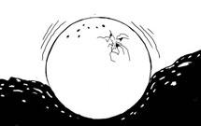

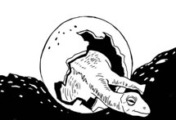

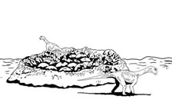

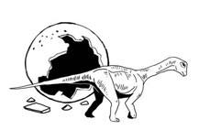

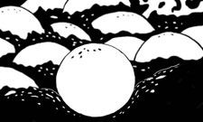

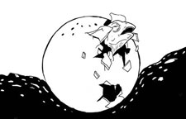

Artist: Brain Choo. Source: Museum Victoria.

## Activity 6: Favourite dinosaur

**Objective**

Students survey each class member’s favourite dinosaur, summarise the information on a bar-graph and count the votes in each category to identify the class favourite.

**What you need**

* Bar graph, as below. Different dinosaurs can be used if you wish.   
  Names may be replaced by illustrations of the dinosaurs.
* A small piece of self-adhesive paper to place on the graph, one per child, with the child's name written on it (you could use small post-it notes).

**What to do**

1. Each student places his/her piece of paper on the bar-graph chart to register a vote.
2. Count the votes for each type of dinosaur.
3. Students count the total number of votes to ensure that everyone voted and that no one voted more than once.
4. The students identify the class’s favourite dinosaur and the one least liked.

## Illustrative GraphActivity 7: How big or small were dinosaurs?

**Objective**

This activity enables students to explore the lengths of different sized dinosaurs by comparing them with their own heights and familiar objects in their environment.

**What you need**

* a ball of string
* scissors
* hole punch
* 1 meter long ruler or tape measure.

**What to do**

1. Use the string and tape measure to make a length of string the same length as each dinosaur.
2. Cut out a dinosaur tag (see next page), and attach it to the length of string.   
   You might like to make one ‘dino-meter’ per pair of students.
3. This ‘dino-meter’ can now be used to compare the length of a *Tarbosaurus*   
   (for example) to other things in the school. For example, you could use the length of string to compare how many ‘Catherines’ fit into the length of a *Tarbosaurus*, or how long a *Tarbosaurus* is compared to the classroom.
4. Have the students list a number of things they would like to compare to the length of the *Tarbosaurus*. Ask them to guess first, and then measure and record their results in their Maths books.

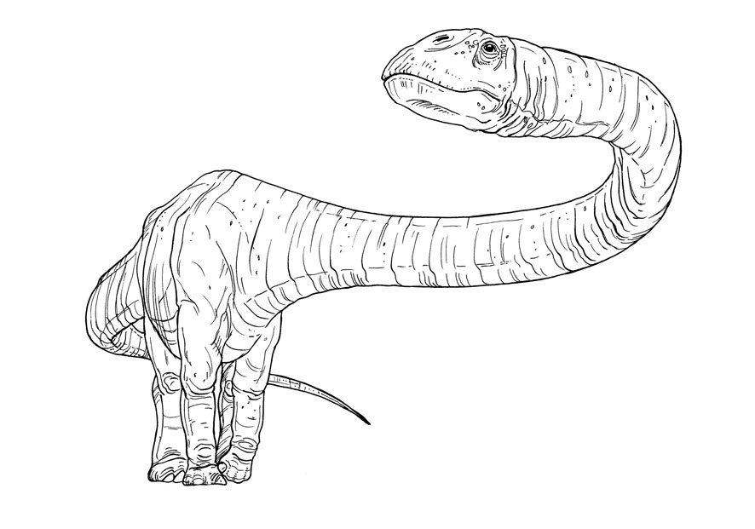For more information about dinosaurs, go to the [*Dinosaur Walk* website](https://museumsvictoria.com.au/website/melbournemuseum/discoverycentre/dinosaur-walk/meet-the-skeletons/index-2.html)

Artist: Andrew Plant. Source: Museum Victoria.

*Talarurus*

5 metres long

*Tarbosaurus*

8 metres long

*Amargasaurus* 12 metres long

These dinosaurs are on display in *Dinosaur Walk* at Melbourne Museum.

Artist: Andrew Plant. Source: Museum Victoria.

*Mamenchisaurus*

25 metres long

*Protoceratops* 2 metres long

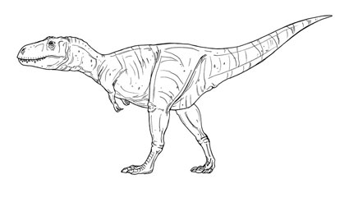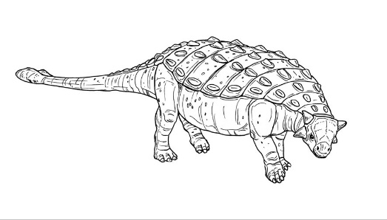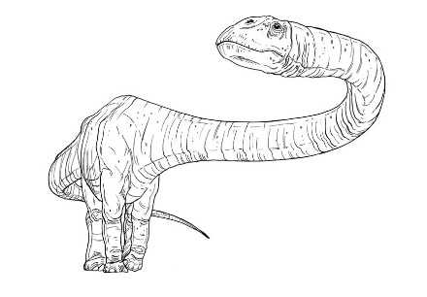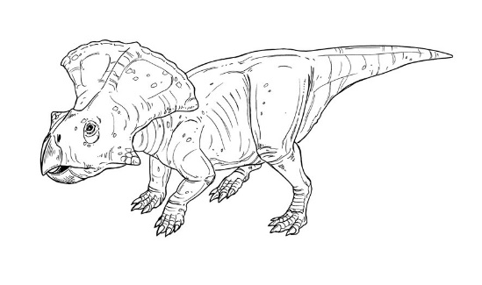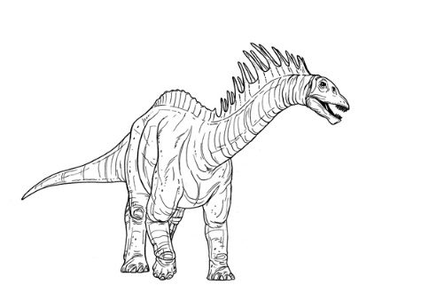

## Activity 8: Who lays eggs?

**Objective**

This activity encourages students to think about which animals lay eggs to reproduce.

**What you need**

1. Scissors
2. Glue
3. Photocopies of animals (below) and work sheet (next page)

**What to do**

1. Cut out the animal pictures – one set for each student or group of students.
2. The students sort the animals into two groups – one group that lays eggs and the other group that does not. Children can work in teams and discuss their thoughts. Discuss with the class what they think.
3. When students have finished sorting, they glue their animals in the correct box (see next page).

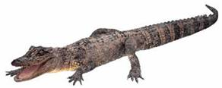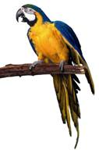

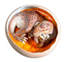

Birds Alligators Dinosaurs

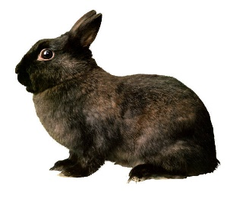 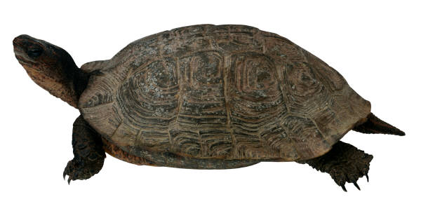 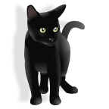

Rabbits Turtles Cats

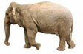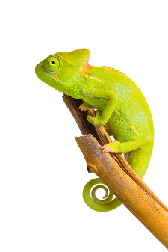 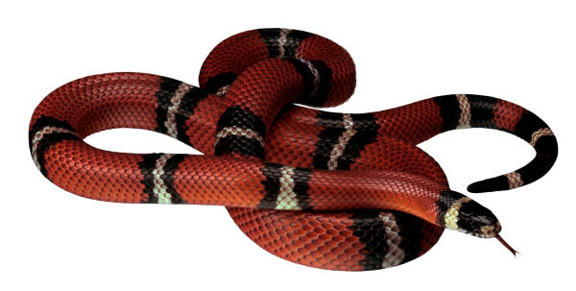

Lizards Snakes Elephants

## Activity 8: Who lays eggs?

Name: ………………………………………………………………….

Glue the animals where you think they belong.

These animals lay eggs.

These animals **do not** lay eggs.

## Activity 9: Who am I?

Objective

In this activity, students observe images of dinosaurs, and based on their observations, draw conclusions about dinosaur lifestyles.

**What you need**

* Photocopies of the images on the next two pages   
  (to be photocopied as large as possible),
* Blutak

**What to do**

1. Place the images of the dinosaurs around the classroom, attached to the walls with Blutak. Place the images in the corners of the room if possible.
2. Allow the students to walk around the room and have a good look at each of the images.
3. After the students have had a good look, bring all the children back to the centre of the room.
4. Explain to the students that you will be reading out a characteristic of certain dinosaurs, and that they are to stand next to the picture that they think matches the description. Explain that there might be more than one correct answer.
5. Do one test trial with the students to check that they understand.   
   Start with: *I am a dinosaur with a long neck.*
6. Now, read out the following characteristics:
   * I walked on 2 legs.
   * I walked on 4 legs.
   * I ate meat.
   * I ate plants.
   * I had sharp claws.
   * I had sharp teeth.
   * I had armour on my back and a club tail.
   * I could reach up high.
   * I was a very fast runner.
   * I had the longest neck of any dinosaur.
   * I am a little dinosaur – only 2 metres long.
   * I am a close relative of *T. rex*.



*Mamenchisaurus*

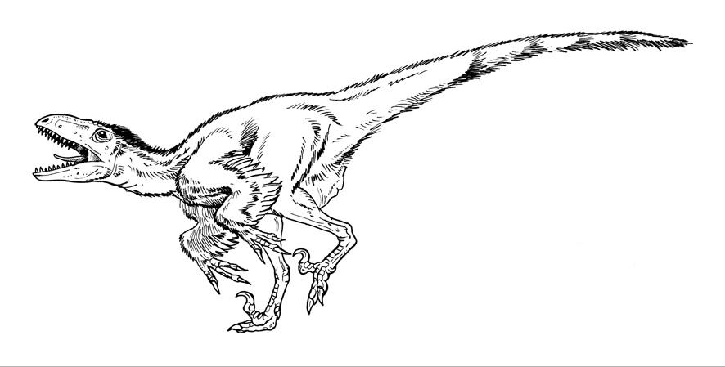

*Deinonychus*

Artist: Andrew Plant. Source: Museum Victoria.



*Tarbosaurus*



*Talarurus*

Artist: Andrew Plant. Source: Museum Victoria.