RESTING PLACES: A History of Australian Indigenous Ancestral Remains at Museum Victoria

Rob McWilliams

Introduction
On Friday 22 November 1985, representatives of Victorian Indigenous communities collected the human skeletal ‘ancestral’ remains of 38 individuals from Museum Victoria. A procession through the heart of Melbourne, along Swanston Street and St Kilda Road, took them to their prepared reburial place in the King’s Domain. This event marked the first of many repatriations of ancestral remains to Indigenous communities in Victoria, to each of the other Australian states, and to New Zealand.
The event also marked a commitment from Museum Victoria to repatriate all of its collection of ancestral remains to the communities of origin. The museum increasingly assumed statutory responsibility as the custodian of remains for the Victorian government and Indigenous communities, with additional remains coming from many sources, including The University of Melbourne, Freemason’s lodges, the Victorian Archaeological Survey, Aboriginal Victoria, the Victorian State Coroner’s Office, Victoria Police and members of the public.
From 1985 to 2016 Museum Victoria has facilitated the repatriation 2,269 sets of remains to traditional owners for reburial. But the challenge is far from over. The museum continues to have custodianship of 1,507 sets of remains that are awaiting claims for repatriation from the appropriate traditional owners. About half of these sets of remains can only be provenanced to ‘Australia’ or a broad region, and not to an identifiable cultural group, consequently they are awaiting a nationally agreed solution to the appropriate resting place for these ancestors.
In August 2016, under the Victorian Aboriginal Heritage Act (2016), responsibility for the repatriation of ancestral remains passed from Museum Victoria to the Victorian Aboriginal Heritage Council, although the museum will continue to play a role as a place of safe-keeping for those remains, and will continue to work closely with the Council to facilitate repatriation to traditional owners. It seemed an appropriate moment to prepare this brief history of how the museum came to hold such extensive sets of ancestral remains, and how over the past three decades it has worked closely with Indigenous communities to return their ancestors to country.

The Earliest Collections
In August 1902, Walter Baldwin Spencer, Director of the National Museum of Victoria - in the company of Richard Walcott (Curator of Ethnology, Industrial & Technological Museum) and Charles French (Government Entomologist, and co-member of the Field Naturalists Club of Victoria) – visited Koondrook on the Murray River.
In his 1985 publication, So Much That Is New, John Mulvaney noted - “They dug trenches across ten large ashy earthen mounds, which [Spencer] termed middens, finding a few stone tools and fourteen human burials.”
In the same year 1902, Spencer wrote to the Chief Commissioner of the Victorian Police, Thomas O’Callaghan.
It is greatly desired to augment the already valuable collections of the Ethnographic Museum here with aboriginal remains; native weapons and implements; and it is thought that a circular letter addressed to the officers in charge of police districts throughout the colony, with your permission, might greatly help.
Aboriginal skeletons, skulls, and other parts, and all kinds of weapons and implements are wanted.
The letter would, it is suggested, have greater weight if sent through you.
The favour of your valuable assistance in this matter would be highly esteemed.
In reply the Commissioner informed Spencer that ‘a copy of your letter has been circulated amongst the Officers in charge of the various Police districts as desired’. The museum had actively begun to build a collection of Australian Indigenous human skeletal remains.
Before 1900, the museum appears to have had 25 registrations of human skeletal remains only, many of which were non-Australian. The museum’s official registers indicate that in the years following 1902, Aboriginal remains were regularly transferred by the Police to the museum, and correspondence records reveal details of the circumstances leading to their removal from their original resting places.
Sometimes the remains, and the documentation, were extensive; sometimes they were both extremely fragmentary. Although an analytical study of the correspondence has not yet been completed, preliminary examination of a sample of 110 Police transfers (of a total of 236 from 1905 to 1978) indicates the sorts of circumstances that led to their collection and transfer to the museum. Although it is difficult to ‘classify’ (and therefore count with absolute accuracy), of 110 transfers sampled from the period 1905 to 1976, the circumstances of the finding of the remains include –
- found in shallow graves (4)
- found on landscape (27)
- found in tree hollows (3)
- found following wind and/or water erosion (17)
- whilst rabitting (12)
- whilst digging holes , trenches etc. (19)
- whilst ploughing (7)
- whilst excavating sand, gravel, shell-grit etc. (21)
It should be noted that these finds were reported to the police and so they will be biased towards ‘innocent finds’ rather than deliberate excavations of areas believed to have previously been occupied by Aborigines.
By 1922, two decades after Spencer’s request to the Police Commissioner, the museum held 369 registrations. Whilst many of these were opportunistic discoveries transferred to the museum by the police, the museum was also extremely active in purchasing crania – for example, from A. Coles (70), A.S. Kenyon (61), H. Quiney (27), C. Richards (10), L.B. Kurtze (2).
The obvious question is: Why was the museum building such a collection?

19th Century Collections of Human Remains
In terms of the history of collecting human skeletal remains during the nineteenth century, the museum was virtually dormant compared to museums and universities, both overseas and in Australia. A number of historians of the museum have argued that this was primarily due to the anti-Darwinian views of Frederick McCoy, the museum director from 1858 to 1899. McCoy’s creationist view of human origins saw humans as separate from ‘nature’, and therefore not to be sought out for addition to the museum collections for a natural history museum. In addition, from 1856 to 1899 the museum was physically situated at the University, where Professor Halford was building a collection in the medical department, and there may have been a tacit agreement not to build two competing collections.
Although there had already been a many centuries’ long history of collecting of human skeletal remains, in the 19th Century medical schools at universities in Europe developed an increasing interest in ‘comparative anatomy’. For the purposes of this paper, I am cutting a long story short, so I note that whilst there were many streams of study, three broad approaches need to be briefly identified.
Firstly, there was dissection of human bodies as anatomists sought to understand the internal workings of the human body – and in particular the differences between males and females. After a number of notorious incidents in the 1820s - including the activities of Burke and Hare who murdered innocent citizens in Edinburgh (Scotland) to sell as bodies to a medical school for dissection - English laws allowed that only executed criminals, and bodies unclaimed from morgues, were available for dissection.
A second stream of study focused on identifying the physical features of different cultural and racial groupings from different local, national and international regions. In Europe, anatomists began measuring the crania of living people – English, Irish, Scottish, Welsh, French, German and so on, including migrants (in Europe) from other ethnic backgrounds. An American sociologist, William Ripley, claimed that by 1899, over one and half million adults and ten million children had been measured in Europe and the United States in order to identify their racial group. In its most simple form, anatomists and physical anthropologists were asking the question: What was similar about each group, and what was dissimilar? This question was fueled by debates about diversity in nature, and theories of evolution … and by the discovery of ‘archaic’ [Neanderthal] remains at Neander Valley, Germany, in 1856. These and other discoveries had led to the recognition that Europeans had a ‘deep past’ – with a Stone Age – a past much older than those proposed by Bishop Usher who had calculated from the Bible that Adam and Eve were created in 2002 B.C. Scientists sought to identify what that past may have been like; they looked to ‘contemporary’ stone using groups; they looked to Australia. But as Turnbull has pointed out “the history of scientific trafficking in the bodily remains of Indigenous Pacific peoples predates the Darwinian era by almost a century”.
A third form of study, ‘phrenology’, was based on the work of an Austrian surgeon, Franz-Joseph Gall (1758-1828). Phrenology sought to answer the question: Did minor variations in the characteristics of a person’s skull reveal their intelligence, their work ethic, their ability to learn, their ability to make moral decisions, and even, their likelihood of committing crimes? Studies began in the English gaols, and inevitably spread to the gaols in New South Wales and Van Dieman’s Land. The primary targets for the phrenologists were criminals who had been sentenced to death. Consequently, phrenologists were sometimes permitted to make masks of the criminals sentenced for execution, and then to collect the crania afterwards. This occurred in Europe and in Australia in the 19th century. (Recent separate studies by Jill Dimond, and by Alexandra Roginski, have revealed that at least one phrenologist, A.S. Hamilton, did not always feel compelled to seek permission, and was involved in grave-robbing.)
Whilst having periods of popularity, phrenology was seen by many as being on the fringe – if not pure quackery - and it was the second stream of study that most occupied comparative anatomists. The nineteenth century was also a period of vigorous colonial expansion by the European powers, bringing them in contact with other Indigenous populations. At this international level, questions arose as to whether there was a relationship between cranial features and culture, inevitably leading to studies of Indigenous people and the collection of their skeletal remains, and (again) inevitably leading to Australia.

The University of Melbourne & the Berry Collection
Several individuals in the anatomy and medical schools at the University of Melbourne were actively involved in the collecting of human remains. These included Professors George Halford (1862-1882), Harry Brookes Allen (1882 -1905), Richard Berry (1905-1929), F. Wood Jones (1930-1937), and amateur collectors such as George Murray Black.
After his arrival in Melbourne in 1905, Professor of Anatomy Richard Berry actively sought to build the University’s collection of crania, including remains from Tasmania as he sought to identify broad similarities and dissimilarities between Tasmanians and Australians. His measurements and illustrations were published in 1910 (focusing on Tasmania) and 1914 (Australia-wide). The latter included a study of a significant number of crania on loan to him from the collection of the museum. Although Berry did not keep extensive records of ‘specific provenances’ of remains , in recent years Dr Colin Pardoe, using university lists and records, was able to identify remains from the Barmah and Nathalia region along the Murray. (Following this research, many of these provenanced remains have been repatriated by the museum, and consultations are underway for others.)
After his 1914 publication, Professor Berry appears to have discontinued his interest in Indigenous remains, and began to focus on measuring the crania of adolescents, and especially delinquents and gaoled criminals, before returning to England in 1929. The Berry Collection remained at the University of Melbourne, and was undoubtedly added to in subsequent years, until it was transferred to Museum Victoria in 2002.

National Museum of Victoria: Collecting in the 20th Century
The museum continued to receive Australian Indigenous remains transferred from the Victorian Police, institutional collections (e.g. a number of remains of over-modelled crania from New Guinea from the War Memorial Collection), and from donations of remains by individuals. The museum also attempted to develop its own ‘comparative collection’ by acquiring remains from overseas, and to a lesser extent through exchanges with other museums.
The museum also received donations of skeletal remains, often from farmers in regional Victoria and from amateur stone artefact collectors who conducted field trips across the state. Groups like the Field Naturalists Club of Victoria (established 1880), and the Victorian Anthropology Society (established in 1934), conducted formal field trips and compiled descriptions (in their newsletters) of sites of Aboriginal occupation now subsumed by development.
Comparative anatomists in the 20th century were no less interested in Aboriginal skeletal remains than their predecessors in the 19th. In 1925, the noted American physical anthropologist Dr Ales Hrdlicka visited Australia and examined the remains in the museum’s collection. A letter to the Chief Commissioner of Police from the museum in 1928, appealing for the transfer of remains found at Panitya (Victoria), indicates that other researchers were carrying out investigations on the museum’s collection; they included Professor Colin McKenzie , Dr Lloyd Warner of the Rockefeller Research Institute, Professor Burkett of Sydney University, and Mr Finlayson of Adelaide.
In the same year, 1928, Herbert Hale and Norman Tindale’s excavations at Devon Downs in South Australia, directed by the South Australian Museum, demonstrated that Indigenous occupation of Australia had a deep antiquity, and suggested a succession of different culture-groups. American physical anthropologist Joseph Birdsell proposed a model of three separate migrations to the continent. Again, such theories led to the examination of skeletal remains in museums, further collection, and anthropometric studies of living populations across Australia.

The George Murray Black Collection
George Murray Black (1874-1965) was a civil engineer living in Tarwin Meadows, near Inverloch in Gippsland. Black had an amateur’s interest in Australian Indigenous skeletal remains, and began a series of field trips from the 1930s to 1950 aimed at excavating remains from locations along and north of the Murray River in NSW, and in South Australia.
By the 1950s there were two George Murray Black Collections: one at the Institute of Anatomy in Canberra, and one at the University of Melbourne. Although there are differing accounts as to how the two Murray Black collections developed, my understanding has been that he sent remains from his earliest series of field trips to (Sir) Colin McKenzie at the Institute of Anatomy in Canberra, but following the retirement of McKenzie in 1937, Black ended his connection with the Institute of Anatomy and began to send what might be called his second collection – remains excavated between approximately 1940 and 1950 - to the University of Melbourne.
However, a young geomorphologist, Jim Bowler (later Professor Bowler, and a Director of Natural Sciences at this museum) talked with Black in the 1960s when the latter was in his 80s. Bowler noted:
On one occasion Black worked over summer in the Murray-Murrumbidgee area, and accumulated two truckloads of skeletons. There was a long delay before the trucks were organised to deliver the material to Melbourne. By the time they arrived, silverfish had eaten the labels, so it was impossible to tell which cranium belong to which post-cranial remains. The entire collection was useless to the university's [of Melbourne’s] Anatomy Department; it was dispatched to the Institute of Anatomy in Canberra, where it stayed until just a few years ago, when the remains were repacked and returned for burial as close as possible to where they came from.
Bowler added:
Murray Black's interest in his skeletal excavations seemed to be confined to questions of orientation - extended versus upright burials, whether the body was lying on its left or right side, and other variations of interment practice. There was no reference to the living populations whose ancestors' remains, regardless of how recent the death, were being collected in the name of science...
As we talked, Murray Black remarked on the antiquity of skeletal examples. If we were searching for ancient remains, he said, an important clue lay in the Cohuna region. Here, on the margins of a lake, rabbits had exhumed fragments of human remains heavily encrusted by soil carbonate, which the observant engineer knew took a long time to form. He provided a sketch diagram, which subsequently proved to define the channelled margin of Kow Swamp. Some twelve years later, following the detective work of Allan Thorne, Kow Swamp became a household word.
In the absence of an attempt to understand the continuity between past and present Aboriginal cultures, `scientific research' was simply grave-robbing. In the eyes of the disempowered remnants of the indigenous occupants, it was sacrilege. Their sense of deep indignation, of institutionalised oppression and exploitation, cannot easily be absolved by modern compromise. The wounds are many and deep; the scars will take a long time to heal.
In an earlier account R.H. Croll wrote in reference to his own son, Robin:
He had an unusual experience in the spring of 1937, when he took part with Mr Murray Black, of Tarwin Meadows (Gippsland), in an excursion into the Riverina near Wakool to obtain aboriginal skeletons for the Canberra Museum, then presided over by Sir Colin Mackenzie. They dug up over a score of skeletons during Robin’s stay of a fortnight; the eventual total was over 200.
In 1984, Victorian Aboriginal Mr Jim Berg became aware of the existence of the ‘George Murray Black Collection’ in the Anatomy Department at the University of Melbourne, and initiated proceedings for their removal from the university and transfer to the museum. This pivotal event will be discussed in detail below.

The Keilor Cranium
In 1940, a cranium was discovered by a worker, James White, digging at the Hughes’ Pit near the junction of Dry Creek and the Maribyrnong River, Keilor, west of Melbourne. Mr Hughes took the remains to the museum. The site was visited by senior museum staff, D.J. Mahony (Director), R.A. Keble and C.W. Brazenor. Although studies were disturbed by the war, the find attracted interest from around the world, and a series of attempts were made to date the remains from its geomorphological layer but apparently estimates ranged from 150 to 150,000 years!
It should be noted that the dating of the remains has a long and complicated history, which cannot be covered here, however by the 1950s, the National Museum of Victoria had purchased the cranium from the pit owner, and the Curator of Palaeontology, Edmund Gill, using the newly developed technique of Carbon 14 dating, had refined its antiquity by dating a hearth layer above the cranium at 8,500+-250 years B.P. (before present). In 1955, Gill published a date of c. 9/10,000 years – not quite 150,000. In 1966, Gill published dating of a small piece of charcoal at the level of the cranium (15,000+-500 B.P), and from a layer 2.1m below the cranium (18,000+-500 B.P.). From a range of evidence, Gill estimated the age of the cranium to be 14,700 years – at that time, the oldest known in Australia.
Edmund Gill, as Curator of Fossils, encouraged the museum to engage in a series of field trips to conduct archaeological excavations, some of which resulted in the finding and collecting of Australian Indigenous remains in Victoria which he sought to date. In 1965, further skeletal remains were unearthed by a worker removing sand near the junction of the Maribyrnong River and Taylor’s Creek, Green Gully, Keilor. The salvage of this ‘Green Gully Burial’, and archaeological deposits nearby, became the responsibility of the Museum, which published the complete and extensive multidisciplinary study in Memoirs of the National Museum, Vol. 30 (1970).

Chowilla Dam
In a series of field trips from 1967 to 1969, businessman and amateur archaeologist Sir Robert Blackwood and Mr Ken Simpson excavated a number of sets of Aboriginal skeletal remains in an area proposed to be flooded as part of a the construction of the Chowilla Dam, 30 km upstream from Renmark on the Murray River in South Australia. The remains were found widely distributed between Wentworth (NSW) and the South Australian border, but the majority were from eight burial sites. Blackwood and Simpson’s report published in the Memoirs of the National Museum included descriptions and drawings of a number of these sets of remains, but this report did not include description of all of the excavated remains.
In 1991, in co-operation with the Mildura Aboriginal Corporation, the Dareton Aboriginal Lands Council and the Victorian Archaeological Survey, Roger Luebbers completed a full description of all skeletal remains using original documentation and diagrams provided by the museum. Almost every one of these remains has been repatriated by the museum in the years since.

Kow Swamp
In the mid-1960s the museum initiated an audit and inventory of its entire Ethnological Collection. Edmund Gill had been promoted from Curator of Fossils to Assistant Director of the National Museum of Victoria, with a key role supervising the inventory. As part of the project, the museum’s collection of Indigenous human skeletal remains was transferred from the Department of Palaeontology to the Ethnology Department.
In 1967, Mr Alan West was appointed Curator of Ethnology, and Mr Alan Thorne was employed to conduct an audit of the ‘Osteological Collection’ in preparation for the relocation of the collection to a discrete, dedicated store, the Biology Bay. During this project, Thorne found that a number of sets of remains, though still having some documentation with them, had become disassociated from their original registration numbers. These sets of remains were subsequently allocated new registration numbers, as too were fragmentary remains that had not previously been allocated registration numbers. (Note that In the process of the audit, Thorne and West recognized that some fragmentary remains were clearly quite distinctively fossilized, and began to investigate their provenance. The history of their detective work is too detailed to relate here, but it led to the relocation of the original burial site of the remains, and further remains at Kow Swamp. The landowner, who was within days of digging irrigation trenches through that section of his property, acceded to the museum’s request to delay his plans and to allow for the salvage of the remains. These remains were to become the focus of a protracted world-wide debate.

The Mildura and District Anthropological Group (MDAG)
The MDAG, a group comprising of a number of enthusiastic amateur archaeologists and historians led and coordinated by Mr Hal Thomas, made extensive surveys in the 1950s and 1960s of the region within a hundred mile radius of the junction of the Murray and Darling Rivers. The material they collected, later donated to the museum, numbered tens of thousands of artefacts and a small number of sets of human skeletal remains. A collection of index cards, and typed log books containing detailed descriptions (and many maps) of approximately 112 field trips, was also donated. The majority of the remains collected by this group have been repatriated but there are a number, some of which are provenanced, that still need to be returned.

An Overview of Legislation and Museum Protocols
Commencing with Baldwin Spencer’s letter to the Commissioner of Police in 1902, the Museum had effectively taken on responsibility for the management of Indigenous skeletal remains in Victoria. As we have seen, the Police transferred ancestral remains to the museum. In 1972, the Archaeological & Aboriginal Relics Preservation Act legislated that the Museum was to be the only legal repository for Aboriginal skeletal remains in Victoria:
The Museum of Victoria shall be the official place of lodgment or relics which are the property of the Crown. [Sections 20A (1)]
All portable relics which are the property of the Crown or which are directed under the Minister to be removed to a place of safe storage under Section 22 (3) shall be entrusted to the care of the Director of the Museum of Victoria to be lodged in the Museum of Victoria, unless the Minister [for Aboriginal Affairs] after consulting the Minister for the Arts, otherwise determines. [Section 20A (2)]
Any person who without the consent in writing of the Secretary or in contravention of any conditions attaching to such consent possess, displays or has under his control any Aboriginal skeletal remains shall be guilty of an offence under this Act. [Section 26B (1)]
It is significant, given later events, that there were two separate Ministers involved in the enactment of the legislation: the Museum’s Minister for the Arts, and the Minister for Aboriginal Affairs. Further in 1973 the Victorian Archaeological Survey (VAS) was set up to provide expertise in the recording of Victorian Aboriginal sites containing archaeological, including skeletal, remains.
However, most importantly, the 1972 Act established the Archaeological Relics Advisory Committee, which consisted of 12 members including ‘three being Aborigines nominated by the Minister’; every member of the Advisory Committee was ‘an inspector for the purposes of this Act’. From my understanding, this was the first formalized inclusion of Victorian Indigenous Community members in decision-making about Ancestral Remains. Surely, a landmark piece of legislation.
In 1973, the Federal Government established the Aboriginal Arts Board. Robert Edwards (a prominent material culture anthropologist, curator of Anthropology at the South Australian Museum, and later, Director of the Museum of Victoria) has written that the existence and operation of the Board was ‘based on the right of indigenous people of Australia to determine the future of their own cultural heritage’ and its role was ‘to promote and develop activities which [gave] expression to this basic right’. The Board promoted widely the idea that museums can and should present living cultures in a way that makes their contemporaneity quite clear to visitors from other cultures.
Alan West, Head of Anthropology at the Museum of Victoria, was involved in these state and commonwealth activities. He was a founding member of Victoria’s Archaeological Relics Advisory Committee, and was seconded to the Aboriginal Arts Board from 1983 to 1986.
In 1978, a UNESCO conference, ‘Preserving Indigenous Cultures: A New Role for Museums’, was held in Adelaide. Papers were presented by key Australian and non-Australian Indigenous traditional owners, as well as experienced museum anthropologists, providing perspectives on culturally appropriate protocols relating to collections of material culture collection and human remains. The conference was one of the key historical events in recognizing the role of Indigenous communities in the management of their cultural heritage.
In May 1983, Museum of Victoria adopted the Council of Australian Museum Director’s (CAMD) policy on human skeletal remains. The museum’s policy provided for the return of recent remains, the return of remains of known individuals, the scientific assessment of remains held by the museum and the recognition of the scientific and/or educational value of human remains. The scientific assessment of the collection was carried out in 1984/85 by Dr Alan Thorne and Mr Stephen Webb. Their report identified remains that were post-1934, known individuals, and a criteria for an assessment of collections was devised. In the same year, the Museum of Victoria established a Human Studies Department that included a Victorian Aboriginal Cultural Heritage Unit, and the museum’s Aboriginal Heritage Advisory Committee, which was to play a critical role in the repatriations phase that were to come.
In 1983 the Victorian Government passed the Museums Act (1983), which created Museum of Victoria from the preexisting two separate state museums. The act reaffirmed the Museum as responsible for the maintenance, storage and documentation of skeletal remains. Section 24 (3) of the Act also gave the Museum power to dispose of, to ‘deaccession’, items in its collections. This section of the Act allows the Museum to return Aboriginal remains to communities. Deaccessioning was done in consultation with the Minister for the Arts and the Minister responsible for Aboriginal Affairs, before Council made its decisions. Decisions put to the ministers were based on the recommendation of the Archaeological Relics Advisory Committee.
As a result, the first requests for repatriations followed -
- 1985 – Victoria, Kings Domain
- 1985 – Framlingham Trust, Warrnambool
- 1985 – Heywood
- 1985 – Lake Hindmarsh
- 1985 & 1986 – Geelong
- 1986 & 1988 - Tasmania
- 1987 – Orbost
- 1987 & 1988 – Cowanna Bend
- 1988 – Swan Hill
- 1988 – Wurundjeri Council (Lancefield)

In the mid-1990s, the museum agreed with community members that obtaining written authorization from two separate ministries could at times be protracted and cumbersome, thus delaying repatriations. In February 1996 the museum gained approval for a simpler, quicker process whereby the Minister for Aboriginal Affairs granted a blanket approval for the Minister of the Arts to repatriate remains to Aboriginal communities, under two conditions: that the museum follow the required process in ‘deaccessioning’ [i.e. Museums Act]; and, that the agreement related exclusively to Aboriginal human remains.
In the period 1969-1972, all Australian Indigenous skeletal remains had been removed from public display at the museum at the instigation of the Curator of Anthropology, Alan West. The Archaeological and Aboriginal Relics Preservation Amendment Act (1984) [Section 26B] noted that it was an offence to display Aboriginal skeletal remains without the written consent of the secretary for the Minister responsible for Aboriginal Affairs.
Finally, The Aboriginal & Torres Strait Islander Heritage Protection (Amendment) Act 1987 noted that where no initial direct return to Aboriginal communities was available, the Museum of Victoria acts as a repository. Aboriginal communities may request the Minister to negotiate the return of skeletal remains from museums.

Power and the Passion = Change
Although the following two stories have been recounted in detail by Mr Jim Berg and Dr Shannon Faulkhead in their publication Power and the Passion. Our Ancestors Return Home (2010), a brief chronology is presented below. However, no-one could tell the story better than Jim Berg and Dr Faulkhead, and their book should be compulsory reading for all those involved with university and museum collections of Australian Indigenous remains.
In March 1984, Mr Jim Berg, an Inspector under the Victorian Archaeological & Aboriginal Relics Preservation Act (1972), became aware that the museum was going to send a collection of Australian Indigenous remains from Kow Swamp and Keilor to America for an exhibition entitled ‘Ancestors’. Jim Berg successfully issued a court injunction to prevent the museum from sending the Ancestors for the exhibition. He recalls that the director of the museum, Barry Wilson, wrote to him to express his regret at the lack of consultation. Jim notes ‘I was later able to assist Barry and the Board of the Museum of Victoria to establish an Aboriginal Advisory Committee under the Museums Act. Some time after this, Val Heap became the first Koorie person to be appointed to the Museum of Victoria Advisory Board.’ The museum’s Aboriginal Cultural Heritage Advisory Committee (ACHAC) is still in place, and has continued to provide advice on cultural heritage issues to the Board for more than 30 years.
The second story of great significance started when Jim Berg became aware of the existence of the George Murray Black Collection in the Anatomy Department of the University of Melbourne. In 1984 Berg, with Ron Merkel of the Victorian Aboriginal Legal Service, prepared a number of injunctions which were served against the University for breaches of the Archaeological & Aboriginal Relics Preservation Act (1972) for being in possession of Aboriginal skeletal remains. Discussions and court proceedings followed, with Berg winning the case and the Murray Black Collection was transferred to the museum.
Stephen Collier, from the Department of Prehistory and Archaeology at the University of New England, was commissioned to conduct a scientific assessment of the Melbourne University collection which consisted of over 1,000 individuals from five cemeteries at Chowilla, Rufus River-Lake Victoria, Euston-Lake Benanee, Poon-Boon, Nacurrie-Coobool, representing the tribal areas of the Maraura, Kureinji, Tati-Tati and Watiwati people. In the months and years that followed the museum assisted with packing and documenting, with coordinating consultations and meetings with relevant communities at various towns along the Murray, and with the repatriation of the Victorian and NSW remains for reburial.
However, the South Australian remains believed to be from the Renmark/Chowilla region were not repatriated at the time. Correspondence files indicate that whilst the Museum and South Australian authorities were in contact in the 1980s (and the 1990s), there was one aspect of the collection that apparently confounded applications for the return of these remains. The Murray Black Collection was never part of the museum’s collection. Applications for return needed to be made to the Federal Minister for Aboriginal Affairs. The museum continued to stress this, but (so far as we are aware) no application to the Minister was ever made, and the Chowilla remains were moved from Swanston Street to Melbourne Museum when the museum relocated in 2000. Museum staff found that the remains were still packed by ‘skeletal element type’ (by Collier and his team in the 1980s) and that the individuals had not been ‘reunited’. The museum undertook the matching and ‘individuation’ and repacking of the remains of more than 200 people.
In 2001, and in correspondence since, the museum has sought advice on these remains, without success. In 2010, in order to ensure that their presence at the museum is not forgotten (through changes in our staff over time), a decision was made to register the remains into the collection. Whilst this action may provoke another examination of different State and Federal legislation in relation to the Murray Black Collection, it is hoped that by the museum actively taking on custodianship of the remains, the action will assist in their repatriation.
As a further postscript to the Murray Black Collection, a number of skeletal elements were transferred to the museum from Melbourne University as part of the Berry Collection in 2002 (see below). Some of these elements appear to have Murray Black numbers on them, that is, they had become mixed with the Berry Collection in the years before 1984, and only re-identified as Murray Black (from the numbering system) when they came to the museum in 2002.

The Victorian Archaeological Survey
In 1973, following the introduction of the Archaeological & Aboriginal Relics Preservation Act (1972, Dr Peter Coutts was appointed Curator of Archaeology in Victoria. Initially, he was based at the museum, but by August 1973 he was located in Exhibition Street, and later in Lonsdale Street. From this point on, all reports to the museum, of Aboriginal human remains and matters relating to cultural sites, were forwarded to Dr Coutts. The aim of the Victorian Archaeological Survey (VAS) was to locate, register and document Aboriginal, Historical and Maritime archaeology sites by professionally trained staff. The location of human remains identified as Australian Indigenous led to their excavation and storage at VAS, and for a time at La Trobe University where skeletal studies could be conducted. Consequently, instead of the police and the coroner reporting and sending discovered Indigenous remains to the museum, from 1973 most remains, notably those in archaeological (in situ) contexts, were sent to VAS.
With the establishment of VAS to provide archaeological expertise, the museum focused primarily on anthropology, based on material culture studies. Although there are approximately 20 registrations directly into the museum collection from the Victoria Police and the Coroner (or Mortuary) in the period 1974 to 1978, the establishment of VAS in 1973 effectively marks the end of Museum-initiated collection of Australian Indigenous remains.
However, this is not where the remains ultimately came to be stored. As a result of Jim Berg’s recognition of the breach of the Archaeological & Aboriginal Relics Preservation Act (1972 by Melbourne University, it was realized that in fact the Victorian Archaeological Survey (VAS), in the Department of the Minister responsible for Aboriginal Affairs, was also technically in breach of the Act! VAS immediately arranged for a recall of all remains on loan for study at La Trobe University, and for the transfer of these remains (88 registrations) to the museum.

Transfer of the Berry Collection
As noted earlier, Richard Berry, Professor of Anatomy at the University of Melbourne from 1905-29, sought to build the university’s collection of Indigenous skeletal remains. After his return to England, the collection came under the supervision of a variety of senior university staff. Significantly, the collection was still at the university at the same time as the Murray Black Collection in 1984 when Jim Berg succeeded in having that collection transferred to the museum. In 2002, the museum was contacted by Aboriginal Affairs Victoria (AAV) and the University of Melbourne. An audit of the Anatomy and Cell Biology Department at the university had identified the presence of Australian Indigenous skeletal remains in its collections – the Berry Collection – and had alerted AAV, which issued orders for the university to transfer the collection to the museum within three days.
Museum staff sought details of the collection from the university, and its own records of correspondence with the university in the mid- 1980s. These records suggested that Jim Berg had also successfully applied for the transfer of the Berry Collection, and that a number of Tasmanian crania had been immediately transferred. The university sought an extension of 12 months (from February 1985) to prepare the remainder of the Berry Collection for transfer. The Secretary of Planning was prepared to extend permission for two months but sought a response from the Relics Committee. At this stage, the university informed authorities that it had identified ‘one skeleton’ in the Berry Collection as ‘definitely of Aboriginal origin’. It is now known that at least one key staff member at the university in the 1980s was most reluctant to release the collection, and with the focus of attention on the Murray Black Collection, the staff member may have been able to quietly ignore the instructions. The collection was not transferred in 1985.
At the University of Melbourne, senior management was clearly alarmed by the finding of Indigenous skeletal remains during the 2002 audit of the Anatomy and Cell Biology Department, and ordered that all university departments conduct similar audits. Other remains were identified in department collections (for example, in the Dental School), and were transferred to the museum. The museum was required to co-ordinate a year-long project to compile an inventory of the Berry Collection, involving three physical anthropologists: Dr Chris Briggs (University of Melbourne and the Victorian Institute of Forensic Medicine), Dr Catherine Bennett University of Melbourne), Dr Michael Green (seconded from Aboriginal Affairs Victoria), and Indigenous research assistant Bill Towney. The Museum employed Dr Colin Pardoe to assess the cranial component of the collection to seek to provenance as many of the remains as possible from university lists, and then from a physical anthropological technique known as ‘biometric (or biomorphic) provenancing’ based on measurements and statistical analyses of cranial characteristics. In a subsequent examination of further skeletal remains at the University of Melbourne, Dr Colin Pardoe identified an additional eight sets of Australian Indigenous remains. These were transferred to the museum in 2012.
Altogether the Berry Collection has added more than 800 newly registered remains to the museum’s collections since 2002.

The Freemasons Collections
In 2002, the museum was contacted by Aboriginal Affairs Victoria, and informed that it should prepare for receipt of another large collection of skeletal remains from Freemasons Victoria. AAV had been notified by police that lodges around Victoria held remains, usually crania and arm or leg bones, for ‘ceremonies’. Following an amnesty granted to the lodges, the remains had been collected for preliminary examination to identify Indigenous versus non-Indigenous remains; the combined collection held both. The Indigenous remains were transferred to the museum. There was not a single piece of documentation identifying the original provenance of the remains, only the location of the lodges. After protracted negotiations with Freemasons Victoria regarding costs, the Museum took on the responsibility of registering and re-housing the collection, and consulting with communities.
Ironically, although the University of Melbourne and Freemasons suffered from some temporary bad press for holding the collections, the responsibility for managing the collections and repatriating them to communities was taken on by the museum. The other institutions did not have to personally confront or consult with Indigenous communities about these remains, or deal with almost unsolvable issues regarding their provenancing and repatriation. That task was left to the museum – a task that has occupied many staff over many years, and continues to occupy us today.

Aboriginal Affairs Victoria (AAV) and the State Coroners Office (SCO)
As noted earlier, in 1984 a large consignment of remains were transferred from VAS (later Aboriginal Affairs Victoria AAV, then the Office of Aboriginal Affairs Victoria OAAV, and now Aboriginal Victoria). In May 2006, in anticipation of the implementation of the Aboriginal Heritage Act (2006), AAV transferred its collection of unprovenanced remains to the museum, and in 2007 and 2008 transferred provenanced remains under its custodianship at the time. In addition, skeletal remains examined by the State Coroners Office (SCO), if identified as Australian Indigenous, were released to AAV who in turn transferred the remains to the museum.
During an inventory of the museum’s Ancestral Remains Collection in 2010, these remains were registered into the collections of the museum, with information on provenance (and skeletal elements present) entered into the database. This was done in order to ensure that appropriate levels of record-keeping and controls were in place. In 2011, the Office of AAV requested that remains transferred from SCO and OAAV be regarded as being stored for ‘safe-keeping only’, and not to be registered into the museum collection. That is, this ‘collection’ whilst stored at the museum, is in the custody of OAAV/AV. The museum accepted this arrangement, and that AV would be responsible for all documentation of these remains, and for their future repatriation.

Repatriation: King’s Domain
Jim Berg’s passion to locate and recover collections of Ancestral Remains in 1984 marked a pivotal moment in time, not just for Victorian Indigenous communities but also for the museum.
The first repatriation of remains from the museum occurred in King’s Domain Garden, on Friday 22 November 1985. Faulkhead and Berg write:
The remains that were reburied were not full skeletons. They were 38 individual bones [8 registrations] whose identity and location of origin was unknown. Whilst many other human remains in the museum had details of where they were from, these remains were simply identified as ‘Victorian’. Their homelands were not known. If they were not buried together as they were, they would have remained in the Museum of Victoria collections until they could be identified, if ever – it felt wrong to let that happen. As the plaque [at the Domain site] says, they needed to return to their Spiritual Mother the Land.
Jim Berg wasn’t alone in his fight to have remains repatriated, but clearly he was ‘providing leadership for the leaders’. Indigenous members attending various meetings of the museum’s ‘Aboriginal Cultural Heritage Committee’ or the ‘Aboriginal Matters Committee’ in 1985 it included Glenda Backall, Bruce Baxter, Jim Berg, Len Clark, Kay Edwards, Jill Gallagher, Val Heap, Kelly Koumalatsos, Herb Pettit, and Robert Thorpe. Minutes of the November 6, 1985, meeting of the Aboriginal Cultural Heritage Committee, noted:
[M]ost arrangements had been made for the reburial. Rod Marks, as publicity officer, will organise an elder to give the speech and to unveil the plaque. A march will be conducted from the Museum to the site. L[en] Clark, as Police Liaison Officer, will inform the police of this march. J[ill] Gallagher reported that the Victoria Archaeological Survey will supply tools for digging the grave. J. Berg requested volunteers for digging. Arthur Cole withdrew his plans to organize musicians at the Myer Music Bowl for the occasion. The rock [to be placed over the burial site] will be removed from the You Yangs on the 15th or 16th of this month. The Melbourne City Council will organise extra parking. The commemorative plaque is to be paid for by the Museum. R. Marks sent out 200 letters to members of the Aboriginal community all over the State. J. Berg called for a meeting for the 13th of November to finalise plans.
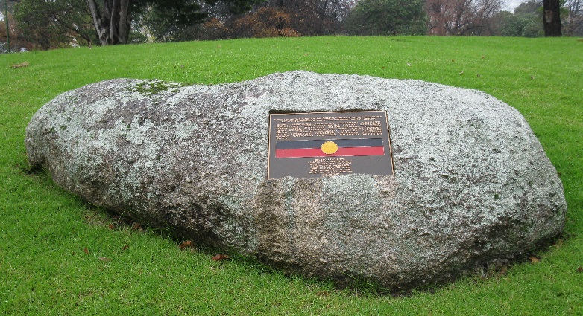
Source: R McWilliams, Museum Victoria

Kow Swamp
The next major return of remains were those from Kow Swamp to the Yorta Yorta people of northern Victoria. This repatriation followed a period of vigorous debate at many levels: local, national, and international. The different perspectives of the excavation of these remains in 1969-1970, and their repatriation in 1990, are well-described in a number of different publications. The museum was inundated with letters from community members, and Australian and international physical anthropologists and archaeologists. Some urged the museum to retain the remains; some urged repatriation for reburial; some urged repatriation under the condition that they not be destroyed or reburied (but placed in keeping places). The museum chose to return the remains, without conditions. The museum has not wavered from this policy, however ‘unconditional’ repatriation means that the museum is not necessarily informed as to the ‘history’ of what happens to the remains after they have left the museum. It has been regularly emphasised to the museum that it is it is the communities’ business, not the museum’s, and the museum respects this view.

The Challenges of Provenancing
The museum recognized that the key to repatriation of remains lay in their provenancing: where had they originally been buried? In the 1980s and 1990s, staff embarked on an extensive search of its archives for correspondence, police files, collection documentation, and other public records, relevant to the remains in the collection. Many Indigenous and non-Indigenous staff contributed to this work. In 1993, the museum contracted an Indigenous community member, Mr Norman Graham as Curator, Skeletal Return Project. In a paper presented to the Conference of Museum Anthropologists (COMA), Norm described his role, which was ‘to work on the unregistered remains housed at the museum, and to return remains to communities in Victoria, as the Museum’s major priority for and contribution to the International Year of Worlds Indigenous Peoples’.
Once he had completed documenting the unregistered remains, Norm Graham worked on enhancing information on the registered remains, and again contacted the relevant Victorian Aboriginal co-operatives, corporations and trusts, working through the Aboriginal Cultural Heritage Advisory Committee and cultural officers within the communities. A significant number of Ancestral Remains were repatriated during Norm’s time in this role. He was then appointed in an ongoing position as Roving Curator, and then as Manager of Bunjilaka at Melbourne Museum. Another Indigenous researcher, Sandra Smith, also took on the role of meticulously searching for and compiling archival records, and providing information to communities.
On a separate front related to repatriation, in the 1990s, the Aboriginal and Torres Strait Islander Commission initiated and funded the National Skeletal Remains Provenancing Project. Between 1995 and 1997 Deanne Hanchant worked as an archival researcher (based at the South Australian Museum - SAM) on the project which aimed to locate the original provenance of the many Aboriginal & Torres Strait Islander Ancestral Remains held in Australian museums. Hanchant noted that ‘The project used archival records in conjunction with biological comparisons of unknown to known remains.” Physical anthropologists who contributed to the project included Dr Colin Pardoe, and Dr Catherine Bennett. With ACHAC’s approval, this museum’s holdings of Ancestral Remains were included in the research.
In the years following the relocation of the collections to Melbourne Museum in 2000, further concerted efforts have been made to consolidate the records into collection documentation files for individual sets of remains, which can be provided to relevant communities to assist in decisions about repatriations of provenanced remains. Occasionally, a new piece of information is added to the files, however the museum recognizes that it has exhausted nearly every avenue of archival enquiry, and that many sets of remains were likely to remain ‘unprovenanced’; for many sets of remains, there is absolutely no documentation, and therefore no leads to follow.
ACHAC asked the question: Is there any other way of provenancing the remains? As noted above, ATSIC’s National Skeletal Remains Provenancing Project collected comparative biometric information (measurements) on provenanced Australian Indigenous remains held in various institutions around the country. The aim of the project was to collect a large database of information on ‘provenanced remains’ that might then be used specifically to identify ‘unprovenanced remains’. One of the foremost proponents of this form of ‘biometric provenancing’, Dr Colin Pardoe, was employed by the museum to review its collection of unprovenanced remains, including those from the Berry, Freemasons, and AAV collections. Many of the remains from these collections (especially the first two) had little or no documentation, although sometimes coding numbers had been inscribed on the remains by different collectors and institutions. Over years of research, Dr Pardoe has identified many of these codes to assist with provenancing. In addition, he uses the large database of biometric information on provenanced remains to assist with provenancing of those remains that have no other information available. For some regions of the country, Pardoe has large sample sizes; for some regions, the sample sizes are smaller.

Reburial at Weeroona Aboriginal Cemetery, 2012
In 2003, Terry Garwood, then a member of the Museum’s Board and Chairperson of ACHAC requested that the museum investigate the issue of how to deal with ‘unprovenanced’ Victorian remains. A workshop chaired by the Head of Indigenous Cultures Department, Dr Gaye Sculthorpe, sought advice from Victorian communities. The recommendation was, simply, that the museum needed to consult widely with Indigenous Community members. Under the new Head of Department, Dr Michael Green, Simon Greenwood (Collection Manager of Ancestral Remains) and Brett Ahmat (seconded to a new position of Manager of the Repatriation Project at the museum), working with Mark Dugay-Grist (Manager of Heritage Services at Aboriginal Affairs Victoria), a group of Victorian Elders was assembled, and Victorian communities were canvassed about a range of options. Whilst not unanimous, the option most clearly favoured was a reburial of unprovenanced remains at Weeroona Aboriginal Cemetery, at Greenvale, Melbourne.
In 2011, following a period of loss of key staff, the project was re-established under the leadership of the then Acting Head of Department, Lindy Allen. Again an Elders Group from across Victorian communities met to consider the Weeroona option, offered by the Weeroona Trust under the leadership of Aunty Georgina Williams, with the assistance of Uncle Glen Peters, a registered undertaker with the Aboriginal Advancement League. Again, although not unanimous, the offer from Aunty Georgina was accepted. Uncle Colin Walker and Uncle Albert Mullett were to assist the museum and the Trust in planning and conducting the ceremony.
In March 2012, the Ancestral Remains of 132 unprovenanced men, women and children were reburied at a memorable event at Weeroona. The Committee decided that there should be no media coverage of the event, but the museum engaged James Henry, a Koorie photographer, to document both the handover event at Melbourne Museum, and the reburial at Weeroona. Those present at Weeroona will never forget the sounds of Uncle Herb Pattens’s leaf-playing, or the words spoken by Uncle Archie Roach, and the poignant strains of him singing Travellin’ Bones.
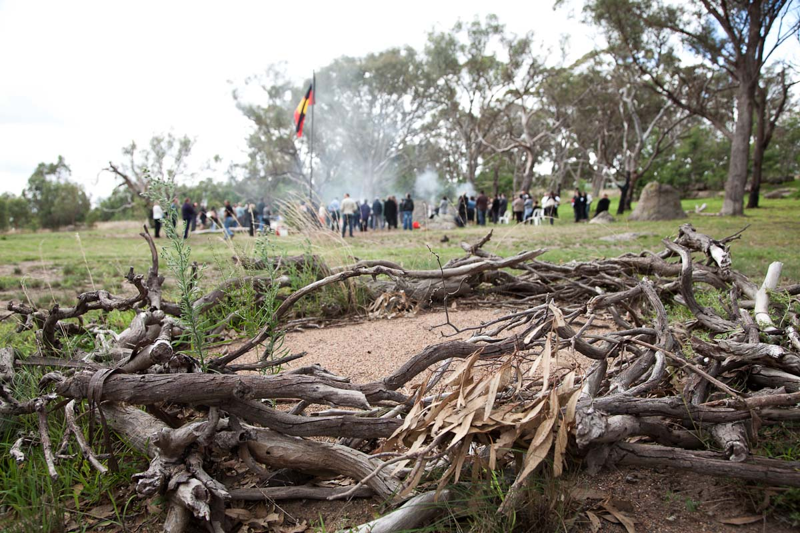
Reburial of unprovenanced Victorian Ancestral Remains, Weeroona Aboriginal Cemetery, March 2012.
Source: James Henry, for Museum Victoria
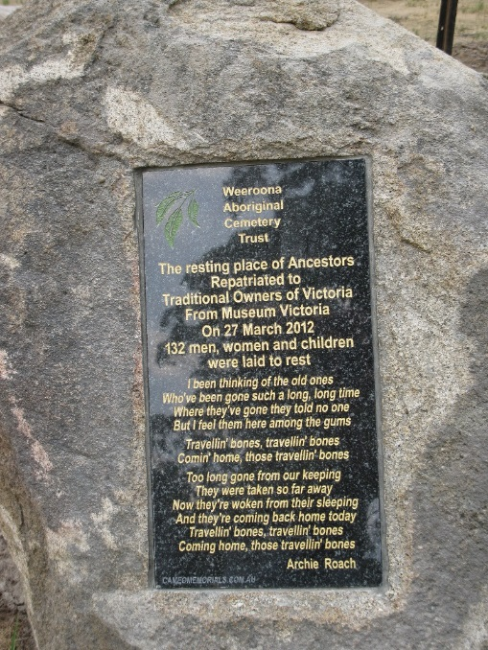
Source: R McWilliams, Museum Victoria

Achievements and Challenges
Since 1983, many museum staff have worked on the skeletal remains collections, documentation, and repatriation. Indigenous staff members of the museum and/or the Victorian Aboriginal Cultural Heritage Unit include (the late) Uncle John ‘Sandy’ Atkinson, Kelly Koumalatsos, Val Heap, Lori Richardson, Sandra Mullett, Leanne Adams, Aunty Joy Murphy, Uncle Brian Patterson, Sandra Smith, Norman Graham, Rodney Carter, Mark Dugay-Grist, Gaye Sculthorpe, Brett Ahmat, Jamie Thomas, and Kerry Hunt.
There have been more than one hundred community members who have sat on the Aboriginal Cultural Heritage Advisory Committee, a committee whose Chair has included Val Heap, Jill Gallagher, Terry Garwood, Gaye Sculthorpe, and Annette Vickery. There has also been a tireless contribution of hundreds of Victorian Indigenous community members and non-Indigenous staff, and strong, genuine support from senior museum managers – especially, it should be noted, Dr Robin Hirst (Director - Collections, Research & Exhibitions) who has provided patient, measured advice and continued support, and Ms Melanie Raberts (Senior Collection Manager, Indigenous Collections) who has prioritised the respectful safe-keeping and management of the Ancestral Remains for more than 20 years.
Repatriations have occurred under the management of various Heads of Human Studies: Dr Ron Vanderwal and Andrew Reeves; the former Aboriginal Studies Department, the Indigenous Cultures Department and now the Humanities Department: Dr Gaye Sculthorpe, Dr Michael Green, Lindy Allen and Dr Richard Gillespie; and museum directors, Barry Wilson, Robert Edwards, Graham Morris, Dr George McDonald, and Dr J. Patrick Greene. Over the last 15 years, the museum has sought the assistance of three experienced physical anthropologists: Dr Colin Pardoe, Dr Michael Greene and Prof Catherine Bennett. Whilst bringing their scientific expertise, as ‘anthropologists’ they brought much more. It was always moving to see their sensitivity and respect for the people they were examining, and for the people with whom they were communicating, the Indigenous community members whose questions they were attempting to answer.
All of these people have made a difference. In 1983 there were 717 ‘registrations’ provenanced to Victoria. Of these, there are now 49 in the collection, awaiting requests for repatriation. However, as has been discussed, since 1984 there have been many additional transfers of Victorian remains to the museum from other institutions, adding to these totals. As of August 2016, 260 Victorian remains are currently in the collection awaiting claims.
However, the museum has wanted consultations regarding repatriation not to be a discussion about numbers on pages, but to be an opportunity to look at the history of the individuals whose remains were to go home. We can’t pretend to remember the details of all of those individuals, but some - and one in particular - I’ll not forget. He was an adult male whose legs had been broken during his life. Both tibias and fibulas had fractured about mid-point below his knees, I can only assume from a slip or jump from a height. The bones had not been realigned, and had fused alongside each other. He would have been in extreme pain for many months, perhaps even years, and would have required a lot of care from his community. But the fusing and further growth of the bones showed that somehow he had lived on, with determination and resilience … not unlike his community.
Ultimately, however, in every year that passes, we are measured on the figures. So, for the record, it is noted that, from November 1985 to August 2016, the museum has facilitated the repatriation of 2,269 sets of remains: 800 from the Murray Black collection, and more than 1400 from the various sources that had lodged remains with the museum. These returns include repatriations to every state in Australia, and to New Zealand.
In addition to the assistance provided by community members and organisations, the museum has been fortunate to have received significant funding, to assist communities with consultations, repatriations and reburials, from the Commonwealth Government - through the Return of Indigenous Cultural Property and Indigenous Repatriation Programs (through the Federal Ministry for the Arts) - and for a shorter period from the Victorian Ministry for the Arts.
At the museum, archival research continues into the remains that are still stored here. Recently, Lindy Allen (Senior Curator, Northern Australia) identified the remains of a Djambarrpuyngu man from Arnhem Land, and the circumstances of his death. The relatively recent possibility of electronically searching digitized newspapers, on-line through Trove, has also proved productive. Research by Alexandra Roginski in 2013, successfully identified the NSW birthplace of a young Aboriginal man, and the circumstances of his death in 1860. The search of ‘new archives’ is pursued, but is not always successful. For most remains that have been lodged here over many years, it is the records from the Victorian Police and Aboriginal Affairs Victoria that provide the documentation that the museum relies on for information on their original resting places.
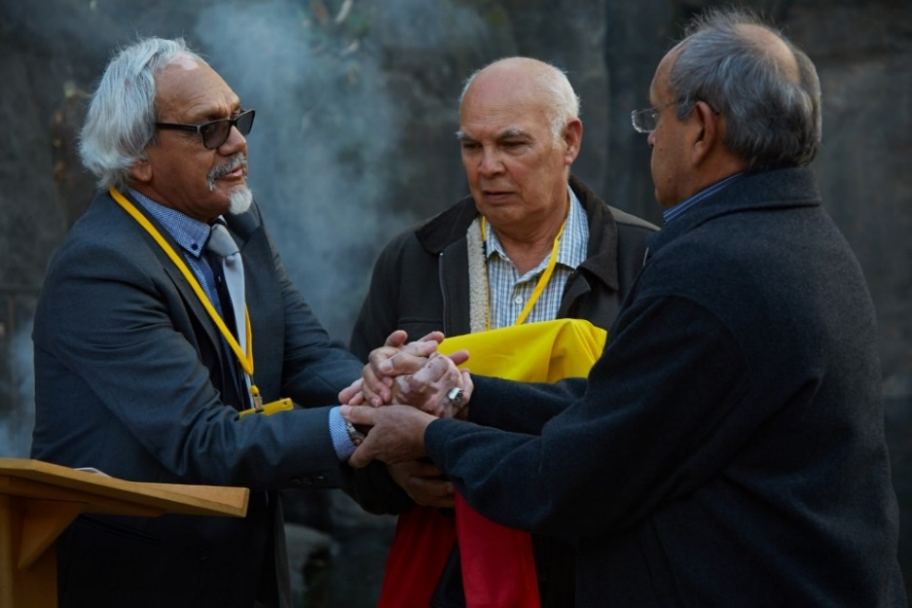
(L-R): (Uncle) James Wilson-Miller & (Uncle) Tom Miller (Wonnarua Elders), and (Uncle) Prof Henry Atkinson (MV’s Aboriginal Cultural Heritage Advisory Committee)
Photographer: Jon Augier, Museum Victoria

Repatriations have sometimes been difficult. Consultations and decisions cannot be rushed; nor can they be extended for too long. Sometimes discussions begin, but other business – either at the museum or within the community – might require more immediate attention, and time passes before anyone notices. Similarly, changes in staff either at the museum or in the community means that steps need to be re-traced. Experience suggests that the optimum period is between six and eighteen months. Anything shorter tends to be rushed; anything longer tends to lose momentum, and requires re-starting, sometimes almost from the beginning.
Contested claims have required periods of discussions. On a number of occasions the museum has had injunctions served on it to actually prevent repatriations. On some occasions, the museum has approved the deaccessioning of remains, but the communities found that they were not fully prepared for their return, and the remains have stayed awaiting collection, or were collected but then not reburied, and stored instead, in offices or on private properties. On other occasions, the museum handed remains to communities in the 1990s, which lodged them with Aboriginal Affairs Victoria, and they were then transferred back to the museum.
Repatriations are confronting events. The museum recognizes that in approaching communities it is re-opening old, unhealed wounds, with all the remembered pain, the anger, the grief, and the sorrow. These can never be entirely extinguished, but there is always a profound sense of relief for communities, and a deserved sense of pride that they have been part of a new and more permanent healing, that comes from finally reburying their ancestors.
Museum Victoria continues to see the repatriation of Ancestral Remains as a high priority. For the museum’s part, we can offer four things to communities wishing to have remains returned: we can offer information; we can offer encouragement; we can offer logistical support; and we can offer financial support. However, we cannot provide the most critical aspect – the knowledge within the communities of that ‘moment’ when they know that they are ready to have them returned.
In April 2016 the Victorian Parliament passed the Aboriginal Heritage Amendment Bill 2015, which comes into force on 1 August 2016. Among other changes to the Aboriginal Heritage Act, the Victorian Aboriginal Heritage Council is ‘to be the central coordinating body responsible for the overseeing, monitoring, managing, reporting and returning of Aboriginal ancestral remains in Victoria’. Museum Victoria and all institutions and individuals are required to transfer ancestral remains to the VAHC within two years. Consequently, after more than 30 years of repatriating remains, the museum will hand to the VAHC the task of returning remains to country. The Council are appointing staff to oversee and facilitate a continued repatriation program. The Act also requires the museum to continue to be the ‘place of safekeeping’ for ancestral remains, on behalf of the VAHC. Museum Victoria, Aboriginal Victoria and the Victorian Aboriginal Heritage Council already work closely to facilitate repatriation, and will continue to do so in order to return ancestors to their final resting place on country.
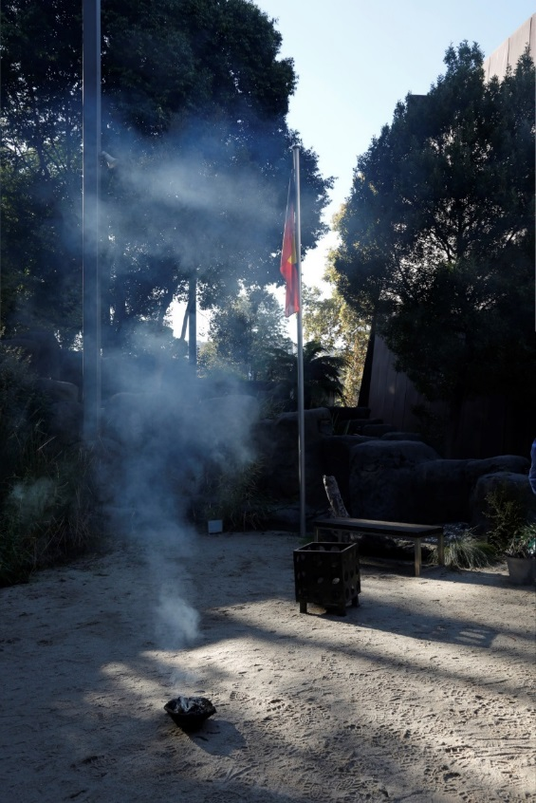

Museum Victoria’s previous names include the National Museum of Victoria (1858-1983), and Museum of Victoria (1983-1998), alongside parallel institutions, the Industrial & Technological Museum et al.
Over 1,400 from the museum collection and 800 from the Murray Black Collection.
At a meeting in Warrnambool in 2014, Taungurung leader, Mick Harding, indicated that he was uncomfortable with the remains stored at the museum being described as ‘a collection’, feeling that this was not an appropriate term. Every single museum staff member who has heard his views appreciated the point he was making, but we haven’t yet identified a suitable term to replace it.
W. Baldwin Spencer to Thos. O’Callaghan, Chief Commissioner of Police, 12th July 1902. Correspondence file, Museum Victoria.
O’Callaghan to Spencer, 24th July 1902. Correspondence file, Museum Victoria.
Researcher, Ms Alexandra Roginski, recently discovered that the A.S. Hamilton Collection, of approximately 50 human crania, had been donated to the museum in 1889, but registration of the Indigenous remains did not take place until 1904-05.
For those interested in a more detailed history, I would recommend Paul Turnbull, ‘British Anatomists, Phrenologists and the Construction of the Aboriginal Race, c. 1790-1830’, History Compass 5/1 (2207): 26-50.
Act for Regulating Schools of Anatomy, 1832.
Claim by William Ripley referred to by Ross Jones, Humanity’s Mirror. 150 Years of Anatomy in Melbourne, Haddington Press, p. 113.
Turnbull, Paul, ‘British Anatomists, Phrenologists and the Construction of the Aboriginal Race, c. 1790-1830’, History Compass 5/1 (2007): 30-31.
Dimond, J, Ned Kelly’s skull’, Overland Literary Journal, Winter 2013.
Roginski, A, The Hanged Man and the Body Thief. Finding Lives in a Museum History, Monash University Publishing, 2015.
Jones, Ross, Humanity’s Mirror: 150 Years of Anatomy in Melbourne, Haddington Press.
Helen MacDonald, in her Human Remains: Episodes in human dissection (2005), has comprehensively documented the activities of individuals and institutions, exhumation of remains in Tasmania, and the events surrounding the desecration of the remains of William Lannney.
Tom Griffiths’ book Hunters & Collectors: The Antiquarian Imagination in Australia, describes the motivations and activities of the ‘stone circle’ of such collectors.
See Museum Victoria, Indigenous Collections, Ancestral Remains Collection Documentation for X72626
Bowler J. Reading the Australian Landscape: European and Aboriginal Perspectives. http://www.ecoversity.org.au/publications/bowler1995.htm
Croll, R.H, I Recall – Collections and Recollections, 1939, p. 103.
For further discussion and details of the history of the two collections, see the chapters by Dr Ross Jones and Professor Lynette Russell in Faulkhead and Berg’s Power and the Passion, Our Ancestors Return Home (Part 3).
In a number of earlier articles in 1953 and 1954, Gill published other test results including fluorine-phosphate ratios for the remains.
Memoirs of the National Museum of Victoria, Vol. 34, May 1973, pp. 99-150.
During the inventory, West and Thorne constructed an index card system to describe each set of remains in the collection at the time. Later, a volunteer, Dr Doug Ellicott, maintained and built on the card system for the period up to about the late 1970s.
Robert Edwards (1980), Introduction. “Preserving Indigenous Cultures. A New Role for Museums, p.3.
Report ‘Museum of Victoria. Management of Aboriginal Skeletal Remains’ (1993).
The National Museum of Victoria and the Science Museum of Victoria.
Letter from the Honourable Haddon Storey (Minister for the Arts), to Mr Graham Morris (Director, Museum of Victoria), received 23 February 1996.
Mr Jim Berg and Dr Shannon Faulkhead in their publication Power and the Passion. Our Ancestors Return Home, Koorie Heritage Trust (2010), p. 12. It was in fact more than this; Val Heap, as chair of the advisory committee, became a member of the museum’s Board of directors. This appointment of the ACHAC Chair, to the Board, continues to this day.
Faulkhead & Berg, Power and the Passion, p.60.
Skeletal elements of individuals were preliminarily matched using Murray Black numbers on the elements, and Stephen Collier’s datasheets. Confirmation and final matching was conducted by physical anthropologist Dr Catherine Bennett.
Minutes of the Aboriginal Relics and Skeletal Material Advisory Committee, 13 February 1985.
Physical anthropologists, Dr Colin Pardoe and Dr Michael Green, were again engaged to assist the museum with this specialised work.
Faulkhead & Berg, Power and the Passion, p.35.
The ‘Aboriginal Matters Committee’ appears to have been set up to prepare for the King’s Domain event. Val Heap was appointed Chair in July 1985. MV Archives – Museum of Victoria – Division of Human Studies – Aboriginal Cultural Heritage Trust (sic) 1985-1988, Older System ~03701, accessed 29 June 2014.
MV Archives – Museum of Victoria – Division of Human Studies – Aboriginal Cultural Heritage Trust (sic) 1985-1988, Older System ~03701, accessed 29 June 2014.
Mulvaney & Kamminga, Prehistory of Australia; J. Flood, Archaeology of the Dreamtime; and, R. Broome, Aboriginal Victorians.
Norman Graham, Aboriginal Skeletal Repatriation at the Museum of Victoria and My Role, COMA, Bulletin of the Conference of Museum Anthropologists, No. 28 August 1996, pp. 45-47.
Deanne Hanchant, ‘Practicalities in the return of remains: the importance of provenance and the question of unprovenanced remains’, in The Dead and their Possessions: Repatriation in principle, Policy and Practice, edited by C. Fforde, J. Hubert & P. Turnbull, Revised edition, 2004, p.312.
Alexandra Roginski’s 2013 Honours thesis research, and the story of Jim Crow, has subsequently been published as Roginski, A, The Hanged Man and the Body Thief. Finding Lives in a Museum History, Monash University Publishing, 2015.

