Top Designs 2025 Access Guide

This Access Guide provides convenient information about accessing Top Designs 2025 at Melbourne Museum and is available online to prepare for your visit in advance.
The guide can be read independently or shared with a friend, family member, carer or support worker. Contextualised photographs have been used to summarise information and experiences.
We hope you find the guide useful and welcome feedback.

Contact
If you would like to talk to Melbourne Museum about particular access requirements, or if you need more information about accessibility, please contact their bookings office on 13 11 02 or email mvbookings@museum.vic.gov.au

Deaf access / 24-hour relay call numbers:

TTY/voice calls: 133 677
Speak & Listen: 1300 555 727
SMS Relay: 0423 677 767

About Top Designs 2025
Celebrating 25 years at Melbourne Museum, Top Designs features outstanding works by students who completed VCE and VCE VET design studies in 2024.
With applications received from government, independent and Catholic schools across Victoria, panels of expert educators selected 77 works across each of the 9 design studies- VCE Media, Product Design and Technology, Theatre Studies, Systems Engineering, Visual Communication and Design, and VCE VET Creative and Digital Media, Music (Sound Production), Furnishing and Engineering Studies.
The panels considered the imaginative ways students responded to the assessment criteria and the strength of design development and folios in their decision-making.
Managed by the Victorian Curriculum and Assessment Authority (VCAA), Top Designs is part of the VCE Season of Excellence, which also includes Top Talks, Top Screen, Top Arts, Top Class and Top Acts.

Location
Top Designs is located at the Melbourne Museum, situated within Carlton Gardens, adjacent to the Royal Exhibition Building.
Address: 11 Nicholson Street, Carlton. Google Maps link.
The exhibition is located inside the Melbourne Gallery on the Upper Level.

Dates and Times
The exhibition is open between 9am and 5pm from Saturday 29 March to Sunday 20 July. Closed Good Friday. Melbourne Museum tends to be quieter between 3pm and 5pm on weekdays during the school term.

Tickets
Your visit to Top Designs is included with Museum entry.
More information and tickets here.
If you have trouble booking online, email: mvbookings@museum.vic.gov.au or call the bookings office on 13 11 02, available 9am–4.30pm daily.
If you have a Companion Card, you qualify for a second, free ticket.
You do not have to book ahead for your companion.
Simply present your companion card at the reception.
If you have a Concession Card, you qualify for a free ticket.

Melbourne Museum Quick Links
Plan your visit
Getting here and parking
Book your car park at Melbourne Museum online
Visitor Map
Sensory Friendly Melbourne Museum floorplan
Accessibility information
Autism friendly Museum social stories

Exhibition Accessibility

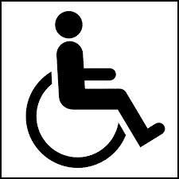
This exhibition is fully wheelchair accessible.

This exhibition includes 22 audio descriptions.
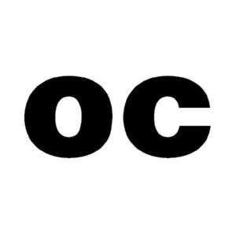
All audio content in this exhibition is open-captioned.

This exhibition is described in an access guide.
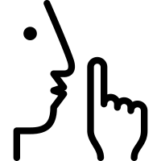
The nearest Quiet Room is located near the entrance of the Gandel Gondwana Garden and has a sign on the door saying Quiet Room.
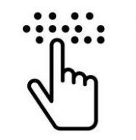
An acrylic Braille tactile map of this exhibition is available.

Large print exhibition labels are available online and in print.

Getting to the Museum
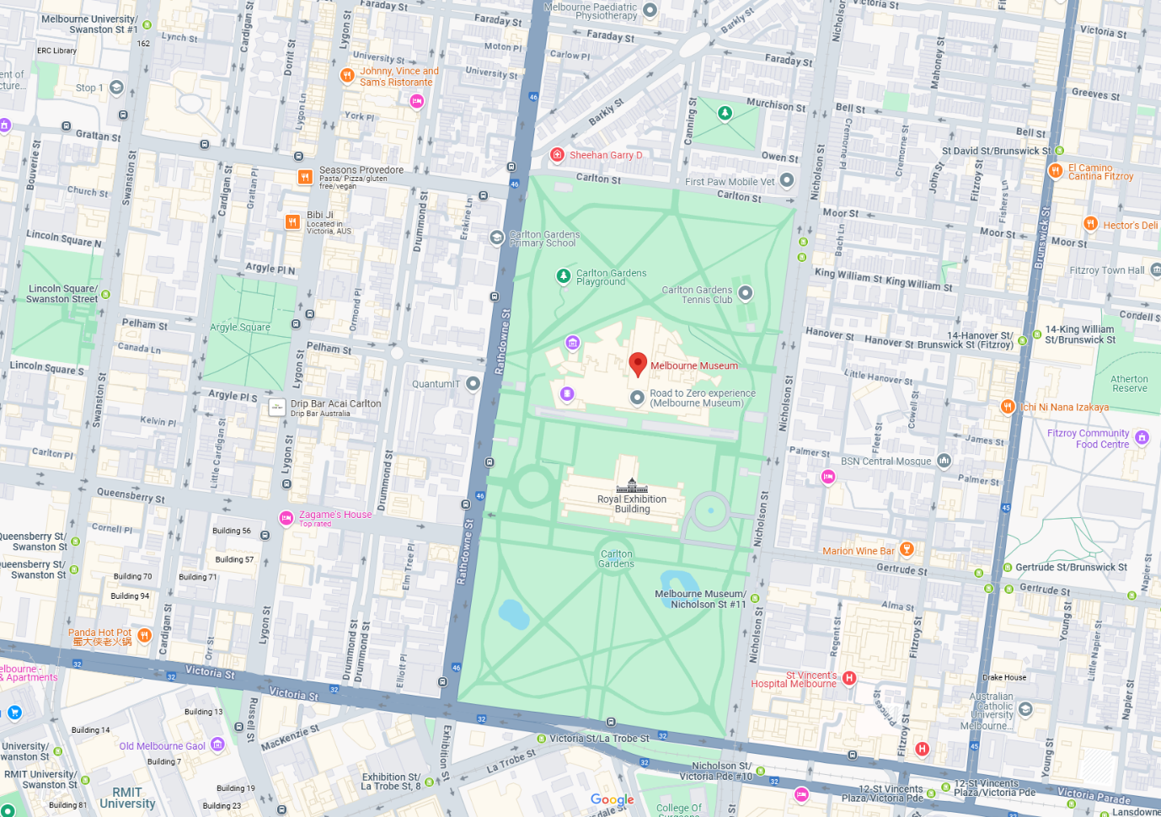Image 1- A computer screenshot of Melbourne on Google maps. The streets surrounding the Museum are Rathdowne Street on the west side, Victoria Street on the south side, Nicholson Street on the east side.

Tram
If taking Tram route 86 or Tram route 96, get off at Stop 11, corner of Nicholson and Gertrude Streets. Melbourne Museum is 300 metres from here.
If taking the free City Circle Tram, get off at the Victoria Street and Nicholson Street intersection. Melbourne Museum is 550 metres from here.

Train
If catching a train get the City Loop train to Parliament Station, which has lift access to the top of Lonsdale Street. Melbourne Museum is 750 metres from here.

Public Transport Quick Links
PTV Journey Planner
Yarra Trams
Metro Trains Melbourne

Parking
The car park is open seven days a week from 5:30am to midnight. Entry is via Rathdowne Street or Nicholson Street. It contains a number of accessible parking spaces on level P2 including pram parking.
The car park entrance has a height restriction of 2.15m. Accessible parking for vehicles over this limit is located on Rathdowne Street.
Two Delta Energy Systems AC EV chargers fitted with type 1 connectors are located on level P2 Nicholson Street. There is no additional cost to use the chargers.
There is 2-hour metered parking along Nicholson Street and Rathdowne Street.
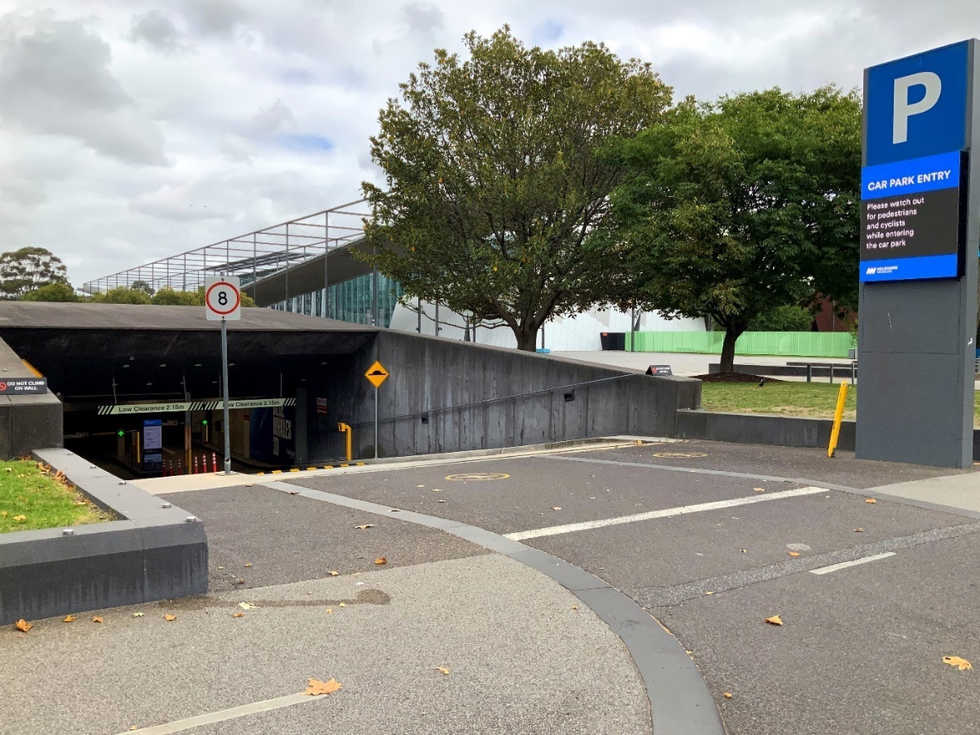
Image 2- a photo of the entrance to the Museum underground carpark on Nicholson Street.

Taxi Zone
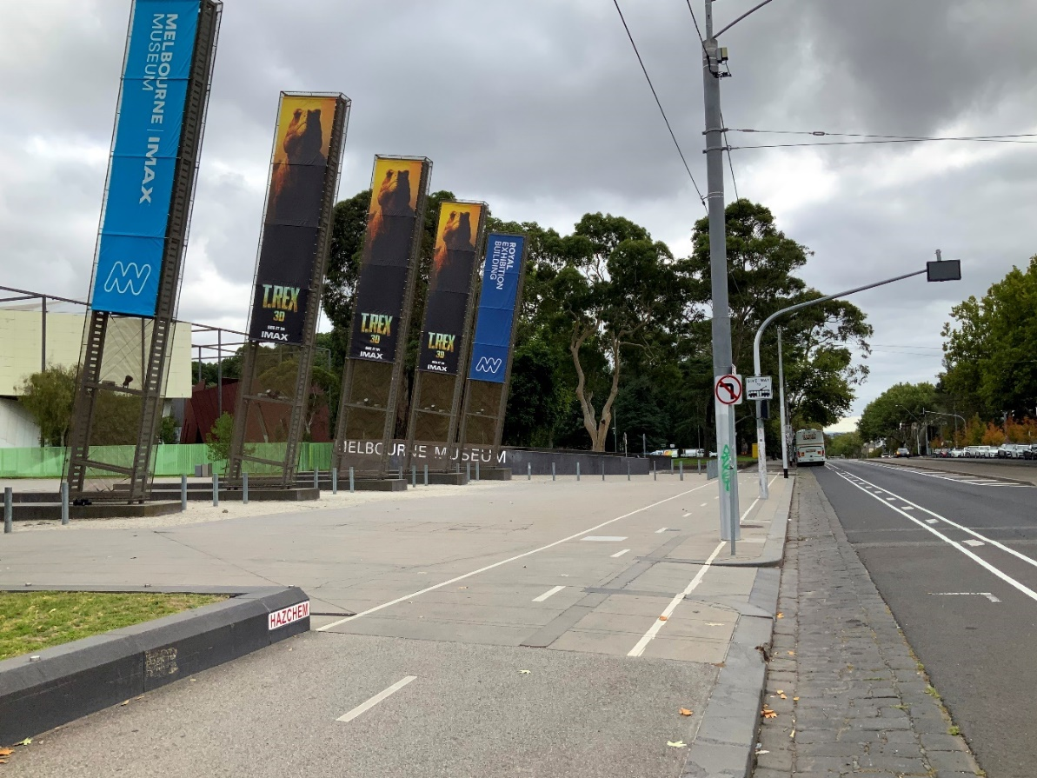
Image 3- a photo of the taxi zone at 11 Nicholson Street, Carlton.

Accessible Drop-off Spot
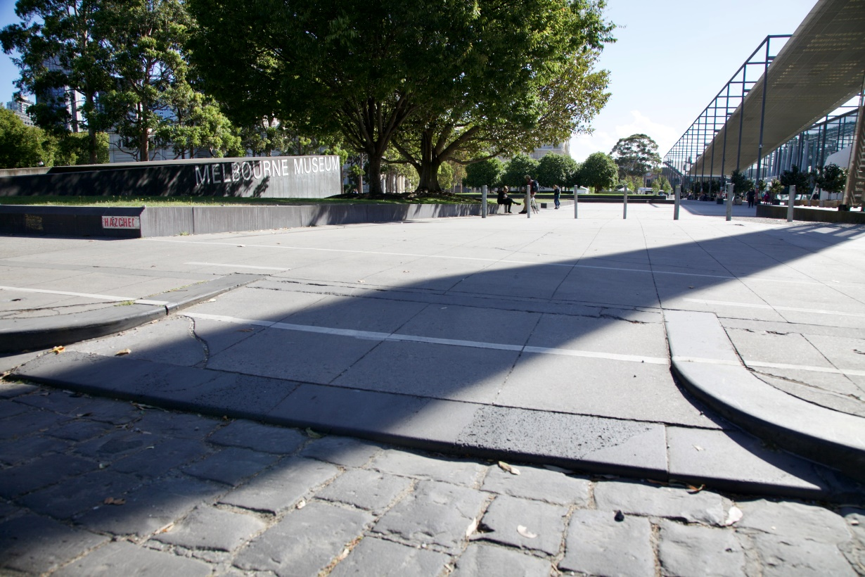
Image 4- a photo showing a 2 metre wide driveway in the taxi zone area at 11 Nicholson Street.

Getting to the Museum Entrance
The entrance to the Museum is 200 metres from the taxi zone / accessible drop-off-spot.
The path is flat, wide, paved, step-free and shaded.
The pathway is shared by different users including cyclists, skaters and e-scooter riders.
As you approach the entrance you will pass bollards, planter boxes and a row of concrete cubes.
The Museum is the big building on your right.
The Royal Exhibition Building is on your left.
Refer to image below.

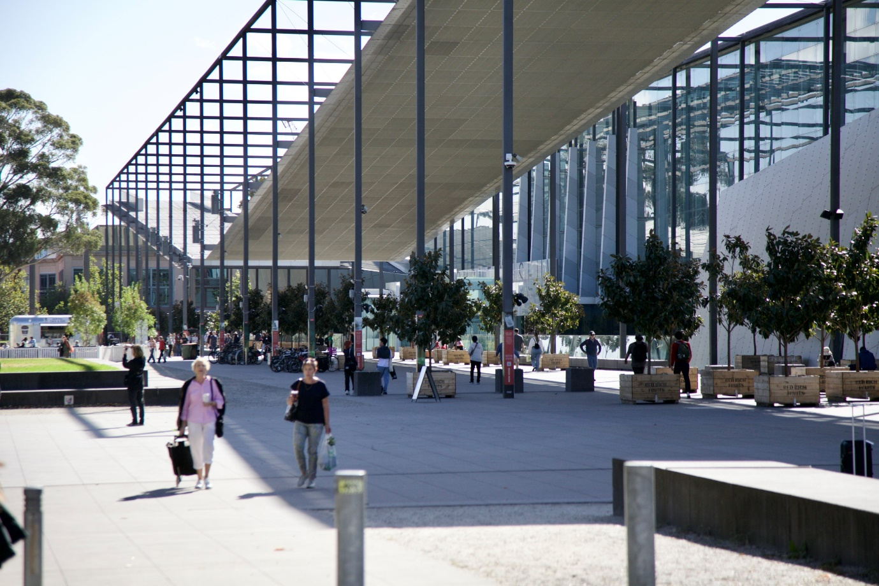
Image 5- a photo of the pathway that leads to the entrances from the taxi zone / accessible drop-off spot from 11 Nicholson Street.
You have reached the Museum entrances when you see words ‘MELBOURNE MUSEUM’ in large capital letters written above on the glass windows.
There is one entrance under the word MELBOURNE, and another entrance under the word MUSEUM.
The two entrances are 20 metres apart.
The glass exterior is highly reflective.
Refer to image below.
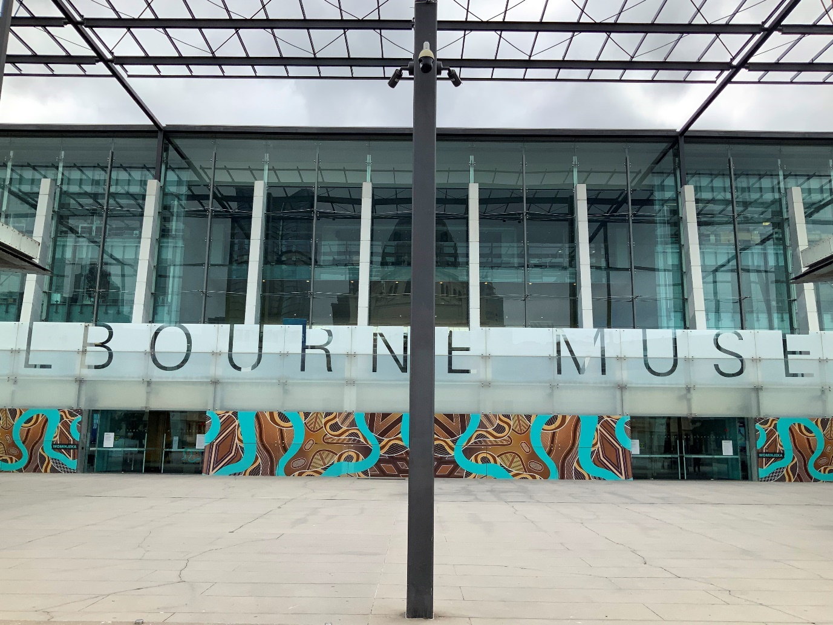
Image 6- a photo showing the Museum’s glass windowed front. The closest entrance from Nicholson St is under the word MUSEUM.

Green space for dog guides and assistance animals
The nearest green space is halfway between Nicholson St and the Museum’s main entrance, on your left. More green spaces can be found in the surrounding parks and gardens behind the Royal Exhibition Building and Melbourne Museum.
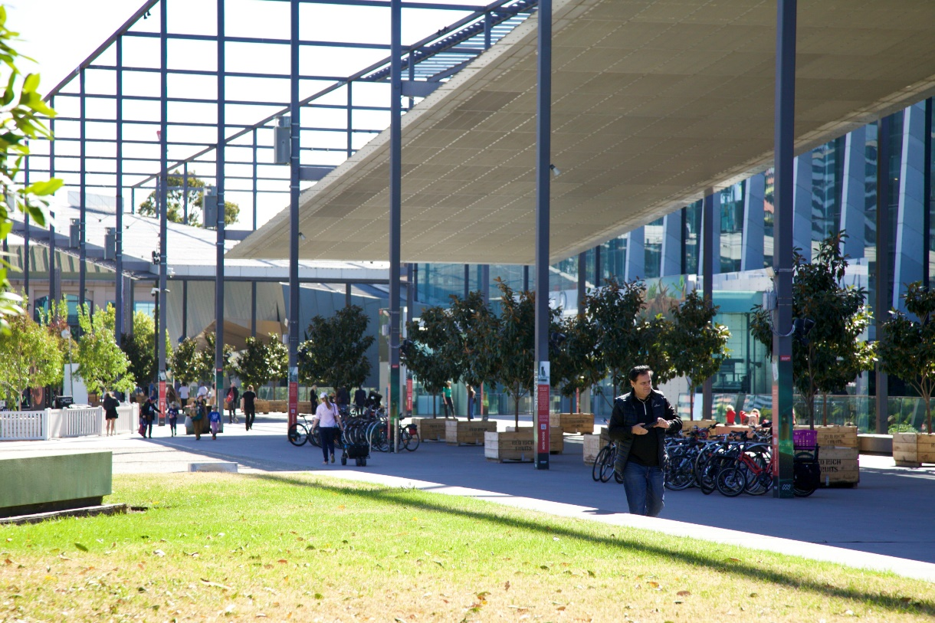

Image 7- a photo of the nearest green space to the Museum’s entrance. Please note this area is not wheelchair accessible and has two big steps.

Foyer
Visitor Engagement Officers are located inside the Foyer near the entrance, at the Information desk and Reception to welcome and assist people with enquiries and ticketing.
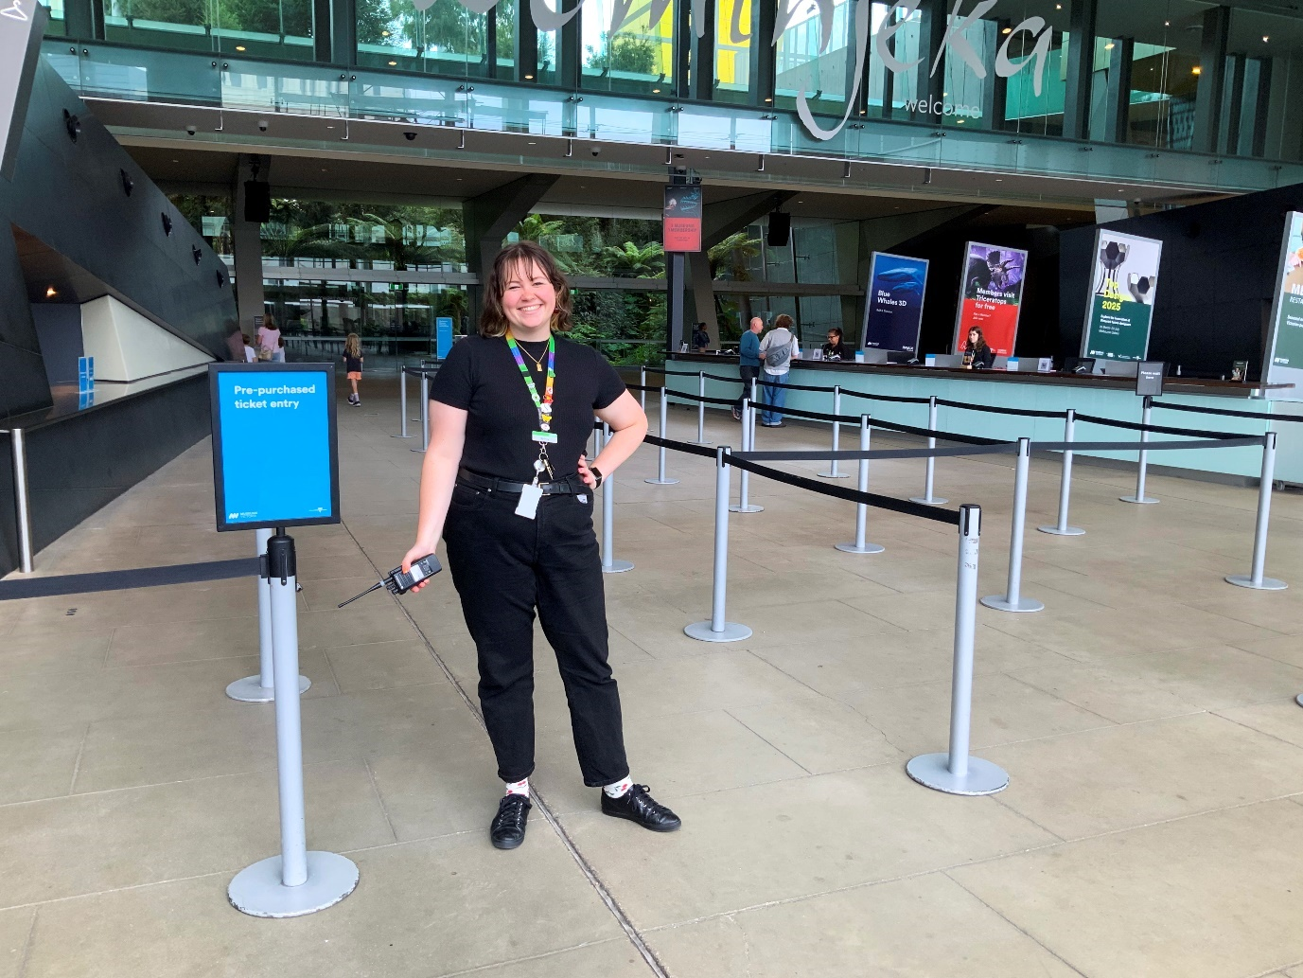
Image 8- a Visitor Engagement Officer stands near the entrance in the Main Foyer. Behind them, on the left, is the Cloakroom, and to the right is the Reception desk.

Information Desk
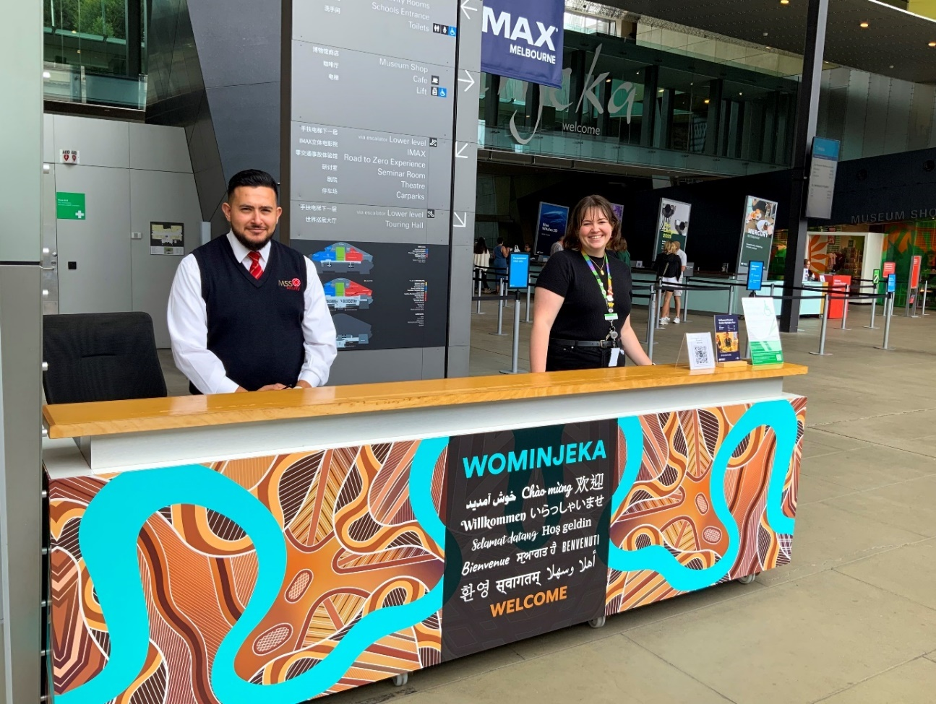
Image 9- a photo of the Information desk front and centre nearest the Museum entrances. Visitor Engagement Officers can be found here. Behind them is Reception.

Reception
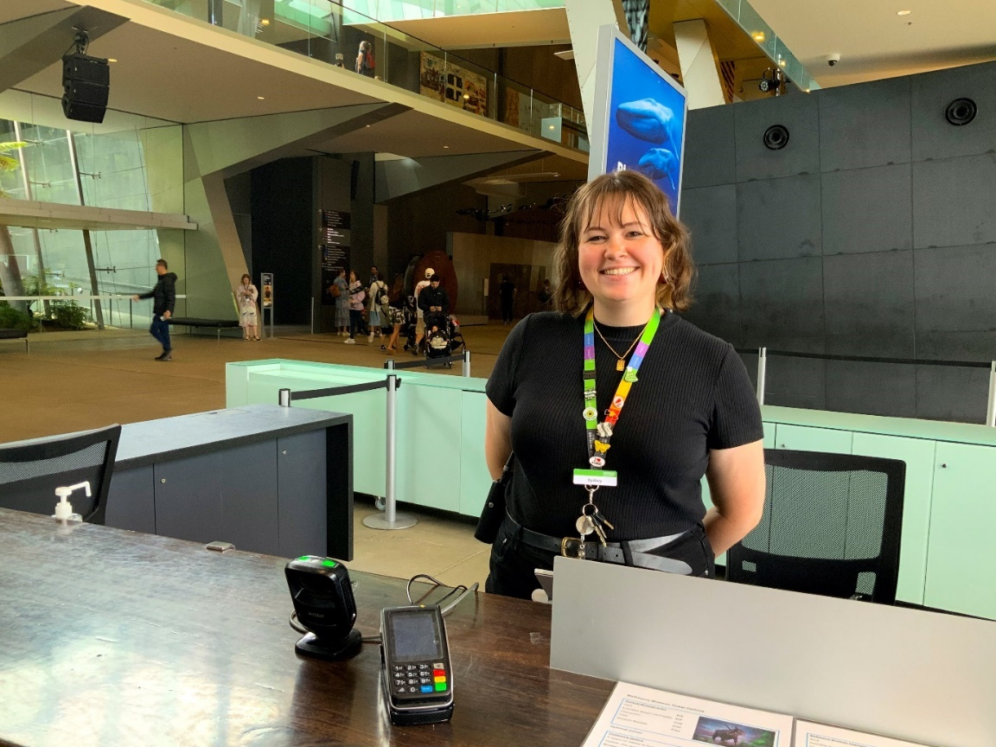
Image 10- a photo of a Visitor Engagement Officer sitting behind the reception desk. An EFTPOS machine, Museum floorplan and a sign with ticket prices is on the desk top.

Cloakroom
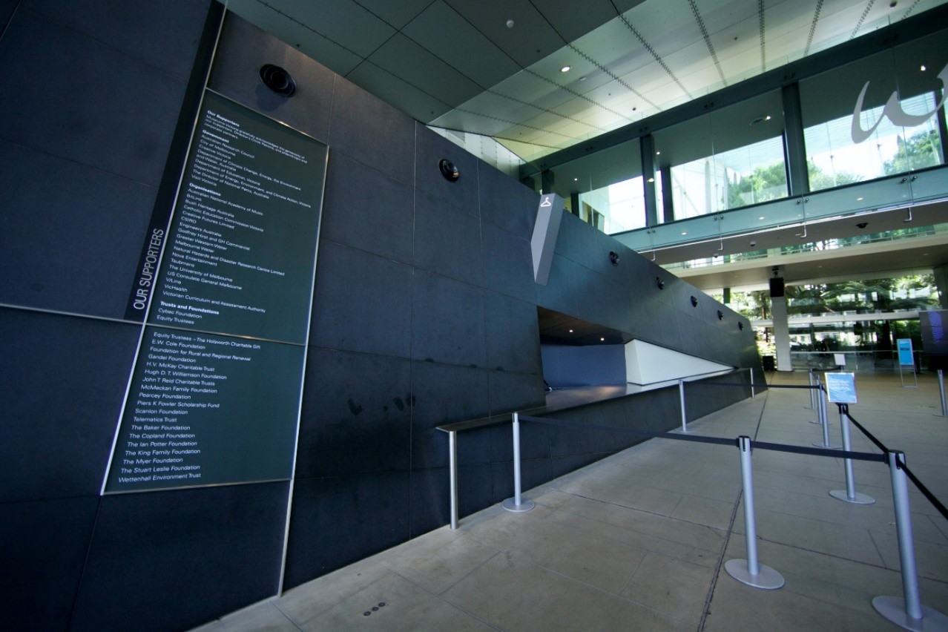
Image 11- a photo of the Cloakroom desk where a Visitor Engagement Officer can assist with storing your belongings during your visit.

Bathrooms
Accessible and all persons bathrooms are located across all three levels of Melbourne Museum.

On ground level (refer to map below)-
RIGHT: Between the Museum Shop and Café and in front of Bunjilaka Aboriginal Cultural Centre.

LEFT: Between the Learning Lab and IMAX, and near the Children’s Gallery.

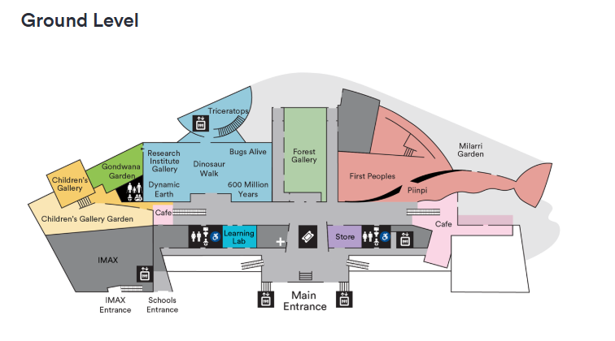

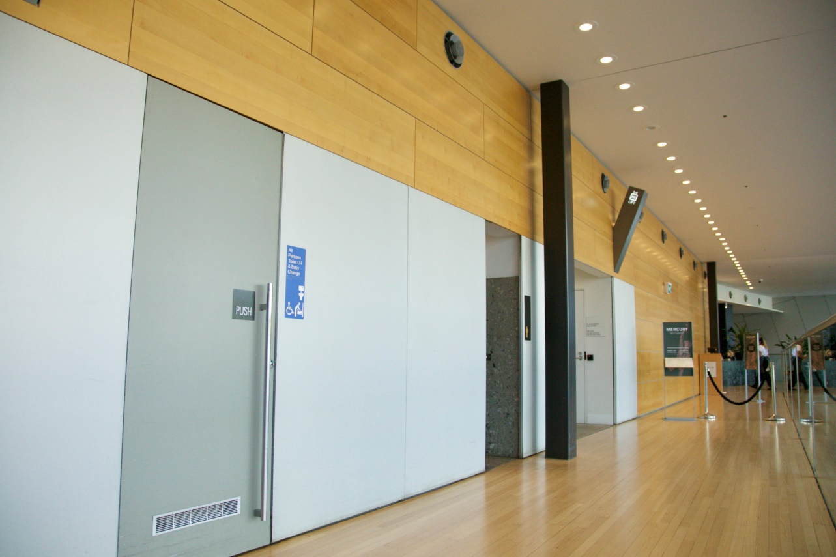
Image 12- a photo of the accessible bathrooms between the Museum Shop and Café.

On upper level (refer to map below)-
RIGHT: Foyer across from Melbourne Gallery
LEFT: Foyer across from Mind and Body Gallery
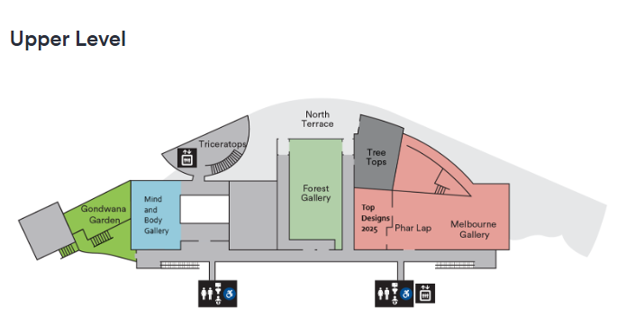

Getting to the Melbourne Gallery

Lifts
Whilst there are two lifts within the Museum, the easier lift to go to the Upper level is found on ground level down the right-hand side corridor of the building, after the Museum Shop, and bathrooms on your left. If you have come to the Café, you have gone too far.

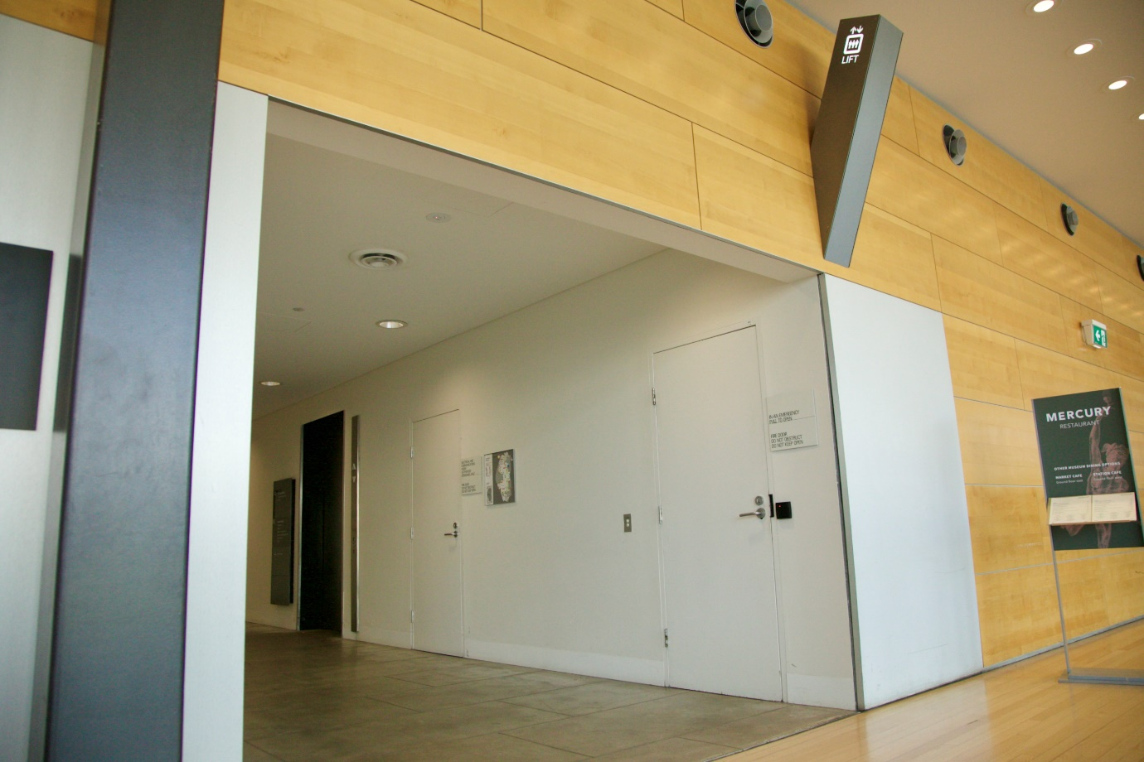
Image 13- a photo of the alcove where after turning left into it, the lifts can be found on your right.

The lifts have tactile indicators in the form of raised print numbers on the buttons, but without Braille or voice guidance. Refer to image below.
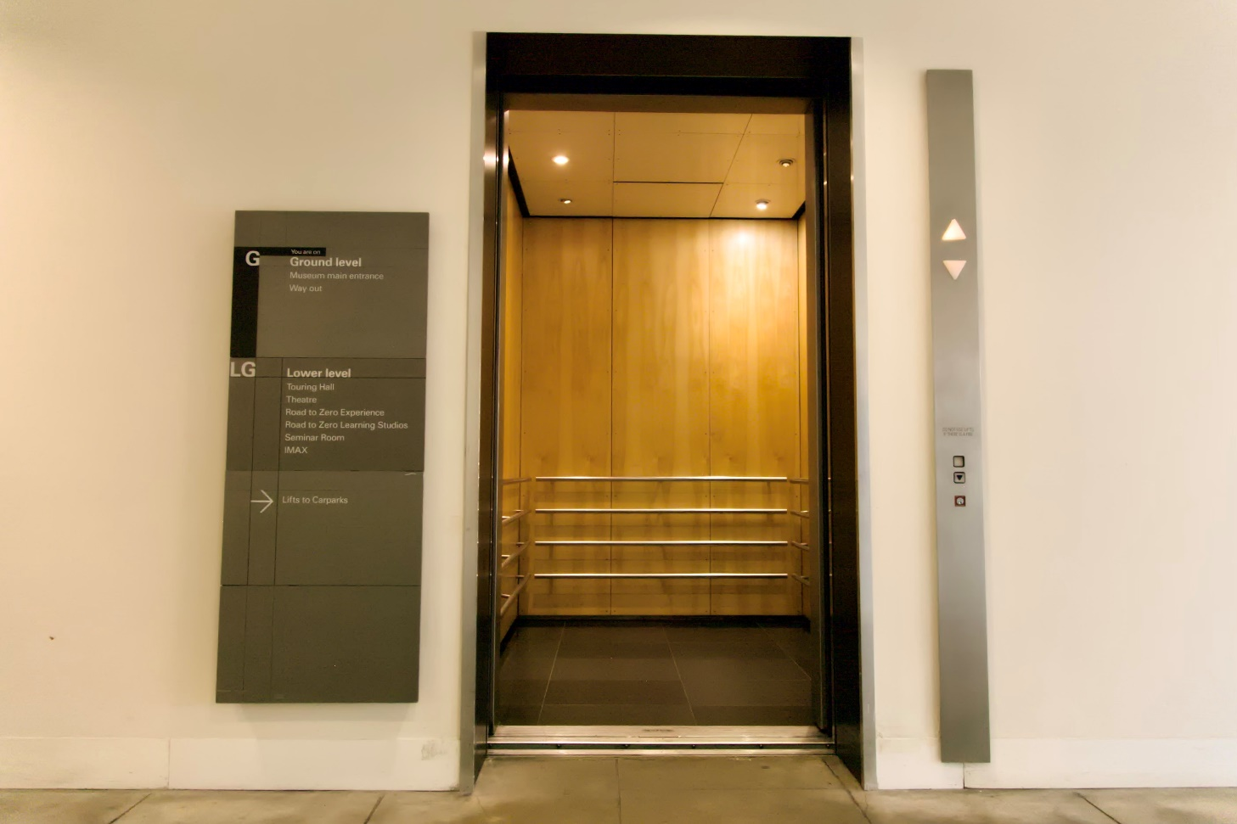
Image 14- A photo of the lift on ground level right hand side of building.

The Melbourne Gallery is on Level 1, the Upper level.
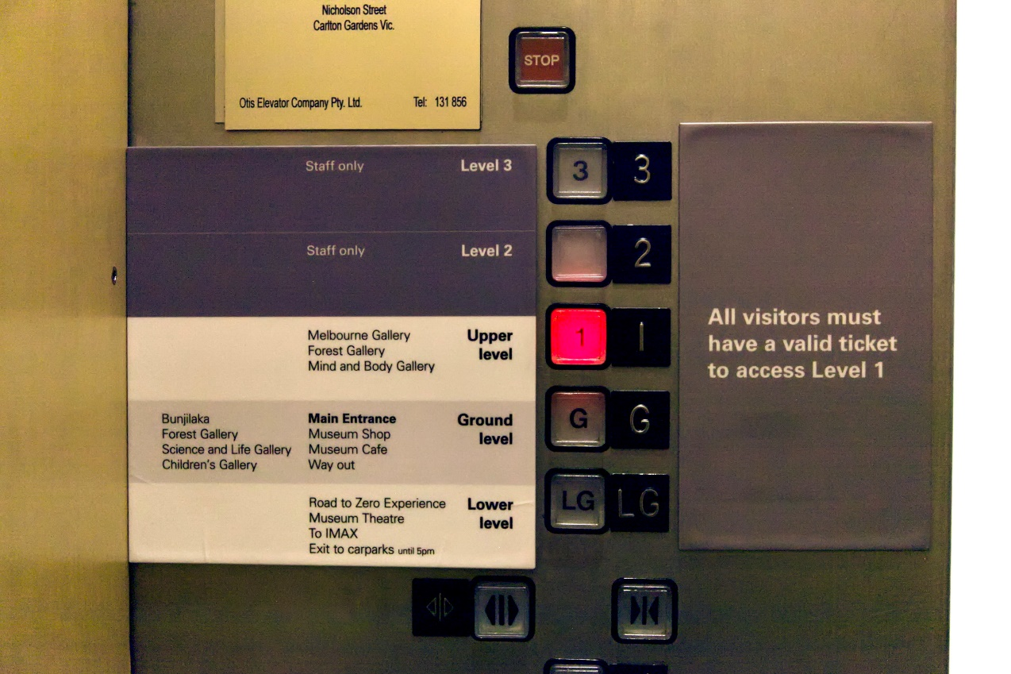
Image 15- a photo of the panel inside the lift on the right hand side as you enter.
Exit lift. Turn right.
Travel along the passageway, past the accessible and all persons bathrooms on left and right, towards the ascending ramp. It has handrails on both sides. Refer to image below.
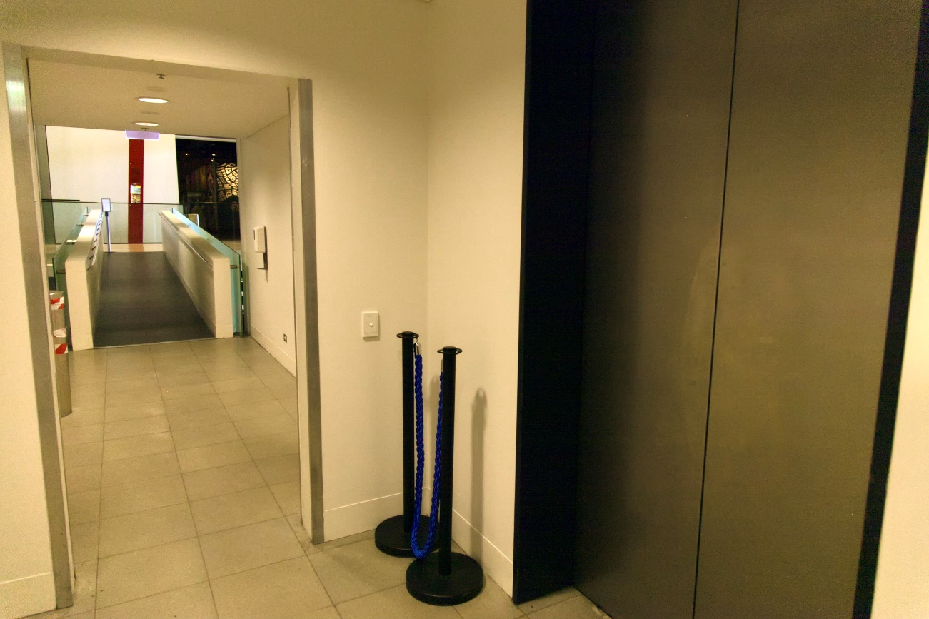
Image 16- a photo of the passageway after exiting the lift.

At the end of the ramp, turn right.
You are now on the Upper level wooden floor mezzanine.
To your left is the entrance to the Melbourne Gallery.
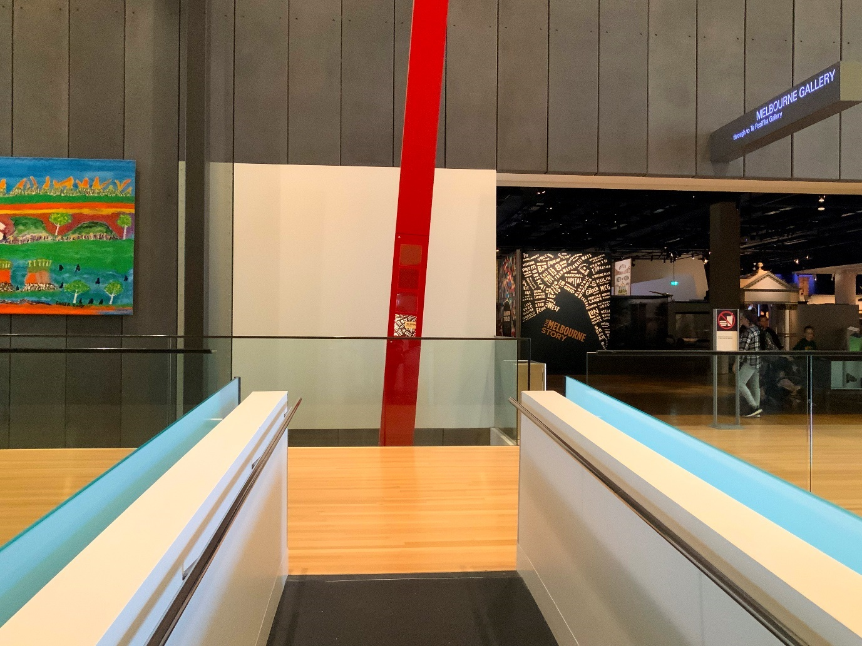Image 17- a photo looking onto the Upper level mezzanine, after exiting the from the lift. It is approx 3 metres wide. There are glass barriers on either side.

Escalators
After obtaining your tickets from reception, the escalators are located behind the Foyer area.
The most direct way to the exhibition is to turn right.
Travelling down the long corridor, at end, about 100 metres away, you will find a pair of escalators that will take you directly to the Upper Level.
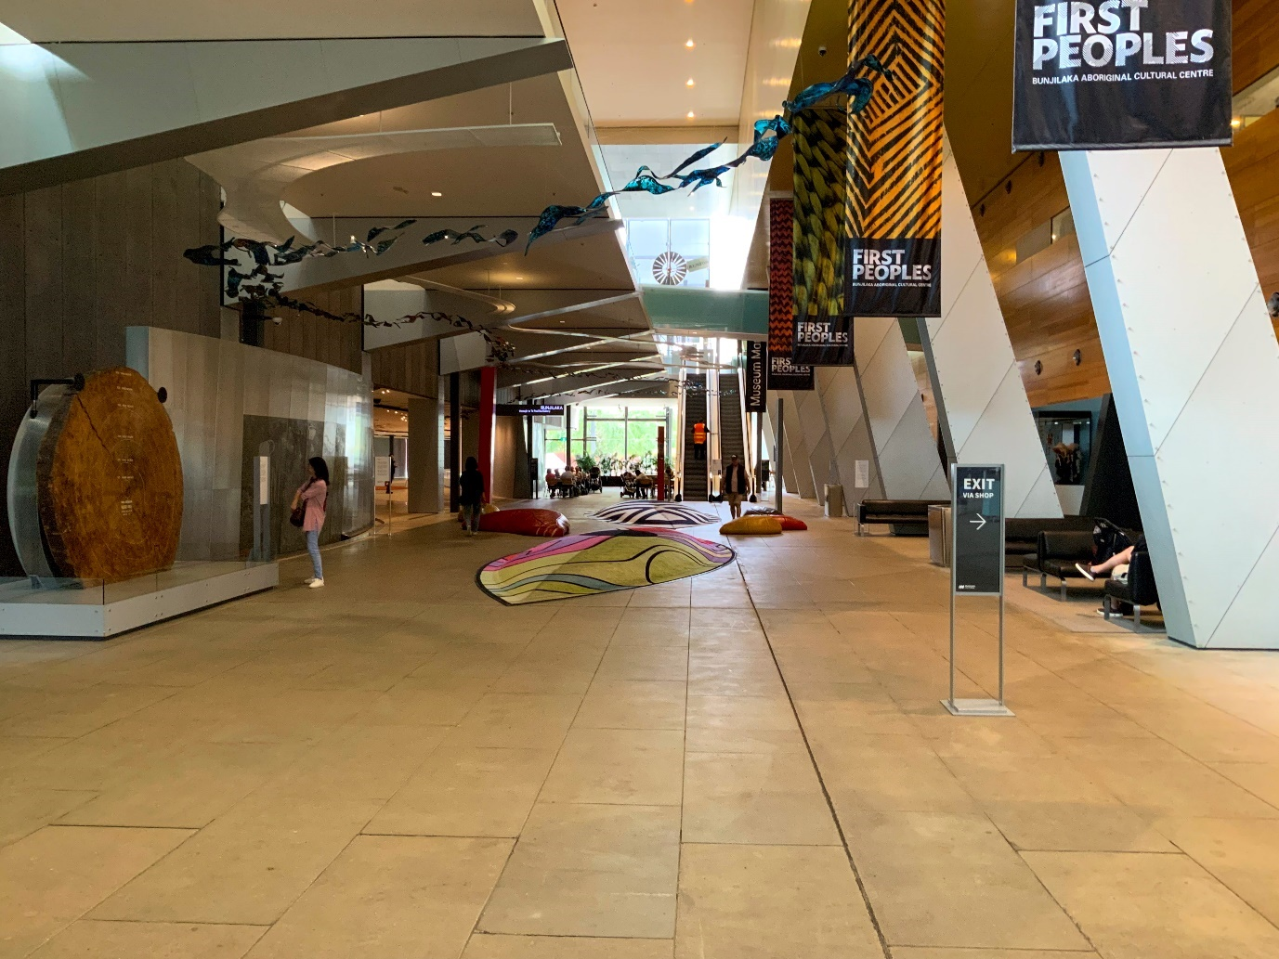Image 18- a photo of the escalators after passing through reception and turning right. You will pass large, textured floor cushions decorated in First Nation designs, and sitting areas and bathrooms on your right. If you have reached the cafeteria you have gone too far.
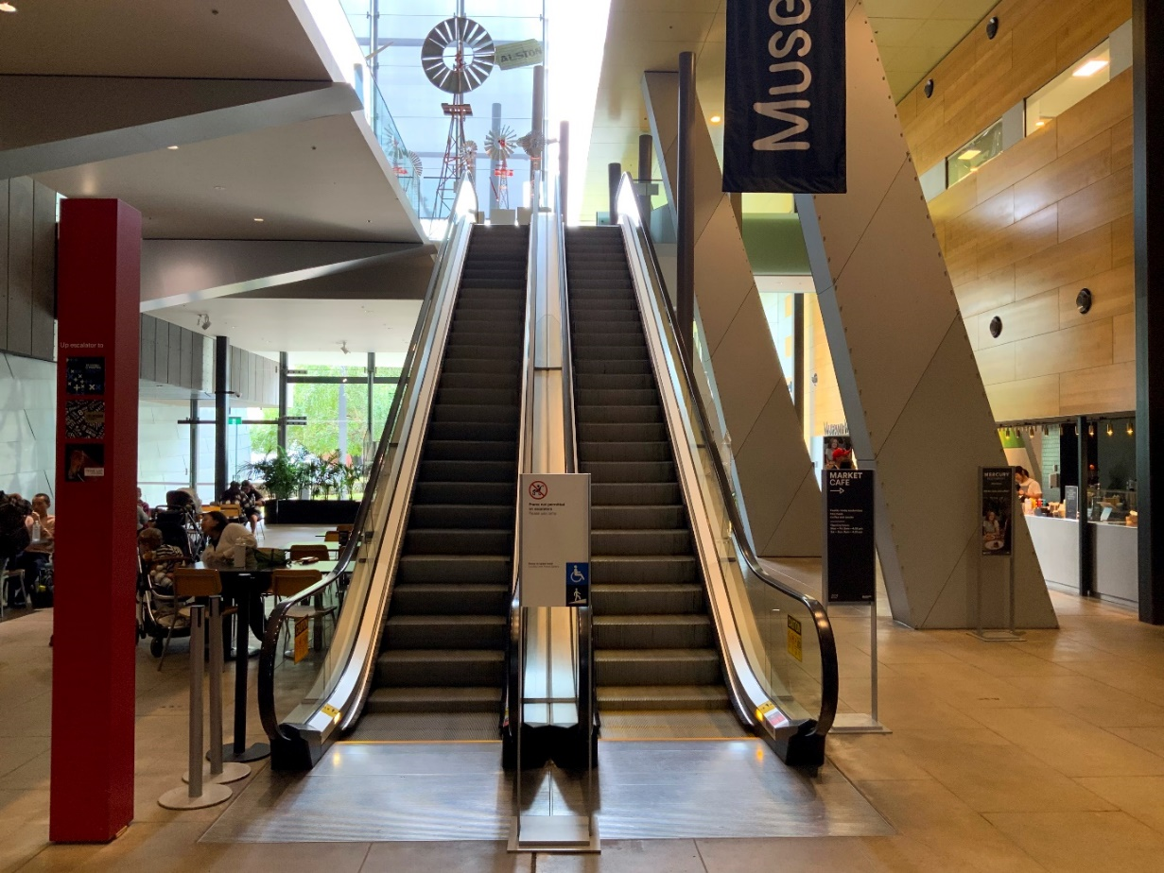
Image 19- a close-up photo of the escalators. The left escalator goes up. The right escalator goes down.
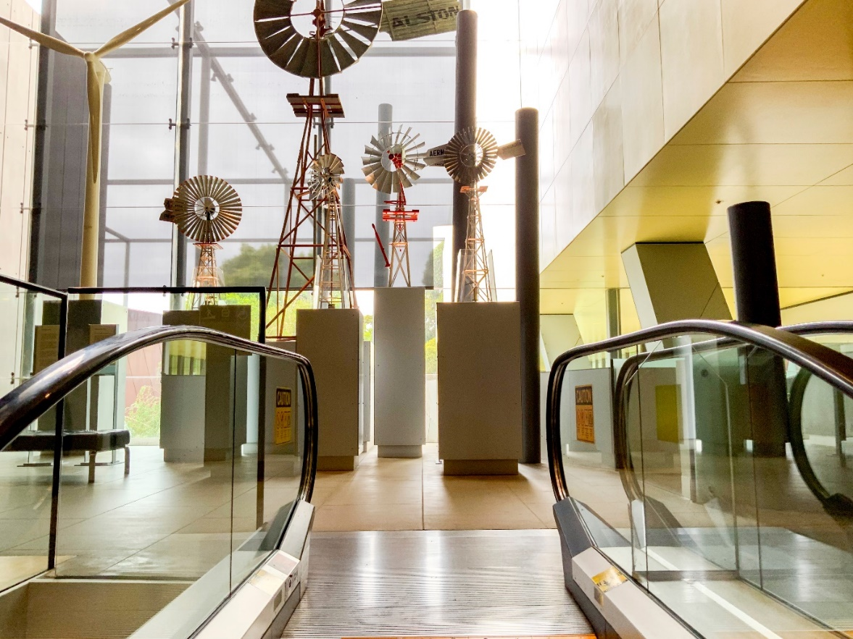
Image 20- a photo of the view at the top of the escalators as described above.
Turn left once you reach the top of the escalators. Travel 3 metres and turn left again. You are on the mezzanine. The entrance to the Melbourne Gallery is 20 metres away, on your right. Refer to image 21 below.

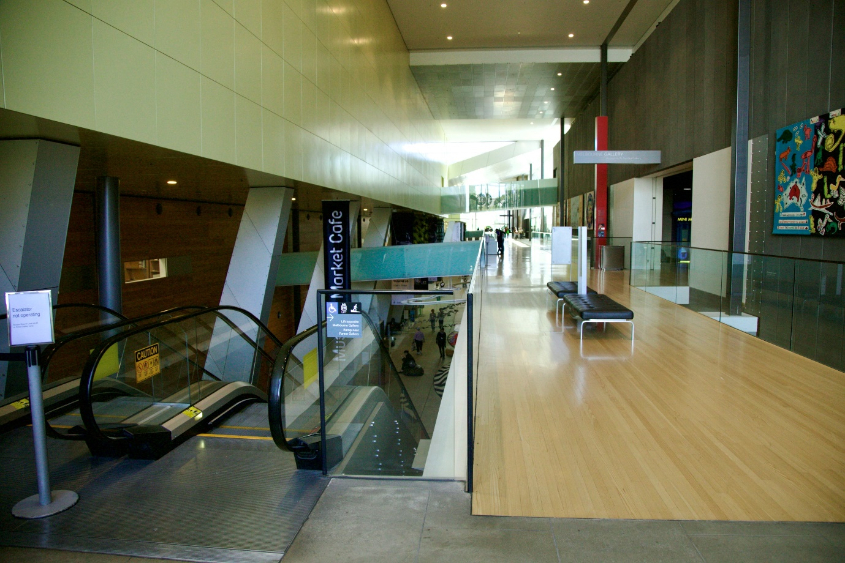Image 21- a photo similar to above but showing a set of escalators in the foreground, with the ramp 10 metres away. These escalators can be found on ground level near Bunjilaka Gallery, and Melbourne Gallery on Upper level.
Note about second pair of escalators:
There is another set of escalators from Ground level to Upper level near the Blue Whale Skeleton and the Science and Life Gallery. Refer to image below.
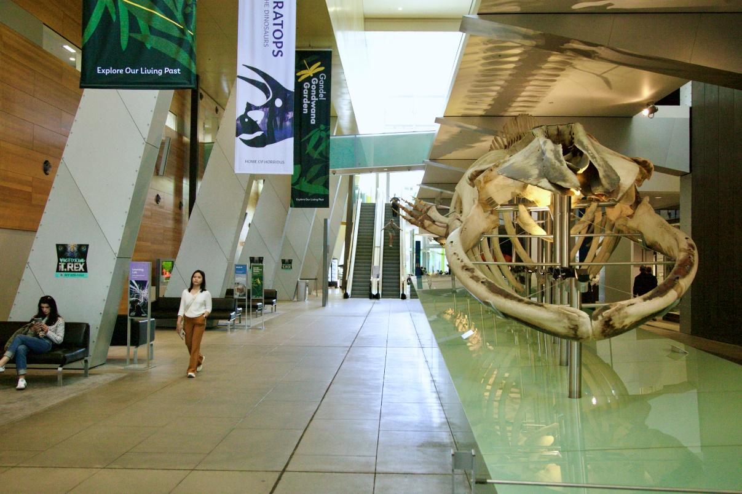
Image 22- a photo of the corridor that leads to the escalators as described above. You will pass an 18.5 metre Blue whale skeleton and the Science and Life Gallery on your right, and sitting areas and bathrooms on your left. If you have come to the Children’s Gallery, you have gone too far.

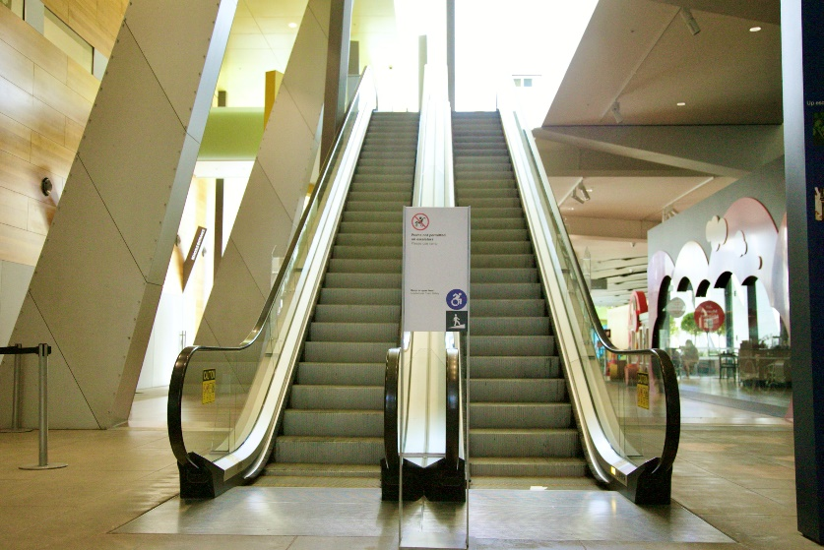
Image 23- a close-up photo of the second pair of escalators. The left escalator goes up. The right escalator goes down.
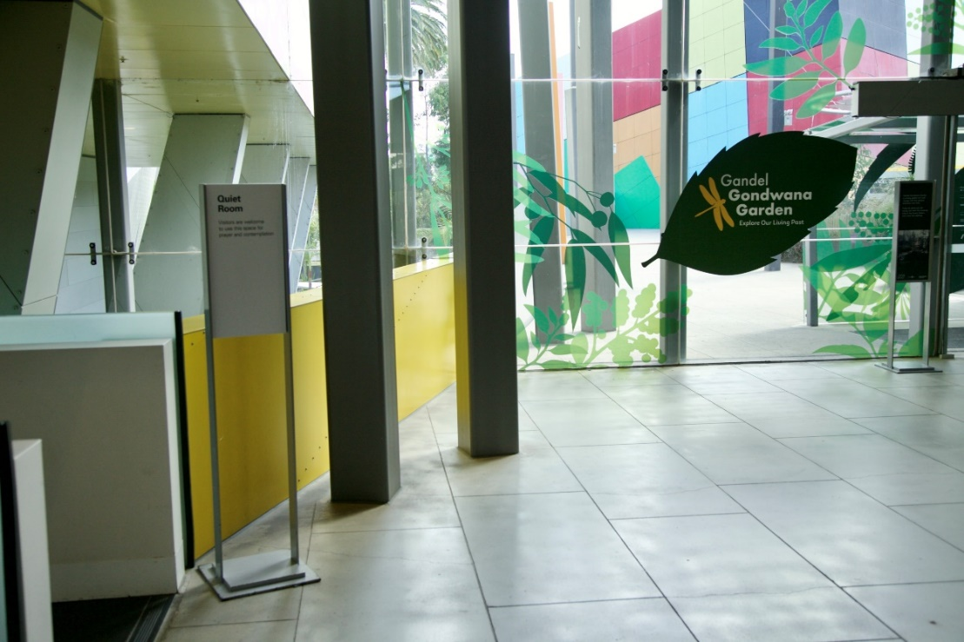
Image 24- a photo of the view at the top of the second pair of escalators as described above.
Turn right once you reach the top of the second pair of escalators. Travel 5 metres and turn right again. You are on the mezzanine. The entrance to the Melbourne Gallery is 100 metres away, on your right. Refer to Image 25 below.
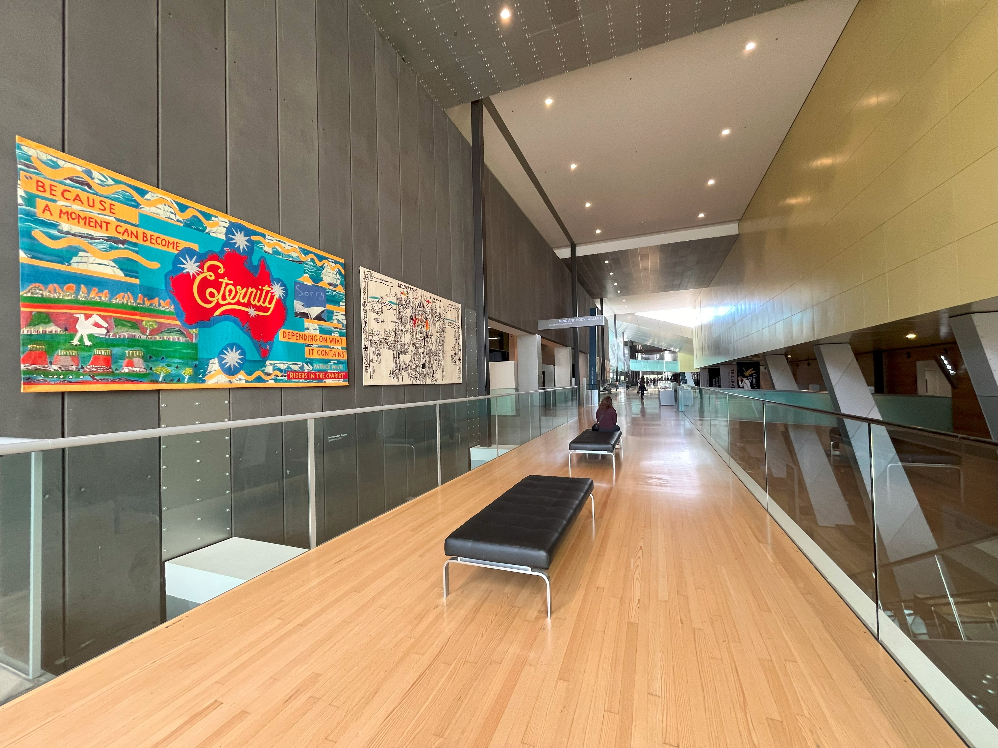
Image 25- a photo of the mezzanine at the top of the second pair of escalators.

Exhibition Information

Exhibition Entrance
To the left of the display on Phar Lap the racehorse is the entrance to Top Designs 2025. Refer to Image 26 below.
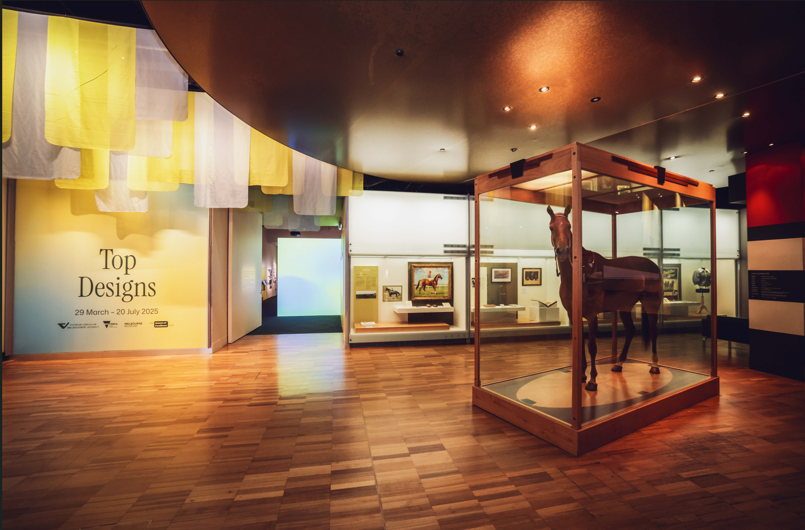Image 26- a photo of the entrance to the Top Designs exhibition to the left of the Phar Lap display in the Melbourne Gallery.

First, you will see the words ‘Top Designs’ in bold blue letters on a pastel blue and yellow graphic application, with fabric fringing hanging above. Refer to Image 27 below.

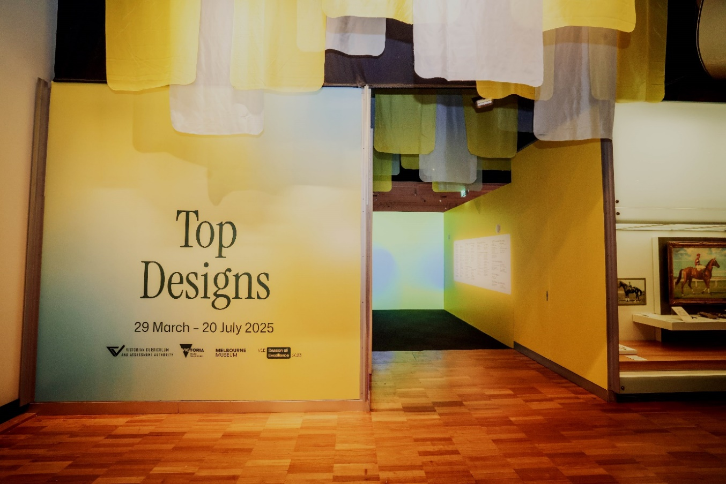
Image 27-

Entrance Corridor
Moving into the entrance corridor, there is a soft motion graphic application in pastel blue and yellow projected onto the wall ahead. Soft music can also be heard in this entryway.
On the left wall of the entrance corridor is an Acknowledgment of Country.
On the right wall of the entrance corridor is a list of all the exhibitor names and schools, grouped by study area. Refer to Image 28

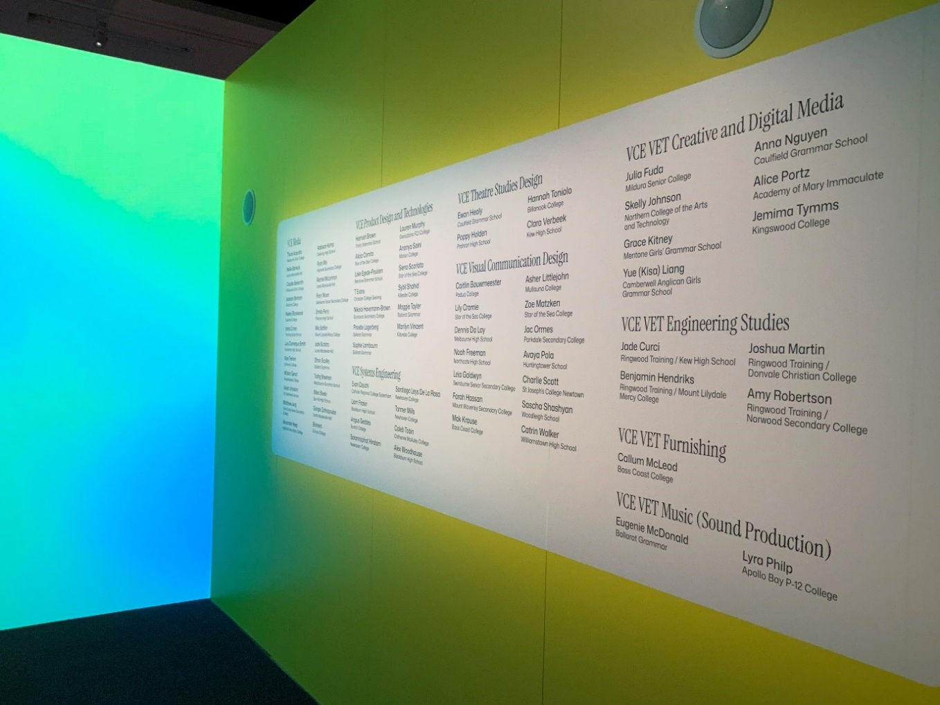Image 28-

Welcome Wall
You will take a left towards the Welcome Wall, which also appears on a pastel blue and yellow graphic application. Refer to Image 29 below.
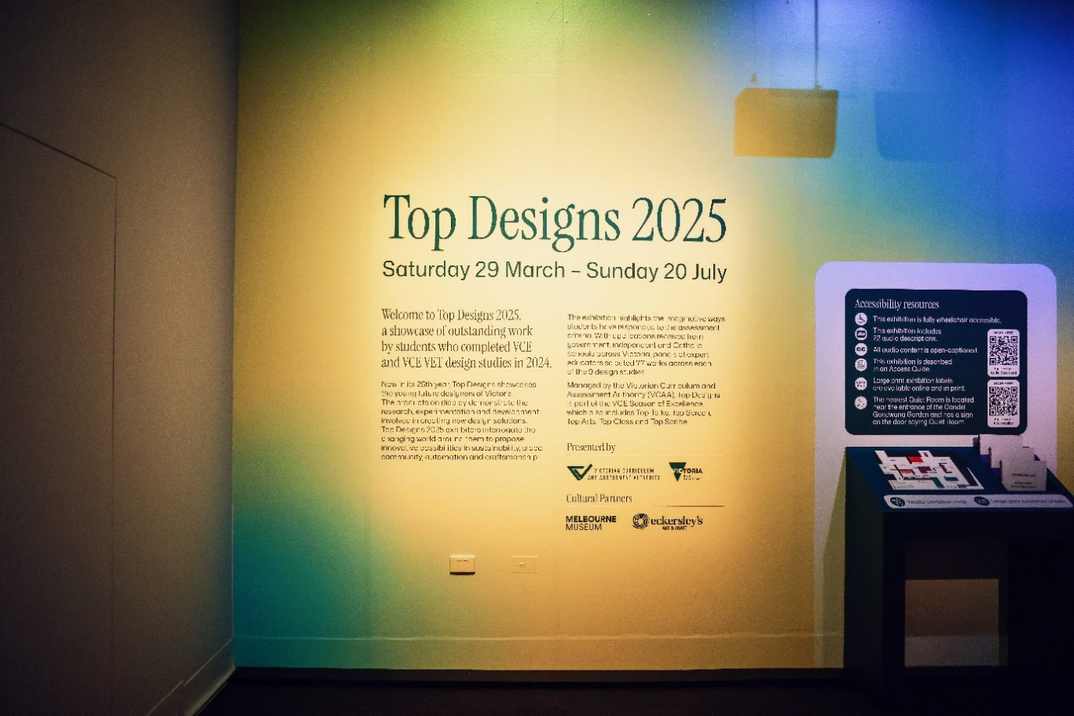
Image 29- a photo of the Welcome Wall.
To the left of the Welcome Wall, there are labels that credit the VET Music (Sound Production) student whose music is playing in the entryway, along with a list of Taubman’s paint colours used in the exhibition.

To the right of the Welcome Wall there is an ‘Accessibility Resources’ information panel.

This panel has two QR codes on the right-hand side margin and both are placed at a wheelchair accessible height.
The first QR code will take you to an audio described exhibition introduction of Top Designs 2025. The second QR code will take people to the Melbourne Museum Top Designs accessibility web-hub.
Beneath this panel, there is a teal-coloured slanted table that contains a tactile, Braille-labelled, A3-sized exhibition floorplan on a pedestal and is accessible to wheelchair users. There are also printed booklets of large format exhibition labels.
A further slanted table is positioned on the right contains touch-screen interfaces to access educational resources. Refer to Image 30 below.
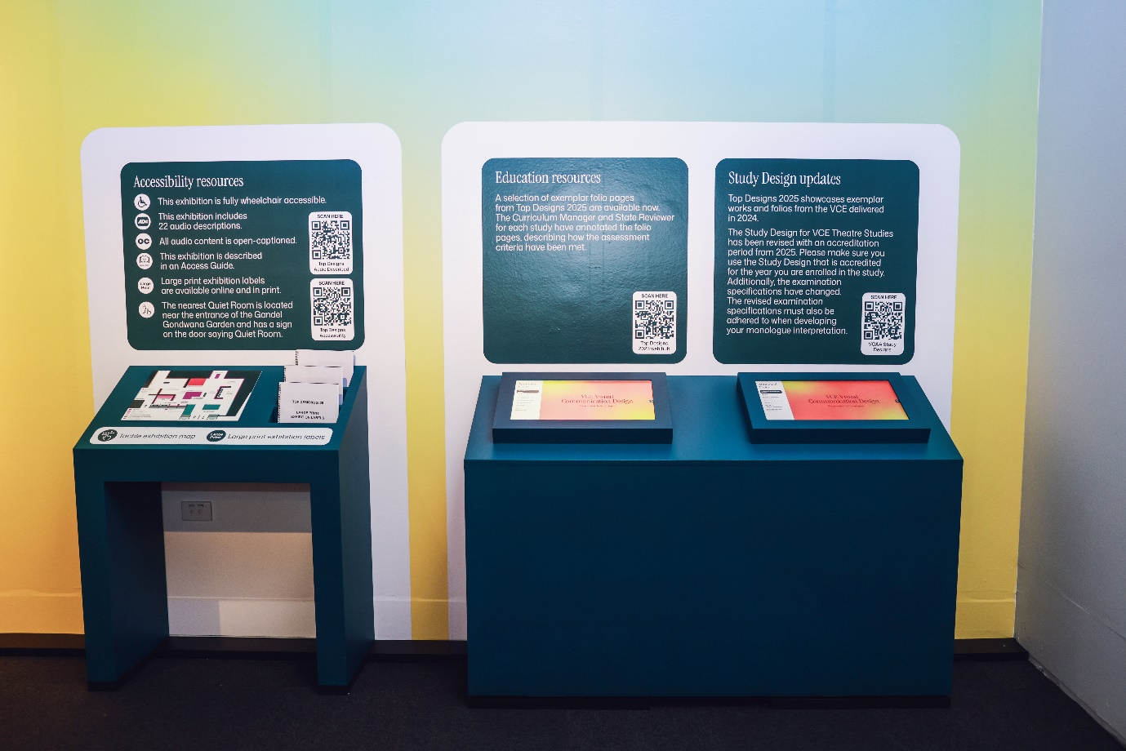Image 30- a photo of accessibility and education resources to the right of the Welcome Wall.

Study Banners
Each VCE and VCE VET design study area has a distinct four metre high x 90 centimetre wide banner in various colours.
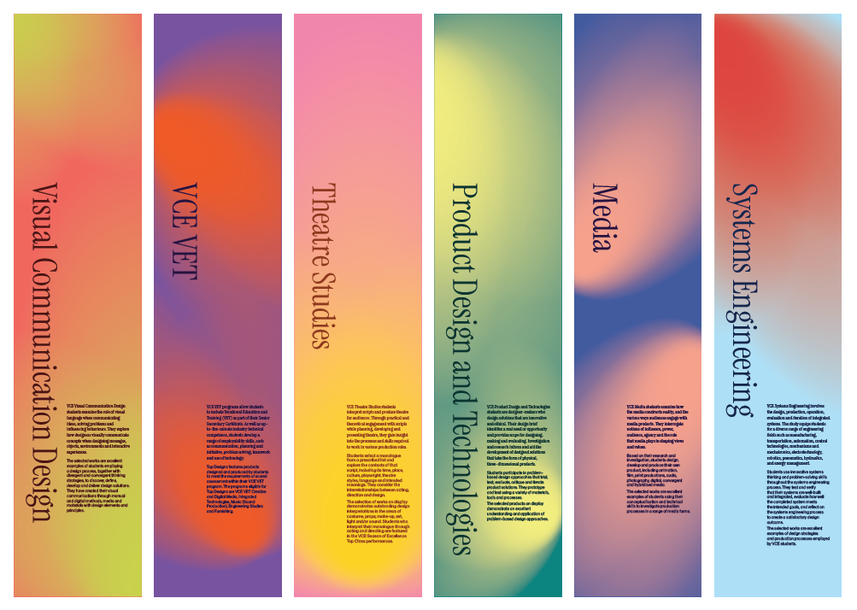
Image 31- Image photos of each banner featuring from top to bottom- the name of study area, paragraph description, on the right-hand side at wheelchair accessible height.

Layout
We will use compass directions to describe the space in a clockwise direction, starting from the entrance and refer to this side of the space as South-
The West wall features the Welcome Wall, Accessibility and Education Resources and VCE Visual Communication Design works.
In the inner area on the left features more VCE Visual Communication Design works.
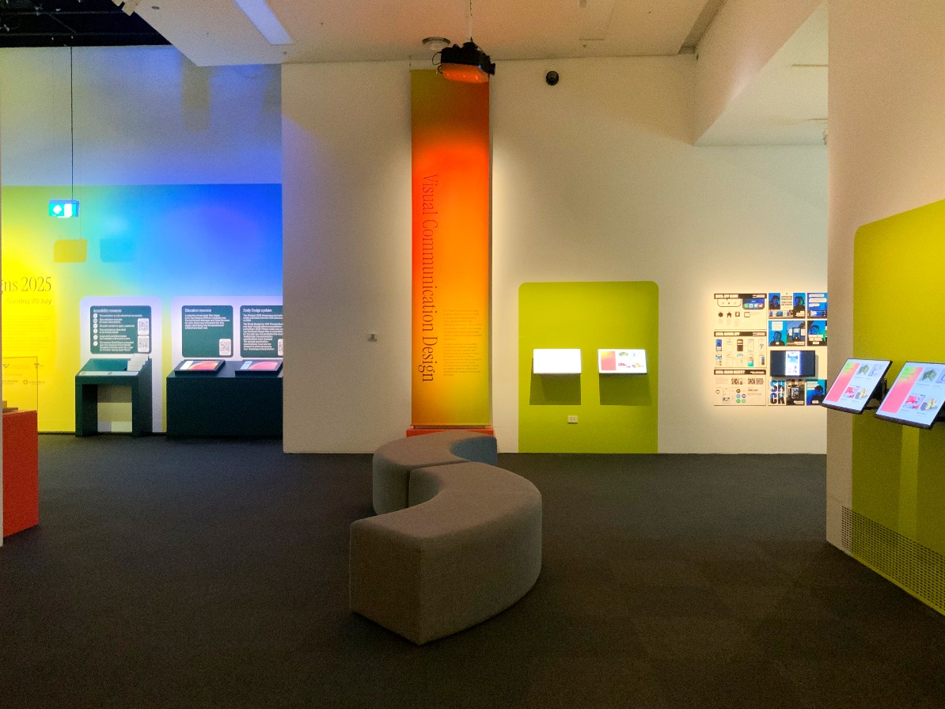Image 32- West view from the entrance

The North wall features Student Interview videos, VCE Visual Communication Design, VCE Systems Engineering, an alcove for VCE Media- Print works and VCE Media Photography works.

In the inner area in the middle of the space is a platform with VCE VET Engineering, VCE VET Furnishing and VCE VET Creative and Digital Media works.
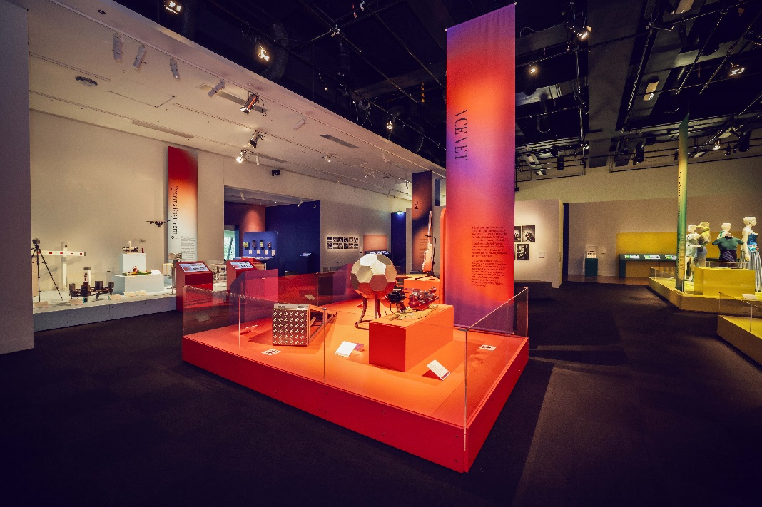

Image 33- North view from the middle of the exhibition space

The East wall features VCE Media- Film and VCE Product Design and Technologies.

In the inner area on the left, there is a freestanding wall with VCE Media- Digital/Online and a second VCE Media- Photography work.

In the inner area on the right, there is a platform with VCE Product, Design and Technologies works.

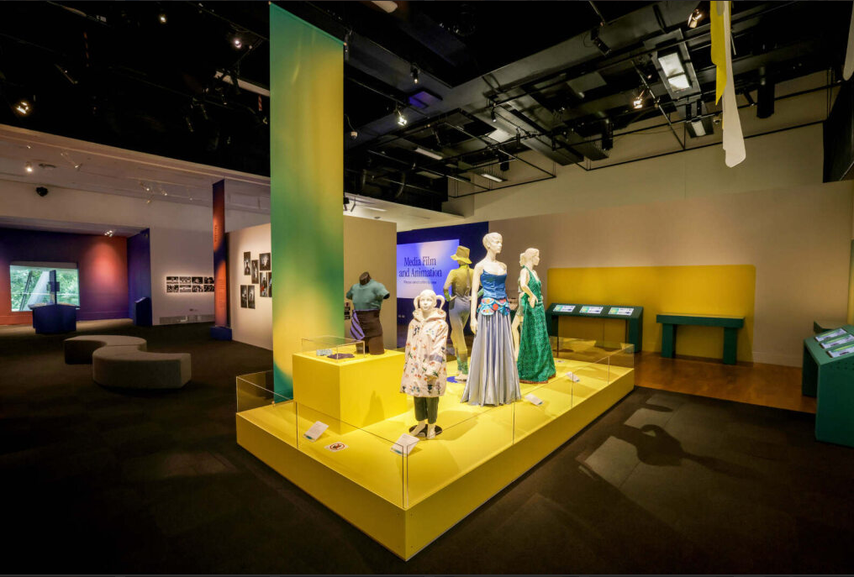Image 34- East view from the exit

The South wall features VCE Product Design and Technologies works, as well as alcoves for VCE VET Music (Sound Production) and VCE Theatre Studies.
There is an enclosed inner area to the right, which features VCE Theatre Studies works and demonstration videos.

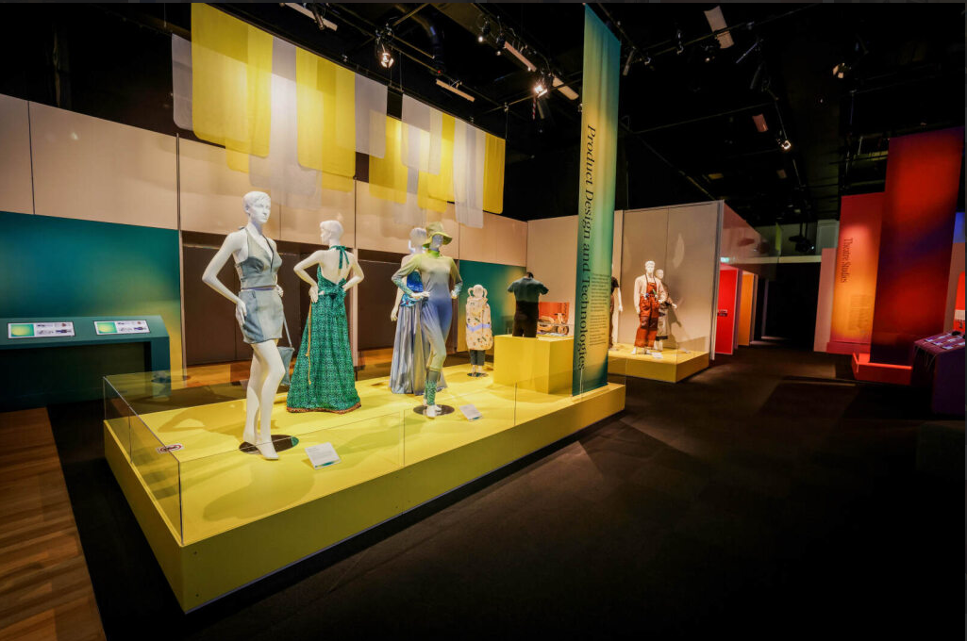Image 35- South view from the right of the exhibition space

Seating
There is ottoman-style seating in the central areas of the exhibition space, as well as seating with back support in the Media- Film and Theatre Studies areas. Refer to Images 36–39 below.
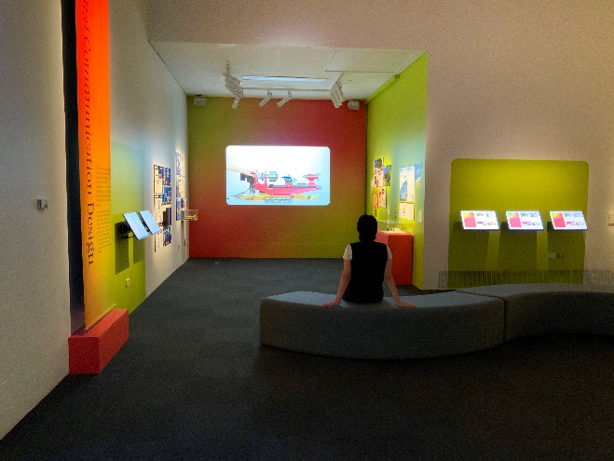 | 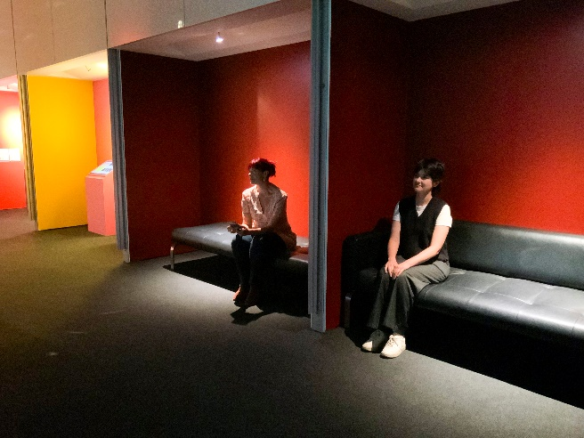
Image 36- person sitting on ottoman style seating in Visual Communication Design area | Image 37- two people sitting in Theatre Studies area
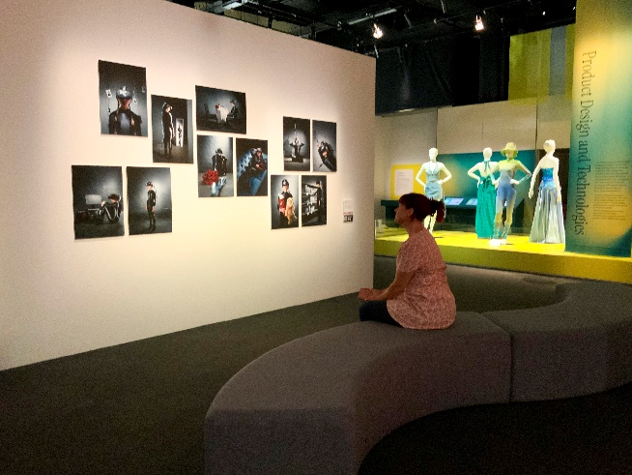 | 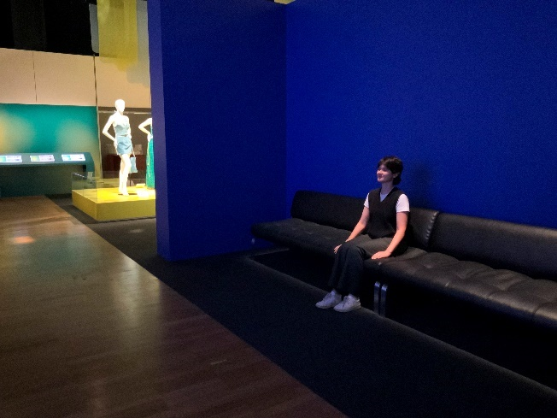
Image 38- A person sitting on long ottoman style seating in Media- Photography and Product Design and Technologies area | Image 39- A person sitting in Media- Film alcove

Exhibit displays and sensory information
Objects are displayed on walls, plinths and platforms at various heights, behind or within clear acrylic cases and walls. Refer to images below.
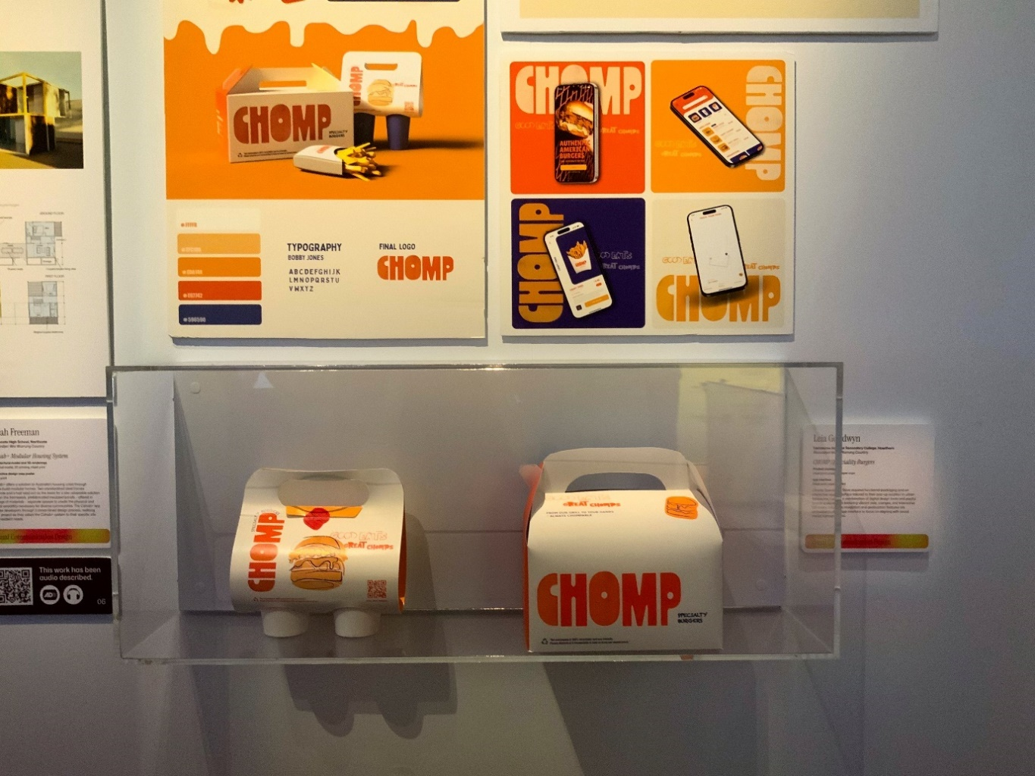
Image 40

Exhibitor labels with student name, school name, title of work and statement is displayed near the work.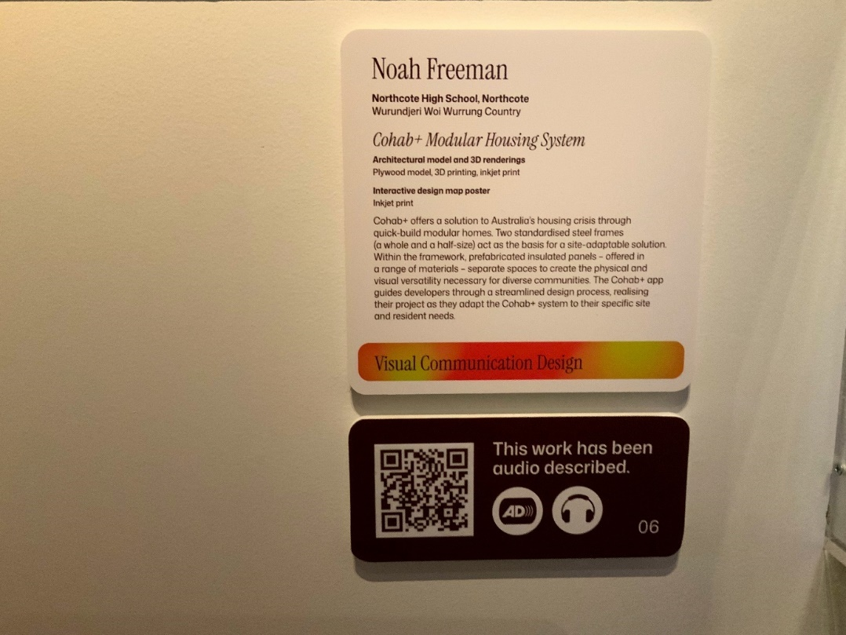
Image 41

There are 22 audio descriptions, ranging from 2-8 minutes in length.
Audio descriptions can be accessed via QR codes, which appear underneath wall labels or an image of the object. Refer to Image 42 and 43.
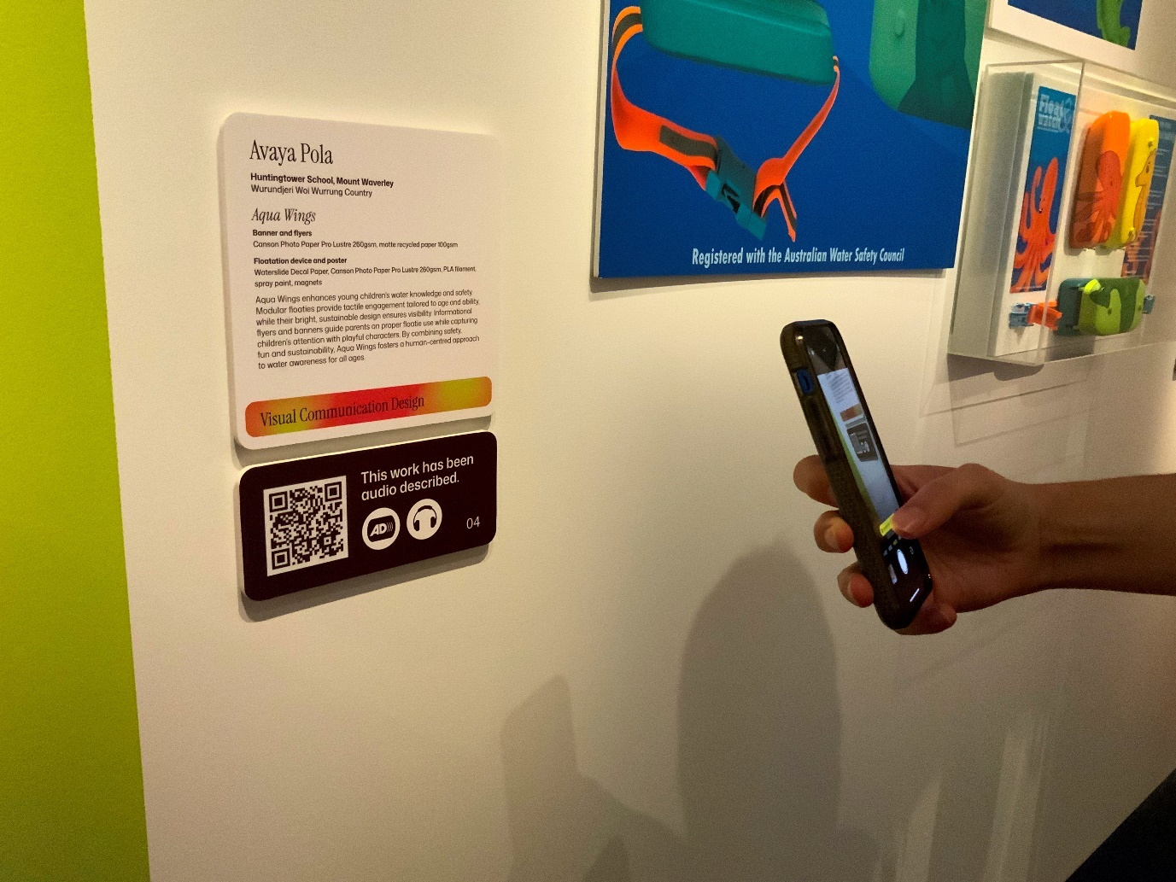
Image 42- a close up photo of a QR code displayed below the wall label of a work in Visual Communication Design. The burgundy and white graphic of the code is on a burgundy background, with text beside it that reads: This work has been audio described.
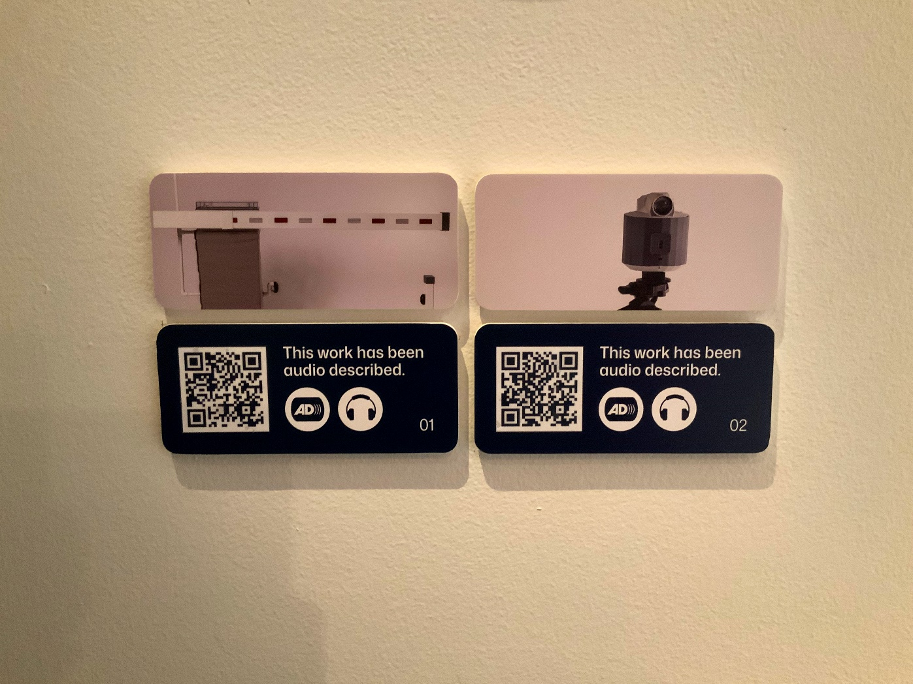
Image 43- a close up photo of two QR code displayed below small printed photographs of Systems Engineering works. The navy and white graphic of the codes are on a navy background, with text beside it that reads: This work has been audio described.

A content warning sign is displayed near the Media- Film area.

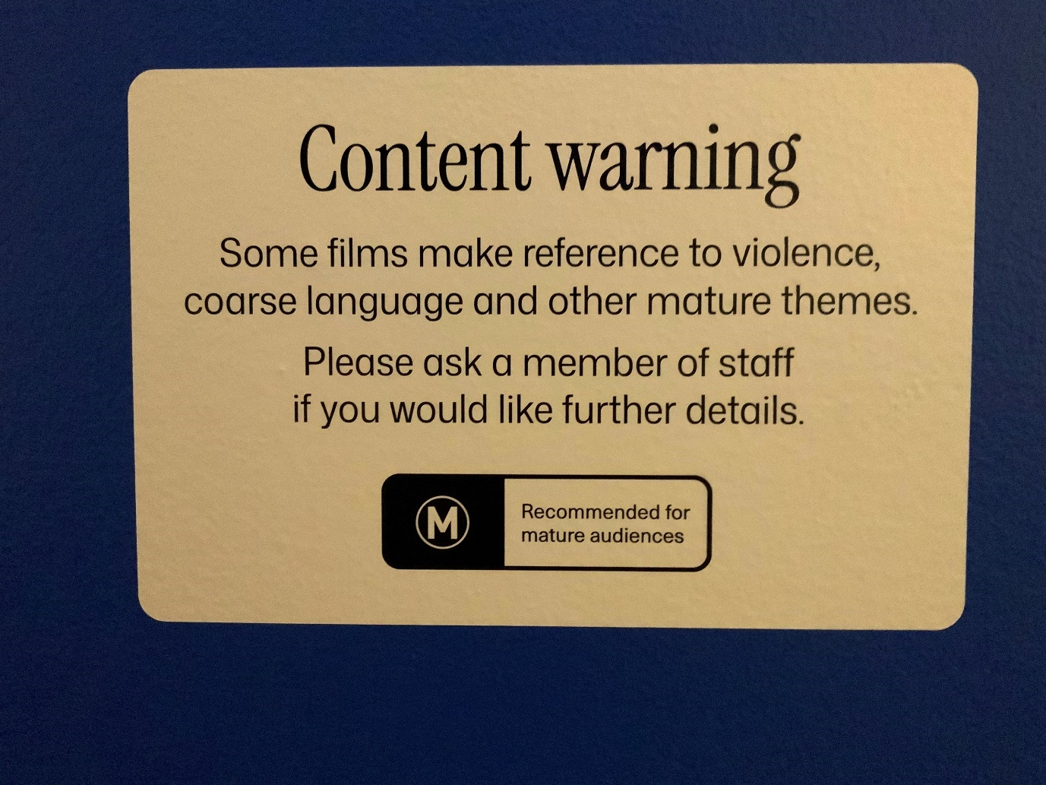
Image 44- White curved edge rectangle with black text reads: Content Warning. Some films make reference to violence, coarse language and other mature themes. Please ask a member of staff if you would like further details. M- Recommended for mature audiences.

Each study area will have a number of ‘digital hubs’. These are touchscreens mounted onto slanting pedestals where one can scroll through digitally scanned student folios.
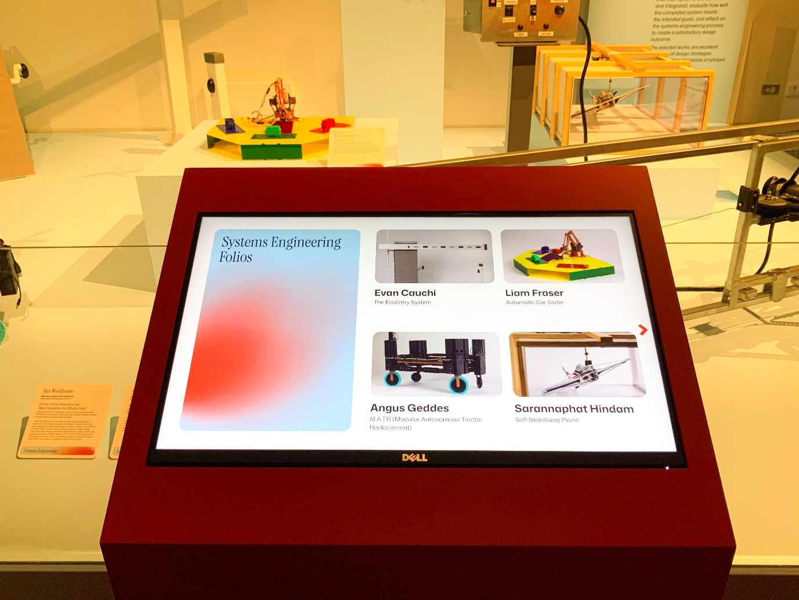Image 45-

Some digital hubs have 1, 2 or 3 touchscreens mounted.
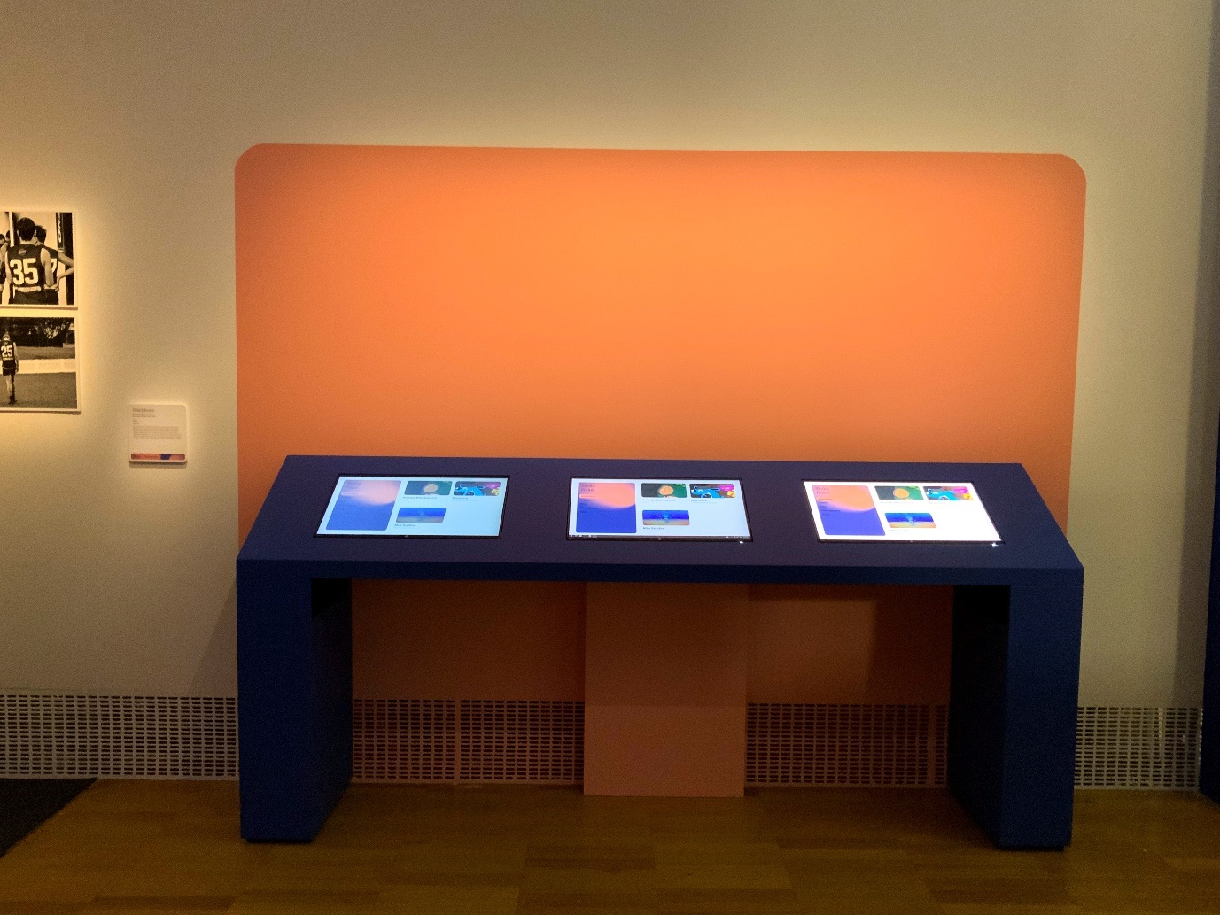Image 46-

Some touchscreens have also been mounted on the wall, such as in the Visual Communication Design area. Refer to image 47.
Although the touchscreens are not screen reader accessible, the font size is large, with high contrast colours, with black text on white background.
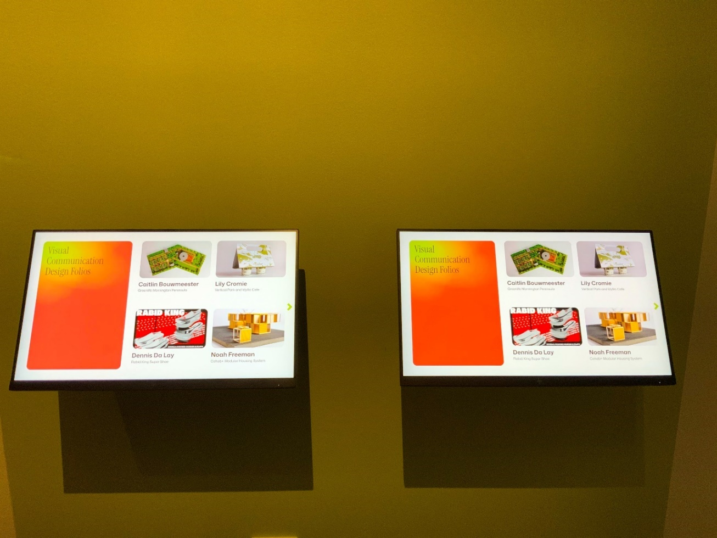
Image 47- a photo of the wall mounted touchscreens in the Visual Communication Design area displayed along the west wall.
All films have open captioning.
The exhibition entryway, student interview films and Media- Film and Media- Digital/Online and VET Engineering have sound playing through the speakers.

VET Creative and Digital Media and Music (Sound Production) works provide headphones for listening. There is no audio for the Theatre Studies video demonstration. Refer to images 48 and 49.
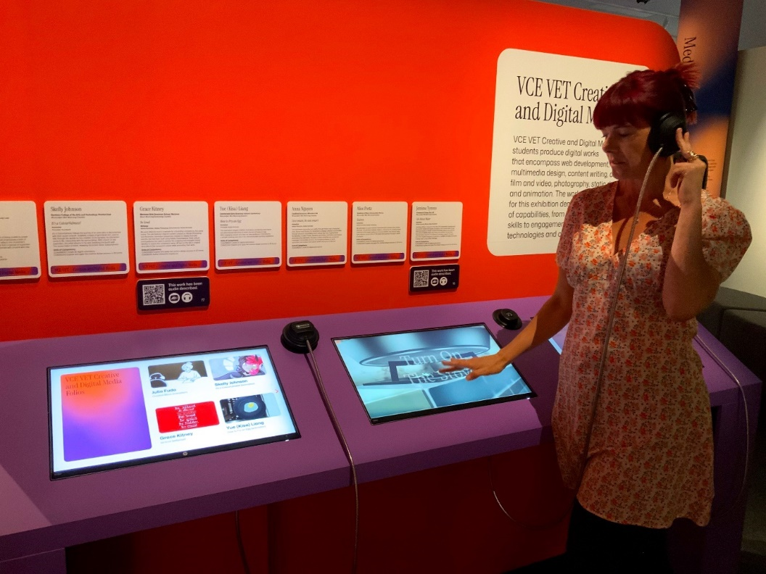
Image 48
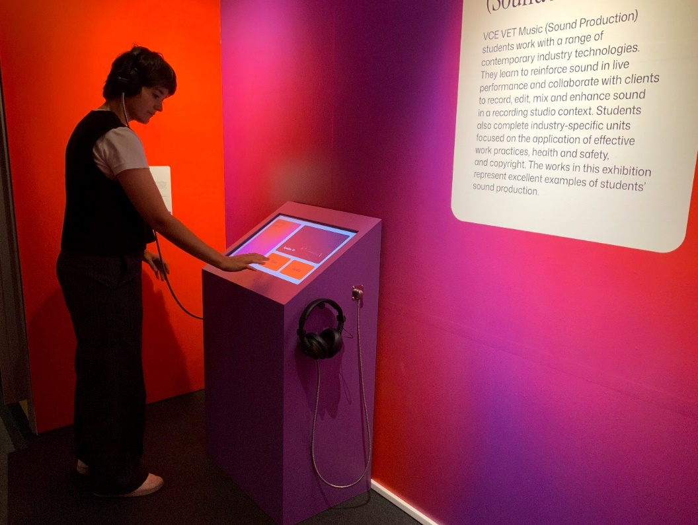
Image 49- a photo of the Music listening station which has two tactile buttons on the pedestal, a chair to the right, and headphones on either side.
VCE Visual Communication Design (study banner sunset pink and lime green)
Visual Communication Design student works span the left-hand end of the north wall and along inner free-standing display walls that have been erected in the inner area right hand side.
Each student’s work is showcased mounted to the wall or presented in a display case, or a combination of both, depending on the nature of the exhibit.
‘Meet the Exhibitor’ films are also projected in this area, in the nook at the end of the north wall.
There are 14 works in total of which 4 are audio described.
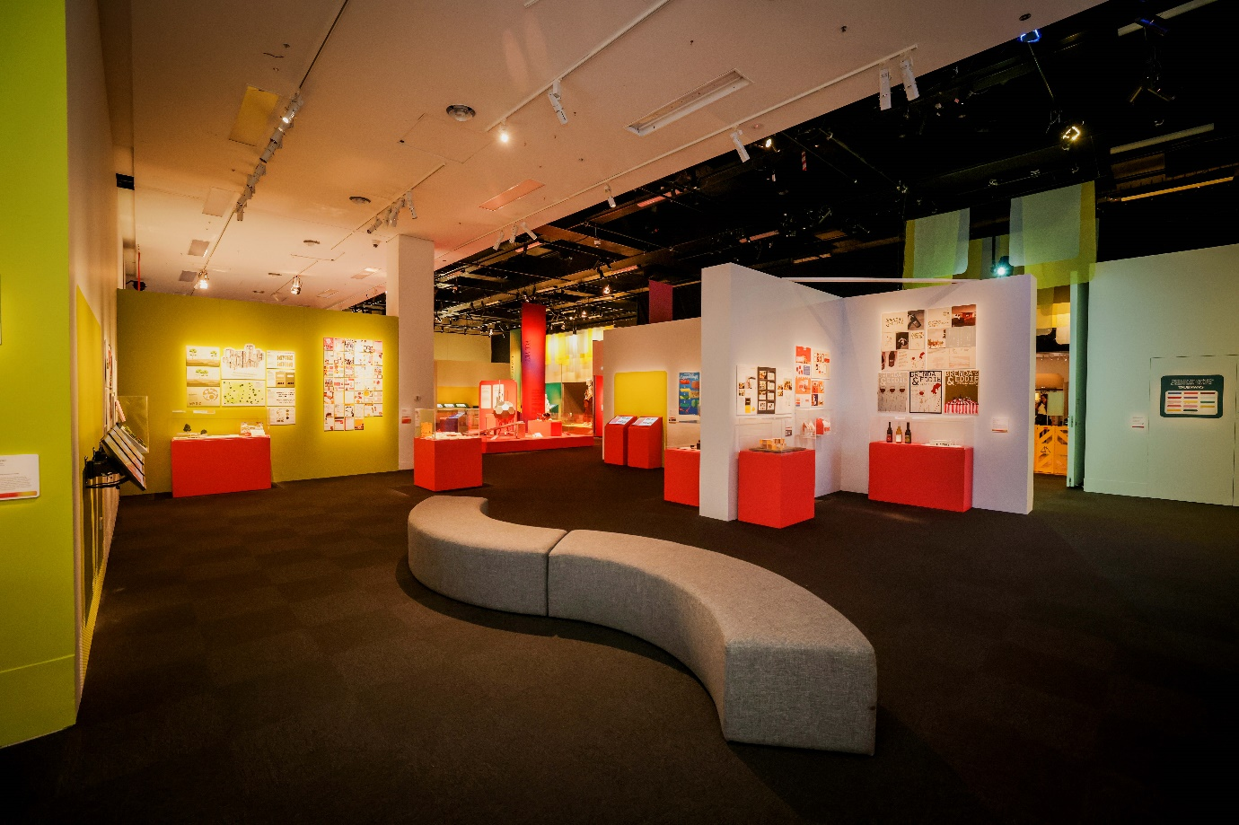
Image 50- a photo of the right hand side of the north wall and east wall each displaying a number of Visual Communication Design student works

VCE Systems Engineering (study banner blue/green)
Systems Engineering student works are located on a platformed area along the north wall, surrounded by clear acrylic barriers.
There are 8 works in total of which 2 are audio described.
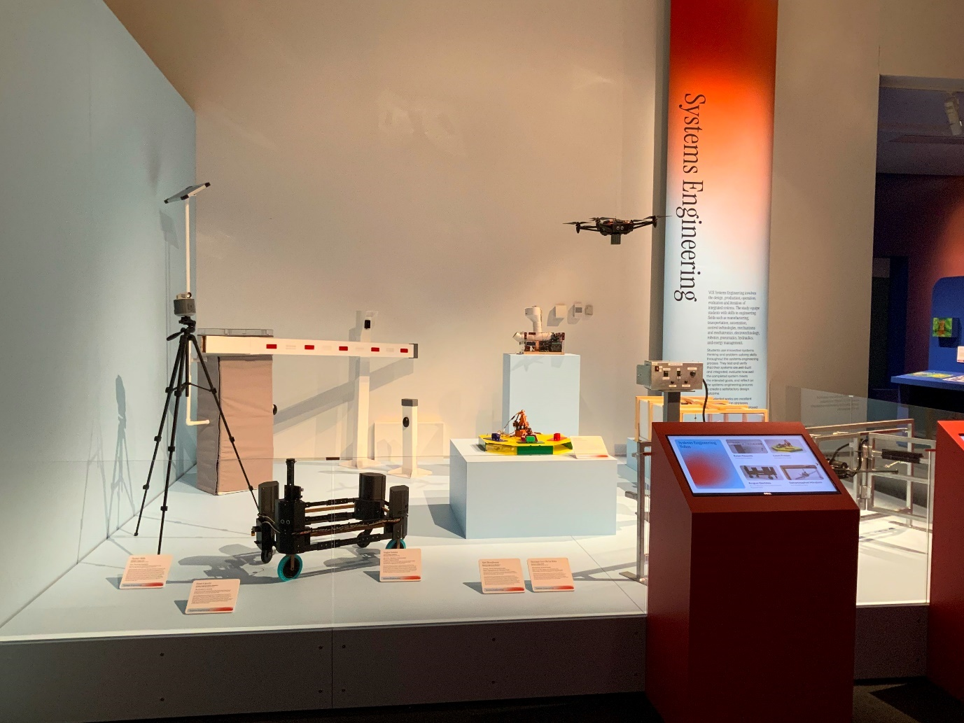
Image 51- a photo of the platformed area with clear acrylic barriers where System Engineering student works are displayed There are three digital hubs in front of this platformed area.

VCE VET (study banner red and purple)

VCE VET Engineering Studies and VCE VET Furnishing
VCE VET Engineering Studies and VCE VET Furnishing are displayed together on the same platformed area in the centre of the exhibition space. There are 4 VCE VET Engineering works in total of which 2 is audio described. There is 1 VCE VET Furnishing work, which is also audio described. 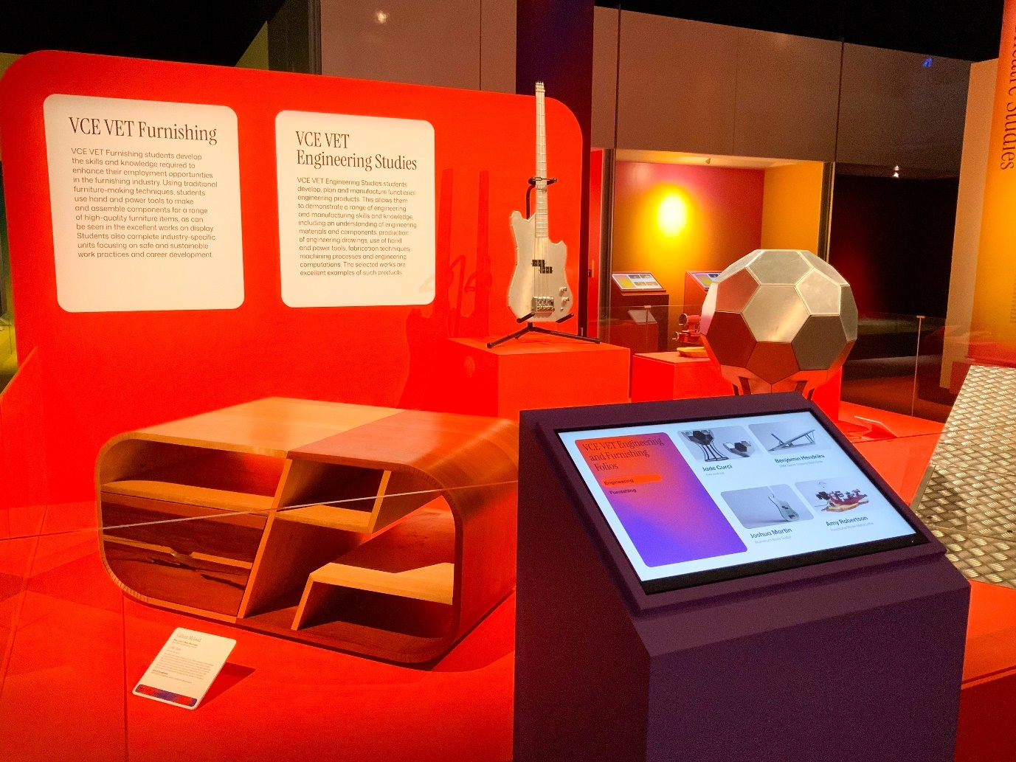
Image 52- a photo of the VCE VET Engineering Studies student works.

VCE VET Creative and Digital Media
VCE VET Creative and Digital Media is located behind the VCE VET Engineering and Furnishing works, located in the centre of the exhibition space. There are 3 free standing screens on a slanted table positioned against a freestanding wall with curved edges.
There are 7 works in total of which 2 are audio described.
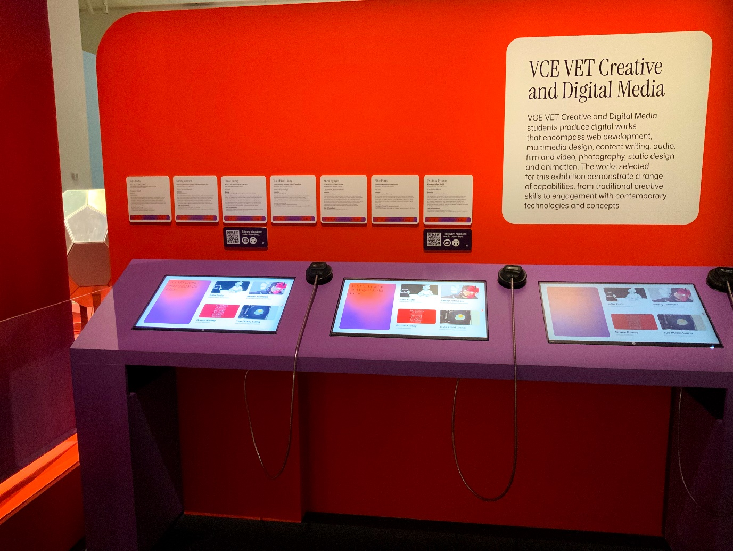
Image 53- a photo of the VCE VET Creative and Digital Media touchscreens in the centre of the exhibition space.

VCE VET Music (Sound Production)
VCE VET Music (Sound Production) is next to the above screens where you can find a listening station that has 2 tactile buttons on a pedestal with headphones on the lefthand side, and a chair to sit on, plus QR code displayed above.
You are welcome to scan the QR code with your phone and use the seating area in the middle to listen to the music using your own headphones. There are 2 works in total.
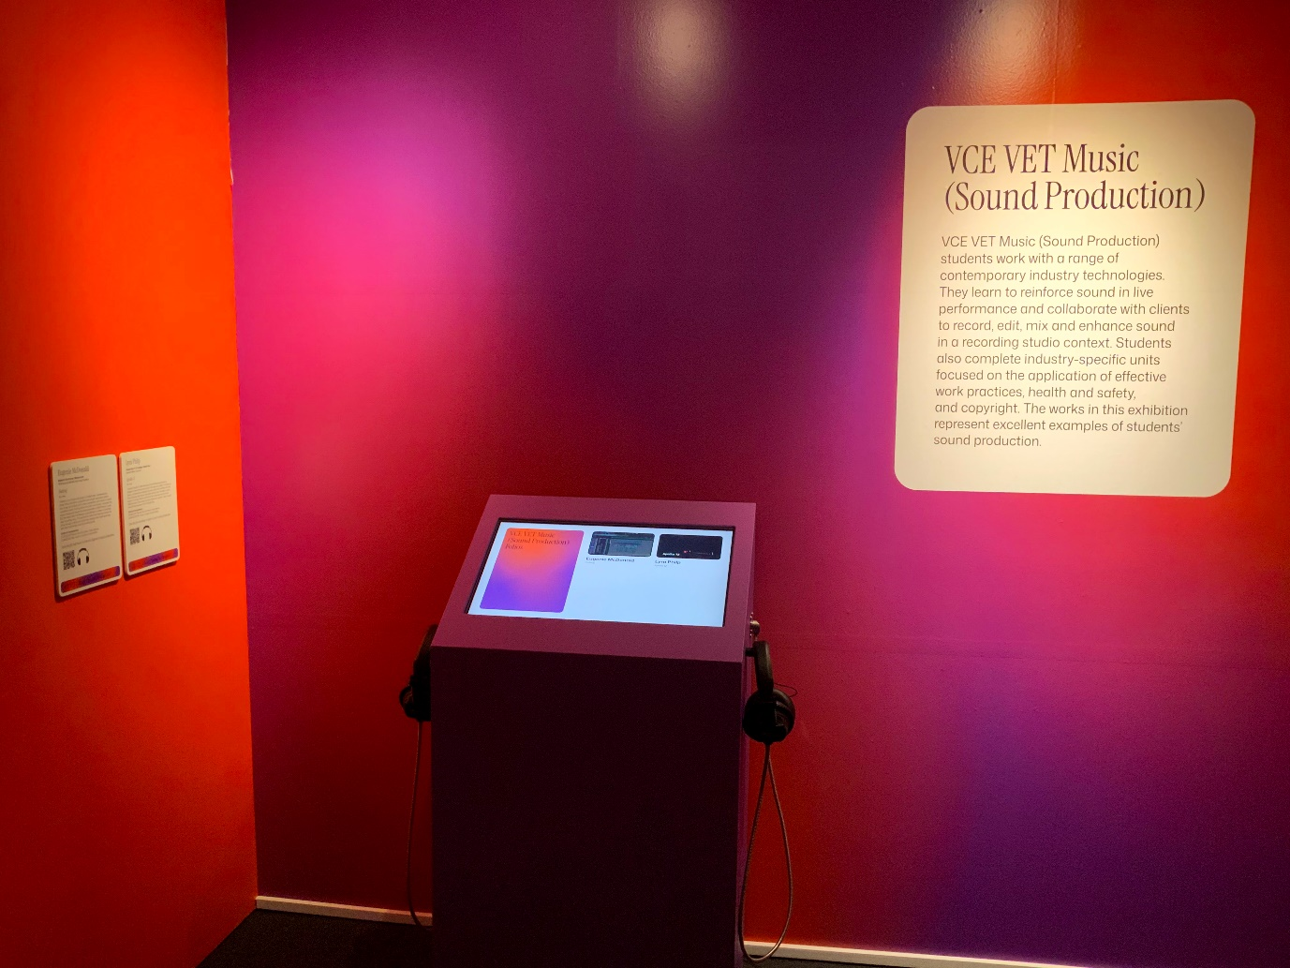
Image 54- a photo of the Music (Sound Production) listening station, a pedestal with two tactile buttons on tops, a chair to the right, and headphones on either side.

VCE Theatre Studies (study banner pink and yellow)
The Theatre Studies area is in an enclosed area along part of the south wall.
There is a 5 minute film projected onto the side freestanding wall in the space, which features four students demonstrating their works. The film has no dialogue or sound and is audio described.
In front of the film is a selection of small props and costumes from each of the four student works.
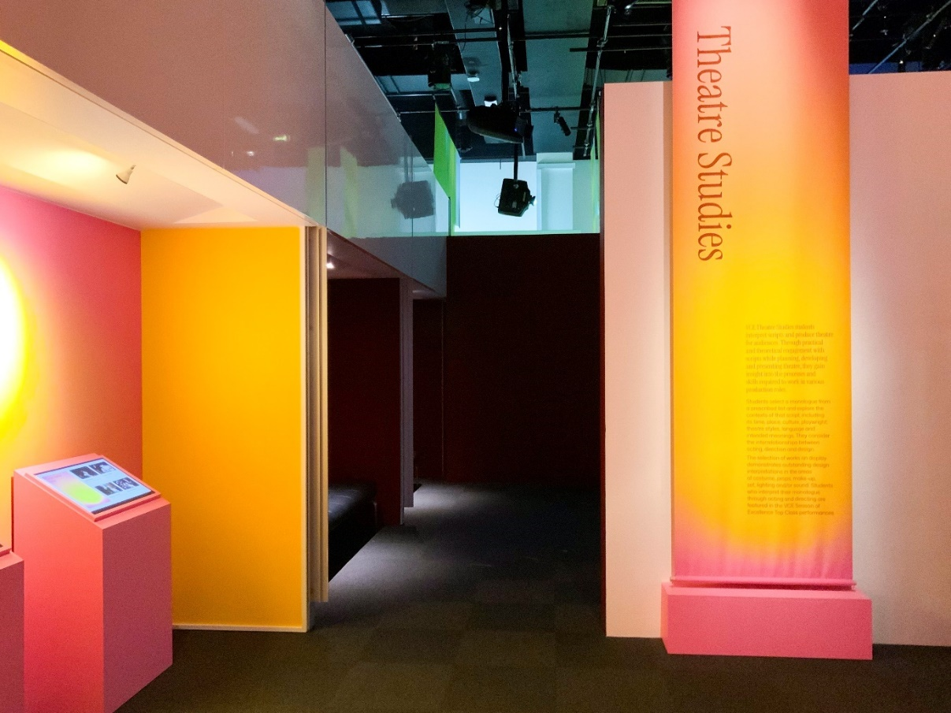
Image 55- entrance to the Theatre Studies area where the 5 minute showreel is projected on the side wall playing in loop.

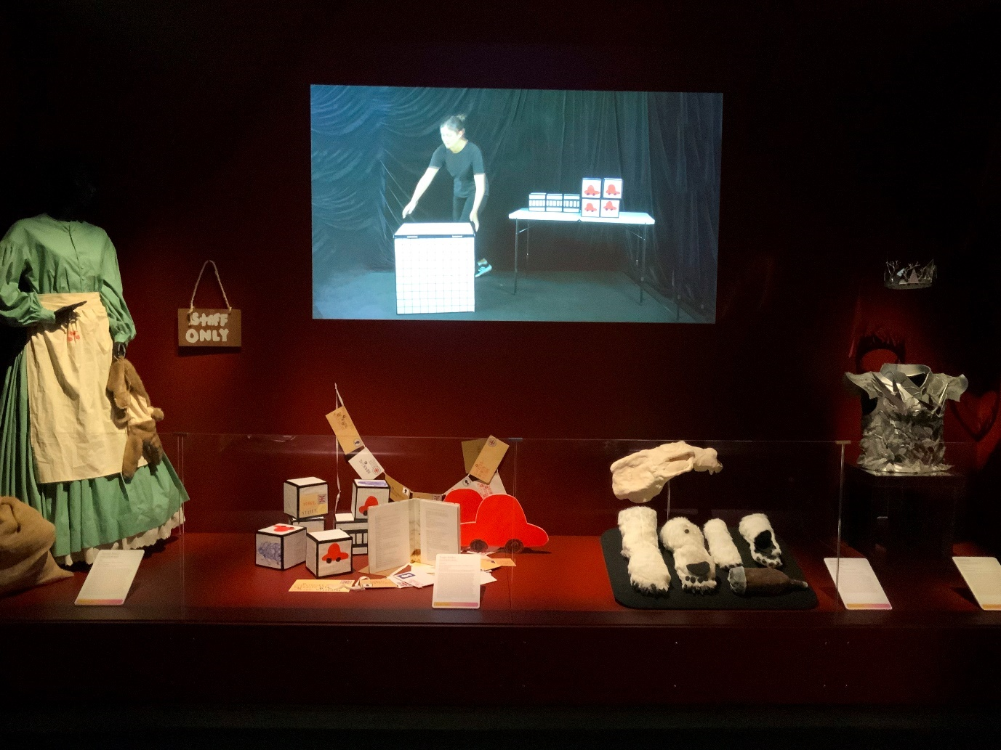
Image 56- a close up photo of the inside of the enclosed area containing Theatre Studies works and videos.

VCE Media- Photography
VCE Media Photography is located towards the north east corner of the exhibition space and features two works.
The first work is comprised of 11 photographs and is located on the inner freestanding wall, next to the Media subject banner.
The second is comprised of 12 photographs and is located on the right hand end of the north wall, next to the Media Digital hubs and is audio described.
Refer to images 57 and 58 below. 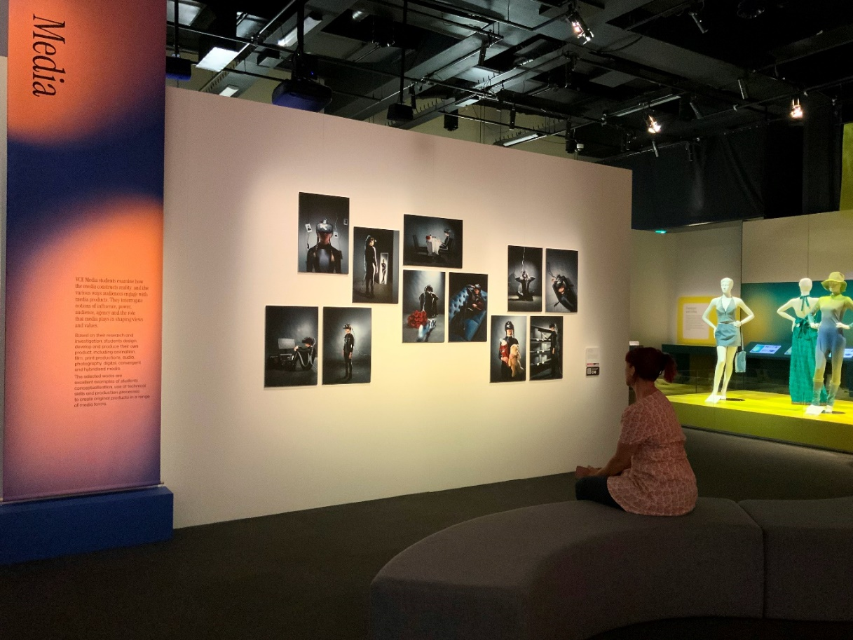
Image 57
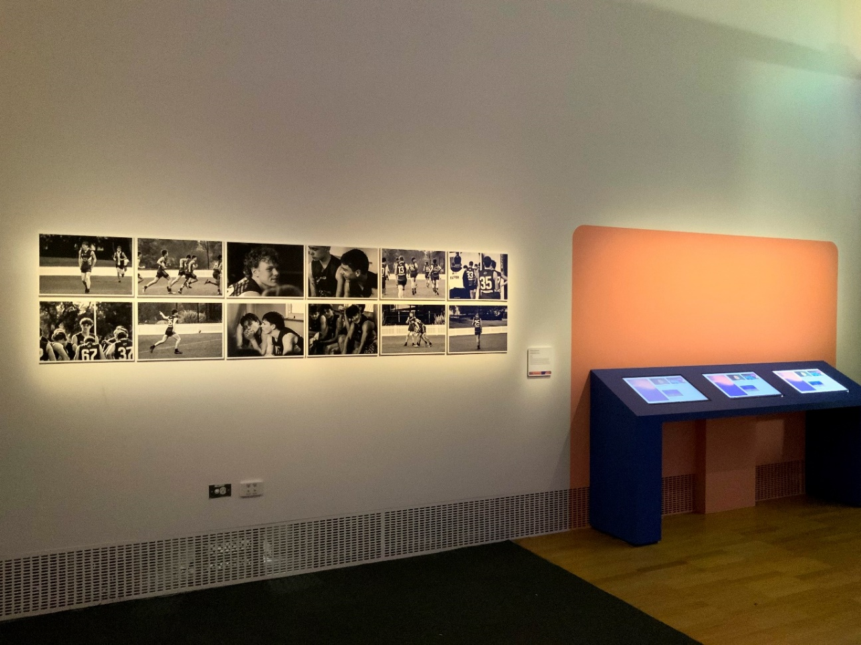
Image 58

VCE Media- Digital/Online

VCE Media- Digital/Online features two works and is located on the side of the freestanding wall, in between the two Media Photography works.

There is a video game, which is audio described, as well as a webtoon that can be accessed via a QR code on the wall label or the Digital Hub. Refer to Image 60 below. 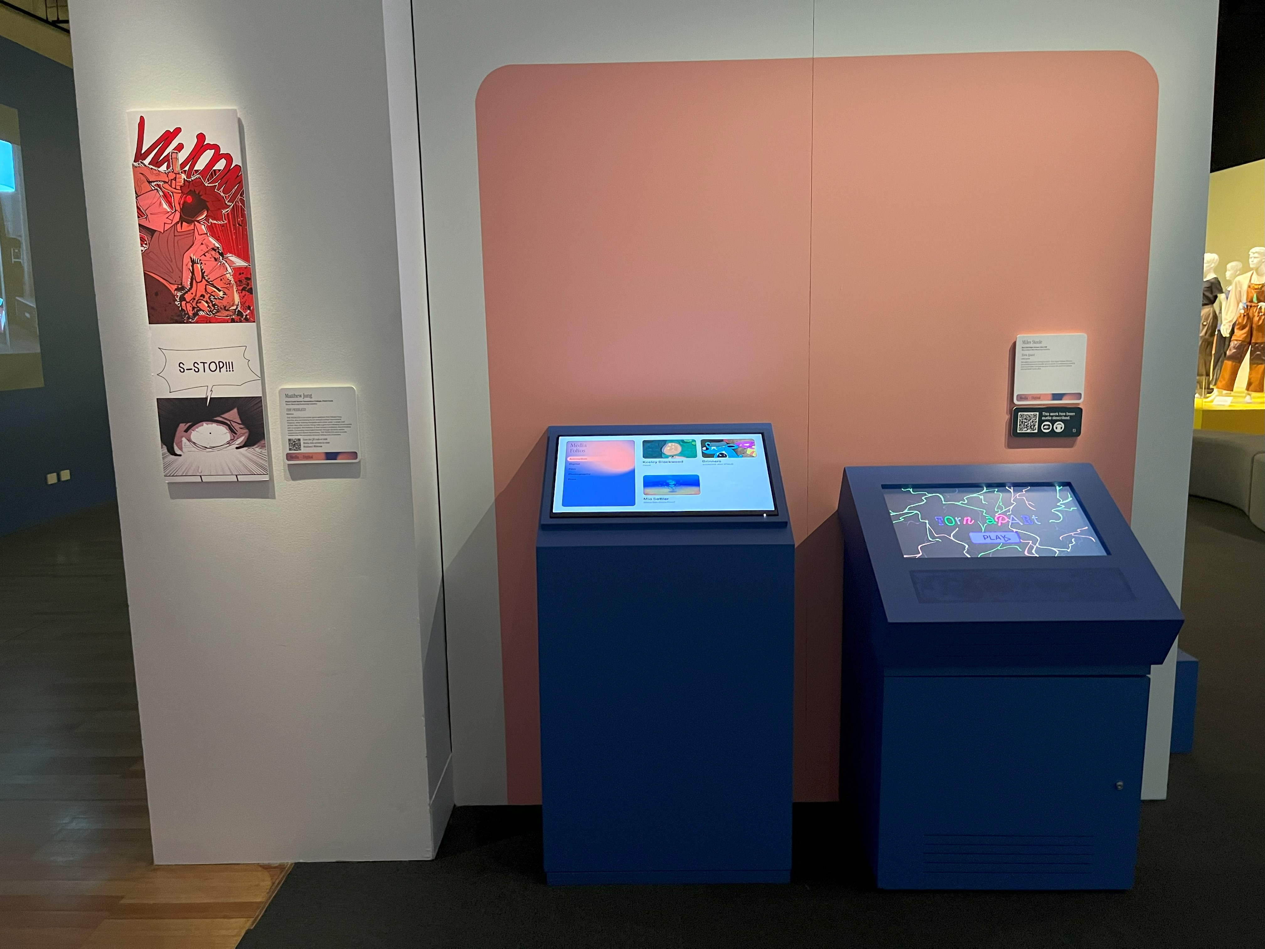
Image 59- new image needed of this area?

VCE Media- Print
VCE Media- Print is in the nook toward the end of the north wall, opposite to Media Film. There are 7 works in total of which 1 is audio described.
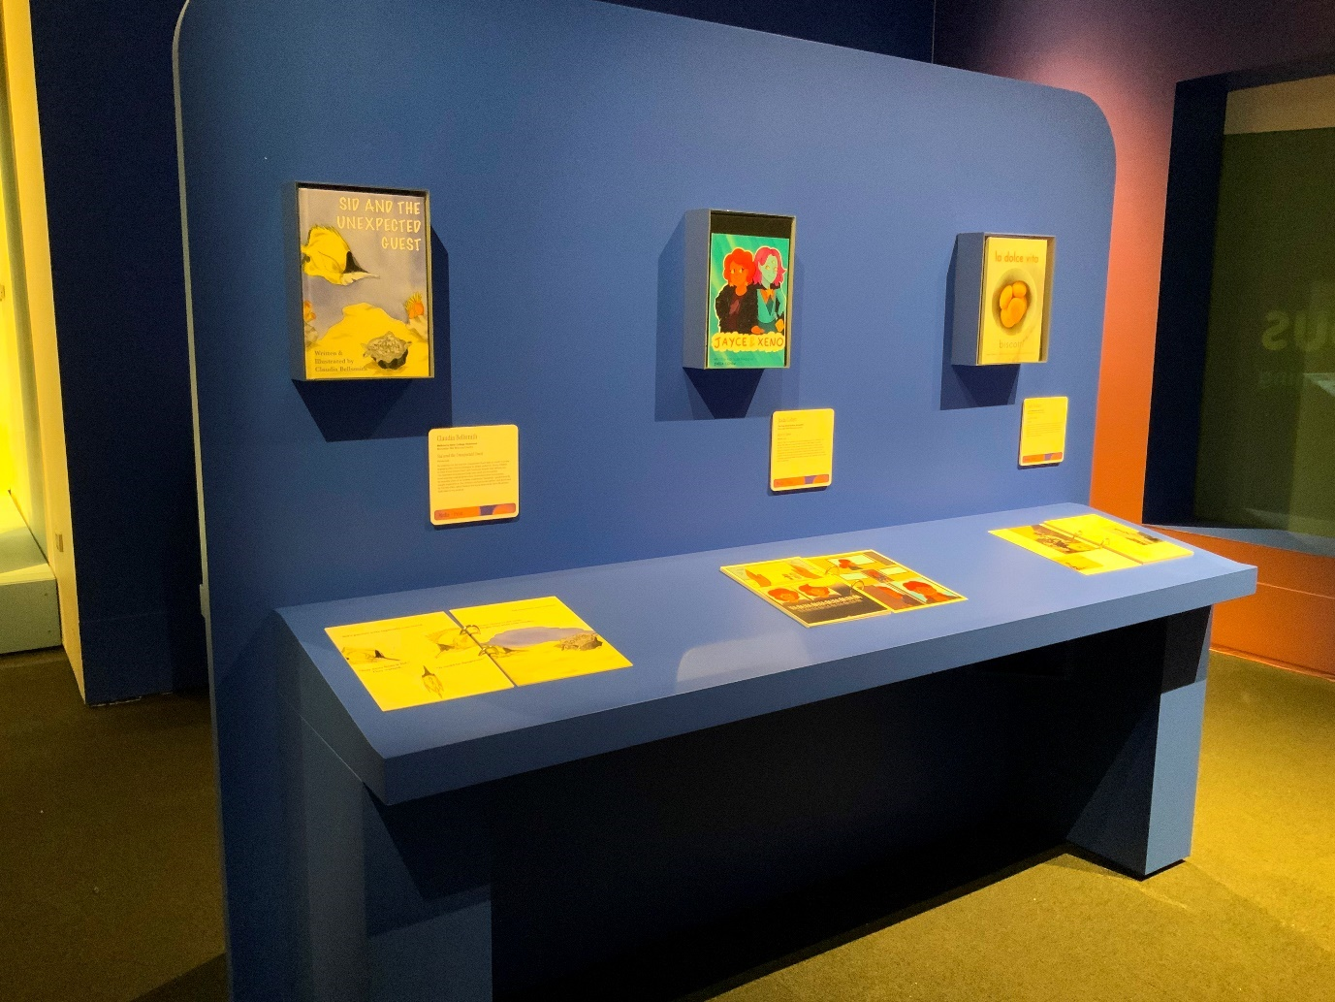
Image 60- a photo of the Media – Print nook on the north wall, next to the Media - Films nook on other end.

VCE Media- Film
VCE Media- Film is projected onto the east wall towards the end of the space, which is partially enclosed by a freestanding wall with seating. The films can be selected using a small touch screen to the left of the projected student films.
There are 13 works in total of which 2 are audio described.
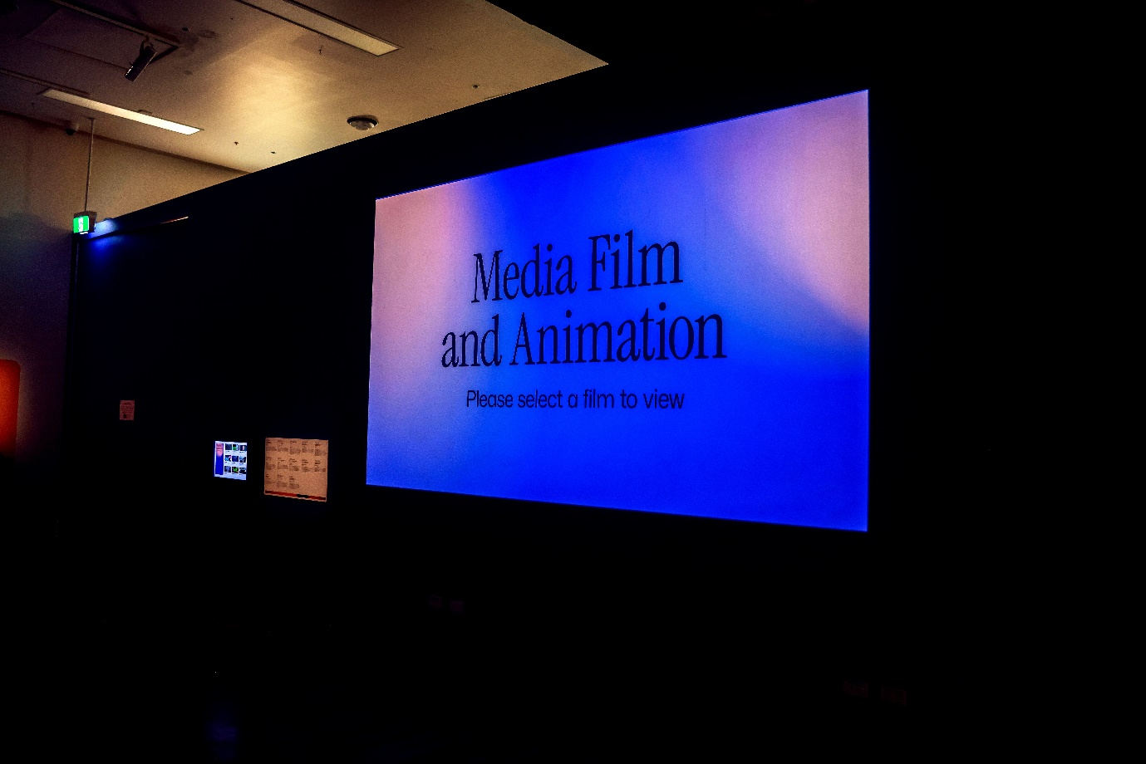
Image 61- a photograph of the Media- Film screen projected onto the east wall, with wall labels and the film selector to the left.

VCE Product Design & Technologies (study banner green and yellow)
Student works are exhibited on the platforms in the inner area nearest to exit. There are 13 works in total of which 4 are audio described.
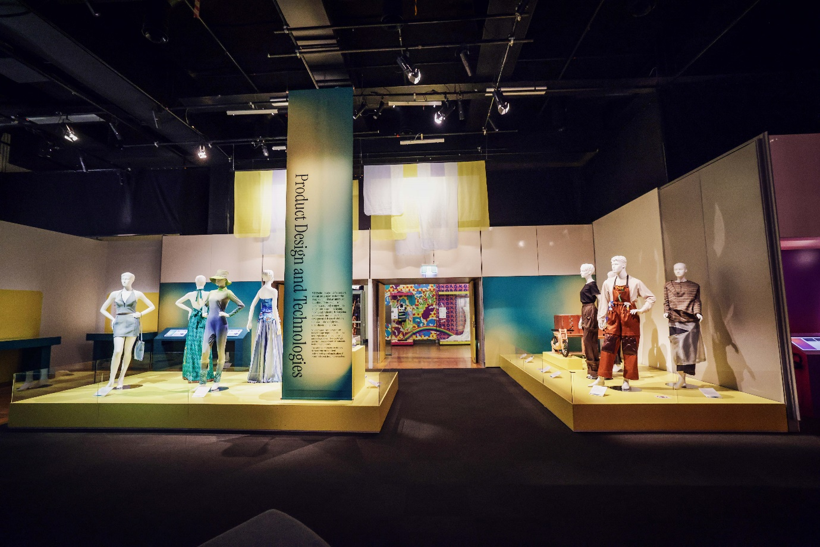
Image 62- a photo of the staging where Product Design and Technologies student works are exhibited.

Quiet Space
The Quiet Space is located on the Upper level, at the top of the second pair of escalators, near the Gandel Gondwana Garden and Mind and Body Gallery.
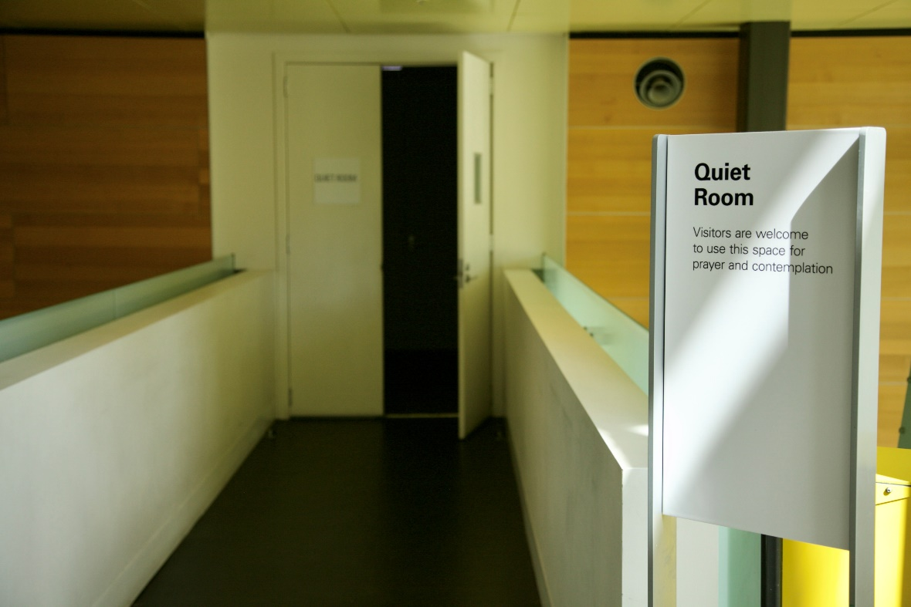
Image 63- a photo of a sign that reads ‘Quiet Room’, with the door ajar in background.
Turn left into and travel along the short bridge or walkway.
Enter the room where you will find a couch, side table and lamp that is dimly lit.
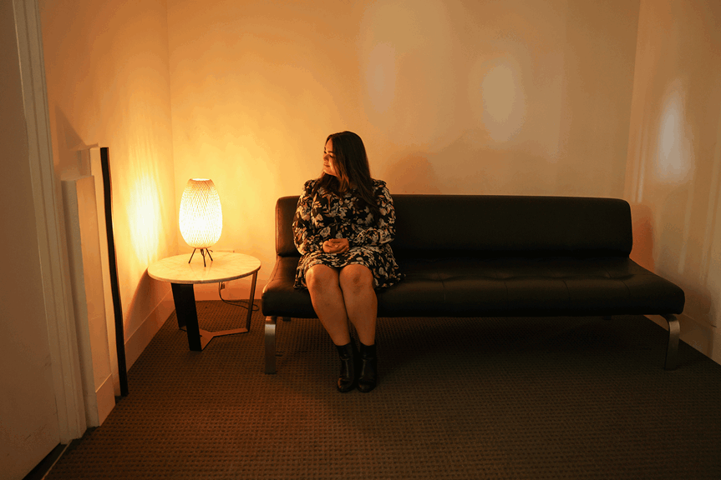
Image 64- a photo of someone sitting on couch in small room warmly lit by lamp on small side table.

Dining at Melbourne Museum
There is the dine-in only Mercury Restaurant and dine-in and takeaway Museum Market Café on ground level, each in close proximity to each other.
There is also the dine-in and takeaway Museum Station Café in the Children’s Gallery, on ground level.
More information about opening hours and menus here.

