Identity: Yours, Mine, Ours Self Guided Program
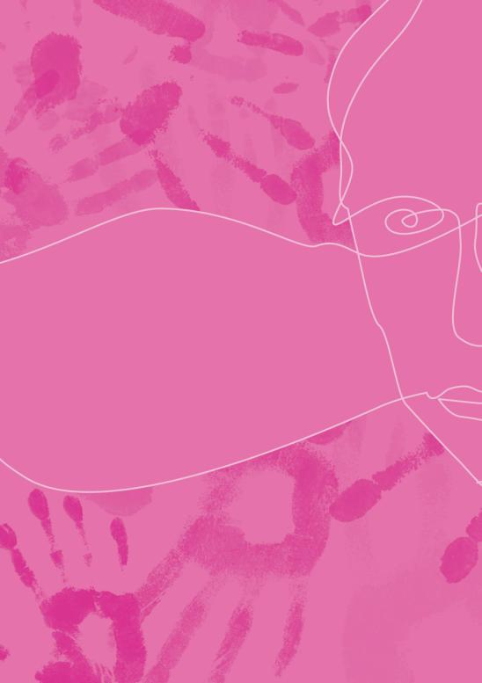
 | Prepared by | Education and Community Programs Team
 |  | Immigration Museum
 | Bookings | (03) 9927 2754 weekdays.
 | Copyright | Teachers may photocopy this kit for educational purposes.

Teacher Notes
Summary | 3
Map | 3
Curriculum Links (selected) | 4
Student Activities
Welcome Hallway | 5
First Impressions | 5
People Like Me | 6
People Like Them | 7

Identity: Yours, Mine, Ours
Self-Guided Program

Identity: Yours, Mine, Ours takes a mirror to our culturally diverse society and asks what it means to belong – or not belong – in Australia today. It focuses on how ethnicity, ancestry, language, spirituality and citizenship make up our sense of who we are and provides fresh and challenging insights into personal identity.

Exhibition layout

The exhibition is divided into three main themes each of which will take students approximately 15 mins in each space:
- First Impressions explores how identities can be formed, assumed or imposed through what is immediately visible.
- People Like Me explores the search for identity and belonging through personal stories.
- People Like Them explores how being different or fearing difference impacts on individual and collective identities.
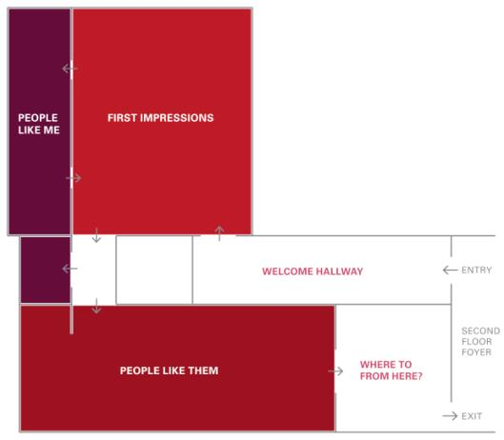

Curriculum Links (selected)

Identity: Yours, Mine, Ours provides an opportunity for students from other learning contexts (including post-VCE) to engage with cultural diversity and develop intercultural understanding (Australian Curriculum - General Capability).

The exhibition provides an especially relevant learning experience for students undertaking VCE English, Sociology, Geography and Politics, listed below.

 | VCE Subject | Unit/Area of Study | Key Links
 | English | Units 3 and 4;  Area of Study 2 (Exploring Issues of Identity and Belonging) | Students explore concepts of identity and belonging across each of the main galleries.  Staff-led program also available: VCE Identity and Belonging  http://museumvictoria.com.au/immigrationmuseum/education/education-programs/identity-and-belonging/
 | Sociology | Unit 3; Area of Study 2  (Ethnicity) | Students explore ethnicity as it relates to the formation of group and individual identities across each of the main galleries.  Staff-led program also available: Ethnicity VCE Sociology  http://museumvictoria.com.au/immigrationmuseum/education/education-programs/ethnicity---vce-sociology/
 | Geography | Unit 4; Global Perspectives  (Global Phenomenon: Migration) | Students investigate individual and collective identities towards developing an understanding of the cultural impacts of global migration.
 | Politics | Unit 2; Area of Study 1 (Global Threads) | Students explore experiences of intercultural exchange and identity formation as a means of deepening understanding global citizenship, and the impact of global interconnection of culture.

1. Welcome hallway

As you enter the exhibition, spend enough time with the projection to see the group of people who appear as you enter reappear in the loop.

How do the people in the projection make you feel?

Record any assumptions you may have made based on the physical appearance of the people. Were these assumptions confirmed or challenged by their behaviour.
2. First Impressions
Focus on two people in the text panels or touch screen
Record some of the ways in which physical appearance and family heritage may have impacted on their identity.
Person Number 1 | Person Number 2

Record an example of a similar process occurring in your own experience.

3. People Like Me
Record some of the ways people in this gallery express their identity.

What are some of the ways in which you express your identity?

4. People Like Them
Record some examples from the gallery of people or groups being treated differently on the basis of their racial or cultural identity.

Record some of the ways in which ideas about cultural identity are disseminated? How are these passed on across generations?

Record an example from your own experience of a time when you felt:
as though you belonged | as though you did not belong

Websites
1 | Title: Identity: Yours, Mine Ours  URL: museumvictoria.com.au/identity
2 | Title: Making History  URL: http://museumvictoria.com.au/discoverycentre/websites/making-history/
3 | Title: Talking Difference  URL: museumvictoria.com.au/talkingdifference
4 | Title: Culture Victoria  URL: http://www.cv.vic.gov.au/

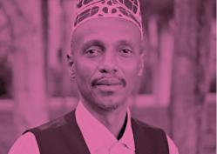 | 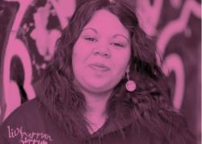
Yusuf Sheikh Omar.  Source: University of Melbourne  Photographer: Dave Tacon  © Creative Commons Share Alike 3.0 2010 | Education caption: Side by side image example.  Source: Museum Victoria  Photographer: Benjamin Healley

