Sensory Friendly Road to Zero

SOCIAL STORY FOR VISITS TO SCHOOLS

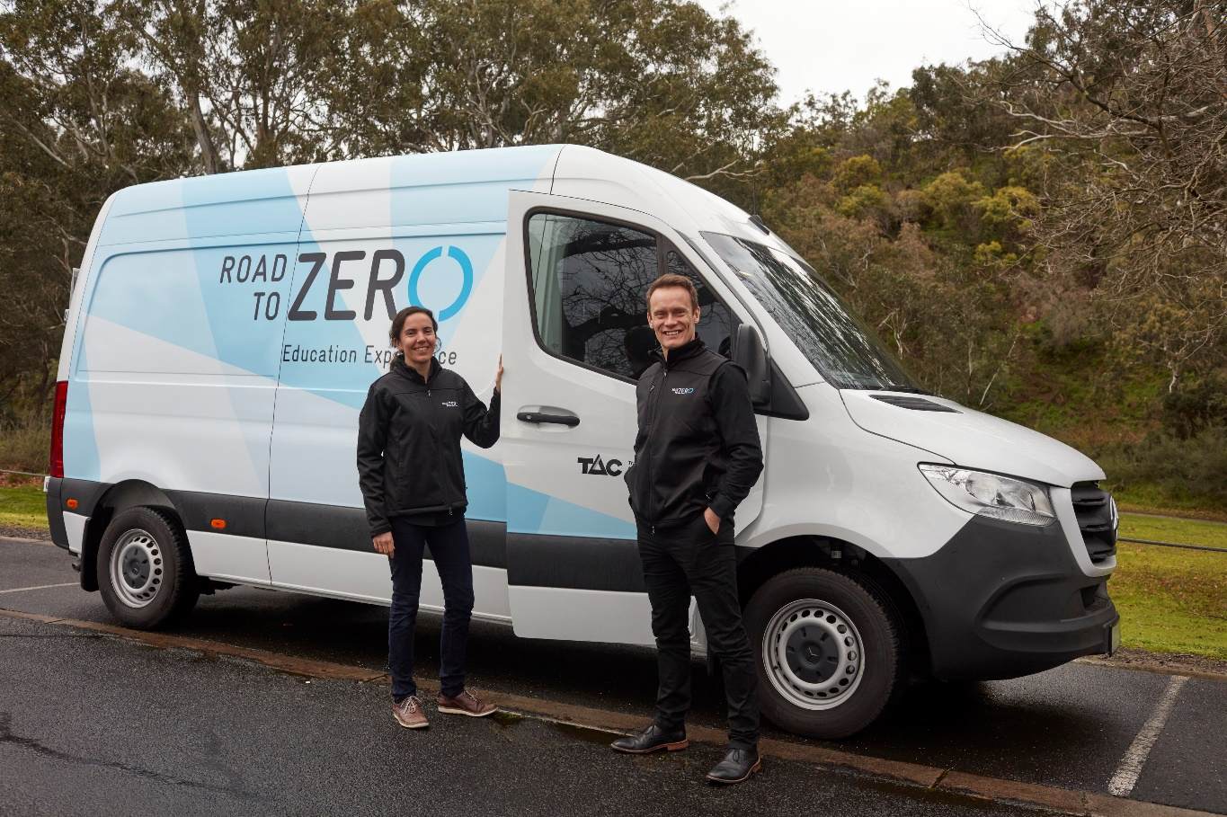

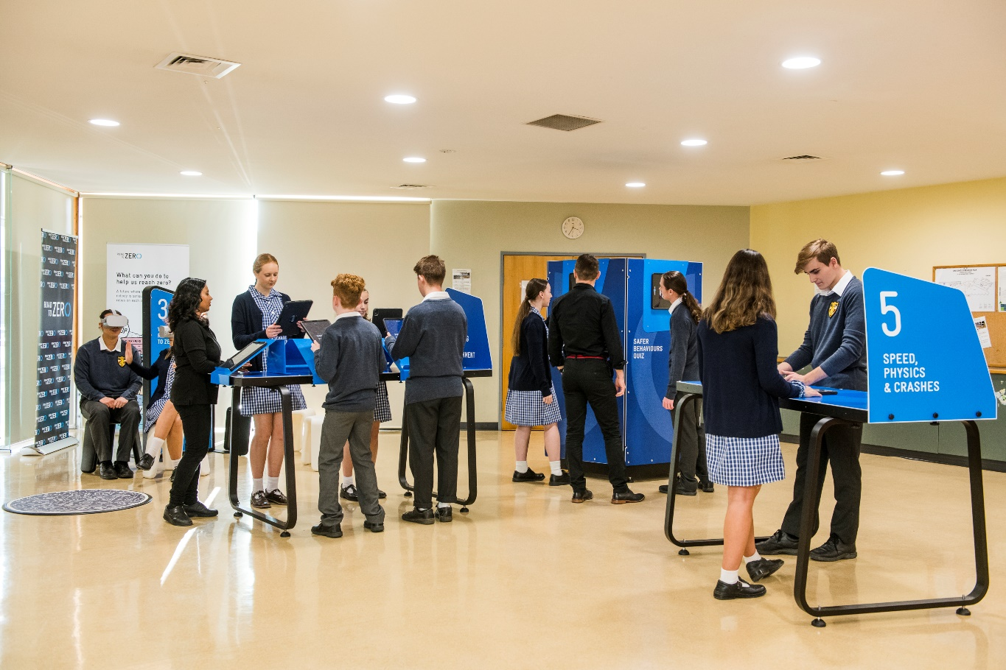
What is Road to Zero?
The Road to Zero education program is coming to my school. During the visit, my class will explore and learn about road safety. The Road to Zero program will include a pop-up exhibition, and a lesson with Road to Zero teachers.
I will get to use an iPad to do different activities. The activities will explain how people can stay safe when using the roads. I can look, listen and learn at the Road to Zero program. I will tell my teacher if I need some quiet time.
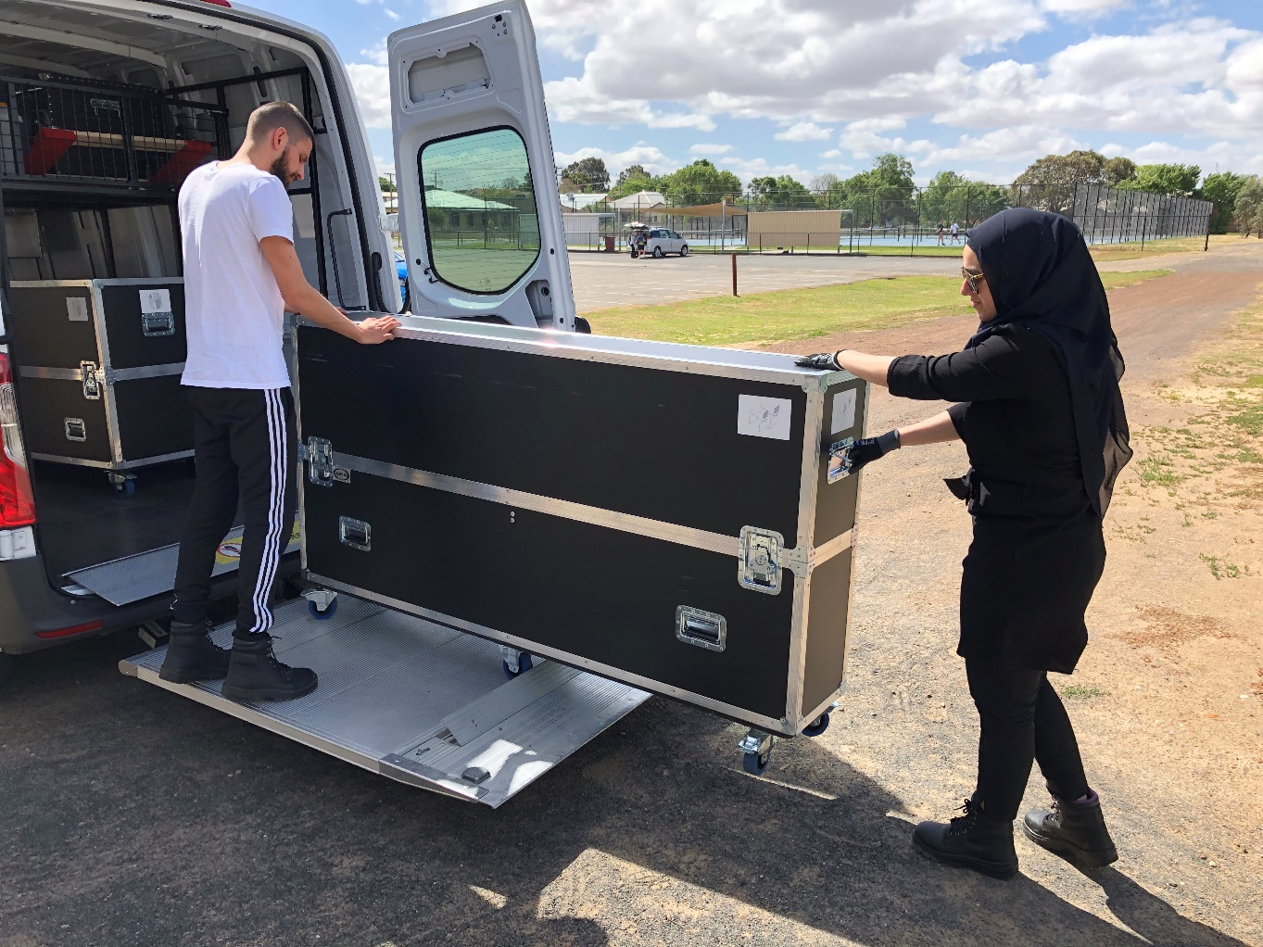
Setting up at my school
Road to Zero teachers will arrive in a big van. They will unload the van and set up their equipment in a room at my school. This might be a classroom, a hall, or a gym. They may move the furniture around to make space for their equipment.
The Road to Zero education program might be at my school for more than one day. I will only be able to use this room when I have a lesson booked with Road to Zero. My teacher will tell me where I need to go and at what time.
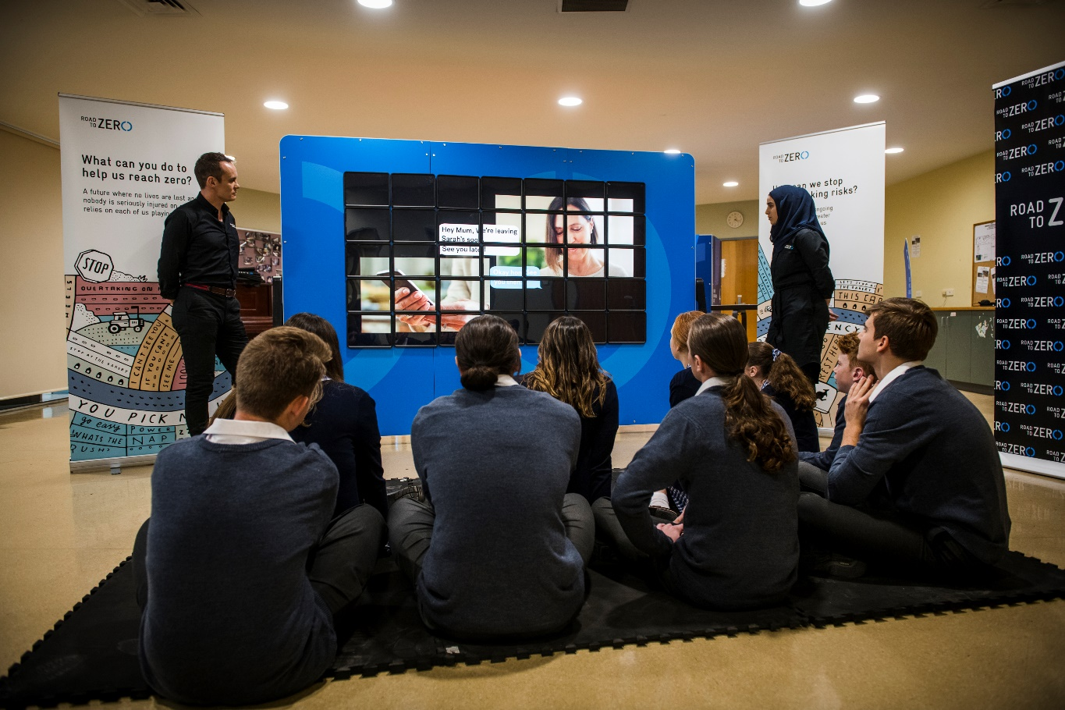
What will I be doing at Road to Zero?
There are three parts to the Road to Zero education program: the introduction, the pop-up exhibition, and the lesson. I will be at Road to Zero for 1.5 -2 hours. My teacher will tell the class when we will be having the program.
I will not be able to eat or drink near the Road to Zero equipment. I will tell my teacher if I need a break to go to the toilet.
During the introduction, I will sit and listen to the Road to Zero teachers for about 15 minutes. I will see a short video played on a wall of iPads, and I might answer some questions.
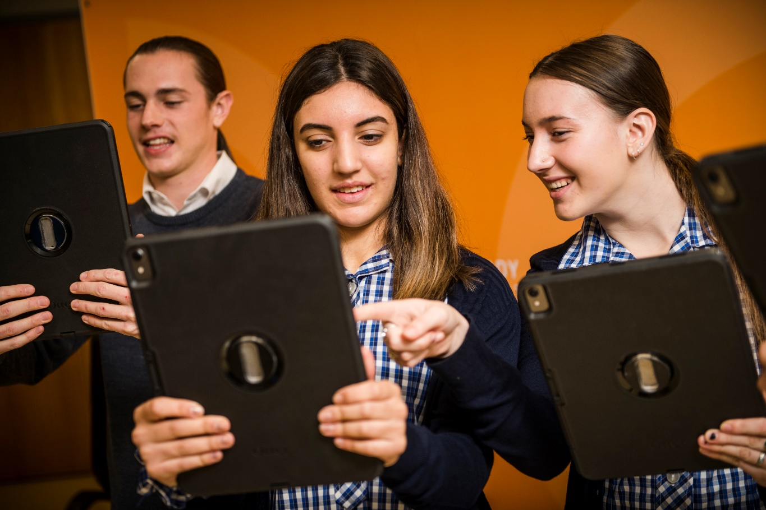
Logging in to the iPad
My class will spend about 40 minutes exploring the pop-up exhibition.
I will get an iPad to use during the program, and will use this to enter my details, including my email address. My personal details will be safe. My teacher, or the Road to Zero staff, can help me log in.
I will be careful when I am using the iPad.

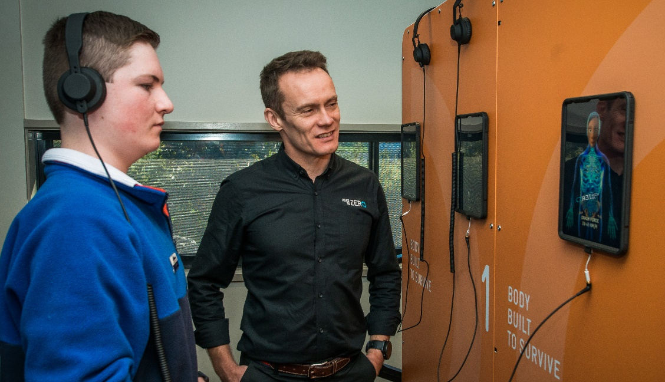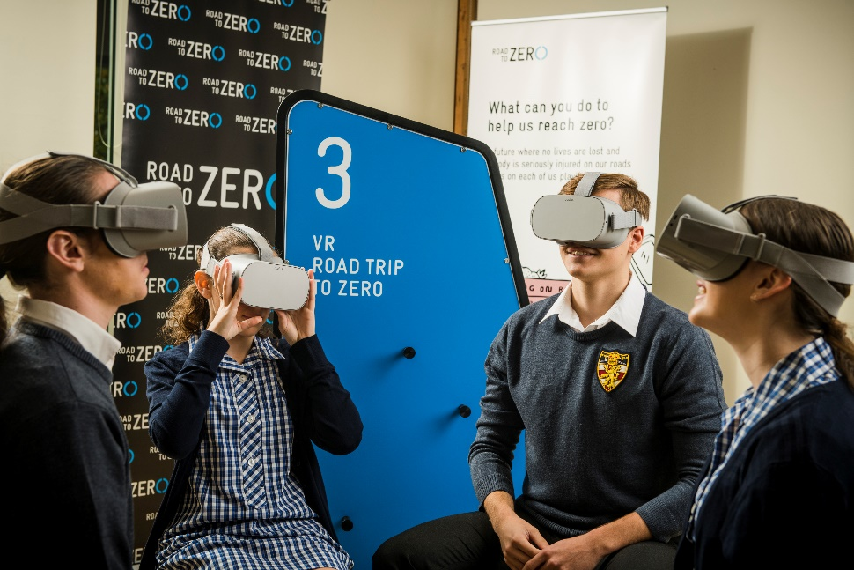
Exploring the pop-up exhibition
I will work in a group with my classmates to do different activities set-up around the room. My iPad will tell me which activity to go to. The teachers can also help me find the right activity if I am unsure.
I will get 5 minutes at each activity with my group. I might have to wait if I finish an activity early. For some activities, I will wear headphones so I can hear what is being said. If I do the virtual reality activity, I will wear goggles on my head. I do not have to do anything that makes me feel uncomfortable, but everything will be fun.

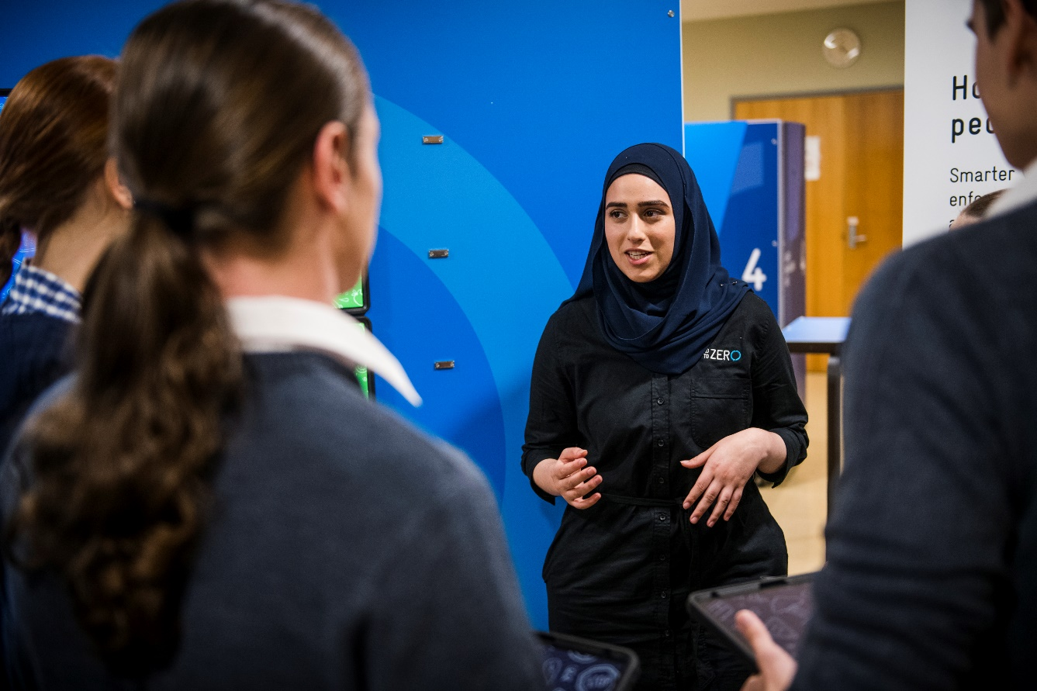
Health or Science Lesson
My class will get to sit down and listen to the Road to Zero teachers talk to us. I can put my hand up if I want to ask questions or if I have an answer to a question.
I may get to work with a friend or with a group of friends on an activity using the iPads. This may be making a video for the Health program, or doing an experiment for the Science program. The Road to Zero teachers will tell us which program we are doing on the day. During the activity I may get to wear headphones.
The lesson will be 50 - 80 minutes.
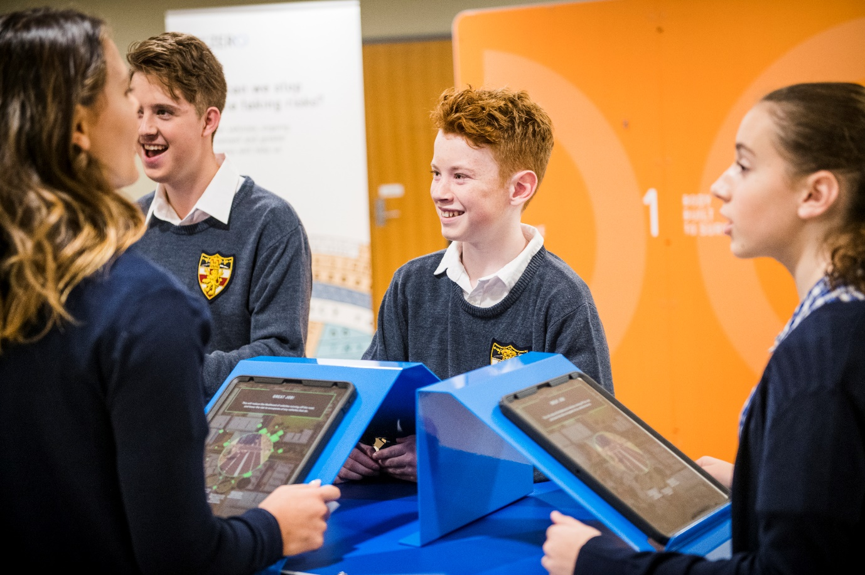
Leaving
Before I leave the Road to Zero program, I will return my iPad and any other equipment loaned to me in the lesson.
My work will be emailed to me so I can look at it another time. I can tell my friends and family about what I learnt during the Road to Zero visit.
When the Road to Zero teachers have finished talking to the classes at my school, they will pack up all their equipment and load it back into their van ready to take back to the museum, or to another school.

