Who Lays Eggs?

Objective
This activity encourages students to think about which animals lay eggs to reproduce.

What you need
- Scissors
- Glue
- Photocopies of animals (below) and work sheet (next page)

What to do
- Cut out all nine of the animals pictured below.
- Sort the animals into two groups – one group that lays eggs and the other group that does not.
- When you have finished sorting, glue your animals in the table (see next page).

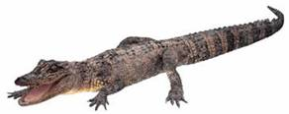
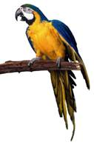
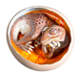

Birds Alligators Dinosaurs

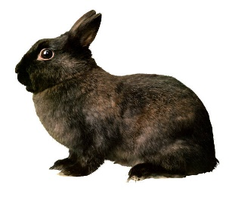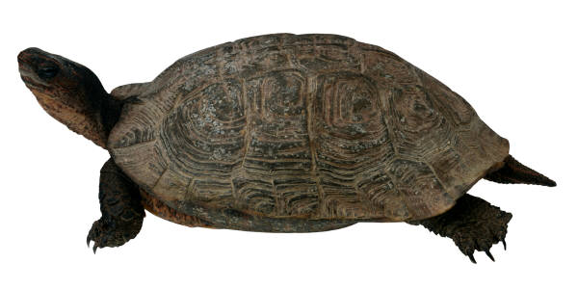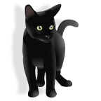
Rabbits Turtles Cats
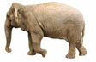
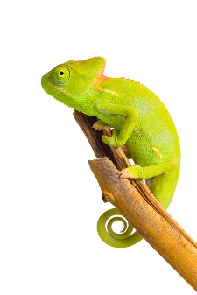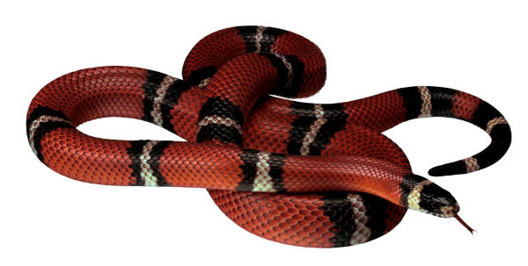
Lizards Snakes Elephants
Who Lays Eggs?

Glue the animals in the table below to show where you think they belong.

Lays eggs | Does not lay eggs

