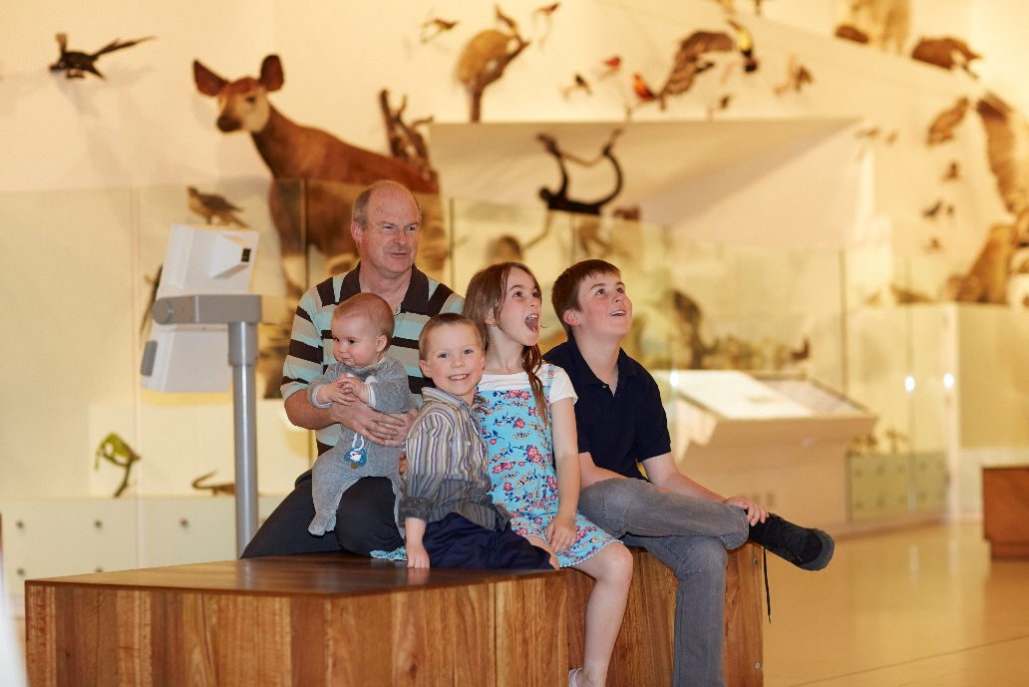
SOCIAL SCRIPTS FOR YOUNGER CHILDREN

My adventure to Melbourne Museum

This book belongs to ____________________
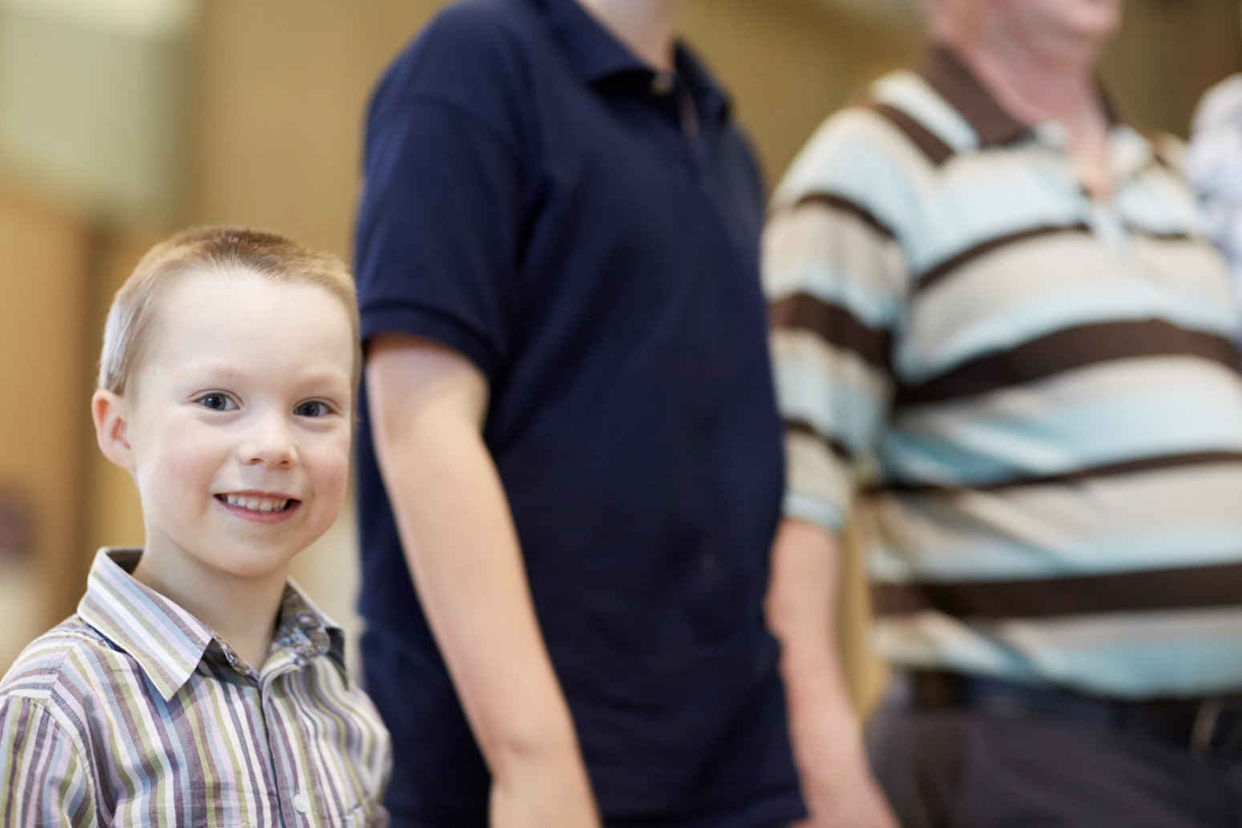
I am going to Melbourne Museum.
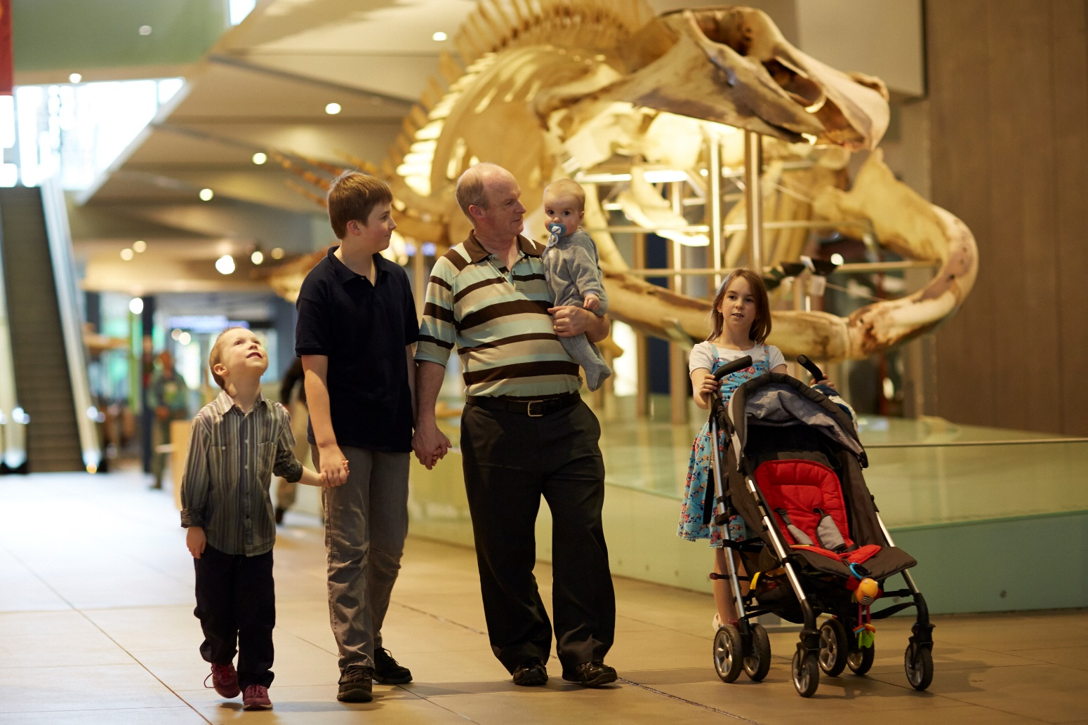
I will see many different things at the museum.

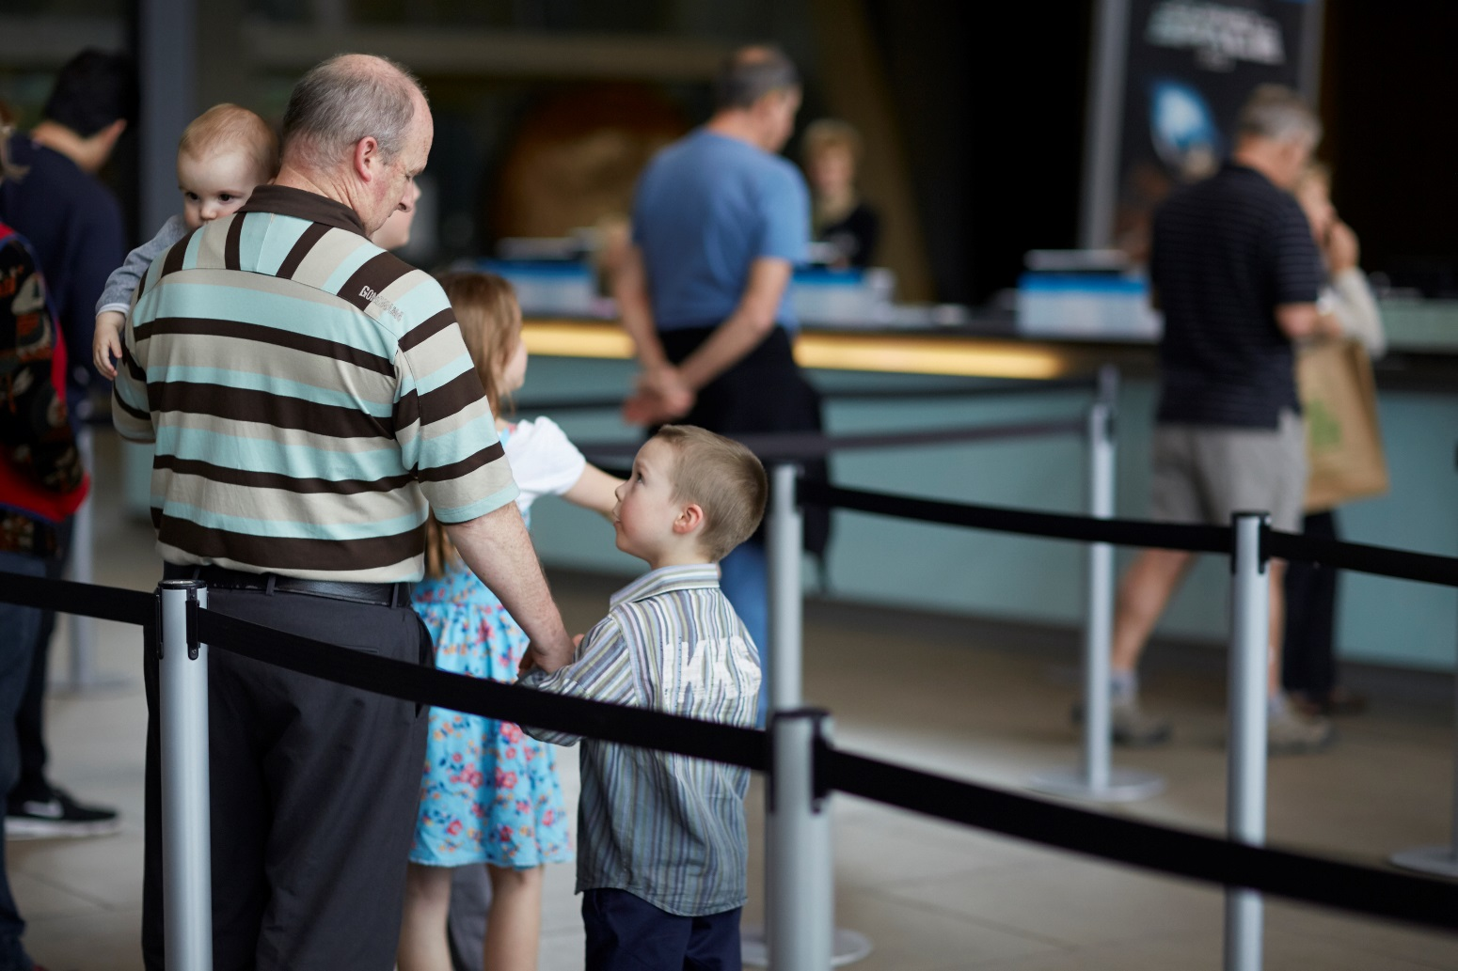
I will have to wait with an adult to buy the tickets.
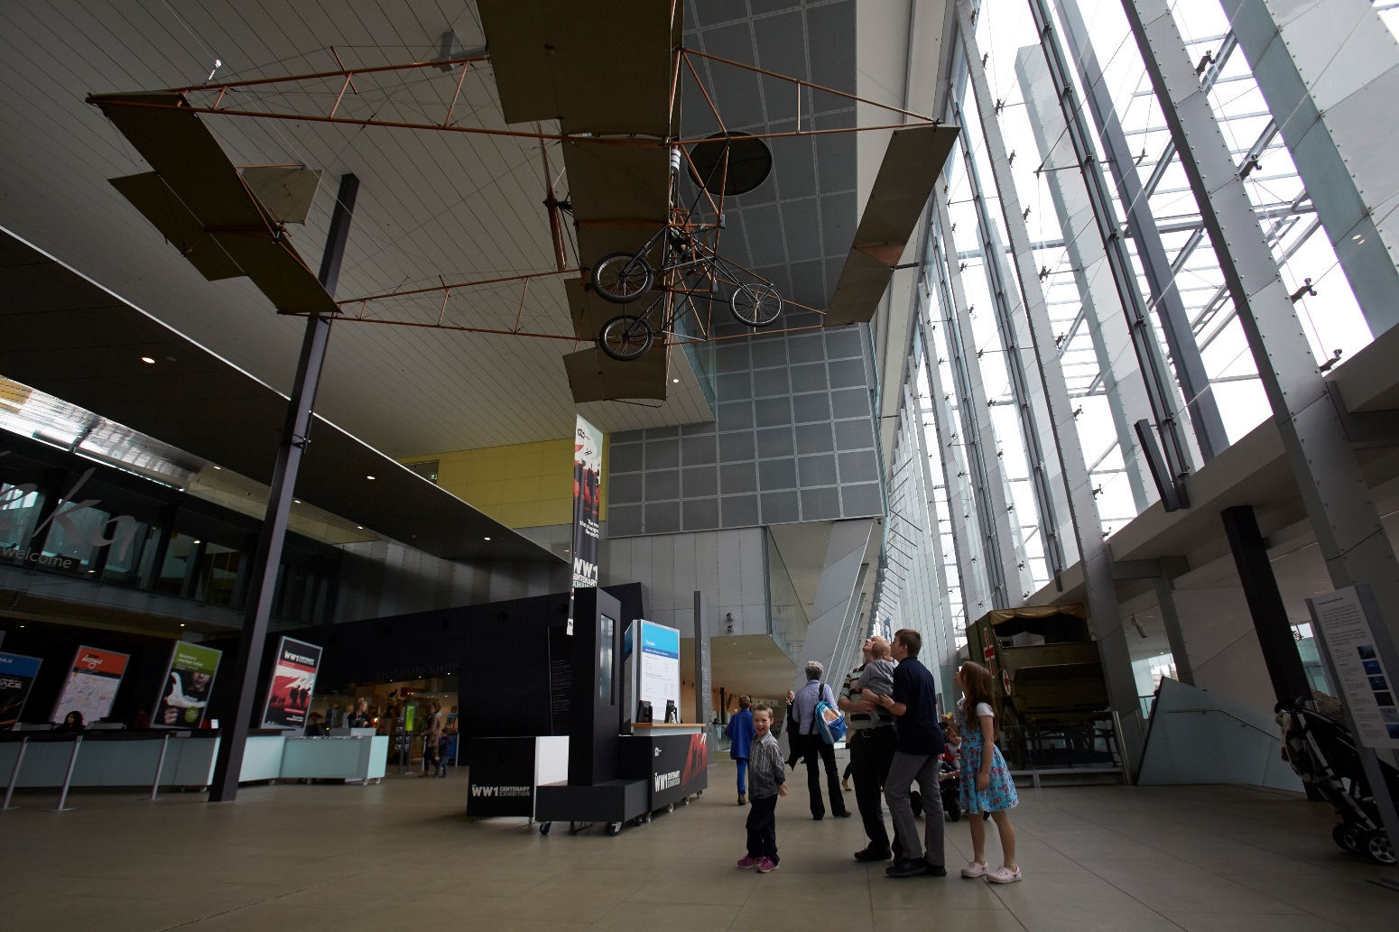
I will see lots of things hanging from the roof. They will not fall down.
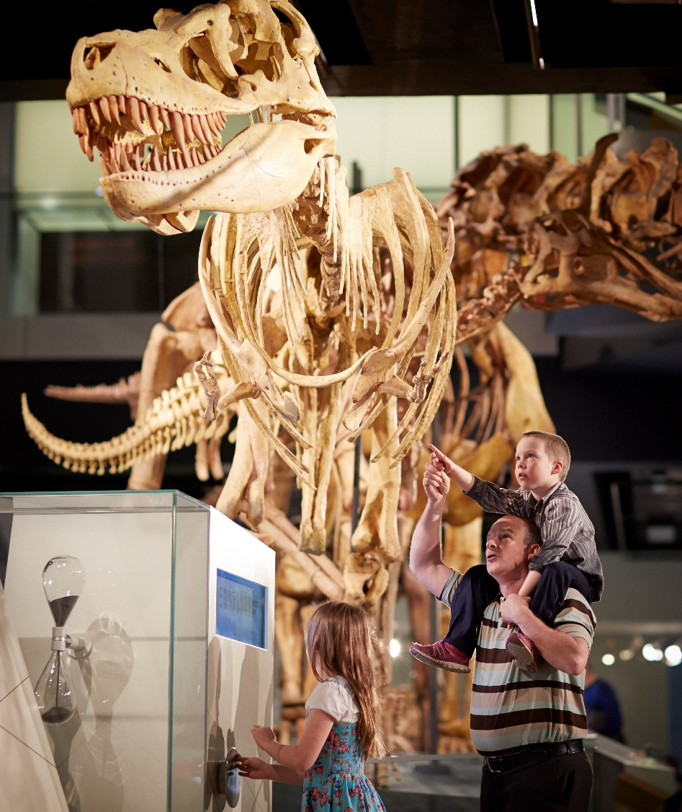
I will see dinosaur bones. They look real but can’t hurt me.
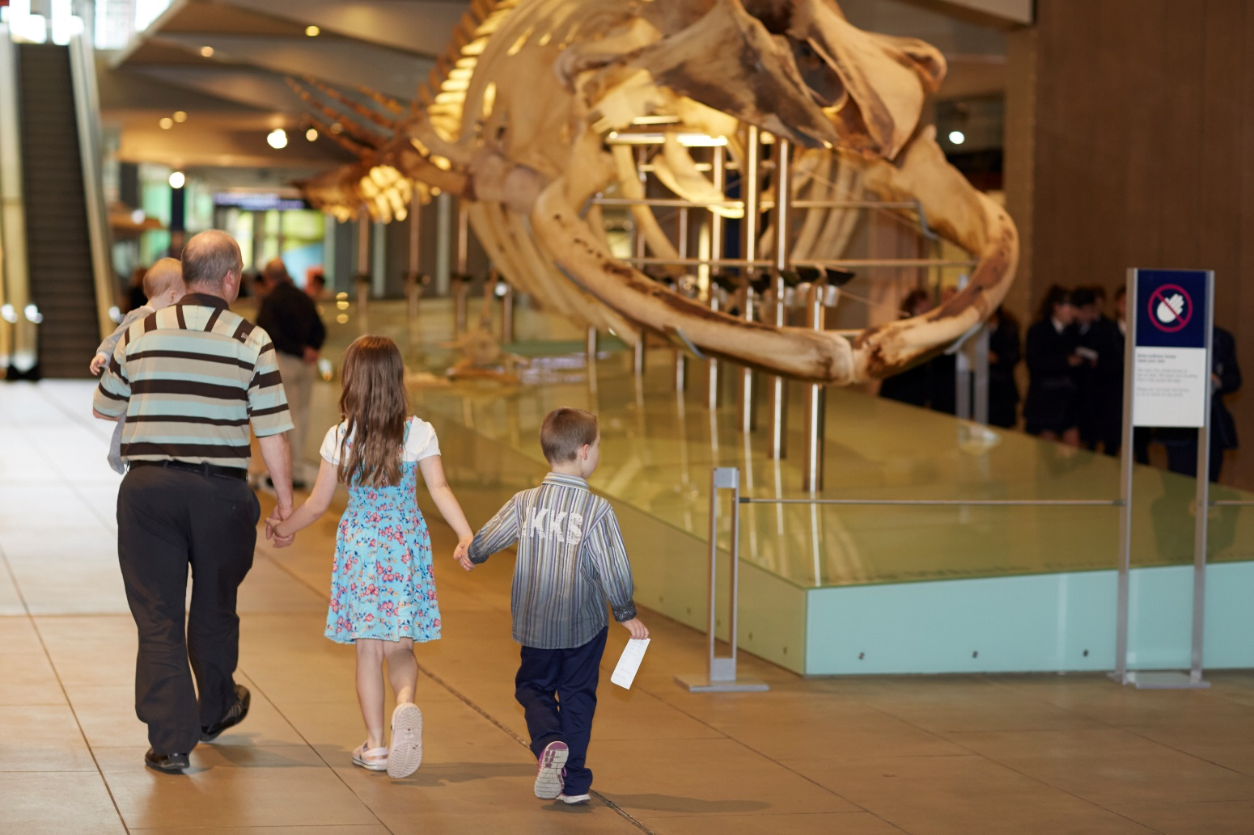
Inside the museum, I must walk with an adult.

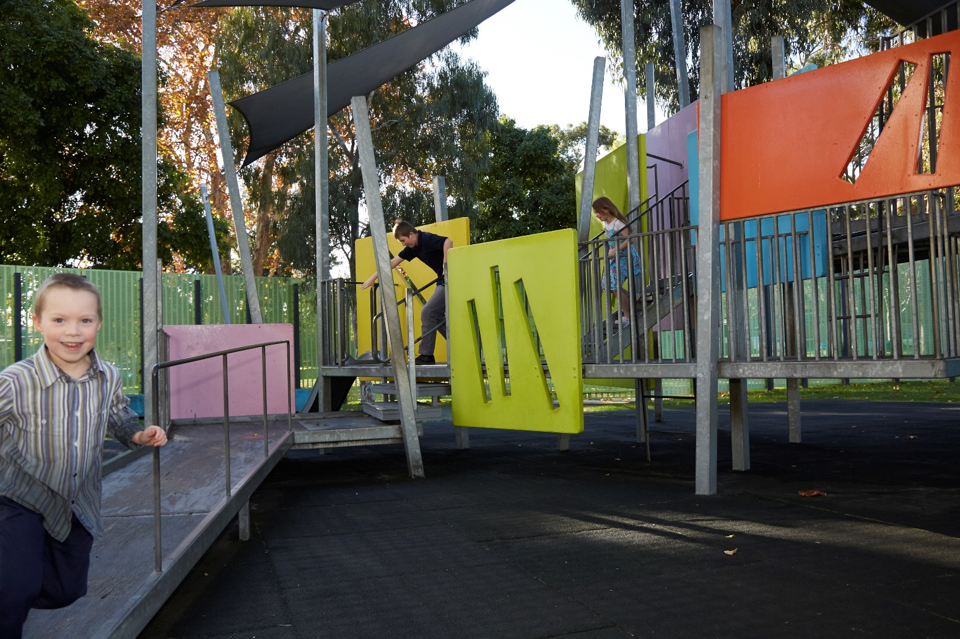
If I need to run around, my adult can take me to the playground.
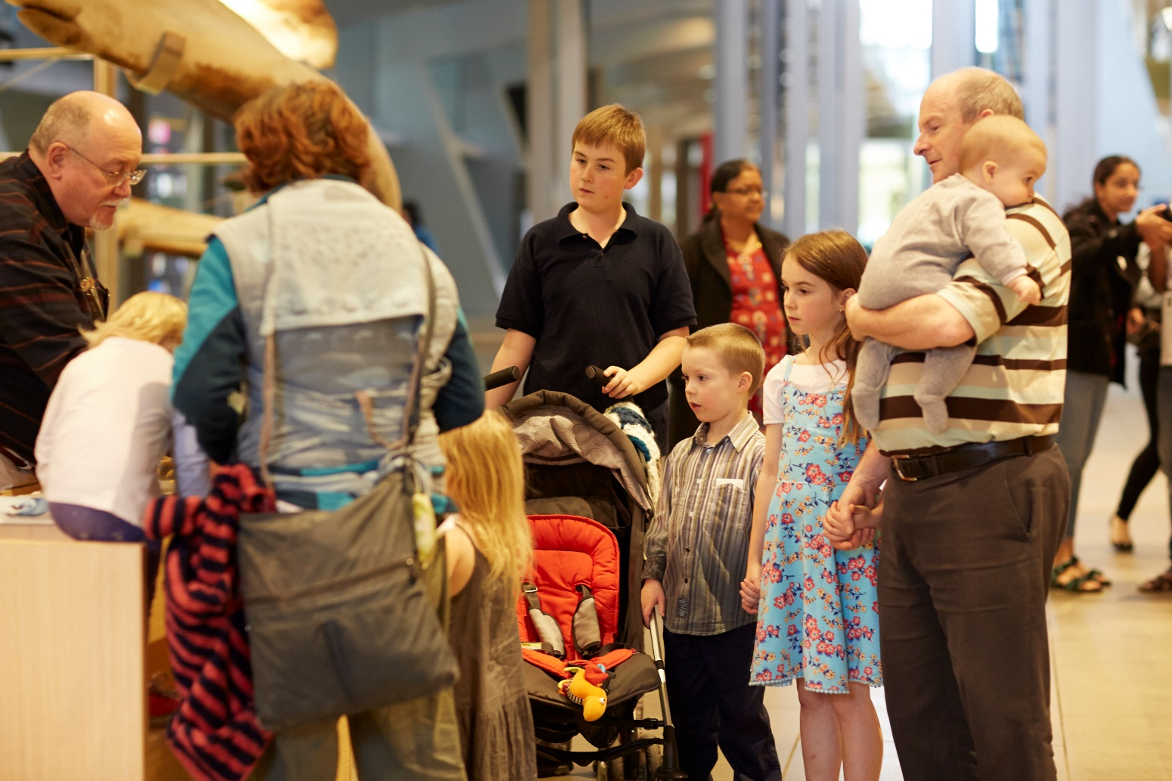
I will take turns with other people.

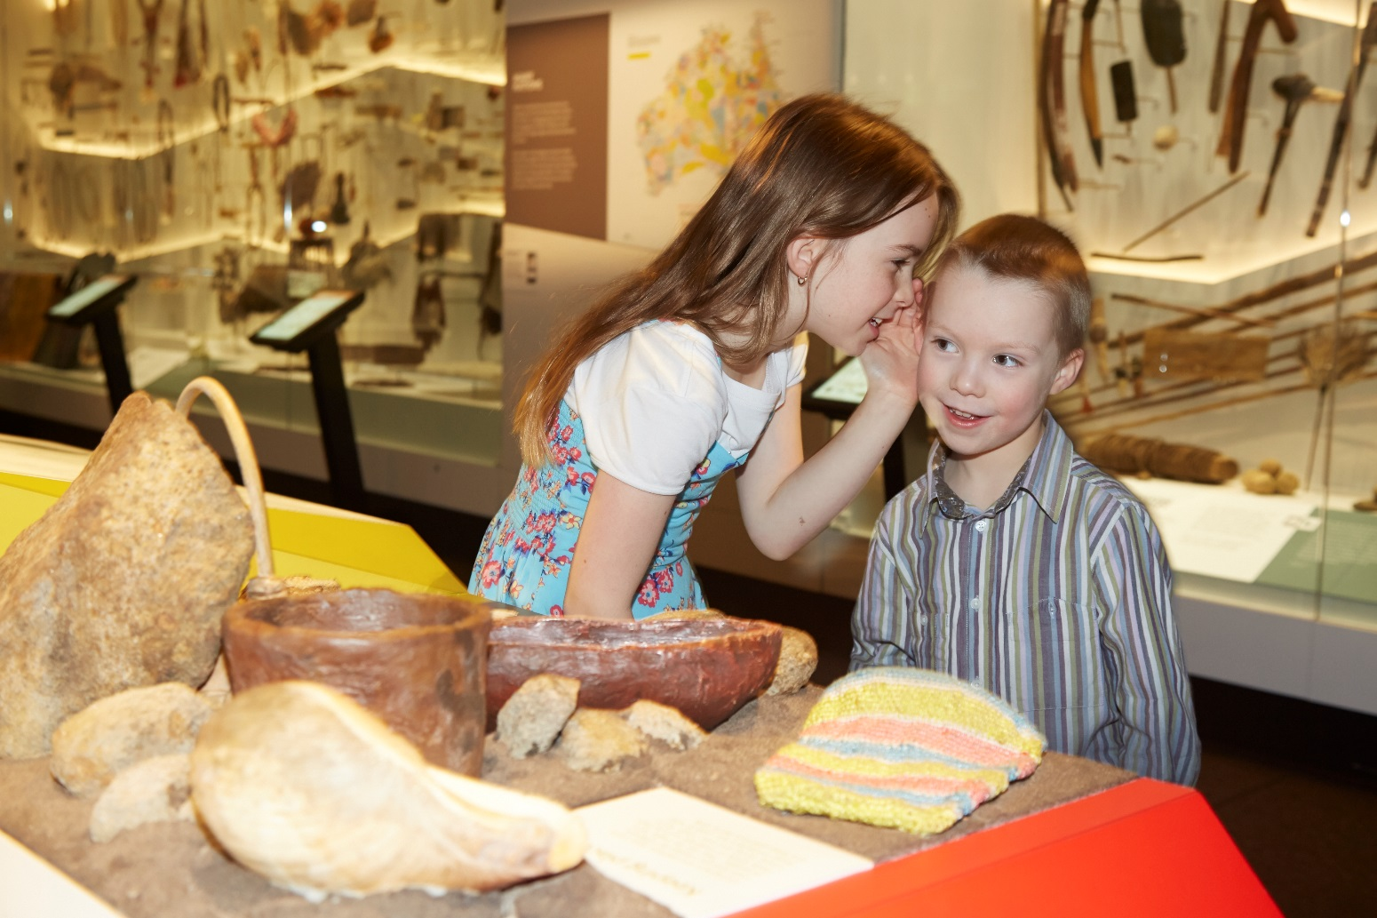
Inside the museum, I will have a quiet voice.
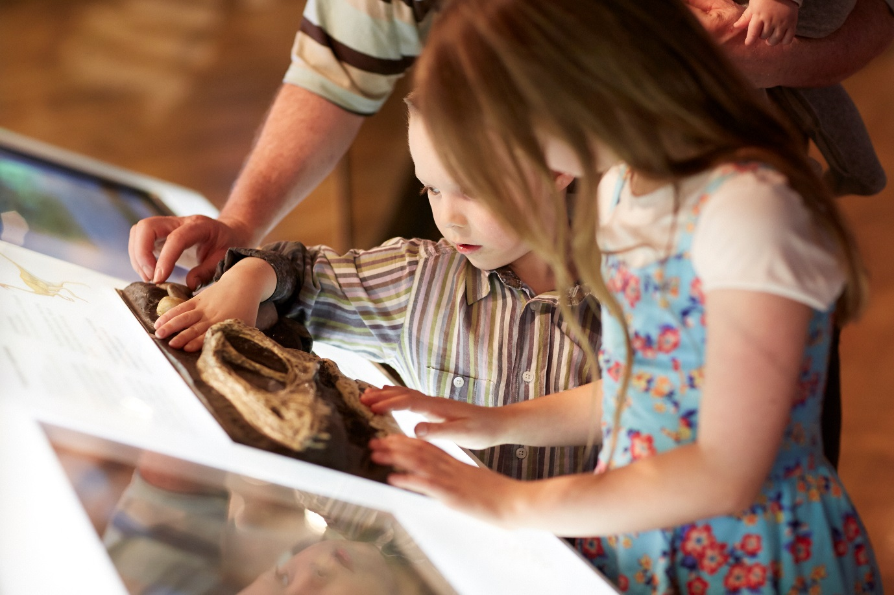
Some things I can touch. Some things I can’t touch.
I will ask an adult which things I can and can’t touch if I am not sure.

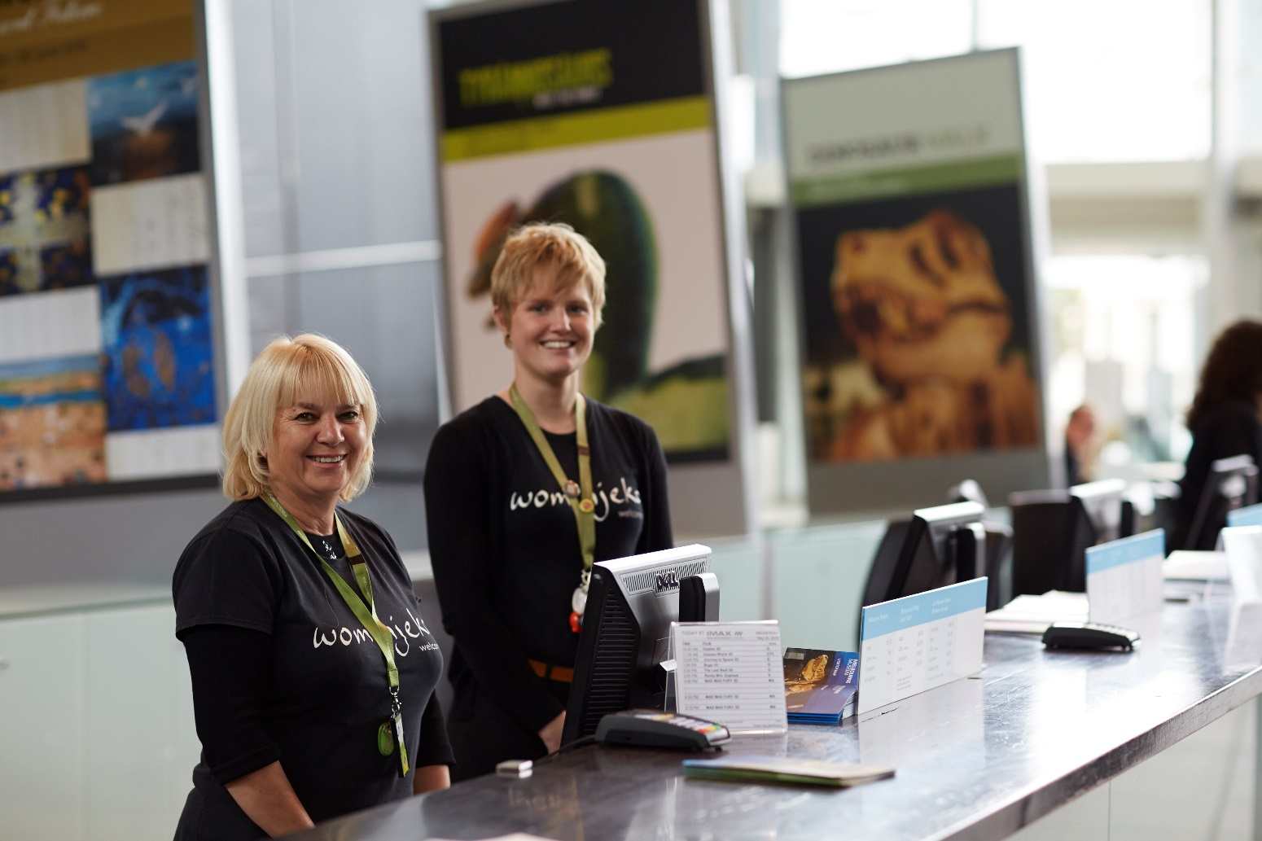
If I get lost I can ask a museum staff member for help.
Staff wear green straps around their necks.
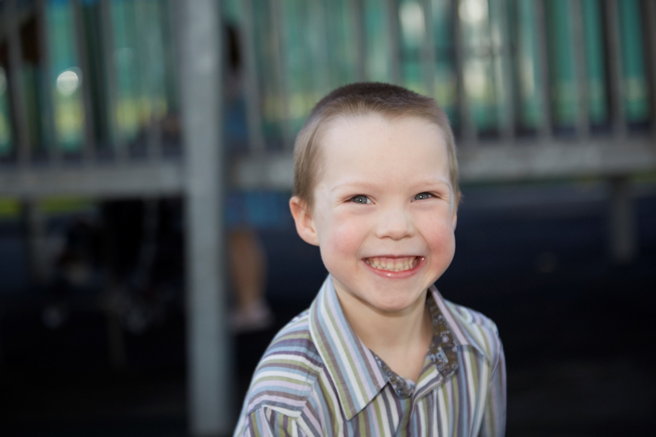
Going to the museum will be fun.

