My Visit to the Immigration Museum
This book belongs to:
_____________________________________________________

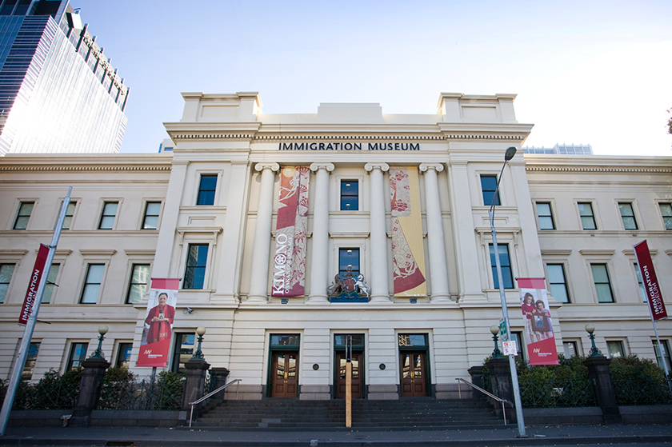

What is the Immigration Museum?
The Immigration Museum is a place with lots of information about Australia’s immigration history. There are lots of big and small things on display. I can find out why some people move to Australia from other countries. I can look, listen and learn at the museum.
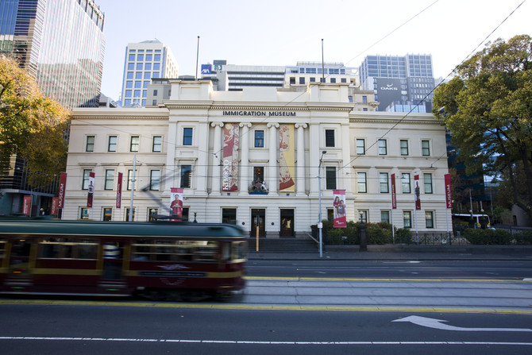

Getting to the museum
The Immigration Museum is in the city. I might go there by car, train, tram or bus. We might need to cross busy roads. I will cross at the lights and I will hold my adult’s hand when I cross the road.
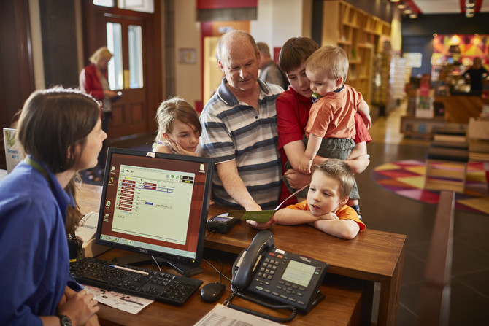

Going into the museum
When I arrive at the Immigration Museum I will see a big stone building with steps and three big doors. I will see a statue above one of the doors. The statue is part of the building and it will not fall on me. When I walk up the steps, the doors might open on their own.
I will walk into the museum and I will be in a large room called the foyer. The ticket desk is in this room, and here we will buy our tickets to get into the museum. I might have to wait patiently behind other people, but we will get our turn. After we buy our tickets, I can go into the rest of the museum. The museum staff member at the ticket desk will give my adult a map so they know where to go.
If I have a bag I can leave it in the cloakroom. The museum staff member will take my bag and put it in a cupboard and lock the door, so I know my bag is safe. Before I leave the museum, I can ask a museum staff member to please get my bag for me.
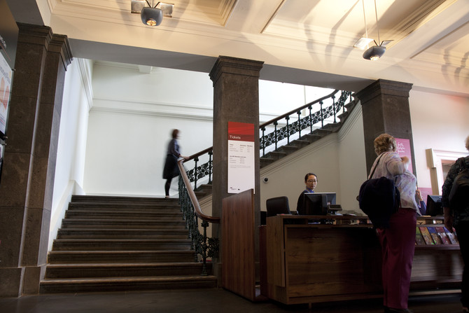

Getting around the museum
The Immigration Museum has three floors. To move around the museum, I can use the big stone stairs or use the lift.
If I use the stairs, I will walk slowly. If I want to, I can hold onto the railing or touch the wall.
The lift is small but will arrive quickly at the floor I want. The lift has a big window so I can see outside. I will see that we are going up or down and I will know the lift is safe.
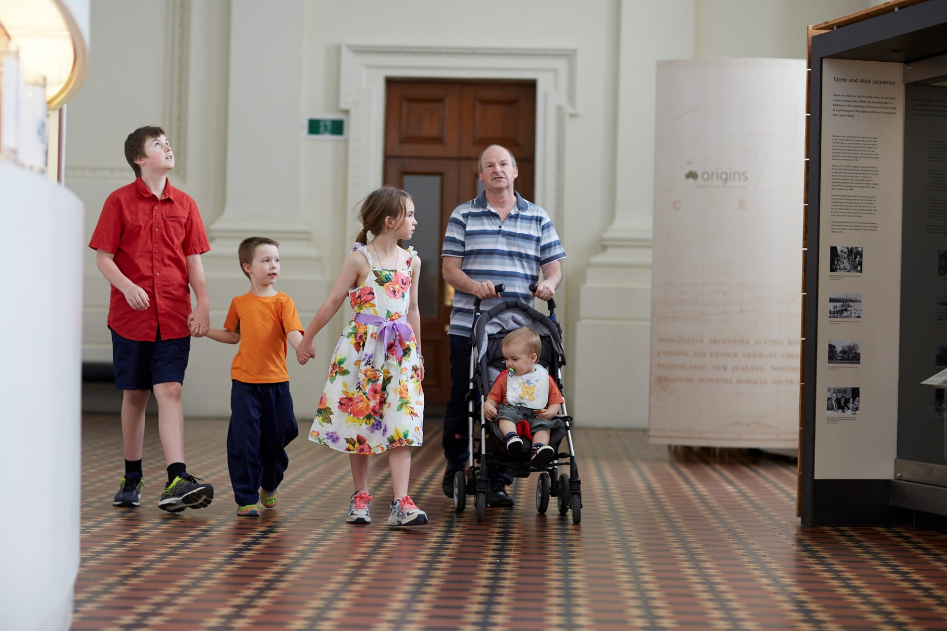

Different spaces at the museum
The Immigration Museum is a special building and inside it looks and feels different from home or school. Some rooms might be big or small. Some rooms might be dark or bright.
I will hear lots of different sounds at the Immigration Museum. I might hear music, people talking or animal noises.
If I don’t like being in an area, I will tell an adult and we can leave the area together. Some areas I will enjoy more than others and that is okay.
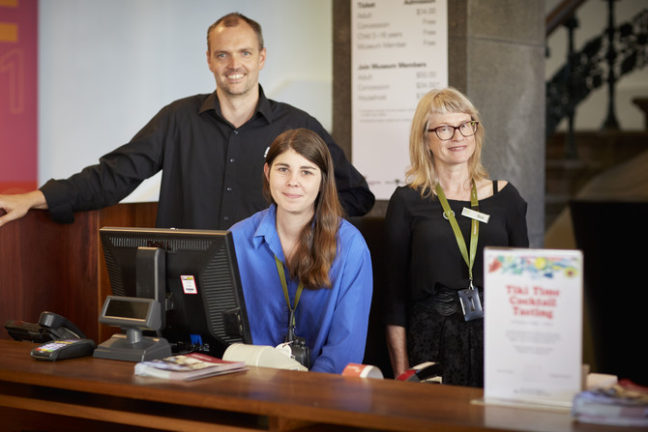

Staff at the museum
Many people visit the Immigration Museum and many people work there too. If I get lost, a museum staff member can help me. They wear tags on coloured straps around their necks.

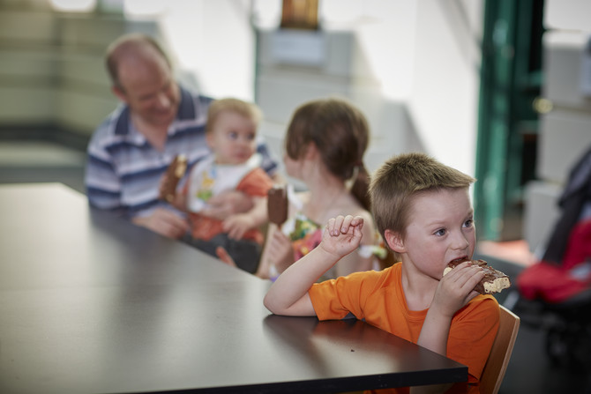

Food and eating at the museum
When I want to eat, I can use the chairs near the cafe, or go to the Atrium with glass walls, or go outside to the courtyard. I will not eat in the rest of the museum.
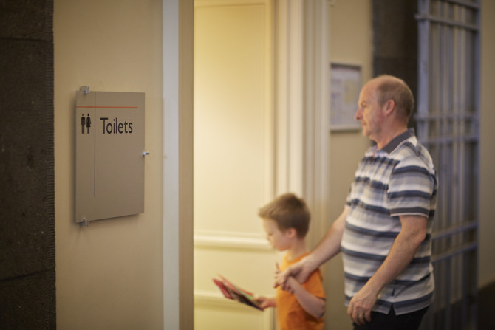

Toilets at the museum
If I need to go to the toilet I will ask my adult to take me there. There might be other people in the toilet, too. When I am finished using the toilet, I will wash my hands.
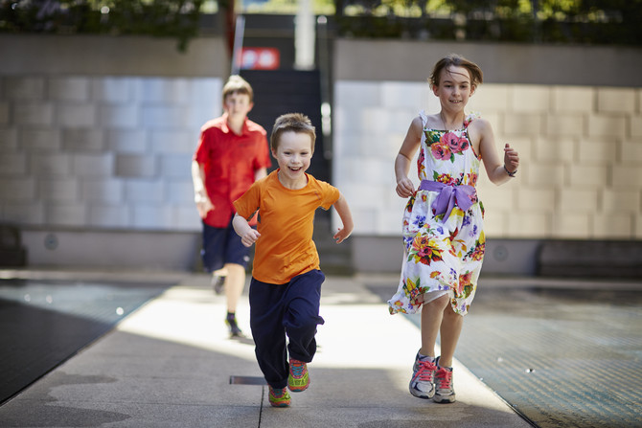

Taking a break
If I need a break or get tired, I will tell my adult. My adult can help me find a calm place to go. The Discovery Centre is a quiet place where I can sit and look at books. If I need to run around I will ask my adult to take me outside to the courtyard. I will stay with my adult and I won’t go outside the gates.
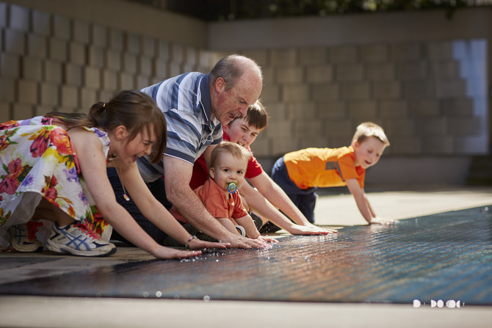

Important things to remember at the museum
When I am at the Immigration Museum I must remember to:
Walk with my adult
Speak with my quiet voice, even though it might be noisy
Take turns with other people
Wait patiently when I have to line up
Only touch objects I am told that I am allowed to

