**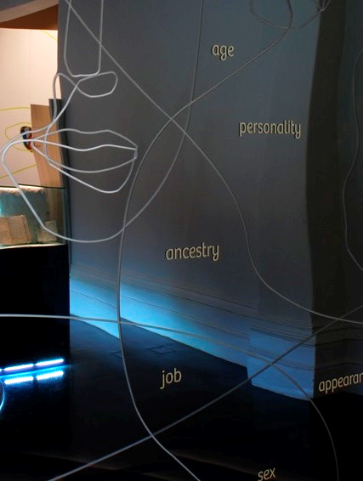**

***Identity: Yours, Mine, Ours***

**Exhibition Research Project**

**executive summary**

**Funded through the australian research council 2012-2015**

 Macintosh HD:Users:walto:Pictures:Work pics and logos:VicHealth_Brandmark_CMYK-for printing.jpg Macintosh HD:Users:walto:Pictures:Work pics and logos:uom:Print:Flat:Primary:UOM-Rev_H_PMS.eps

|  |  |  |  |  |  |  |  |  |  |  |
| --- | --- | --- | --- | --- | --- | --- | --- | --- | --- | --- |
| **\\mm-fs1\shared\CRE\Exhibitions - Archive\IM Exhibitions\Exhibitions Permanent\Identity\ARC Project 2012-2014\Final Report Version\First Impressions Mirror Caz copy.jpg\\mm-fs1\shared\CRE\Exhibitions - Archive\IM Exhibitions\Exhibitions Permanent\Identity\ARC Project 2012-2014\Final Report Version\First Impressions Mirror Caz copy.jpg*Identity: Yours, Mine, Ours***  **Exhibition Research Project**  **Executive Summary**  **Published by: Museum Victoria**  **First printed: April 2016**  **This research evaluation was funded by an Australian Research Council Linkage Grant (LP120100080)**  The research was conducted through Deakin University within the Alfred Deakin Institute for Citizenship and Globalisation, and included researchers at the University of Melbourne. The following are partner organisations on this project: Museum Victoria (Immigration Museum and Melbourne Museum) and the Victorian Health Promotion Foundation. | | | |  | | | | |  | |
| |  |  |  |  | | --- | --- | --- | --- | | **Research Evaluation Team**  Dr Jessica Walton (Research Fellow, Deakin University)  Prof Yin Paradies (CIA, Deakin University)   |  |  |  | | --- | --- | --- | | **Deakin University –**  Prof Emma Kowal  Prof Fethi Mansouri | **University of Melbourne –**  Prof Margaret Kelaher  **Australian National University –**  Dr Naomi Priest | **Museum Victoria –**  Dr Moya McFadzean  Ms Carolyn Meehan  Ms Jan Molloy  Ms Linda Sproul | | | **Research Assistance**  Ms Melinda Herron  Ms Hannah Reich  Dr Philipp Schorch |   **Recommended Citation**  Walton, J., Paradies, Y., McFadzean, M., Molloy, J., Sproul, L., Priest, N., Kowal, E., Mansouri, F., Kelaher, M., Meehan, C. 2016. *Identity: Yours, Mine, Ours Exhibition Research Project Evaluation Report.* Museum Victoria, Melbourne, Victoria. | | | |  | | | | |  | |
| **Cover Image**  *First Impressions Mirror*  *Identity: Yours, Mine, Ours Exhibition*  Source – Museum Victoria | http://mirrors.creativecommons.org/presskit/logos/cc.logo.large.png | |  | | |  | |
|  | |  | | |  | |  | | |

Executive Summary

## About the exhibition

In 2011, Museum Victoria launched the *Identity: Yours, Mine, Ours* (IYMO) exhibition at the Immigration Museum in Melbourne. This major long-term exhibition primarily targets secondary school students, which supports secondary school curriculum units about identity, belonging and ethnicity. The exhibition’s core aims were to provide a dynamic participatory environment that encouraged reflection, challenged assumptions and compelled visitors to think about ways they could effect positive change in their everyday lives.

## About the evaluation

In 2012, an Australian Research Council Linkage Grant (#LP120100080) was awarded to evaluate the exhibition. This evaluation project involved a multi-disciplinary and multi-institutional team, including universities, a museum and a government agency. The overall aim was to understand the public role of museums in countering racism and promoting positive attitudes and acceptance toward people from diverse racial, ethnic and cultural groups. Specifically, this study aimed to examine the appropriateness, feasibility, acceptability and effectiveness of the IYMO exhibition in reducing racism and increasing acceptance of racial, ethnic, and cultural diversity among secondary school students in Years 10-12 and teachers.

The research questions included:

1. How appropriate, feasible and acceptable is the IYMO exhibition as an intervention for promoting positive attitudes toward cultural diversity and a critical understanding of racism among Victorian students in Years 10-12?
2. What is the effect of the IYMO exhibition on the attitudes, emotions, beliefs and behaviours of Victorian students in Years 10-12 in relation to racism, cultural diversity and racial and ethnic identity?

A pre-post study design was used to examine the effects of IYMO on students. A combination of survey, interview, focus group and video diary methods were used in this research to assess these changes over time resulting from a school visit to IYMO.

## Participants and methods

A total of seven schools, which included ten classes, participated in the project. Six of the seven schools took part in the majority of the evaluation components (surveys, video diaries, focus groups, narrative interviews). In terms of survey participation, five of the seven schools completed baseline surveys. There were 80 students who participated across the qualitative evaluation components and 46 students who completed the survey across all three time points (Time 1 – before the exhibition visit, Time 2 – two weeks post-visit, and Time 3 – three months post-visit). Individual interviews were completed with seven school staff and a focus group/interview was completed with six museum staff. All ethics approvals were received by April 2013. All data collection was completed by December 2014.

## Key research findings

Overall, the qualitative data demonstrate that the museum exhibition helped to challenge previous assumptions about cultural diversity, to develop a heightened awareness about the students’ sense of identity and belonging and to foster a more critical understanding of racism. It also raises some significant yet subtle issues relating to understandings (or not) about ethnicity and the social construction of ‘whiteness’ as a normal or neutral identity. The following provides a brief summary of key findings highlighted in the report:

**The IYMO exhibition created an affective and intimate atmosphere** that unsettled, confronted, affirmed and broadened students’ understanding of identity, belonging and racism. Importantly, the exhibition’s affective dimension provided an entry point through which students could connect to the individual people and their stories. In this way, the exhibition material became more than just a series of stories, objects and facts. The exhibition was enlivened by the interaction between students’ emotions, personal experiences and perspectives and the audio-visual presentation of people’s stories, which were brought to life through their individual voices and expressions.

**IYMO is a successful example of the effectiveness of exhibitions which are both multi-sensory and multi-modal in the ways information and experiences can be presented.** In particular in IYMO, the combination of interactive audiovisual displays that directly and tangibly engaged students along with the practical everyday content helped make the material accessible to the students. This provided a familiar connection to the exhibition through which they could begin to challenge their thinking and for some, to become more aware of their behaviours in terms of how they interact with people from different backgrounds in their everyday lives. The qualitative findings illustrate the subjective impact the experience in the exhibition had on the students and the ways through which the immersive and interpersonal approach of the exhibition helped to facilitate this.

**For the teachers, the exhibition’s focus on diverse stories of people’s experience enlivened their teaching practice** because it provided depth to the abstract concepts of identity and belonging they had been discussing in the classroom. The IYMO exhibition was used mainly as a resource to refer to when discussing topics in the curriculum. Teachers explained that the shared experience in the exhibition provided concrete examples that they could draw on to illustrate key concepts.

**The IYMO exhibition helped the students to critically think about racism and strategies to counter racism in everyday life.** The tram simulation was central to the students’ discussions because the video helped them to think about racism from multiple different perspectives. They then connected these perspectives to their own experiences at school and around their neighbourhood. The tram simulation as well as other exhibition content about the history of racism as well as anti-racism efforts in Australia stimulated the students’ reflection on these issues. In particular, students talked in-depth about bystander anti-racism in relation to their experiences and discussed conditions that influenced whether or not they took action when witnessing interpersonal racism.

**For some students who identified as ‘white Anglo,’ the IYMO exhibition was disproportionately focused on white people’s identity as racist** and lacked diverse representations. Although there are issues with the students’ uncritical understanding of how ‘whiteness’ is normalised at a systemic level and, in this sense, how these ‘invisible’ white perspectives are overrepresented in Australian society, it does draw attention to the need for a more nuanced understanding of cultural identities, inter-ethnic tensions, the potential for othering or racist perspectives from people from diverse ethnic/racial backgrounds and a more rigorous critique of how ‘visible’ racial, ethnic and cultural differences become essentialised in popular discourse about multiculturalism.

**Those teachers who, whether consciously or unconsciously, conflated notions of ‘Anglo-Australian’ ethnicity and ‘Australian identity’, found the IYMO exhibition difficult to engage with.** The report has revealed how an insensibility about ‘white privilege’ and/or non-recognition of an ‘Anglo ethnicity’ by teachers can impact upon teacher-learner interaction, and thus limit the ways in which issues about discrimination, multiculturalism and identity can be discussed in schools. As a consequence of this perspective, where ‘ethnicity’ is not associated with an ‘Anglo’ heritage that is seen to be normal/neutral, the idea of ‘othering’ can prevent teachers from being able to interpret the IYMO exhibition as fundamentally about them and their identity as ‘Australian’.

**Not all students recognise that they have an ethnic or cultural background or if they do, do not necessarily view themselves in terms of ‘having an identity’.** Students from ethnic minority backgrounds also emphasised that they are more than just their ‘ethnic identity’. Comparatively, most white and Anglo students did not think they had an ethnic or cultural identity and viewed themselves as ‘cultureless’. This is consistent with international research about the normativity and invisibility of whiteness and demonstrates the IYMO exhibition’s potential to open up dialogue and develop awareness of self in relation to concepts of ‘whiteness’ positionality and privilege.

## Impacts on students and teachers

The multi-method qualitative research approach that this evaluation used was able to capture rich data about what the students experienced in the exhibition and the impact it had on them. As evidenced by the students’ experiences, the museum exhibition was not simply an informational exercise to increase literacy and comprehension levels. In addition to the new knowledge that the students acquired, it was also an affective experience which brought up memories, lived experiences and emotions about a range of issues raised in the exhibition. The audio-visual experiences and the interactive elements (e.g., ‘welcome’ video corridor, tram simulation, audio handsets, touch table) created a subjective and at times, intersubjective experience through which the students personally connected with the people whose stories they read, heard and felt. In addition to the impacts described above (e.g., challenging assumptions through perspective-taking and empathy, and reflexivity), the students also identified incremental but significant changes in their behaviours and attitudes toward people who may be perceived to be different to them.

The following provides a brief summary of key impacts on students and teachers highlighted in the report:

**Enhanced understanding of what it means to live in a multicultural society:** At one level, students, particularly international students, talked about the visit as a ‘useful’ place where they could acquire information about people from different cultural backgrounds. For students who were already familiar with the idea of Australia as a multicultural society, the depth of knowledge that they acquired in the museum provided a critical layer that they previously had not considered or been exposed to.

**Challenging assumptions:** The in-depth knowledge and personal stories the students acquired at the exhibition helped provide a starting point to begin challenging their assumptions. In terms of developing intercultural understanding, acquiring knowledge is necessary but not sufficient to address prejudice.

**Perspective-taking and reflexivity:** There was some indication of reflexivity, particularly by students who took the time to critically reflect on what they learnt in relation to their own experiences, either at the exhibition or in their own time. For some students, it stopped at learning *about* other people whereas for other students, perspective-taking and empathy moved toward reflexivity. This tended to happen when there was a personal and felt connection to the people’s stories in the exhibition as well as meaning-making about how those stories relate to their own lives in terms of similarities or differences.

**Heightened awareness and understanding of racism:** Another key issue that students highlighted repeatedly was the heightened awareness and deeper understanding they had about racism. On a conceptual level, most of them knew that racism exists in Australia. However, for people who had never experienced racism, either as a target, perpetrator or bystander, the exhibition, particularly the tram simulation, offered the opportunity to experience a realistic scenario.

## Summary of learnings from thematic research data

The following are the key learnings extracted from the detailed research data analysis outlined in sections 4-11:

## Anticipating IYMO

Teachers and students:

1) Value museum experiences that engage with significant contemporary social issues.

2) Appreciate how museum experiences have the potential to deepen their understanding of topics and issues they have discussed in the classroom.

3) Respond positively to exhibitions which challenge preconceived ideas about museum experiences (i.e., static, not interactive) and their potential for active engagement.

## Encountering IYMO

Providing elements of ‘surprise’ in exhibitions (e.g., ‘Welcome’ video installation and the ‘First Impressions’ touch table) worked to:

1. Unsettle the students in a way that evokes curiosity. Although the students were prepared in terms of learning about key concepts around identity and belonging at school, their first encounter with the ‘Welcome’ video installation immediately confronted the students’ assumptions about who someone is and their sense of belonging, which set the scene for the rest of the exhibition.
2. Challenge the students’ expectations of a museum experience. For example, the ‘First Impressions’ touch table creates an introspective environment where they were encouraged to deepen their understanding and disrupt stereotypes about people based on physical appearance.

## Feeling IYMO

The multi-sensory storytelling medium provides opportunities for:

1. Direct engagement with personal stories, artefacts and images which invite students to confront and reflect on their own feelings about identity, belonging and racism.
2. Physical interaction with the displays, such as picking up an audio handset and hearing someone on the other end talk about what happened to them and how those experiences made them feel. The students did not just read about people, they felt connected to real people by hearing and seeing people from diverse backgrounds talk about their experiences growing up in Australia.
3. Deeper connections that enabled a sense of civic responsibility. The intimate and interactive nature of this engagement ‘got under their skin’ and, through a familiar connection (e.g. talking on an audio handset), they could also begin to go a bit deeper by becoming open to the other person’s experience.

## Living IYMO

In-body, interactive exhibition experiences which focus on race-based discrimination, encourage students to:

1. Find affirmation in shared experiences of loneliness and alienation and realise that these experiences are not unique to them.
2. Engage in deep discussions and self-reflection about issues and experiences of racism (as victims and bystanders), particularly via the presentation of multiple perspectives which provoke empathetic responses.

## Talking Identity

Presenting an exhibition on complex and challenging concepts such as ‘personal identity’ pushes students and teachers to:

1. Engage with their assumptions about their own identity (or perceived lack thereof) and attempt to articulate their reflections of either lived experience or through relational observations.
2. Reflect on conventional understandings (whether spoken or unspoken) of identity ‘hybridity’, demonstrating the importance of legitimising individual expressions of identity, whether singular or multiple.
3. Encounter the perceived absence of personal identification of ‘Anglo’ as an ethnicity when considering cultural diversity in Australia.

## Activating IYMO

Presenting a variety of forms of racism (both subtle and overt) and ways to experience that racism in exhibitions provokes students to:

1. Explore conflicting responses in discussions about what constitutes a racist artefact or act.
2. Place themselves in a real-life situation and challenge themselves as to how they might act (or not) as an anti-racism bystander.
3. Question what might be appropriate action to take as an anti-racism bystander.

## Teaching IYMO

Taking a complex, cross-disciplinary topic and presenting it through both personal stories and real-life simulations (both in-gallery and online) provides teachers with:

1. Ways to reflect on their own previously unrecognized or unspoken personal experiences relating to identity and racism, as well as those of their students.
2. Opportunities for affective immersion in scenarios only formerly understood in a conceptual or intellectual way.
3. Space to encounter representations of identity, and how this impacts on what they bring to teaching topics relating to identity and diversity.
4. An invaluable value-adding resource for existing lesson plans that has lasting use post-exhibition visit, particularly due to strong online materials.
5. A series of valuable shared experiences with students (personal stories and ‘real-life scenarios’) for ongoing class discussion on various curricular themes.
6. A heightened awareness of social and cultural issues needing discussion in their schools (by teachers and students) not previously considered relevant or necessary.
7. A boost to their acknowledged professional understanding, capability and confidence to teach complex subjects.

## Impacts of IYMO

Acknowledging the limitations of the survey findings (due to the small sample size), the richness of the qualitative data, and the breadth and degree of exhibition impact on students, it can be concluded that:

1. Exhibition experiences offering strong immersive and interpersonal opportunities can build knowledge, challenge assumptions and heighten personal awareness through self-reflection.
2. The contracted nature of school visits require exhibitions to provide high-impact affective moments of interaction (such as the ‘Welcome’ video installation, ‘First Impressions’ touch table and Tram simulation) to deliver the key content – and that museum experiences can trigger this alliance within the student between the cognitive and affective learning domains.
3. These high impact moments of interaction seem especially engaging to students who have little to no meaningful interactions with culturally and socially diverse people, and/or direct experiences of racism.
4. Student and teacher learnings from exhibitions can range from a more detached, ‘educational’ experience, to more practical, ‘lived’ understandings through simulated and human interactions.
5. It is the ‘felt’ affective experience that primarily remains with students and teachers (immersion, emotional stories), enabling a degree of reflexivity, and/or moments of painful recognition.

## Report recommendations

The following summary recommendations are centred on teaching practice, museology and further academic and industry research, including some thoughts on future directions for research on young people’s experiences of racism and cultural diversity and the potential for museums to play a key role in providing spaces to combat racism and support further conversations about these issues in communities.

Recommendations specific to improving the IYMO exhibition can be found near the conclusion of the report.

**Teaching practice:**

In relation **to teaching practice**, the findings from this research identified:

* A need to explore ‘Whiteness’ as a social construction that requires understanding and insight as to how it can impact teacher practice in Australian classrooms. A visit to the IYMO exhibition elicited responses from teachers that indicated an often unacknowledged conflation of ‘Australian Identity’ and ‘Anglo ethnicity’.
* A gap between the exhibition experience and classroom practice in terms of continuing to build on the interactive learning approaches used in the exhibition. Teachers commented that while the exhibition experience helped to enliven classroom discussions and they felt more capable teaching about topics on ethnicity, identity and belonging in the curriculum, they did not have the time or resources to develop the exhibition learnings further. Schools would benefit from an updated resource package that includes comprehensive teaching resources/package about racism and diversity that teachers can immediately apply in their teaching practice, supported by extended Professional Learning that allowed for personal exploration and deeper understanding of ‘visible and invisible’ identities within Australia.

**Museology:**

In terms of **museum policy and practice**, this evaluation demonstrated that:

* An immersive, interactive and affective approach, that is ‘the embodied process of learning,’ to engaging with racism and experiences of identity and belonging, is critical to developing a more diverse and deeper understanding of these issues. While knowledge acquisition is important, simply learning *about* racial, ethnic and cultural diversity is not enough.
* The audio-visual and interactive approaches (multi-modal experiences) used in the museum exhibition facilitated this more reflexive and empathetic understanding of racism and diversity that simply *reading about* these contemporary issues could not evoke.
* An understanding of the importance of the ‘constructed’ experience and the role of learning in the ‘affective’ register affords social and ethical engagement that can activate the learners’ ethical and political imaginations and make space for social justice.

**Research:**

Finally, in terms of recommendations for **research**:

* Further research is needed to investigate the role of ‘embodied processes of learning’.
* Further longitudinal research is needed to better understand long-term impacts from museum experiences on students' attitudes and behaviours. This includes the impact of public learning institutions such as museums and the subsequent implementation of evidence-based teaching materials in classrooms that build on those initial museum experiences.
* Future studies could explore new ways to measure types of reflexive and affective shifts quantitatively, as has been recently undertaken by some researchers (Paradies, Franklin, & Kowal, 2013).

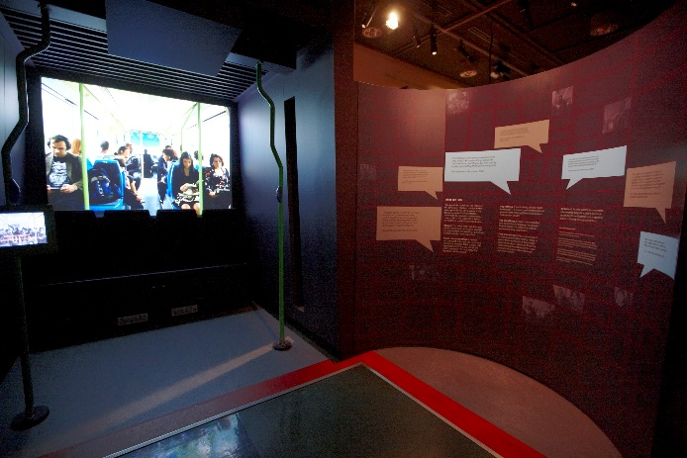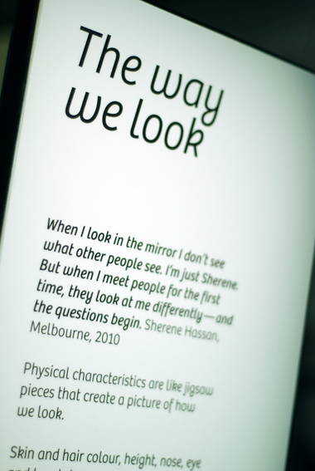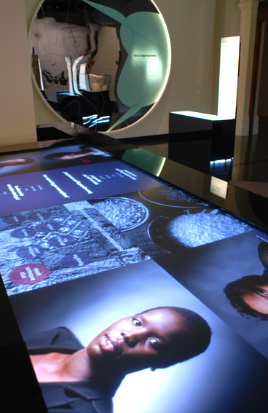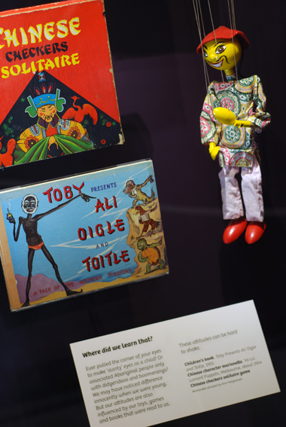

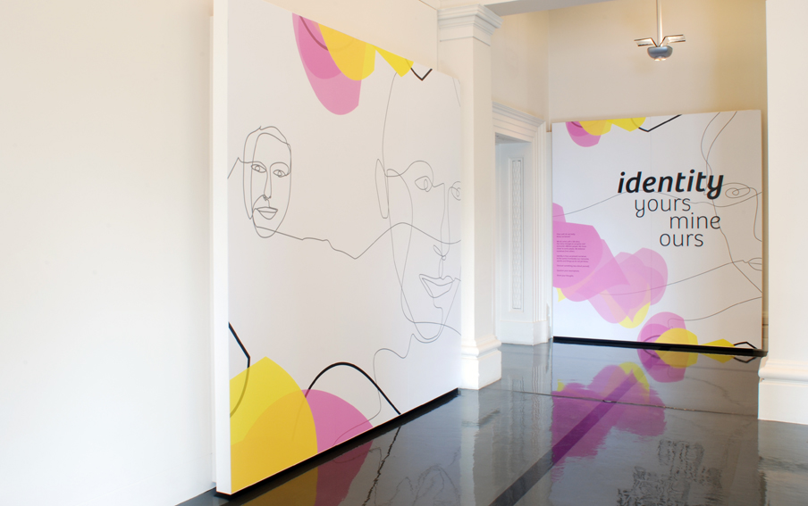



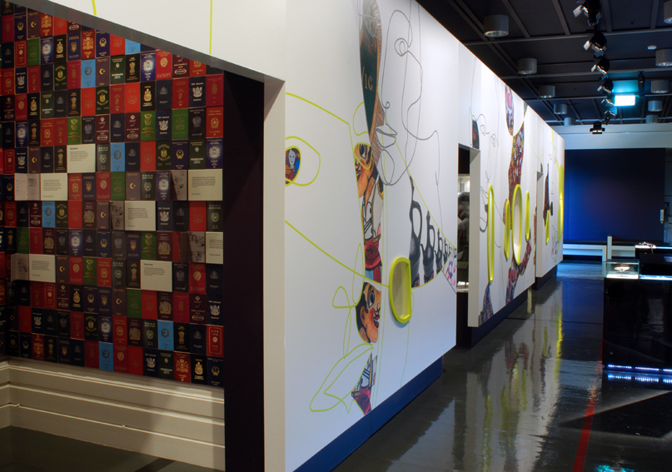

*Identity: Yours, Mine, Ours Exhibition*

Source – Museum Victoria