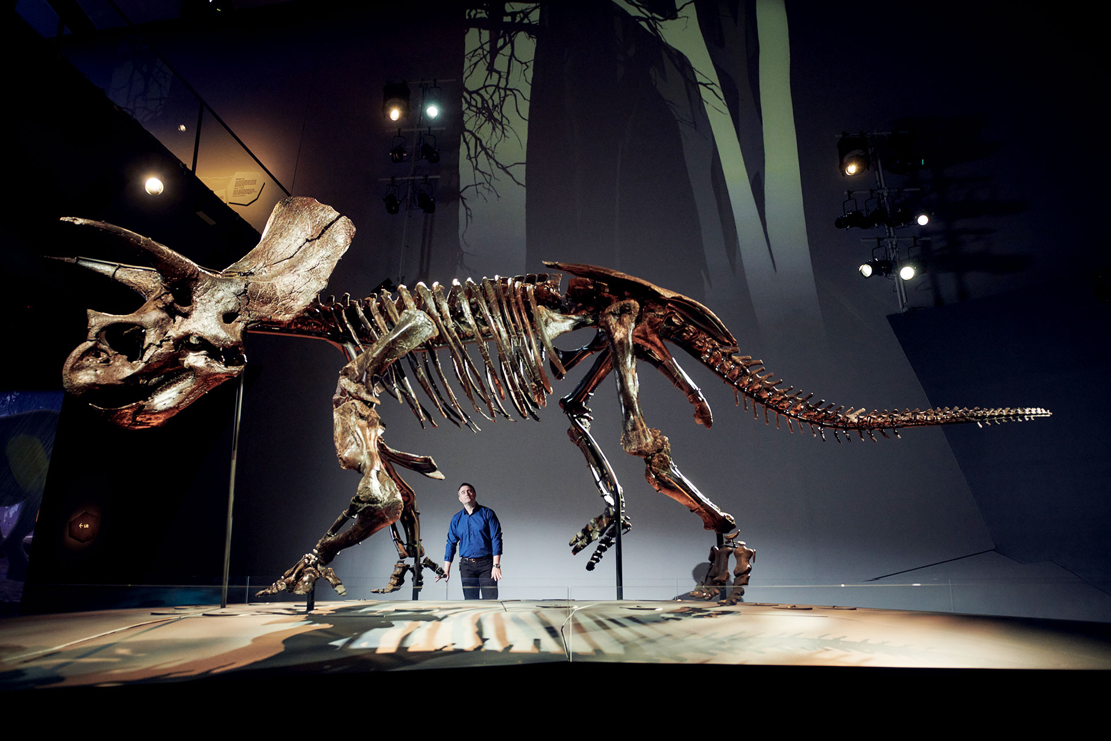
I am going to visit the Triceratops: Fate of the Dinosaurs exhibition at Melbourne Museum.
My adult can buy tickets before we arrive, or at the front ticketing desk.
I might have to wait patiently in line.
I will remember to stay with my adult for the whole of my visit to the museum.
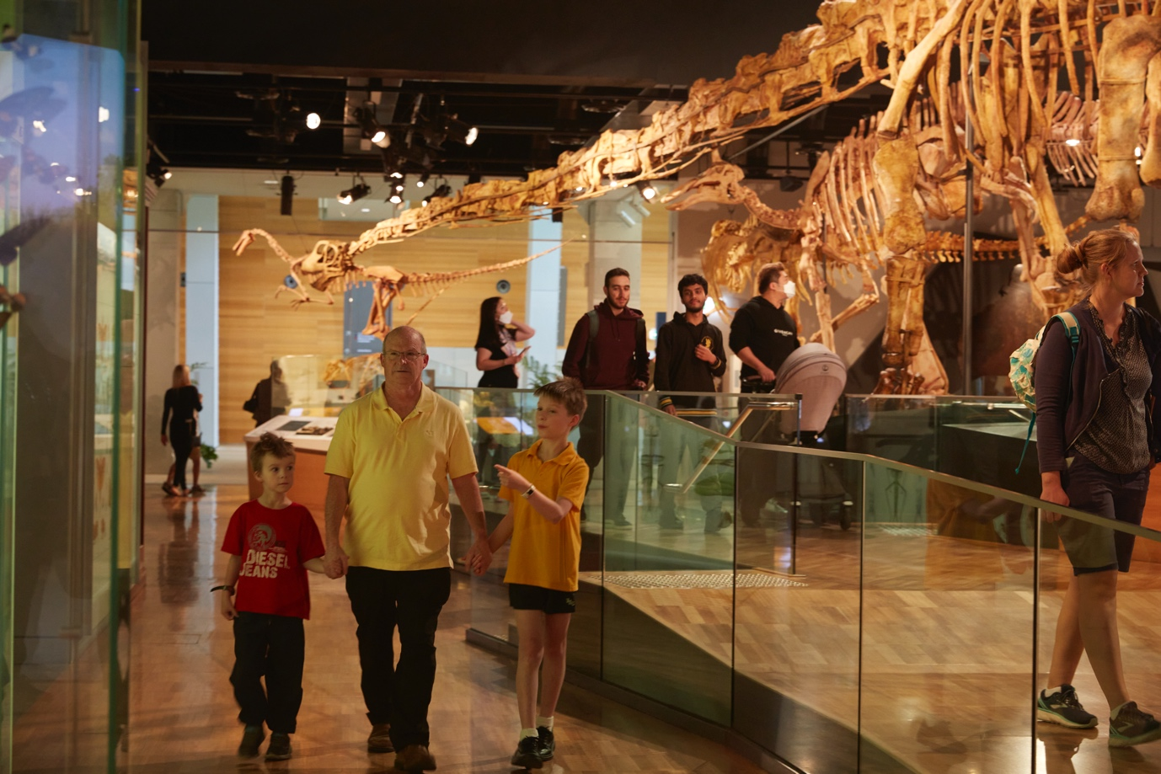
On my way to the Triceratops exhibition, I will walk past the very big Pygmy Blue Whale skeleton and then past other dinosaur skeletons.
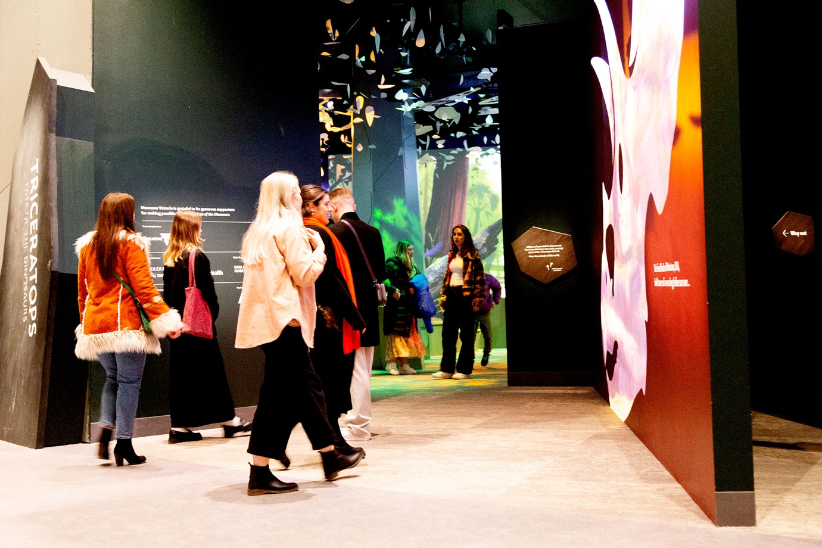
At the entry of the exhibition, I will see the shape of a Triceratops head.
I will enter the Triceratops exhibition.
The exhibition is noisy and dark in some areas, but it will be okay.
There might be a lot of people visiting at the same time as me and their voices might be loud too.
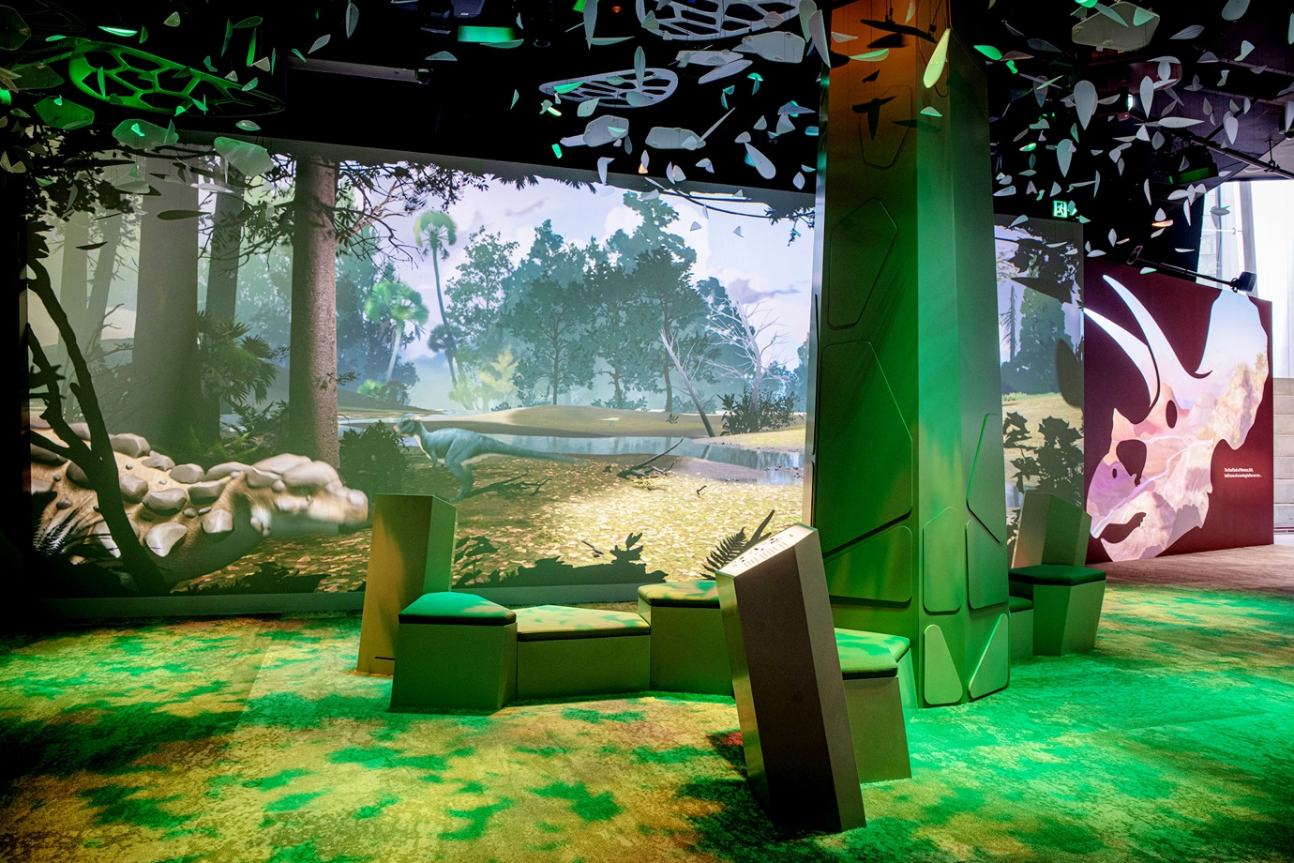

The first area has three walls that show animations, like cartoons, of the Cretaceous Period.
The Cretaceous Period is the time when Triceratops lived on earth.
The animations show the trees, landscape and animals who lived with Triceratops.
I can read some information and sit on a couch and watch.
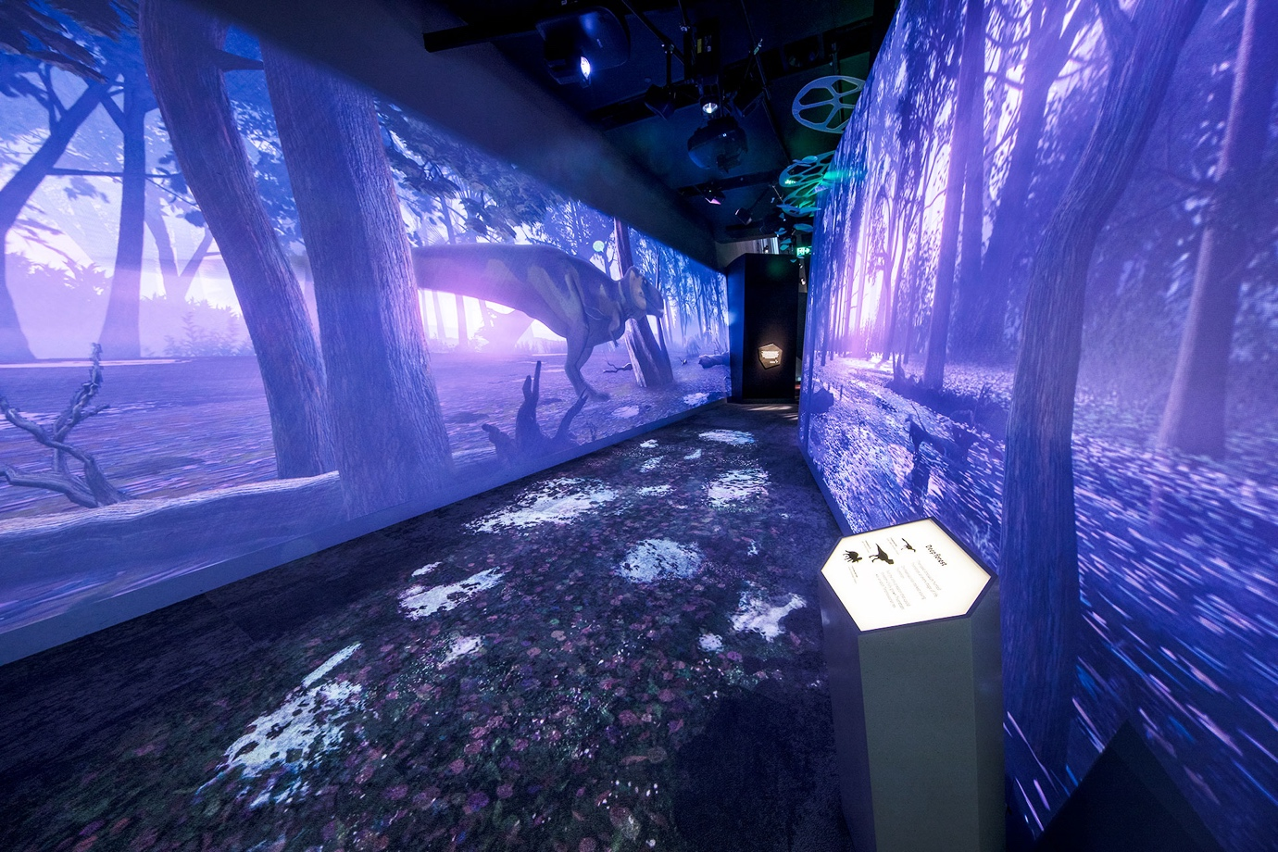
I will then walk in a dark corridor which also has animations of the dark forest of the time of Triceratops.
I might find the sound, flashing lights and images scary, but they are not real and cannot hurt me.
If I feel scared, I can hold my adult’s hand.
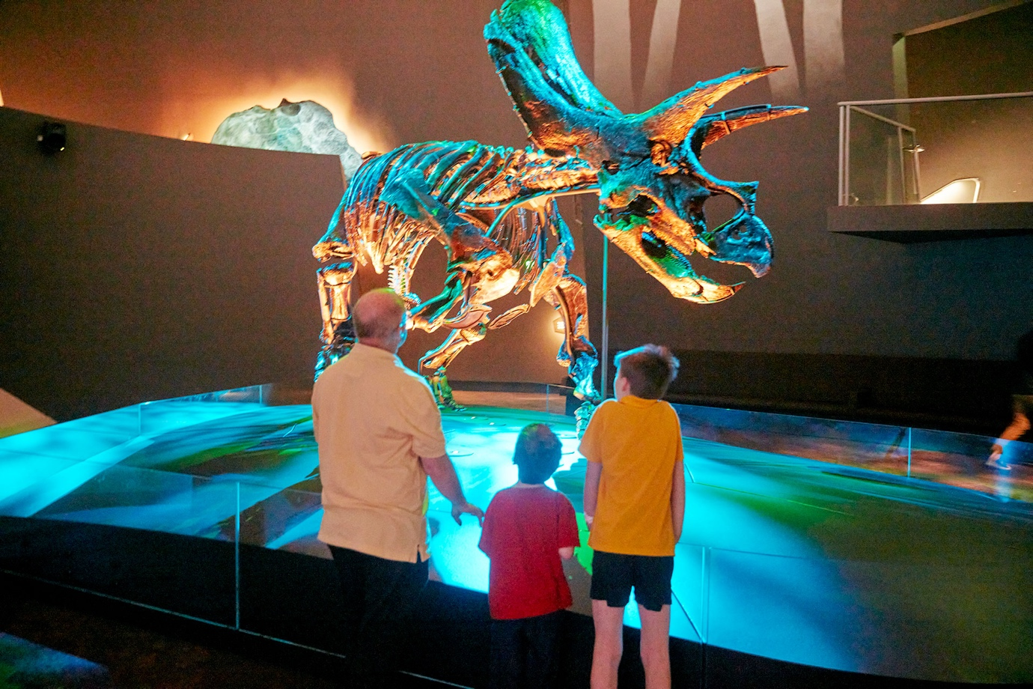
The real Triceratops skeleton is the next thing on display, and it looks like the bones are made from metal.
This area is quite dark, but the skeleton can’t hurt me. If I do not like the sounds in this area I can leave if I need to.
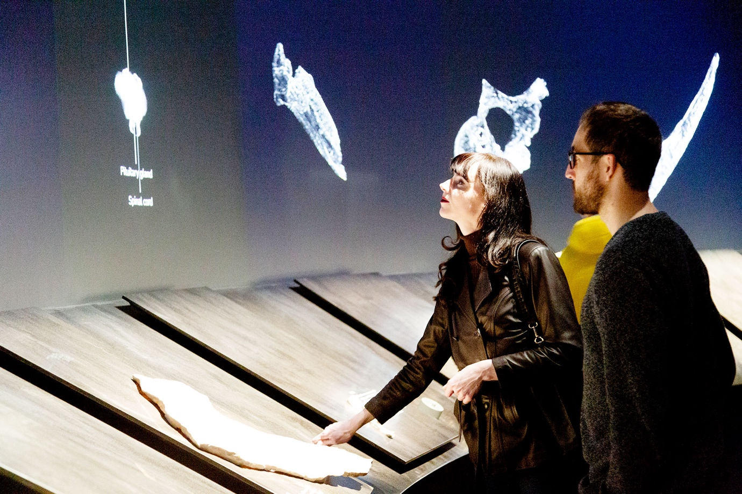
Next to the skeleton I can find and touch casts of parts of Triceratops’ skeleton and see a skin imprint of Triceratops.
I will wait my turn and share with other visitors.
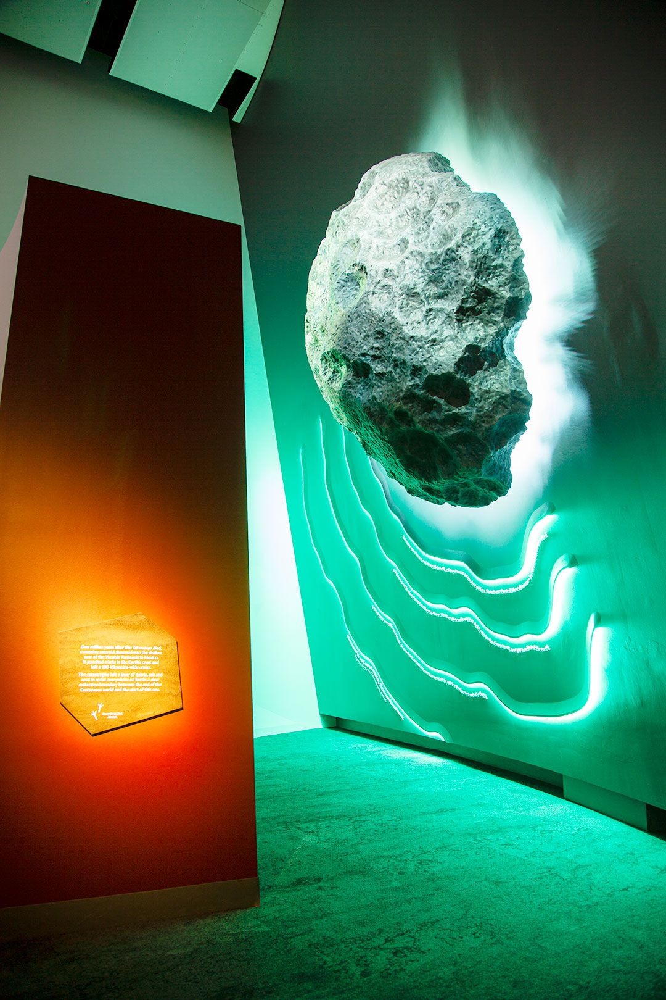
I will see a sculpture of a meteorite.
A large meteorite hit the earth about 65 million years ago and most of the plants and the animals, including Triceratops, died.
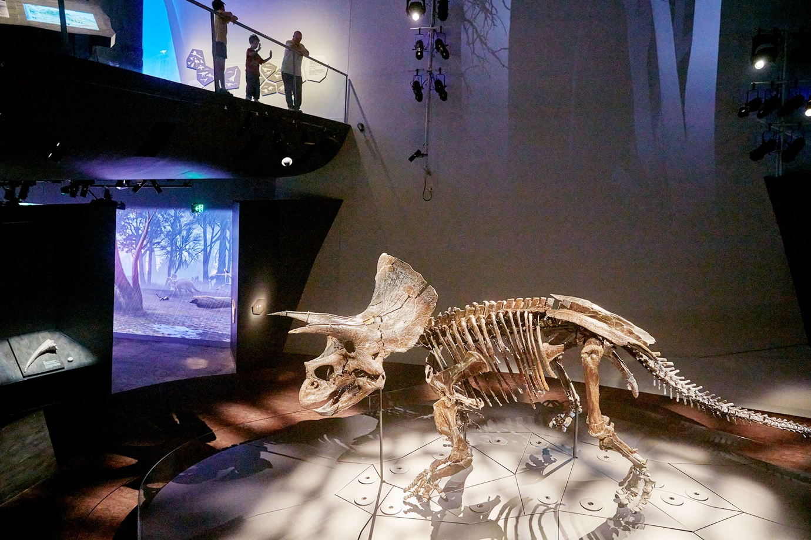
I will climb the stairs and can look over the Triceratops skeleton.
There is a small lift on the other side of Triceratops if I don’t want to climb the stairs.
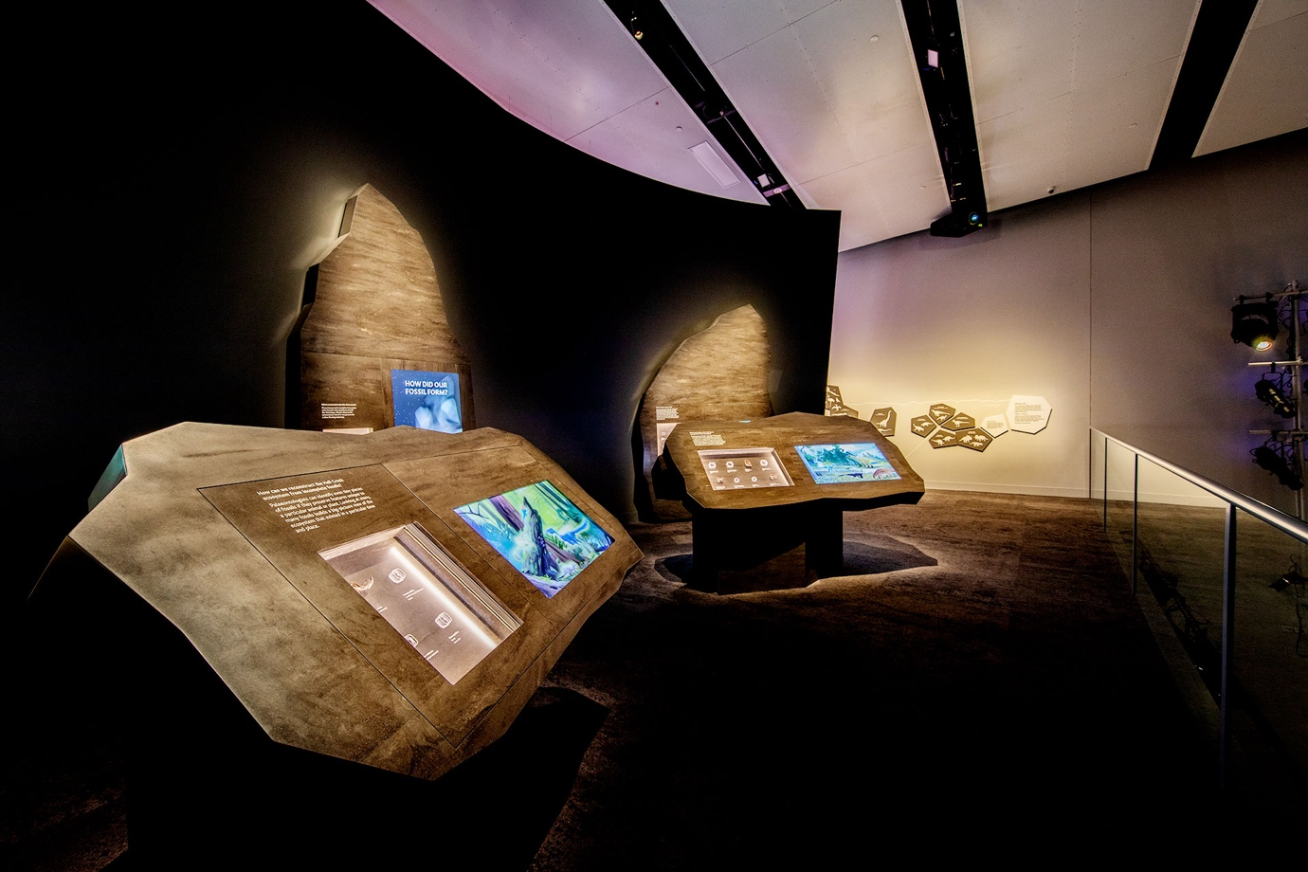
Upstairs, there is an area with screens showing animations, and showcases with real objects found in Hells Creek in the United States of America, where the Triceratops skeleton was found.
I can look at the objects and play with the screens. I will take turns and share with other people.
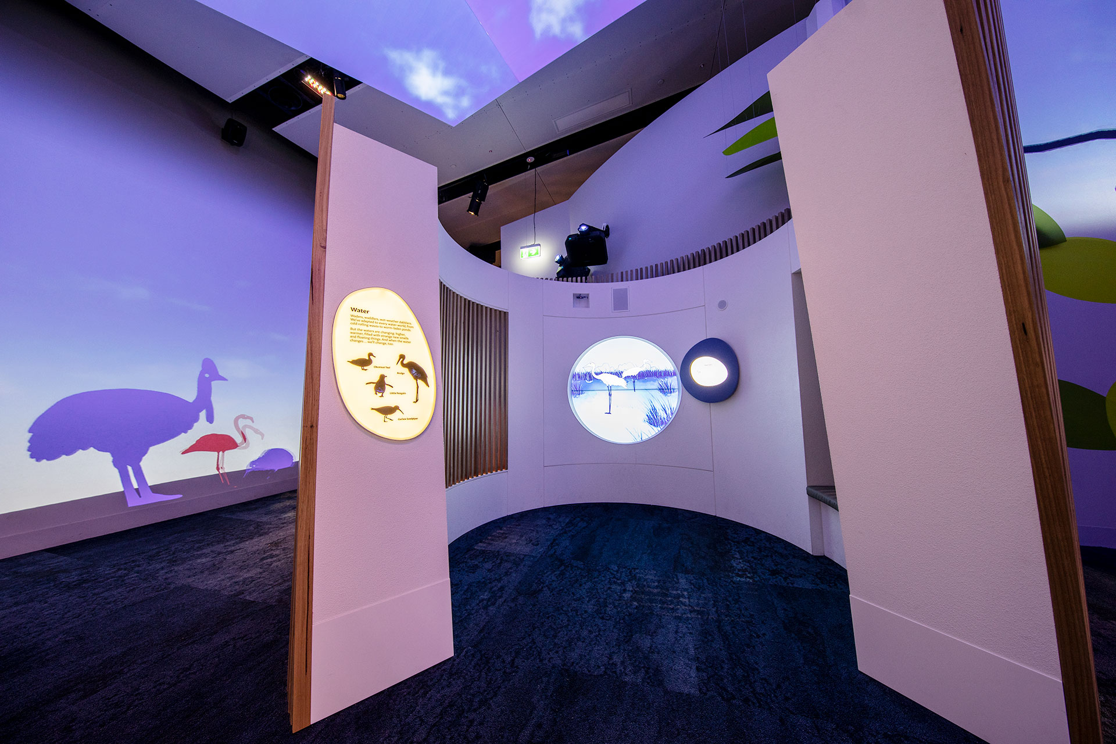
I can enter three different booths which show animations of birds in their environments.
I can try to make the same birdcalls as the ones I hear.
I can exit the exhibition from here. After I leave, I can talk about what I experienced and learned.

